Dynamic Production Tracking and Color-Coded Dashboard for Manufacturing Equipment

Prof. P.B.Tathe Prof. Ashwin Ramteke Atharva Borawake Shivam Bunge Suraj Gore

Dept. of Entc Dept. of Entc Dept. of Entc Dept. of Entc Dept. of Entc

Pune Institute of Pune Institute of Pune Institute of Pune Institute of Pune Institute of

Computer Technology Computer Technology Computer Technology Computer Technology Computer Technology

+

*Abstract*—

This project presents a real-time production monitoring and color indication dashboard for industrial machinery. The system addresses the issue of manually monitoring the quantity and quality of production of each machine in a factory and provides an automated solution that reduces manual errors and improves efficiency. The objective of this project is to implement automation to reduce the manual effort of constantly updating the status of machines and providing accurate and real-time updates to the factory manager.

The project utilizes the MERN stack, including MongoDB for data management, AWS for remote data management, and Node.js for the backend. The dashboard incorporates a color indication system to inform the manager about the current production status of each machine. The system uses a color code to indicate the level of production deviation from the planned quantity, with red, yellow, green, and orange colors representing specific levels of deviation. The manager can access the dashboard remotely, and the system sends alerts via SMS and email in case of any deviation from the planned production quantity.

The result of this project is the successful implementation of a real-time production monitoring and color indication dashboard. The dashboard provides accurate and timely updates, reducing the manual effort of monitoring production status. The factory manager can monitor the production status from their office or home and make informed decisions based on the dashboard updates.

The significance of this project lies in its ability to efficiently manage data from multiple machines in a factory, reducing manual effort, enhancing productivity, and minimizing downtime. The project's approach can be implemented in other industries to efficiently manage data and reduce manual efforts. This project contributes significantly to the field of industrial automation and production monitoring, and its outcomes can be applied to other similar projects.

# INTRODUCTION

The global industries have recently reached a unanimous decision to transition from a paper-based record system to an online platform. This innovative website allows for seamless form filling using tablets, with data securely processed and stored on the cloud. This shift not only saves considerable time, money, and resources but also eliminates the previously required effort invested in filling out paper forms and reviewing them.

In manufacturing industries, efficient production monitoring and control are vital. It is crucial to ensure optimal performance of each machine, thereby maximizing overall production output. However, traditional manual monitoring methods often prove to be tedious and error-prone, leading to significant losses for the industry. To overcome these challenges, our team has developed a real-time production monitoring and color indication dashboard for industrial machinery.

Our project's primary objective is to automate the production monitoring process, enhance efficiency, and reduce manual errors. The dashboard offers a user-friendly interface for monitoring machine performance, tracking production quantities, and receiving alerts when production falls below or exceeds predetermined thresholds. The incorporation of color-coded indicators on the dashboard provides a quick and intuitive visual representation of the production status, empowering managers to make prompt and informed decisions.

The implications of our project for the manufacturing industry are substantial. It enables streamlined data management, reduces manual efforts, and ultimately improves overall productivity. This survey paper provides a comprehensive analysis of our project, encompassing its objectives, methodology, results, and significance.

# LITERATURE REVIEW

1. The Impact of Digitalization and Industry 4.0 on Business : The role of this literature review is to define the concepts of digitization and industry 4.0 and to demonstrate that ERP systems are a reliable solution for process automation. Technological evolution has a major impact in the development and study of the concepts of digitization and industry 4.0.This paper consists description of all the four industrial revolutions as well along with advantage of industry 4.O over previous industry stages and its applications.
2. Design and implementation of a Cloud SaaS framework for Multi-Tenant applications : It studies the important aspects of cloud computing which includes features like extensibility and multi-tenancy. It proposes a SaaS platform for implementation of multi-tenant services. It also proposes a framework which make development and management of its applications. It also highlights the important cloud and clustering features. It further proposes methods to realize SaaS framework for implementation of multi-tenant applications
3. Industry 4.O an overview : This paper consists of described concept of industry 4.O, technologies , challenges and outcomes comes under industry 4.O. In this context, the overall goal of the study is to intensify the discussion and provide an overview of Industry 4.0 to show how combination of advanced technologies and internet can create new opportunities to overcome the current industrial challenges.
4. Critical Success Factors of Industry 4.0 in Automotive Manufacturing Industry It provides critical factors which are crucial in achieving goals of Industry 4.0 in the Automotive Manufacturing Industry. In this paper, Important properties of CSF(Critical Success Factors) and performance outcomes of Industry 4.0 implementation were examined. This paper also studies the relationship between CSF and operational performance, product performance, economic performance and responsiveness. These relationships are further examined by regression analysis. The result concluded that Data governance is the most crucial factor, since it affects all four performance outcomes. Legal aspects and collaboration and teamwork are other critical factors
5. A MVC Framework for Policy-Based Adaptation of Workflow Processes: A Case Study on Confidential- ity: It proposes a Model-View-Controller (MVC) framework for policy-based adaptation of workflow processes. Then complete implementation of the tasks is modeled as aspects and then selected from the library according policy based adaptation logic. Based on the properties of the surrounding and running model the suggested framework can automatically adapt a workflow instance.
6. From Industry 3.0 to Industry 4.0: production modernization and creation of innovative digital companies: Some mechanical and assembly productions of existing companies of the Industry 3.0 and mechanical and assembly productions of perspective companies of the Industry 4.0 are described in this paper. The basic components of a smart factory and their interconnection to organize a production activity using humanless and paperless technologies are defined. A comparison analysis of parts and blanks movement to complete route sheet of the item manufacturing (radio and electronic item designing) in the companies of the Industry 3.0 and Industry 4.0 is given. The components of a digital item designing company to be created and implemented in the industry at first hand are defined.

# PROPOSED METHODOLOGY

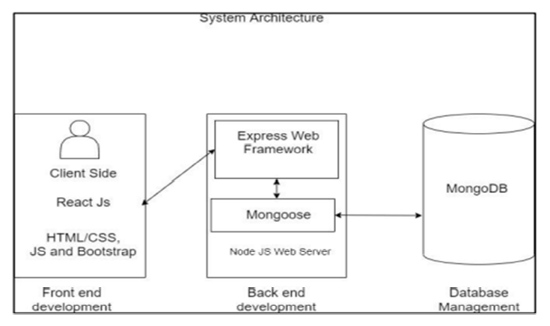

## Fig. 1. System Architecture

The proposed system is a Software as a Service (SaaS) product, utilizing a standard Web Application System Architecture. The project development employs the popular and widely adopted MERN stack technology.

The frontend development is carried out using ReactJS, a renowned open-source JavaScript library for building user interfaces based on UI components.

For the backend development, ExpressJS is utilized as a server to manage routing paths and handle requests. Node.js, an open-source backend JavaScript runtime engine, complements ExpressJS.

To store and maintain data for the full stack website, we have utilized MongoDB Atlas, a fully managed cloud database service.

The cloud platforms employed in this system include AWS, where an EC2 instance is deployed for server hosting, and AWS SNS for SMS notifications. Netlify is used for frontend deployment, with continuous deployment enabled via GitHub branch integration.

.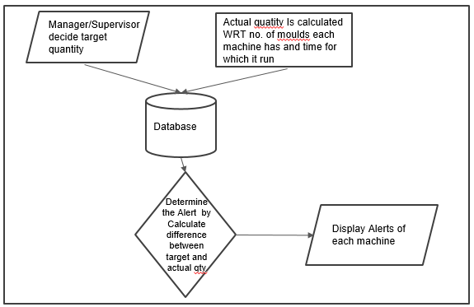

## Fig. 2. Flowchart

In this proposed system, key authorities such as General Managers, Managing Directors, and Supervisors establish initial planning for each machine department and individual machines within the industry. Autonomous systems fitted on the machines monitor their actual production at regular intervals. The variance between actual and planned production triggers color-coded alerts, which are sent to the respective authorities. Operators can also raise alerts in the event of issues such as material shortages, faulty production, or errors in machine handling.

These alerts are then forwarded to the appropriate industry authorities based on their type and severity, enabling immediate action to be taken. This proactive approach significantly contributes to improving overall productivity within the industry

# CONCLUSION AND FUTURE SCOPE

## A. Conclusion

The implementation of the Real-time Production Monitoring and Color Indication Dashboard for Industrial Machinery using the MERN stack has provided an automated solution to a common problem faced by many industries. The dashboard allows for the efficient monitoring of production quantity and provides color-coded alerts in real-time, which reduces the need for manual labor and improves overall efficiency. The system has been successfully implemented and demonstrated to work according to plan, with positive feedback from the manager regarding its usefulness and ease of use.

B. Future Scope

As, there are several areas for improvement and expansion. Firstly, the system can be further optimized for even more efficient data management and processing. This can be achieved by implementing machine learning algorithms to predict production trends and improve overall accuracy. Secondly, the system can be integrated with other industrial systems such as inventory management, supply chain management, and quality control. This will provide a more comprehensive solution to industrial needs and improve overall productivity. Finally, the system can be scaled to larger industries and organizations to provide a wider reach and benefit to more people.

### ACKNOWLEDGMENT

We begin by expressing our heartfelt gratitude to our project mentor, Prof. P. B. Tathe for their unwavering support, timely assistance, and invaluable contributions in helping us achieve the success of our project. We extend our appreciation to all those who have made significant contributions to this project. We are particularly grateful to Prof. P. B. Thate for providing expert guidance in software designing and connections. We would also like to acknowledge the lab faculty members for providing us with the necessary lab facilities and equipment whenever required.

We would like to thank our fellow batchmates for their unwavering moral support and timely assistance, which played an essential role in our journey. We extend our special appreciation to the team members for their complete coordination, honest efforts, and willingness to complete this project successfully. Finally, we would like to thank all those who have contributed to our project in any way, for their invaluable support and encouragement throughout the project.

### REFERENCES

1. Laura-Eugenia-Lavinia BARNA, The Impact of Digitalization and Industry 4.0 on Business, The 4 th International Conference on Economics and Social Sciences Resilience and economic intelligence through digitalization and big data analytics June 10-11, 2021 Bucharest University of Economic Studies, Romania
2. P. Morakos and A. Meliones, ”Design and implementation of a Cloud SaaS framework for Multi-Tenant applications,” IISA 2014, The 5th International Conference on Information, Intelligence, Systems and Applications, 2014, pp. 273-278, doi: 10.1109/IISA.2014.6878755
3. Beatrice Santos, F. Charrua-Santos, T.M. Lima, Industry 4.0: an overview. at: <https://www.researchgate.net/publication/326352993>
4. M. S. Bhatia and S. Kumar, ”Critical Success Factors of Industry 4.0 in Automotive Manufacturing Industry,” in IEEE Transactions on Engineering Management, vol. 69, no. 5, pp. 2439-2453, Oct. 2022, doi: 10.1109/TEM.2020.3017004
5. K. Geebelen, E. Kulikowski, E. Truyen and W. Joosen, ”A MVC Framework for Policy-Based Adaptation of Workflow Processes: A Case Study on Confidentiality,” 2010 IEEE International Conference on Web Services, 2010, pp. 401-408, doi: 10.1109/ICWS.2010.81
6. D A Zakoldaev, A V Shukalov and I O Zharinov, From Industry 3.0 to Industry 4.0: production modernization

and creation of innovative digital companies.