Student Attendance System using Face recognition

Sharvari Basarkar, Siddhant Bedmutha, Shubham Hire, Pratiksha Lad

Dept. of Information Technology

P.E.S MODERN COLLEGE OF ENGINEERING, PUNE

*Abstract*— *The student attendance system is a web application that utilizes face recognition, machine learning, Redis, Python, and Streamlit to automate and enhance the process of recording and managing student attendance in educational institutions. Traditional attendance methods, such as manual roll call or barcode scanning, are time-consuming, error-prone, and often suffer from attendance fraud. This web application offers a reliable and efficient solution by leveraging face recognition technology.*

*The system utilizes machine learning algorithms to train a face recognition model capable of identifying students accurately. This model is integrated into the web app, which provides an intuitive and user-friendly interface for administrators and teachers to manage attendance records. By capturing real-time images of students through webcams or mobile devices, the system matches the faces with the stored database of registered students and records their attendance automatically.*

*To ensure scalability and efficient storage of student information, Redis, an in-memory data structure store, is utilized as a fast and reliable database system. Redis allows for quick retrieval and manipulation of attendance records, providing real-time updates and analytics. Python's extensive libraries and frameworks, such as OpenCV and TensorFlow, enable seamless integration of face recognition capabilities.*

*Streamlit, a powerful web application framework, is employed to create an interactive and visually appealing user interface. With Streamlit, administrators and teachers can access attendance reports, generate insights, and perform administrative tasks with ease.*

*The student attendance system web app offers numerous benefits, including accurate attendance tracking, reduced administrative burden, increased efficiency, and improved transparency. By leveraging face recognition, machine learning, Redis, Python, and Streamlit , this system presents a comprehensive solution to enhance the attendance management process in educational institutions, ultimately contributing to improved academic outcomes and streamlined administrative operations.*

*Index Terms: Python ,OpenCV,Redis,Streamlit,Tensorflow.*

# **Introduction**

This project aims to develop a cutting-edge Student Attendance System Web App by leveraging the power of Face Recognition, Machine Learning, Redis, Python, and Streamlit. By combining these technologies, we can create a robust and efficient system that automates attendance management while ensuring accuracy and reliability.

Face recognition, powered by Machine Learning algorithms, offers a highly secure and convenient way to identify individuals based on their facial features. This technique eliminates the need for manual attendance-taking methods, such as paper-based sign-in sheets or barcode scanning, which are susceptible to manipulation or proxy attendance. With face recognition, the system can accurately verify the identity of each student in real-time.

To store and manage the attendance data, Redis, a fast in-Permemory database, will be employed. Redis provides efficient data storage and retrieval capabilities, allowing seamless integration with the web app. This ensures that attendance records are stored securely and can be accessed swiftly for reporting and analysis purposes.

Python, a versatile and widely-used programming language, will serve as the primary language for implementing the web app. Python's extensive libraries and frameworks make it an ideal choice for developing complex applications like the Student Attendance System. Its simplicity and readability also enable faster development cycles.

Streamlit, a Python library, offers an intuitive and user-friendly interface for creating web applications with minimal effort. Its interactive and responsive nature allows users to navigate through the system seamlessly. Streamlit's simplicity empowers developers to rapidly prototype and deploy web apps, reducing the overall development time.

By combining Face Recognition, Machine Learning, Redis, Python, and Streamlit, we can build a comprehensive Student Attendance System Web App that brings efficiency, accuracy, and convenience to attendance management. This project aims to revolutionize traditional attendance tracking methods and enhance the overall educational experience for students and educators alike.

# **Literature Survey**

[1] This study that was proposed in the year 2022 proposes an automatic attendance system using face recognition for schools and universities. The system consists of three parts: a training stage where student photos are captured and stored, an attendance system where lecturers take photographs of students and upload them to the system, and a student profile system to retrieve student data by capturing their pictures. The authors used a combination of two deep learning algorithms, Multi-Task Cascaded Convolutional Neural Network (MTCNN) and FaceNet, to develop the face recognition system. The testing results showed 100% accuracy for face detection and 87.03% accuracy for face recognition. The authors suggest future work could involve linking the system to a mobile application or website, improving face recognition accuracy for non-frontal faces, and incorporating a larger database of students.

[2] Another study presents an automated attendance-taking system using face recognition, with a mask-checking feature as a measure against the Covid-19 pandemic. The authors compared the performance of two face detection algorithms, Histogram of Oriented Gradients (HOG) and Haar-Cascade, and found that HOG provided better accuracy under changing lighting conditions. They used convolutional neural networks (CNNs) and a Support Vector Machine (SVM) classifier for face recognition. The authors also developed a graphical user interface (GUI) system for instructors to generate attendance automatically, add new students, and check attendance on previous dates. Future work could involve integrating the system into the Student Management System of the university/school for automatic generation of attendance.

[3] This paper discusses the use of a face recognition-based attendance system to eliminate the burden of manual attendance management for teachers. The system aims to address issues such as proxies and false attendance markings. The authors propose using face recognition technology to accurately capture and record attendance. However, the abstract does not provide detailed information on the methodology or results of the sytem. Further information is needed to assess the effectiveness of the proposed system.

Overall, the reviewed papers propose the use of face recognition technology for automated attendance systems in schools and universities. They highlight the potential benefits of such systems, including increased efficiency and convenience. The papers also suggest future work to improve the accuracy, accessibility, and integration of the systems with other existing systems. However, more detailed information on the methodology, results, and limitations of the proposed systems would be beneficial for a comprehensive literature review.

# Proposed system

1. *Architecture:*

The proposed student attendance system is based on face recognition algorithms. In this system each student image will be captured and then face regions then of all students is extracted and the pre-processed for further processing. After recognition of faces then it is passed for post-processing where the attendance of every student is generated into excel sheet.

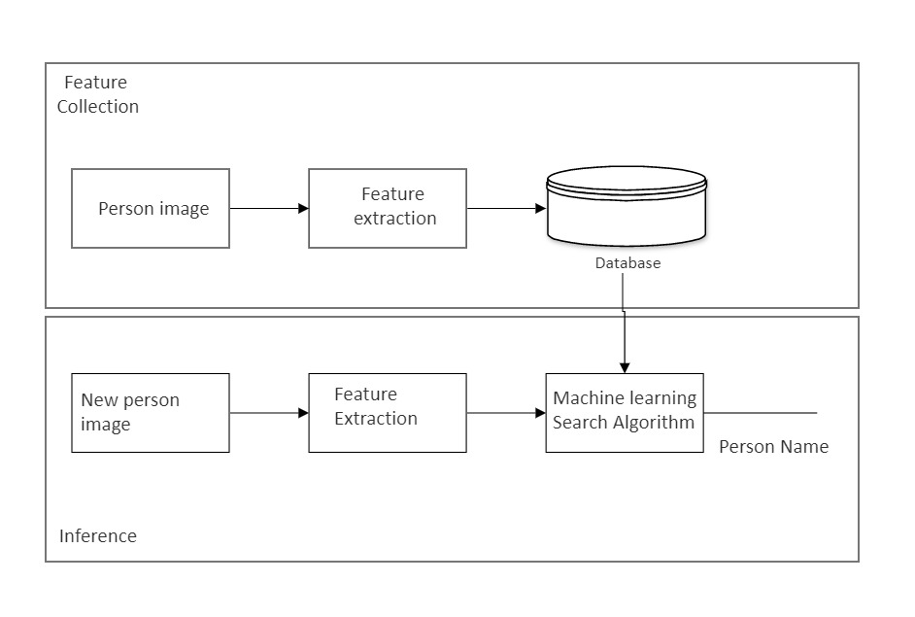

Fig.1. Proposed student attendance system

1. *Methodology*:

Developing an intelligent attendance management system,

some steps need to be followed to achieve this Successful . The steps are definable as follows:

* Image capture
* Face Detection
* Pre-processing
* Database Development
* Feature Extraction and Classification
* Post-Processing

*Image capture:*

*The project starts with capturing images using a camera or webcam.The camera will be used to capture images of students and teachers for face recognition.The captured images will be used as input for the face detection and recognition process.*

*Face Detection:*

*Once the images are captured, the face detection algorithm is applied to locate and extract faces from the images.The face detection algorithm analyzes the images and identifies the regions containing faces. This step is important to isolate and extract facial features for further processing.*

*Pre-processing:*

After detecting faces, pre-processing techniques are applied to enhance the quality of the images and prepare them for feature extraction.Pre-processing may involve operations like resizing, cropping, normalization, and grayscale conversion.These operations ensure consistency in the input images, removing variations such as lighting conditions and image sizes..

*Database Development:*

This phase comprises of embedding capture of each individual and store it in database for further process. In our database we have taken images of each student from different angles, different expressions and different light conditions. A database is developed to store the registered information of students and teachers. The database will contain the necessary information such as name, unique identifier, and any additional data required for attendance management. This database will be used to compare and match the detected faces with the registered faces.

Following figure shows sample of extracted and pre-processed faces in the database.

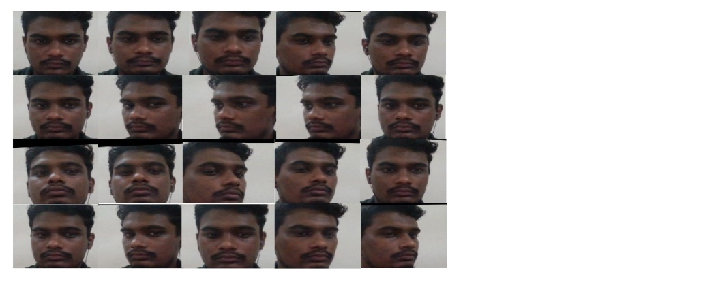

**Fig.2 Sample Database images**

*Feature Extraction and Classification:*

The performance of Face recognition also depends upon feature extraction and their classification to get accurate results. Feature extraction is achieved by extracting important features of face from the image.In this step, feature extraction algorithms are applied to the pre-processed images to extract distinctive features from the faces. The extracted features can include facial landmarks, texture patterns, or other facial attributes. These features are used to create a unique representation, such as a face embedding or a feature vector, for each face in the database. The Euclidean distance and Manhattan distance are then used to compare the distance between the image and the trained images and then the best matched indexed result is then identified as that recognized face.

*Euclidean Distance:*

The Euclidean distance or Euclidean metric is the ordinary distance between two points that one would measure with a ruler, and is given by the Pythagorean formula.By using this formula as distance, Euclidean space becomes a metric space. The Euclidean distance between points P and Q is the length of the line segment connecting them [PQ]. In Cartesian coordinates, if P = (p1, p2, … , pn) and Q = (q1, q2, … , qn) are two points in Euclidean n-space, then

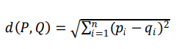

In three-dimensional Euclidean space, the distance is:

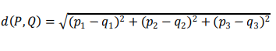

Once the face embeddings are obtained, cosine similarity can be used to measure the similarity between two face embeddings.

*Cosine Similarity:*

Cosine similarity is a metric that measures the cosine of the angle between two vectors.

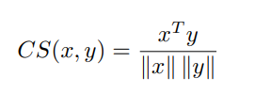

It quantifies the similarity between the vectors, where a value close to 1 indicates a high similarity, and a value close to -1 indicates a high dissimilarity.

*Post-processing:*

Once the features are extracted, a classification algorithm or search algorithm is used to compare the detected faces with the registered faces in the database. The classification algorithm matches the detected faces with the registered faces by comparing the extracted features.If a match is found, the system identifies the person by their registered name.

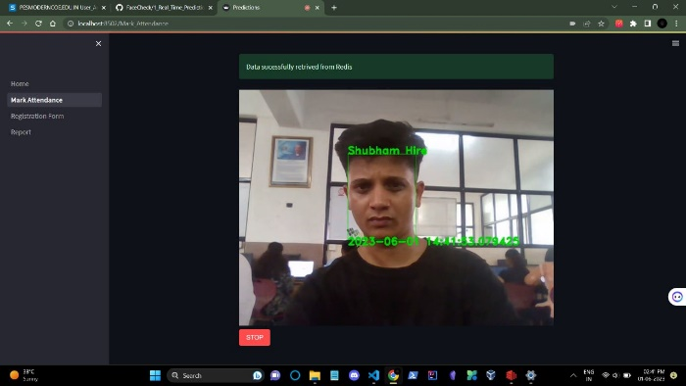

**Fig.3a Recognized Face**

If no match is found, the system labels the detected face as "unknown."

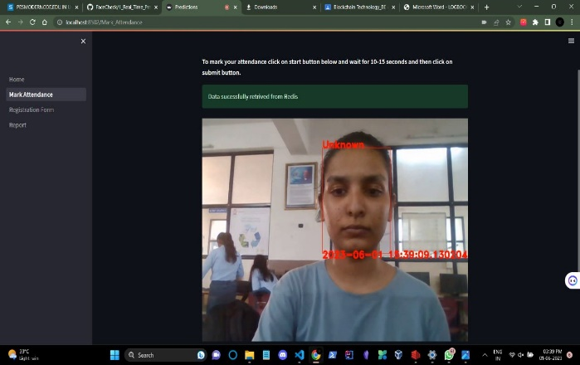

**Fig.3b Not Recognized Face**

# **Conclusion and Future Scope**

In conclusion, the development of a student attendance system web app using Face Recognition technology offers significant advantages in the realm of attendance management. The utilization of Face Recognition technology ensures a reliable and secure method of student identification. By analyzing unique facial features, the system can accurately recognize and verify the identity of each student, eliminating the need for manual attendance taking and reducing the chances of errors or fraudulent attendance. This technology provides a convenient and seamless experience for both students and teachers, saving valuable time and resources. The implementation of a student attendance system web app using Face Recognition technology revolutionizes attendance management in educational institutions. It enhances accuracy, efficiency, and security while providing a seamless and convenient experience for all stakeholders. This innovative solution promotes a proactive approach to attendance tracking and empowers educators to focus on teaching and student engagement, ultimately enhancing the overall educational experience.

The future scope for a student attendance system web app using Face Recognition is promising, with several potential areas for further development and improvement.

Continued advancements in Machine Learning algorithms and Face Recognition technology can lead to improved accuracy and faster recognition speeds. Integrating additional biometric modalities, such as fingerprint recognition or voice recognition, can further enhance the system's security and accuracy. By combining multiple biometric factors.

real-time notifications and alerts can be valuable for attendance monitoring. For example, sending instant notifications to parents or guardians when their child arrives or leaves the college premises can improve communication and safety.real-time notifications and alerts can be valuable for attendance monitoring. For example, sending instant notifications to parents or guardians when their child arrives or leaves the school premises can improve communication and safety. Interactive dashboards and visualizations can provide a comprehensive overview and aid in decision-making processes.

# **Result**

The implemented face recognition-based attendance system has successfully achieved the following outcomes:

*Image Capture*:

The system effectively captures images using a camera or webcam, providing input for face detection and recognition.

*Face Detection:*

A robust face detection algorithm has been implemented, allowing the system to locate and extract faces from the captured images.

*Pre-processing:*

Pre-processing techniques, such as resizing, cropping, normalization, and grayscale conversion, have been applied to enhance image quality and ensure consistency.

*Database Development:*

A reliable database has been developed to store the registered information of students and teachers, including names and unique identifiers required for attendance management.

*Feature Extraction and Classification:*

The system employs feature extraction algorithms to extract distinctive facial features from pre-processed images. These features are then used for creating unique representations, such as face embeddings or feature vectors, for each face in the database.

*Post-Processing:*

Through the use of classification or search algorithms, the system compares the detected faces with the registered faces in the database. Matches result in the identification of individuals by their registered names, while unmatched faces are labeled as "unknown." Attendance logs are generated as a CSV file, documenting the attendance records.



**Fig.4 CSV file generated**

# **Reference**

1. D. H. Gowda, K. Vishal, K. B. R, N. Kumari Dubey, and P. M. R, “Face Recognition based Attendance System.”, *International Research Journal of Engineering and Technology*,
2. I. Al-Amoudi, R. Samad, N. R. H. Abdullah, M. Mustafa, and D. Pebrianti, “Automatic Attendance System Using Face Recognition with Deep Learning Algorithm,” in *Lecture Notes in Electrical Engineering*, Springer Science and Business Media Deutschland GmbH, 2022, pp. 573–588. doi: 10.1007/978-981-16-2406-3_44.
3. A. Jadhav, A. Jadhav Tushar Ladhe, and K. Yeolekar, “AUTOMATED ATTENDANCE SYSTEM USING FACE RECOGNITION,” *International Research Journal of Engineering and Technology*, 2017,
4. S. Dev and T. Patnaik, “Student Attendance System using Face Recognition,” Proc. - Int. Conf. Smart Electron. Commun. ICOSEC 2020, no. Icosec, pp. 90–96, 2020, doi: 10.1109/ICOSEC49089.2020.9215441.
5. K. H. Teoh, R. C. Ismail, S. Z. M. Naziri, R. Hussin, M. N. M. Isa, and M. S. S. M. Basir, “Face Recognition and Identification using Deep Learning Approach,” J. Phys. Conf. Ser., vol. 1755, no. 1, 2021, doi: 10.1088/1742-6596/1755/1/012006
6. C. Gomes, S. Chanchal, T. Desai, and D. Jadhav, “Class Attendance Management System using Facial Recognition,” ITM Web Conf., vol. 32, p. 02001, 2020, doi: 10.1051/itmconf/20203202001.
7. B. T. Hung and N. N. Khang, “Student Attendance System Using Face Recognition,” vol. 3, no. 7, pp. 967–977, 2021, doi: 10.1007/978-981-33-6307-6_98