**SMART HELMET INTEGRATED WITH AIRBAG SYSTEM**

**Sindhu K1, Mukesh kumar B2, Manoj S3, Akash Kumaar G R4 , Vani M5**

1Assistant Professor, CSE, Sambhram Institute of Technology, Bengaluru, Karnataka, India

2345Student, CSE, Sambhram Institute of Technology, Bengaluru, Karnataka, India

**ABSTRACT**

*An integrated helmet airbag system is a revolutionary technology that aims to provide additional protection for motorcycle riders in the event of an accident. It is a safety device that integrates an airbag system into a helmet, providing an extra layer of protection for the head and neck. This innovative technology has the potential to save countless lives, and its development is a significant step forward in motorcycle safety. The integrated helmet airbag system consists of a set of sensors that are strategically placed throughout the motorcycle. These sensors are designed to detect the sudden deceleration or change in speed that typically occurs during a crash. When a crash is detected, the sensors trigger the deployment of the airbag system. The airbag system in the helmet works in the same way as the airbag in a car. It is designed to inflate rapidly upon impact, creating a cushion of air around the head and neck of the rider. This cushion of air helps to reduce the risk of serious injury by absorbing the impact of the crash. The integrated helmet airbag system is an excellent addition to existing safety measures such as helmets and protective clothing. The system works to protect the head and neck, which are the most vulnerable areas of the body in the event of an accident.*

***Key Words*:** Smart Helmet, Airbag integrated Helmet, Helmet with sensors.

1. **INTRODUCTION**

A smart helmet integrated with an airbag system is a revolutionary safety gear designed to protect motorcyclists in case of accidents. This helmet incorporates advanced technologies to detect and respond to sudden impacts that may occur during a collision, deploying an airbag to protect the rider's head and neck from injury. The helmet is equipped with sensors that detect any abrupt changes in motion, such as a fall or a collision, and trigger the airbag to inflate instantly to form a protective cushion around the rider's head and neck. This helps to reduce the impact of the accident on the rider's head, neck, and spine, significantly reducing the risk of severe injury or fatality. Moreover, the smart helmet is also designed to monitor the rider's behavior and provide essential information on their surroundings, such as traffic conditions and weather updates, using built-in sensors and communication devices. In summary, the smart helmet integrated with an airbag system is a significant advancement in motorcycle safety, providing riders with unparalleled protection and enhanced situational awareness, making riding safer and more enjoyable.

1. **PROBLEM STATEMENT**

Smart helmets with integrated airbag systems may be significantly more expensive than traditional helmets, which could make them prohibitively expensive for many riders. This could limit their adoption and reduce their overall impact on rider safety. The integration of an airbag system into a helmet could make maintenance and repair more complicated and expensive. For example, the airbag may need to be replaced after it has been deployed, which could be costly and time-consuming. Finally, there may be concerns about whether riders will be willing to adopt a smart helmet with an integrated airbag system. Some riders may be resistant to new technology, while others may not see the value in investing in a more expensive helmet.

1. **BLOCK DIAGRAM**

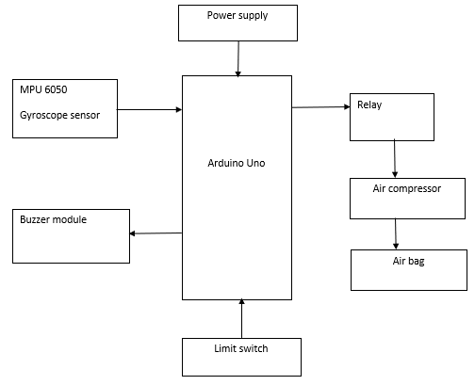

An innovative and special safety solution for motorcycle riders is the integration of several components in a smart helmet with an airbag system. For the components to work continuously, this integrated system is fueled by a dependable power source. When the Arduino microcontroller obtains power, it turns on and begins to regulate the functions of all other attached parts. The MPU 6050 sensor senses or detects changes in acceleration and orientation and provides some crucial information for collision detection. The MPU 6050 has a 3-axis accelerometer and a 3-axis gyroscope sensor in the MPU 6050 for detecting or sensing any sudden changes in riders' movement. The accelerometer is also used to determine the liner's movement speed, and the gyroscope sensor determines rotational movement. A buzzer module that generates or releases a loud warning sound is triggered by the Arduino when a probable collision is detected, alerting the rider and anybody close. In addition, a limit switch is used to determine whether the rider is wearing a helmet properly and to alert the Arduino to start the airbag deployment system if any sudden changes are detected. The relay module is in charge of managing the air compressor's activation, which quickly inflates the airbag in the event of a collision. To protect the rider from accidents and injuries, the air compressor is activated if the relay module detects any negative or abrupt changes. This air compressor then releases or inflates the airbag.

Overall, this integrated system is fueled by a dependable power source, guaranteeing that all of the parts continue to work. With the help of its collision detection, auditory warnings, and quick airbag deployment features, the smart helmet aims to drastically lower the possibility of serious head and neck injuries for motorcycle riders.

**4. COMPONENTS**

**ARDUINO:**

Arduino is an open-source electronics platform based on easy-to-use hardware and software. It consists of a physical programmable circuit board, a software development environment, and a community of users and developers.

The Arduino microcontroller is the heart of the Arduino platform. It is a small computer on a single integrated circuit that can be programmed to control a wide range of electronic devices and sensors..

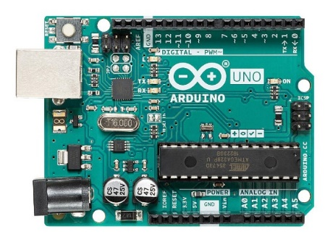

It is designed to be easy to use, even for people without technical backgrounds, and offers a range of features for controlling and communicating with other devices.

**Buzzer**

A buzzer is an electrical device that produces sound when an electrical current passes through it. Buzzer is a type of transducer that converts electrical energy into sound energy. The sound produced by a buzzer can range from a simple beep to a complex tone. Buzzers are used in a wide range of applications, including alarms, timers, and electronic games.

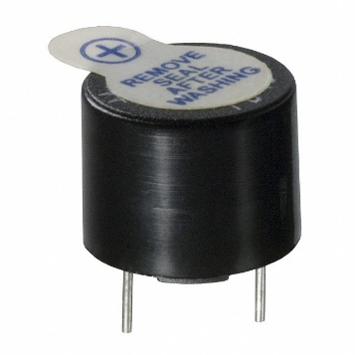

**Relay:**

Relay modules are electronic components that allow control signals to switch power to high-current loads. They consist of a relay, a control circuit, and a set of input and output pins. The relay is an electromechanical switch that is controlled by the input signal, which activates the coil of the relay. When the coil is activated, it switches the output circuit, allowing power to flow to the load.

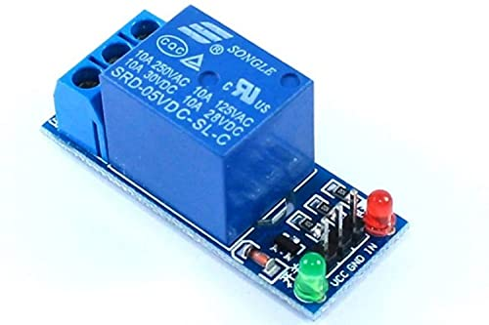

**MPU 6050 SENSOR:**

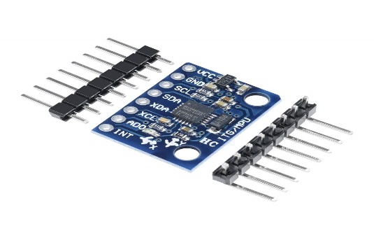

MPU6050 is a micro-electromechanical system (MEMS) sensor that combines a 3-axis gyroscope and a 3-axis accelerometer in a single chip. The MPU6050 is commonly used in a wide range of applications, including robotics, drones, gaming controllers, and motion sensing devices.

**AIR COMPRESSOR**

An air compressor is a device that converts power into potential energy stored in compressed air. This compressed air can then be used for various applications such as powering tools, inflating tires, or operating machinery. Air compressors come in many different shapes and sizes, and can be powered by a variety of energy sources such as electric motors, gasoline engines, or diesel engines.

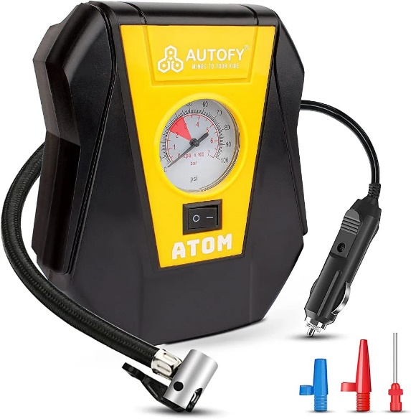

**5. RESULT**

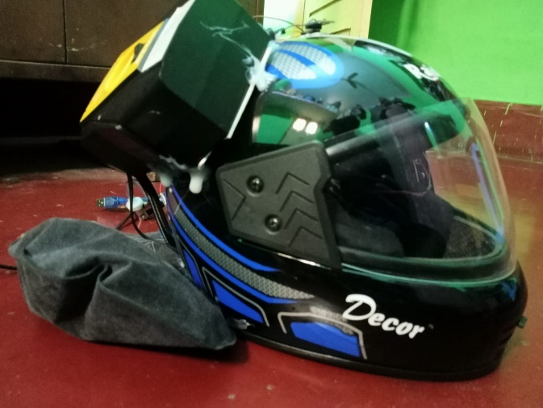

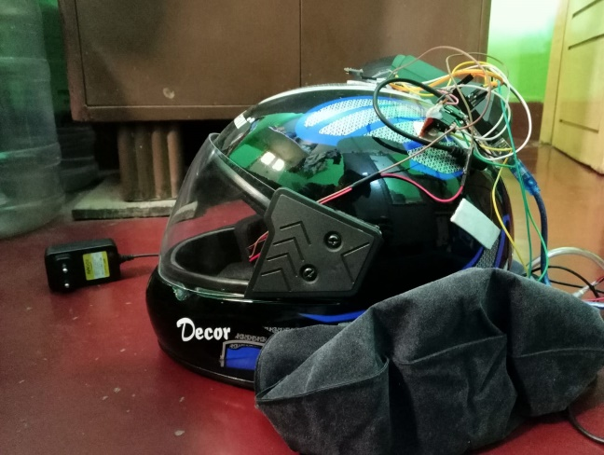.

**6. CONCLUSIONS**

A smart helmet integrated with an airbag system has the potential to provide enhanced protection for individuals who engage in high-risk activities such as motorcycling or extreme sports. By incorporating sensors that detect impacts and triggering airbags to inflate rapidly, the system can help reduce the risk of head and neck injuries. However, creating such a system requires careful design, testing, and refinement to ensure that it is effective and reliable. With proper implementation, a smart helmet integrated with an airbag system could significantly improve the safety of individuals engaging in high-risk activities.

**7. REFERENCES**

[1]. Dheeraj Khandelwal, (2017) - Airbag ECU coupled Vehicle Accident SMS Alert System, International Conference on Inventive Computing and Informatics, 978-1-5386-4031- 9/17/$31.00 ©2017 IEEE..

[2]. Durga K Prasad Gudavalli, C.Vidya sagar (2017) - Helmet Operated Smart E-Bike, International Conference on Intelligent Techniques in Control, Optimization and Signal Processing, 978-1-5090- 4778-9/17/$31.00 ©2017 IEEE..

[3]. Jesudoss A, Vybhavi R and Anusha B, (2019) - Design of Smart Helmet for Accident Avoidance, International Conference on Communication and Signal Processing, 978- 1-5386-7595- 3/19/$31.00 ©2019 IEEE

[4]. Kushal S. Patel, Sarvesh S. Patel (2016) - Method and apparatus for safety using inflated bags through smart sports clothes, International Conference on Communication Control and Automation. 5. Mohd Khairul Afiq Mohd Rasli, Nina Korlina Madzhi, Juliana Johari (2013) - Smart Helmet with Sensors for Accident Prevention, International Conference on Electrical, Electronics and System Engineering, 7978-1- 4799-3178-1/13/$31.00 ©2013 IEEE.

[5]. Albing, M., et al. "Integrated helmet airbag system for motorcycle riders: Development and evaluation of a prototype." Traffic injury prevention 20.7 (2019): 741-748

[6]. Bärgman, J., et al. "Feasibility of an Integrated Motorcycle Helmet Airbag System." Proceedings of the 22nd International Technical Conference on the Enhanced Safety of Vehicles (ESV). Vol. 2. 2011.

[7]. Brühning, E., et al. "Investigation of the Head Protection System Airbag Helmet." Proceedings of the 24th International Technical Conference on the Enhanced Safety of Vehicles (ESV). Vol. 2. 2015.

[8]. De Bruyne, G., et al. "Development and validation of a numerical model of a motorcycle helmet integrated with an airbag system." Journal of biomechanics 70 (2018): 41-48.

[9]. Eksioglu, M., et al. "A study of the effects of an integrated airbag helmet on head and neck injury criteria in head-first motorcycle impacts." Traffic injury prevention 22.1 (2021): 1-7