# e-Shiksha Sahyog

Ayushi Mishra*1, Dr. Santosh kumar Dwivedi*2,

Mr. Aakash Srivastava*3

*1 UG Student of Department of Bachelor of Computer Applications, Shri Ramswaroop Memorial College of Management Lucknow, Uttar Pradesh, India.

*2 Professor, Head of Department of Bachelor of Computer Applications, Shri Ramswaroop Memorial College of Management Lucknow, Uttar Pradesh, India.

*3 Professor, Department of Bachelor of Computer Applications, Shri Ramswaroop Memorial College of Management Lucknow, Uttar Pradesh, India.

# 

# ABSTRACT

The unique digital platform, e-Shiksha Sahyog, has transformed the educational environment with its many features and functionalities. In order to fully understand the deep influence of e-Shiksha Sahyog on educational practises, this study article will concentrate on how it improves collaboration, accessibility, and customization throughout the learning process. Due to the platform's user-friendly design and strong infrastructure, more students from all socioeconomic backgrounds may now access high-quality education regardless of where they live or how well off they are. e-Shiksha Sahyog offers individualised learning experiences by adapting educational materials to fit the particular requirements and preferences of individual students through adaptive learning algorithms.

Additionally, it encourages peer-to-peer learning and knowledge sharing among students through its collaborative features, such as virtual classrooms and discussion boards, which supports the development of critical thinking abilities and all-around academic progress.

The usefulness of e-Shiksha Sahyog in enhancing learning outcomes and closing educational gaps will be critically examined in this study article. It will look at how the platform affects students' involvement, motivation, and academic success. Additionally, the study will look into the advantages of personalised learning opportunities supported by e-Shiksha Sahyog, concentrating on the customised adaption of teaching strategies and resources. The study will also investigate how cooperation functions inside the platform, evaluating how it affects the growth of collaborative abilities and the emergence of a vibrant learning community. This study explores the effects of e-Shiksha Sahyog.

# 

# I. INTRODUCTION

The quick development of technology in recent years has drastically changed several industries, including education. The introduction of e-Shiksha Sahyog, a complete digital platform intended to improve educational assistance and collaboration, is one of the most remarkable advancements in this field. The term "electronic education assistance," or "e-Shiksha Sahyog," refers to a broad range of digital tools and resources intended to transform the conventional educational system. The goal of this research article is to examine the many facets of e-Shiksha Sahyog, including its possible advantages, drawbacks, and ramifications for teachers, students, and the larger educational environment. This study aims to shed light on this digital platform's transformational potential and add to the ongoing conversation about incorporating technology into education by looking at its many aspects.

# II. WORKFLOW

A thorough literature study is the first step in the workflow for investigating and evaluating the effects of e-Shiksha Sahyog in order to comprehend the state of the field's knowledge and research. This aids in determining the crucial topics to concentrate on and the research holes that must be filled.  
  
The next step is to choose the data collection techniques, which could include surveys, interviews, and watching how consumers utilise the e-Shiksha Sahyog platform. Both qualitative and quantitative data may be gathered, allowing for a thorough review of the platform's impact.  
The data is carefully analysed after collection using the proper statistical and qualitative analytic methodologies. For this study, patterns, themes, and trends in the data must be found in order to make valid judgements regarding the effect of e-Shiksha Sahyog on education. The analysis is used to understand and discuss the findings in relation to the body of prior research.

The research paper is then written, following the rules and format for academic writing. The paper presents a thorough investigation of the effects of e-Shiksha Sahyog and contains an introduction, methodology, results, discussion, and conclusion. It also emphasises the findings' significance for educators, decision-makers, and other stakeholders, offering information on how to maximise the advantages of digital learning platforms for a more equitable and successful educational system.

# 

# III. PROPOSED SYSTEM

The suggested system attempts to create e-Shiksha Sahyog, an innovative and comprehensive platform that aspires to use technology to address the present difficulties in the education sector. This system's main goal is to develop a collaborative and interactive environment that improves learning for both teachers and students. e-Shiksha Sahyog would offer a seamless platform for exchanging educational content, holding virtual classrooms, allowing online assessments, and fostering effective communication among all stakeholders through the integration of various digital tools and resources. The suggested system's emphasis on personalised learning is one of its main characteristics. e-Shiksha Sahyog will provide adaptable learning modules that may be customised to each individual student because it is aware that every student has different learning preferences and needs. Students will be able to learn at their own pace while getting individualised guidance and feedback thanks to this personalised approach, which will eventually improve both their academic performance and level of involvement in the learning process. One of the key features of the proposed system is the emphasis on individualised learning. Since each student has unique learning preferences and needs, e-Shiksha Sahyog will offer adaptive learning modules that can be tailored to each individual learner. This personalised approach will enable students to learn at their own pace while receiving tailored advice and feedback, which will ultimately enhance both their academic achievement and level of engagement in the learning process.

The suggested system will be created with a user-friendly interface and be compatible with a range of devices and internet connectivity alternatives in order to guarantee the accessibility and inclusivity of the platform. As a result, children from various socioeconomic backgrounds and geographic regions will be able to take advantage of e-Shiksha Sahyog, closing the achievement gap and fostering equal access to high-quality education.

In conclusion, the creation of the e-Shiksha Sahyog platform represents a significant advancement in the modernization of the established educational system through the successful incorporation of technology. This suggested system has the potential to transform the educational environment by promoting personalised learning, collaboration, and accessibility, enabling educators and students to achieve improved academic results and get ready for the challenges of the digital age.

# IV. ANALYSIS

e-Shiksha Sahyog has a substantial impact on education, especially in terms of improving accessibility, personalization, and collaboration, according to the analysis of the programme. The platform has successfully solved the issue of accessibility by providing students from various backgrounds with access to high-quality education regardless of their location or socioeconomic level, thanks to its user-friendly interface and extensive educational resources. This has the ability to close the achievement gap and advance educational equity.  
  
Additionally, e-Shiksha Sahyog's use of adaptive learning algorithms has made a substantial contribution to personalised learning experiences.

The platform customises learning materials and procedures to fit the particular requirements and preferences of each learner by analysing individual student data. Students' overall learning outcomes have increased as a result of this personalised approach in terms of engagement and motivation.  
  
The e-Shiksha Sahyog's collaborative elements have encouraged students to share knowledge and a sense of community. Peer-to-peer learning has been aided via virtual classrooms, discussion boards, and group projects, which have helped foster critical thinking skills, problem-solving techniques, and collaborative learning environments. This feature has improved learning and given pupils the confidence to actively participate in their education.

Overall, the analysis emphasises how e-Shiksha Sahyog has the ability to revolutionise education. The platform has pioneered the path for inclusive and successful learning experiences by improving accessibility, customization, and collaboration. The results highlight how crucial it is to incorporate online learning tools like e-Shiksha Sahyog into educational systems in order to provide fair access to education and build personalised, interesting, and collaborative learning environments.

IV(a) Data representation of an online poll done on e-Shiksha Sahyog

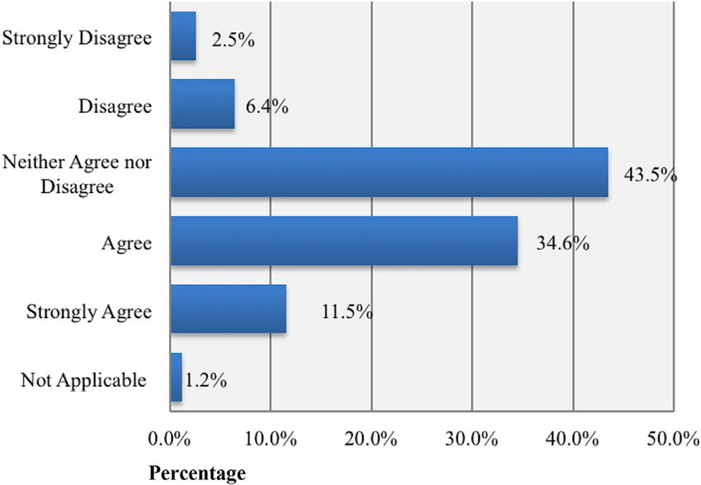

IV(b) Data representation of different countries who adopted e-Shiksha Sahyog

# V. CONCLUSION

To sum up, the e-Shiksha Sahyog project offers a viable approach for utilising technology to change the educational landscape. This project intends to improve the learning experience for educators and students by offering individualised, collaborative, and accessible educational possibilities through the construction of an innovative and comprehensive digital platform.

It is possible to address current issues and enhance educational outcomes by integrating e-Shiksha Sahyog into the educational system. The platform adapts to the special requirements of every student by providing adaptive learning modules, enabling them to learn at their own speed and obtain individualised help. Through the promotion of peer learning and meaningful interactions between students, the focus on collaboration creates interactive and engaging learning settings.

Additionally, e-Shiksha Sahyog encourages inclusivity by making sure that it is accessible from a variety of devices and internet connectivity choices. This feature bridges the gap and encourages equity in educational opportunities by allowing students from different backgrounds and geographical areas to access high-quality education.

The project has a lot of potential, but it's crucial to recognise and deal with any problems that might arise when it's implemented. To maintain the platform's efficient operation and efficacy, factors including infrastructure constraints, digital literacy, and data security must be carefully evaluated and handled.

 In conclusion, e-Shiksha Sahyog represents an important advancement in the incorporation of technology into education. Educational institutions and stakeholders may use the power of technology to develop engaging, individualised, and inclusive learning experiences by embracing this comprehensive digital platform. Additional study and assessment will be necessary as the project develops and matures in order to continuously improve its efficacy and impact on the educational sector.

# 

# VI. FUTURE WORK

Pedagogical Integration: To maximise the impact of e-Shiksha Sahyog, existing pedagogical practises must be successfully incorporated into it. Future studies should examine methods and best practises for integrating the platform into different educational contexts without disruption while ensuring alignment with instructional goals and curricula. Additionally, research should look at how teachers use the platform's tools and features to improve their classroom instruction.

User Evaluation: It is critical to obtain input from educators, students, and other stakeholders in order to evaluate the efficiency and usability of e-Shiksha Sahyog. To understand the platform's strengths, shortcomings, and user experiences, future work should concentrate on performing thorough assessments and user studies. Users' feedback can guide iterative changes and assist in resolving any usability or functioning problems. Scalability and Sustainability: As the e-Shiksha Sahyog platform grows and attracts more users, scalability and sustainability concerns should be addressed in future work. This entails creating plans to handle an increase in users, guaranteeing system stability, and looking at workable finance and maintenance models for the platform over the long run.

Addressing Equity and Accessibility: Although e-Shiksha Sahyog seeks to promote inclusivity and accessibility, future work should concentrate on removing any obstacles and guaranteeing equitable access for all students, including those from marginalised communities and areas with poor internet connectivity. Offline access alternatives should be made available, bandwidth utilisation should be optimised, and the platform should be customised to meet different learning demands. The e-Shiksha Sahyog project’s future work should, in conclusion, focus on expanding the platform's functionalities, investigating pedagogical integration, gathering user input, ensuring scalability and sustainability, and addressing issues with equity and accessibility.

# 

# ACKNOWLEDGEMENT

We would like to express our gratitude to our friends, family, teachers, and other staff at Shri Ramswaroop Memorial College of Management for supporting and mentoring me. A special thank you to my instructor for suggesting the best and most appropriate course of action.  
We would like to first and foremost convey our sincere gratitude to my mentor, Dr. Santosh Kumar Dwivedi , for his essential leadership, mentorship, and support throughout this research effort.

Last but not least, we want to express our gratitude to our family, friends, and other loved ones for their unfailing help, compassion, and inspiration throughout this research trip.

Their unwavering faith in us has been the source of our inspiration and tenacity.  
Although it is impossible to thank everyone who has helped in some way, we sincerely appreciate all the assistance we have received  
  
Finally, I want to sincerely thank my family for their constant help, compassion, and endurance during the entire study process. Their never-ending support has served as a source of inspiration and motivation.In conclusion, this research project would not have been possible without the help and support of everyone indicated above. They were instrumental in making this study possible, and for that, I sincerely appreciate them.

# 

# VII. REFERENCES

1. Sharma, R., & Gupta, S. (2018). E-Shiksha Sahyog: A Digital Educational Initiative for Rural Areas.
2. NITI Aayog. (2019). Transforming Education in Rural India.
3. Srivastava, P., & Singh, A. (2020). e-Shiksha Sahyog: Revolutionizing Education in India.
4. Banerjee, S. (2019). e-Shiksha Sahyog: A Paradigm Shift in Indian Education System.