**Plant Disease Detection Using Digital Image Processing And Machine Learning**

**Pratiksha Lahu Gapat*1, Pooja Kiran Deokar*2, Tanuja Shivaji Gaygoye*3, Prof. N.M.Dimble*4**

*1,2,3Computer Dept., NESGI, Pune, India.

*4Guide, Computer Dept., NESGI, Pune, India.

# ABSTRACT

Identification of the plant disease is the key to prevent the losses in the yield and the quantity of the agricultural product. The studies of the plant disease means the studies of visually observable patterns seen on the plants. Health monitoring and disease detection on plant very critical for sustainable agriculture. It is very difficult to monitored plant disease manually. It requires tremendous amount of work expertise in the plant disease and also required the excessive processing time. Hence image processing is used for the detection of plant disease by capturing the images of the leaves and comparing it with the dataset. The dataset consist of different plants in the image format. Apart form detection users are directed where different pesticides are displayed. In this project, we investigate the problem of visual plant disease recognition for plant disease diagnosis. Compared with other types of images, plant disease images generally exhibit randomly distributed lesions, diverse symptoms and complex backgrounds, and thus are hard to capture discriminative information. To facilitate the plant disease recognition research, we use a plantvillage plant disease dataset with plant disease categories and images. Based on this data set, we tackle plant disease recognition via visual regions and loss to emphasize diseased parts. Diseases are investigated utilizing different image processing techniques and digonosed so that Farmers can overcome from yield and financial loss.

Index Terms:- Plant disease detection, python, image processing, etc

# INTRODUCTION

India is a cultivated country and about 70%Population depends on agriculture. Farmers have large range of diversity for selecting various suitable crops and finding the suitable pesticides for plant. Hence, damage to the crops would lead to huge loss in productivity and would ultimately affect the economy. Leaves being the most sensitive part of plants show disease symptoms at the earliest. The crops need to be monitored against diseases from the very first stage of their life-cycle to the time they are ready to be harvested. Initially, the method used to monitor the plants from diseases was the traditional naked eye observation that is a time-consuming technique which requires experts to manually monitor the crop fields. In the recent years, a number of techniques have been applied to develop automatic and semi-automatic plant disease detection systems and automatic detection of the diseases by just seeing the symptoms on the plant leaves makes it easier as well as cheaper. These systems have so far resulted to be fast, inexpensive and more accurate than the traditional method of manual observation by farmers In most of the cases disease symptoms are seen on the leaves, steam and fruit. The plant leaf for the detection of disease is considered which shows the disease symptoms. There are many cases where farmers do not have a fully compact knowledge about the crops and the disease that can get affected to the crops. This application can be effectively used by farmers thereby increasing the yield rather than visiting the expert and getting their advice. The main objective is not only to detect the disease using image processing technologies. It also directs the user directly to where the user can purchase the medicine for the detected disease.

There is developing Indian population, which is increasingly dependent on the agricultural yield. Plant diseases causes many significant damages and losses in crops around the world. A new automatic method for disease symptom segmentation in digital photographs of plant leaves. The diseases of different plant species have mentioned. Plant diseases cause severe threats to global food security by reducing  
crop production all over the world. According to the statistics, about 20-40 percent of all crop losses globally are due to plant diseases. Therefore, plant disease diagnosis is critical to the prevention of spread of plant diseases and reduction of economic losses in agriculture. Farmers generally use naked eye observation to judge the diseases. But sometimes this may be an inaccurate way. Many times, farmer needs to call the experts for detecting the diseases which is also time consuming in large farms. Using digital image processing techniques, number of applications has found in different fields such as industrial inspection, medical imaging, remote sensing, and agricultural processing etc. Therefore, there is a need for plant Disease detection to detect disease at early stage an increase crop production.

**LITERATURE SURVEY**

This section of literarure survey eventually reveals some fact based on thoughtful analysis of many authors work as follows. Plant disease recognition: A large scale benchmark dataset and visual vision and loss reweighting approarch[1]. In this paper Xinda Liu, Weiqing Min provides different types image processing techniques which can directly be implemented in Tensor Flow for preprocessing of the image and also brief about the image segmentation and image classification. For the feature extraction the paper provides clustering method which can easily calculate shape and colour oriented features. Strategies/Methodologies embraced in paper:

• Image pre-processing

• Image enhancement

• Convolutional Neural Network based classifier

Plant leaf disease detection and classification using image processing[2].In this paper author Yin Min Oo, Nay chi htum proposed methodology for the analysis and detection of plant diseases using digital image processing techniques. In this paper the automated plant leaf disease detection system is perform by five main steps: Image acquisition ,image pre-processing, segmentation, feature extraction and classification. Diseased leaf images are captured and stored for experiment. Then images are applied for pre-processing for image enhancement. Captured leaf images are segmented using K-means clustering method to form clusters. GLCM and LBP features are extracted after applying K-means and SVM has been used for classification and detection of plant leaves diseases namely Bacterial blight, Cercospora, Leaf-spot, Powdery mildew and Rust.

Plant disease detection using image processing[3]. In this paper author Mr.V.Suresh, D Gopinath, M Hemarvarthini use image processing for the detection of plant disease by capturing the image of the leaves and comparing it with the dataset. A k-means segmentation is used for partitioning the leaf image into for clusters using the square eucliden distance. The method applied for feature extraction is colour cooccurence method for both colour and texture feature. Strategies/Methodologies embraced in paper:

• Tensor flow

• Convolutional Neural Network

# 

# PROPOSED METHODOLGY

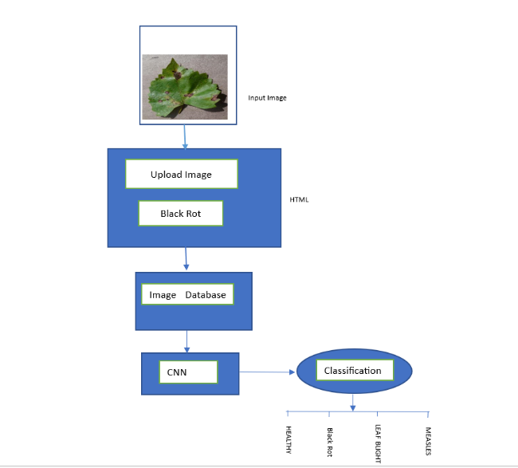

**Figure 1:** Proposed Methodology

1) Image acquisition: Firstly, the images of various leaves acquired using a digital camera with required resolution for better quality. The construction of an image database is clearly dependent on the application. The image database itself is responsible for the better efficiency of the classifier which decides the robustness of the algorithm.

2) Image pre-processing: In the second step, this image is pre-processed to improve the image, Pre-processing includes colour conversion, histogram, and histogram equalization. Colour conversion and histogram equalization is used to improve the quality and clarity images.

3) Filtering: Filtering is a technique for modifying or enhancing an image. Filtering is a neighbourhood operation, in which the value of any given pixel in the output image is determined by applying some algorithm to the values of the pixels in the neighbourhood of the corresponding input pixel.

4) Segmentation: Image segmentation refers to the process of partitioning the digital image into its constituent regions or objects so as to change the representation of the image into something that is more meaningful and easier to analyse.

5) Feature extraction: Hence in this step Hence in this step the features from this area of interest need to be extracted. These feature are needed to determine the minimum sample image. Feature can be based on colour, shape and texture.

6) Classification: The classification phase implies to determine if the input images is healthy or diseased. If the images found to be diseased some existing works have classified it into number of diseases. For classification a software routine is required to be written in MATLAB also referred to as a classifier.

# ALGORITHM DESCRIPTION

The last step in our processing of the leaf phase is the testing of various images and identifying the diseases. The algorithm used in the classification program is CNN. CNN consists of a complex network chain that extracts the characters in the images and classifies them to get specified results related to the input. Neural networks build with many layers like the input layer, convolutional layer, output layer, and fully connected layer. The Convolutional layer can add more layers to it. Firstly, we load the input data and create the convolution layer. Each layer consists of an activation function. Together with the convolutional neural network, we add a pooling function. Here five convolutional layers build, with corresponding pooling is added. At the end of each layer take the fully connected layer and give a SoftMax activation function. Finally, the regression layer is used for receiving the result and using the optimizer. Another important parameter is learning rate (LR) which represents the speed at which one learns the model. Here we set the learning rate as 1.e-3. After the model building, load the data in the model. Training data convert for x and y. x is the image and y defines the label. We use the variable for the model to represent healthy and unhealthy. Finally, give the data for the model and detect if it is healthy or diseased. CNN algorithm is more efficient for dividing a huge amount of data and it can be described as an efficient machine learning algorithm. As it is building on finding solutions to classification and identification tasks. It can be learning characters automatically on the dataset. This algorithm analyses visual leaves more efficiently. The structures of this algorithm change dramatically. The quality and type of training data collectively impact the capabilities of the model. Classifier accuracy depended on the data. Classification is made with the nature of their primary causal agent, either infectious or healthy.

**ALGORITHM 1:**

Training and Testing Algorithm

Input: providing an image of leaves localization

Output: classification of a review into healthy or diseased, it is diseased provides the remedies for overcoming the deficiency.

Step1: Start

Step2: prepare a database (healthy or diseased)

Step 3: pre-processing normalization

Step4: Train CNN

Step5: real images from Google or dataset

Step6: pre-processing

Step7: test network

Step8: if the probability of healthy > probability of unhealthy display a healthy leaf, otherwise display a diseased leaf.

Step9: go to the fourth step

Step10: stop

# 

# 

# 

# RESULTS AND DISCUSSIONS

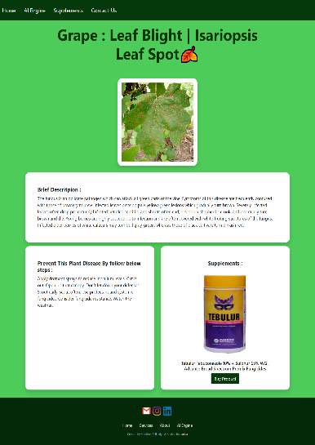



**CONCLUSION**

maximizing the production of crops consisting of efficient leaf disease identification and further derivation is a major thing. This can be activated using an automatic leaf disease identification model building the concept of image processing strategy. This work addressed extracting the characters of individual images and further classifying them in two ways are, healthy or diseased. After the classification which provides it is diseased leaf and as well as the remedies for recovering the deficiency. Here we use a convolutional neural network (CNN) algorithm. Which contains a hierarchy of layers that helps for efficient detection purposes.

The overall phases are outlined, it starts with the large collection of datasets that are used for training and testing to the pre-processing phase and further training the method for CNN and optimization. With these image processing strategies, we can accurately recognize and classify a variety of leaf diseases. Here we put the images for detection in both ways, real-time from the Google or trained datasets. In this project, we built the model with proper methods and implementation steps. The proposed system is computationally more accurate than the pre-existing one and provides easier and faster results corresponding to the input image.it aims to make helping the farmers and avoid loss. Overall, this work is conclusive in demonstrating how CNN applied to empower farmers in their fight against leaf disease. Soon work should be focused on diversifying training datasets and also on testing with similar web applications in real-life situations. Without such practical developments, the struggle against plant diseases will continue to exist.it causes many losses are happening in crop productivity.

# REFERENCES

1. W. Lin et al., “Human in events: A large-scale benchmark for humancentric video analysis in complexevents,”2020, arXiv:2005.04490. [Online]. Available:
2. Peng Jiang , Yuehan Chen ,Bin Liu , Dongjian He , Chunquan Liang ,’ Real-Time Detection of Apple Leaf Diseases Using Deep Learning Approach Based on Improved Convolutional Neural Networks’, ( Volume: 7 ), pp. 06 May 2019.
3. https://www.sciencedirect.com/science/article/pii/S2214317316300154
4. Jadhav, S.B.; Udupi, V.R.; Patil, S.B. Identification of plant diseases using convolutional neural networks. Int. J. Inf. Technol. 2020, 1–10. [CrossRef]
5. <https://doi.org/10.1016/j.gltp.2022.03.016>
6. S.Bashir,N.Sharma,Remote Area Plant disease detection using Image Processing, IOSR Journal of Electronics and Communication Engineering , Volume 2, Issue 6,pp.31-34,2012.
7. A. Marko, K. Mirjana, S. Srdjan, A. Andras, and S. Darko,“Solving current limitations of deep learning based approaches for plant disease detection,” SymmetryBaseline,vol. 11, no. 7, p. 939, 2019.
8. P Krithika, S Veni Leaf disease detection on cucumber leaves using multiclass support vector machine IEEE International Conference on Wireless Communications, Signal Processing and Networking , pp. 1276-1281
9. Al-Hiary H., S. Bani-Ahmad., M. Reyalat., M. Braik. and Z. AlRahamneh. Fast and accurate detection and classification of plant diseases. International Journal of Computer Applications.
10. X. Shu, J. Tang, G. Qi, W. Liu, and J. Yang, “Hierarchical long shortterm concurrent memory for human interaction recognition,” IEEETrans. Pattern Anal.Mach. Intell., early access, Sep. 2018, doi: 10.1109/TPAMI.2019.2942030.