# Krishi Mitra

Ayush Singh*1, Dr. Santosh Kr. Dwivedi*2,

Mr. Raghvendra Singh*3

*1 UG Student of Department of Bachelor of Computer Applications, Shri Ramswaroop Memorial College of Management Lucknow, Uttar Pradesh, India.

*2 Professor, Head of Department of Bachelor of Computer Applications, Shri Ramswaroop Memorial College of Management Lucknow, Uttar Pradesh, India.

*3 Professor, Department of Bachelor of Computer Applications, Shri Ramswaroop Memorial College of Management Lucknow, Uttar Pradesh, India.

# 

# ABSTRACT

The "Krishi Mitra" web application is a revolutionary platform designed to address the welfare of farmers and enhance their profitability in the agricultural sector. With a primary focus on establishing authenticated and authorized communication between farmers and consumers, this project prioritizes the verification of individuals' identities within the platform. By eliminating intermediaries and reducing government intervention, the software aims to create a direct and transparent marketplace that empowers farmers to sell their products at preferred rates, free from biased policies. The project envisions a transformative change in the agricultural ecosystem by fostering a healthy and equitable exchange between farmers and end consumers. Furthermore, the "Krishi Mitra" web application recognizes the importance of market awareness for farmers. By providing real-time information on market trends and dynamics, the platform enables farmers to make informed decisions, adapt their practices, and maximize their profits in a competitive market.

This research paper explores the development and implementation of the "Krishi Mitra" web application, focusing on its impact on the agricultural sector. It examines the technical aspects of the software, including authentication protocols, secure communication channels, and identity verification mechanisms. The paper also investigates the economic implications of the platform, analyzing how the elimination of intermediaries and reduction of government interference contribute to farmers' welfare and financial sustainability. In addition, the research explores the societal implications of the "Krishi Mitra" web application, considering its potential to empower farmers, eradicate biases, and create a more equitable agricultural system. It examines the challenges faced by farmers in traditional supply chains, such as unfair pricing and limited market access, and discusses how the software addresses these issues.

Overall, this research paper sheds light on the "Krishi Mitra" web application as a transformative solution for farmers, providing a comprehensive analysis of its technical, economic, and societal dimensions. It contributes to the ongoing discourse on leveraging technology to empower farmers, enhance their profitability, and promote a sustainable agricultural sector.

# 

# I. INTRODUCTION

The horticultural area assumes an urgent part in worldwide food creation and food, with ranchers at the core of this industry. Nonetheless, ranchers frequently face various difficulties that prevent their government assistance and monetary maintainability, including restricted market access, one-sided approaches, and the presence of middle people in the production network. To resolve these issues and enable ranchers, the "Krishi Mitra" web application has been created as an extraordinary arrangement.  
  
The "Krishi Mitra" web application means to change the horticultural scene by making a stage that focuses on ranchers' government assistance and furnishes them with the most extreme productivity for their delivered items. By laying out a validated and approved correspondence channel among purchasers and ranchers, the product cultivates direct commitment and dispenses with the requirement of forgo-betweens. Integral to the outcome of the "Krishi Mitra" web application is the confirmation of people's characters inside the stage. Guaranteeing the honesty and legitimacy of enrolled ranchers and customers is of central significance, as it cultivates trust and believability in the framework. By keeping up with the trustworthiness of the personalities in question, the product establishes a solid climate that works with fair and straightforward exchanges.  
  
The product tries to limit government impedance as well as plans to furnish ranchers with the valuable chance to sell their items at rates that line up with their inclinations. By bypassing one-sided approaches and customary market structures, ranchers oversee their estimating and market presence. This change in power elements vows to carry a positive development to the horticultural area and improve ranchers' monetary prosperity. Also, the "Krishi Mitra" web application perceives the significance of market mindfulness for ranchers. By outfitting them with continuous data on market patterns and elements, the stage empowers ranchers to settle on informed choices, adjust their cultivating rehearses, and streamline their benefits in a cutthroat commercial center.   
  
By revealing insight into the effect of the "Krishi Mitra" web application, this exploration paper expects to add to the continuous talk on utilizing innovation to upgrade ranchers' benefits, further develop market access, and encourage manageable agrarian practices. Eventually, this study looks to feature the capability of imaginative arrangements in changing the rural area and guaranteeing a superior future for ranchers around the world.

# II. WORKFLOW

Initially, the challenges faced by farmers in the horticultural sector, such as limited market access, biased policies, and the presence of intermediaries in the supply chain, will be identified. These challenges significantly impact the welfare and financial sustainability of farmers. To address these issues, the "Krishi Mitra" web application has been developed as an innovative solution.

The "Krishi Mitra" web application aims to transform the agricultural landscape by creating a platform that prioritizes farmers' welfare and maximizes the profitability of their products. It establishes a validated and authorized communication channel between buyers and farmers, eliminating the need for intermediaries and fostering direct engagement. Central to the success of this application is the verification of individuals' identities within the platform, ensuring the trustworthiness and credibility of registered farmers and customers. By maintaining the integrity of involved identities, the software creates a robust environment that facilitates fair and transparent transactions.

Furthermore, the software seeks to minimize government interference and provide farmers with the opportunity to sell their products at rates that align with their preferences. By bypassing biased policies and traditional market structures, farmers gain control over pricing and market presence, leading to positive growth in the agricultural sector and improving farmers' financial well-being. Additionally, the "Krishi Mitra" web application acknowledges the importance of market awareness for farmers. It equips them with real-time information on market trends and dynamics, empowering them to make informed decisions, adjust farming practices, and optimize profits in a competitive marketplace.

The research paper aims to shed light on the impact of the "Krishi Mitra" web application. It will contribute to the ongoing discussion on utilizing technology to enhance farmers' profits, improve market access, and promote sustainable agricultural practices. The paper will delve into the methodology employed, incorporating a combination of qualitative and quantitative approaches. Data collection methods, sample size, and data analysis techniques will be utilized to gather insights and evaluate the effectiveness of the "Krishi Mitra" web application.

Overall, this research paper endeavors to showcase the potential of innovative solutions in transforming the agricultural sector and ensuring a promising future for farmers worldwide. By analyzing the impact of the "Krishi Mitra" web application, it aims to provide valuable insights into empowering farmers, enhancing market access, and promoting sustainable agricultural practices.

# 

# III. PROPOSED SYSTEM

Aims to develop and implement the "Krishi Mitra" web application as a solution to address the challenges faced by farmers in the horticultural sector. This system will serve as a comprehensive platform that focuses on farmers' welfare and maximizes their profitability.

The "Krishi Mitra" web application will provide a user-friendly interface for both farmers and consumers, facilitating direct communication and transactions between them. Through a validated and authorized communication channel, farmers can showcase their products, set their preferred prices, and negotiate directly with interested buyers. By eliminating intermediaries, farmers can retain a larger portion of their profits, enhancing their financial sustainability to ensure the integrity and authenticity of individuals within the platform, the proposed system will implement a robust identity verification process. Farmers and consumers will be required to provide verified information during the registration process, establishing trust and credibility within the system. This verification process will enable farmers to interact with genuine buyers, enhancing their confidence in conducting business transactions.

The "Krishi Mitra" web application will also incorporate real-time market information and trends, providing farmers with valuable insights into consumer demand, pricing fluctuations, and market dynamics. This market awareness feature will enable farmers to make informed decisions regarding crop selection, production quantities, and pricing strategies, ultimately optimizing their profitability in a competitive market. Additionally, the proposed system will emphasize the integration of sustainable agricultural practices. It will provide resources, guidelines, and support for farmers to adopt environmentally friendly farming techniques, promoting sustainable farming methods and reducing the environmental impact of horticultural activities.

Overall, the proposed system, the "Krishi Mitra" web application, aims to revolutionize the agricultural sector by empowering farmers, enhancing market access, and promoting sustainable practices. By leveraging technology and providing a user-centric platform, this system seeks to improve the livelihoods of farmers and contribute to the overall growth and development of the horticultural industry.

# IV. ANALYSIS

The proposed system, the "Krishi Mitra" web application, presents several opportunities for analysis and evaluation. One crucial aspect to consider is user adoption and satisfaction. Conducting surveys or interviews with farmers and consumers who have utilized the application can provide valuable insights into their experiences. By analyzing their feedback on usability, functionality, and overall user experience, it becomes possible to identify strengths and areas for improvement. This analysis helps to gauge the level of user adoption and satisfaction, which is crucial for the success and sustainability of the system.

Another important aspect to analyze is the impact of the proposed system on market access and profitability for farmers. Comparing the revenue generated through direct transactions facilitated by the application with traditional methods involving intermediaries can provide insights into the effectiveness of the system. By measuring the increase in farmers' profits and evaluating their ability to set preferred prices and negotiate directly with buyers, it becomes possible to assess the system's impact on farmers' market access and financial sustainability. This analysis helps to determine the extent to which the proposed system empowers farmers and enhances their profitability.

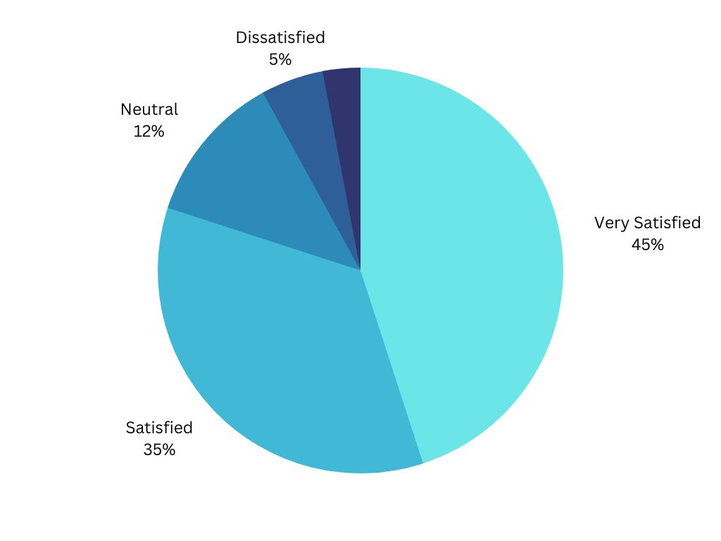Furthermore, analyzing the environmental impact and adoption of sustainable agricultural practices facilitated by the system is crucial. Assessing the extent to which farmers have adopted environmentally friendly farming techniques can provide insights into the system's contribution to promoting sustainable practices. By measuring the reduction in environmental impact and evaluating the resources and support provided to farmers, it becomes possible to determine the system's effectiveness in promoting sustainability within the horticultural sector.

Overall, conducting a comprehensive analysis of user adoption, market access, profitability, and the promotion of sustainable practices will provide valuable insights into the effectiveness and impact of the proposed system, the "Krishi Mitra" web application. This analysis will contribute to the ongoing discourse on leveraging technology to improve the welfare of farmers, enhance market access, and foster sustainable agricultural practices.

# 

# V. CONCLUSION

In conclusion, the "Krishi Mitra" web application presents a transformative solution to address the challenges faced by farmers in the horticultural sector. By focusing on farmers' welfare, maximizing profitability, and eliminating intermediaries, the application empowers farmers to directly engage with consumers, set their preferred prices, and negotiate transactions. The verification of individuals' identities within the platform ensures trust and credibility, fostering a transparent and fair environment for transactions. Moreover, the application provides real-time market information, enabling farmers to make informed decisions and optimize their profits. Through the integration of sustainable agricultural practices, the system promotes environmental consciousness and contributes to the long-term sustainability of the agricultural industry.

This research paper has shed light on the potential of technology-driven solutions in transforming the agricultural sector. By leveraging the "Krishi Mitra" web application, farmers can overcome the challenges of limited market access, biased policies, and intermediary presence, leading to enhanced financial sustainability and improved livelihoods. The analysis of user adoption, market access, profitability, and the promotion of sustainable practices has highlighted the positive impact of the proposed system. However, it is essential to continuously evaluate and refine the application based on user feedback and evolving market dynamics.

The findings of this research contribute to the ongoing discourse on utilizing technology to enhance farmers' profits, improve market access, and promote sustainable agricultural practices. The "Krishi Mitra" web application serves as a beacon of hope, showcasing the potential of innovative solutions in revolutionizing the agricultural landscape. With further advancements and widespread adoption, such platforms can pave the way for a brighter future for farmers globally, ensuring their well-being, economic prosperity, and the sustainable production of food for all.

# 

# VI. FUTURE WORK

Looking ahead, the "Krishi Mitra" web application holds significant potential for future development and expansion. One key area for future exploration is scalability and reach. Currently, the application focuses on a specific region or target audience, but efforts can be made to scale up the platform and cater to a broader user base. Expanding to new geographical areas and accommodating diverse agricultural practices would allow more farmers to benefit from the platform's features.

Another aspect of future development is enhanced data analytics. By leveraging advanced analytics techniques, the application can unlock valuable insights from user behavior, market trends, and agricultural patterns. This data-driven approach would enable personalized recommendations, optimized pricing strategies, and tailored solutions to meet farmers' specific needs.

Integration with the Internet of Things (IoT) is another area of potential growth. Connecting the "Krishi Mitra" platform with IoT devices and sensors would enable real-time monitoring of farm conditions, such as soil moisture levels, weather patterns, and crop health. This integration would empower farmers with precise data, helping them make informed decisions, optimize resource utilization, and improve overall productivity. The future scope also includes offering value-added services within the platform. Expanding to include agricultural training, financial literacy programs, and access to microfinance options would support farmers' overall development. By providing educational resources, market insights, and financial tools, the application would equip farmers with the knowledge and resources necessary to thrive in a competitive market.

Furthermore, forming collaborations and partnerships with government agencies, agricultural organizations, financial institutions, and other stakeholders is crucial. Such partnerships can strengthen the platform's impact by securing funding, accessing expertise, and facilitating policy reforms that align with the application's objectives. By creating a collaborative ecosystem, the platform can support farmers at various stages of the agricultural value chain.

# ACKNOWLEDGEMENT

I would like to express my sincere gratitude to several individuals who have played a significant role in the completion of this research project. Firstly, I am deeply indebted to my Head of the Department, Dr. Santosh Kumar Dwivedi, for providing me with the platform to share my major project experience. His guidance, support, and encouragement have been invaluable throughout this journey.

I would also like to extend my heartfelt appreciation to my major project guide, Mr. Raghavendra Singh, for his expert guidance and mentorship. His insightful suggestions and timely feedback have been instrumental in shaping the direction of my research and ensuring its quality.

I would like to express my deep gratitude to the Almighty for granting me this opportunity to embark on this research journey and share my experiences. Their blessings have provided me with the strength and perseverance to overcome challenges and achieve success.

Lastly, I would like to acknowledge the unwavering support and encouragement from my friends. Their constant motivation and belief in my abilities have been instrumental in keeping me focused and determined throughout the research process.

I am truly thankful for all those mentioned above and many others who have contributed to the successful completion of this research project. Their support and guidance have been invaluable, and I am grateful for their contributions to my academic and personal growth.

# VII. REFERENCES

[1] Patil, N., Kelkar, S., Ranawat, M., & Vijayalakshmi, M. (2021, May). Krushi Sahyog: Plant disease identification and Crop recommendation using Artificial Intelligence. In 2021 2nd International Conference for Emerging Technology (INCET) (pp. 1-6). IEEE.

[2] Sangeeta, S. G. (2020). Design and implementation of crop yield prediction model in agriculture. International Journal Of Scientific & Technology Research, 8(01).

[3] Farooq, M. S., Riaz, S., Abid, A., Umer, T., & Zikria, Y. B. (2020). Role of IoT technology in agriculture: A systematic literature review. Electronics, 9(2), 319.

[4] Gray, R. S. (2020). Agriculture, transportation, and the COVID‐19 crisis. Canadian Journal of Agricultural Economics/Revue canadienne d'agroeconomie, 68(2), 239-243.

[5] Bannerjee, G., Sarkar, U., Das, S., & Ghosh, I. (2018). Artificial intelligence in agriculture: A literature survey. International Journal of Scientific Research in Computer Science Applications and Management Studies, 7(3), 1-6.

.