**IMPLEMENTATION ON MOVIE RECOMMENDATION SYSTEM**

**Sakshi Gaikwad1, Kajal Jalan2, Pornima Maknikar3, Ashwini Morale4, Pearl Yadav5**

Department of Information Technology

PDEA’s College of Engineering (Manjari B.K.)

Pune, India,

**ABSTRACT**

The project is an implementation of a movie recommender system. It is developed to search through the movie databases and extract the data required. It tries to extract relevant information by analyzing certain criteria. The criteria are like popularity, genre, plot, etc. This system uses content-based filtering, collaborative filtering and hybrid filtration to analyze the datasets and make a system that provides the exact movie recommendations for the users. It is observed that the recommendation systems are used immensely at organization, business purposes to make various strategies, to get computed analysis, etc. Such type of systems is gaining high demand in the business and the industrial world, as well as the entertainment industry. It is also observed that these systems are used even by normal people resulting to the increasing popularity and demand. The usage of these type of systems is growing today. It shows the increasing need considering the times saved efficiently with the implementation of the system. It reduces the workload of manually browsing and the analysis steps followed next. These systems are generally used with the movie’s websites or with many commercial applications. It will make movie suggestions more relevant as per the need of the users.

**Keywords:** Analysis, Filtration, Evaluation, Hybrid Filtering Technique, SVD.

1. **INTRODUCTION (Font-Times New Roman, Bold, Font Size -12)**

This work deals with the concept of a recommendation system by improving it to provide precise recommendation of movies considering various aspects concerning the user interests and give a better time saving output. Normally a person will have to go through all the movies present from all the ages along with all the genres, plots, actors, directors, etc and analyse it manually which increases the unnecessary expenditure too. In addition to this the output cannot be said to be one expected as there are many in line and it doesn’t always stand up to the mark. This is time consuming as well. However, recommender systems minimize the transaction costs, improves the quality and decision-making process to users by giving their final analysis using the filtering algorithms and the evaluation matrices all together step by step to give the user preferred recommendations. These systems are used widely in the industry and businesses by various top companies like Google, Instagram, Spotify, Amazon, Reddit, Netflix etc. often to increase engagement with users and the platform. For example, Spotify would recommend songs that are similar to the ones that you repeatedly hear, previously visited music sites or the ones that you liked to listen to. Amazon gives such recommendations by using this system based on the previously visited, collected or bought by the user. Such type of recommendation systems precisely uses the mixture of two algorithms: content-based filtering and collaborative-filtering to find accurate suggestions that the user might prefer or will want to choose. The collaborating filtering technique is generally based on the user’s queries and experiences. This technique tends to find similar users and recommend what similar users like. The collaborative filtering will look at the user’s previous experiences and behaviour to analyse the preferred choices the user can make. It generally works on some simple techniques. For example, you have put some items in your cart on the site. You might have even purchased some items previously. This plays an important role in generating what your preference can be. The recommendation system tends to keep giving recommendations similar to ones you encountered. The Content-based filtering technique generates recommendations based on movie characteristics such as genre, director, actor, plot, and so on. This strategy will be improved by emphasizing a little more on some specific attributes of these types of movie characteristics. This filtering technique of content-based filtering generates the recommendations concerning the user and the user interests that the user might prefer or wants to prefer. Many times, the user doesn’t know what they might like but based on their previous choices the system generates suggestions that the user was never aware is something that they prefer. If the user has searched for any of the item’s past history. This filter autosaves the data of the previously surfed items to classify the taste of the user.

Like previously mentioned, we are using the mixture of two algorithms. This mixture is known as the hybrid- filtration which is widely used in the making of recommendation systems. The mixing of the two filtrations results in this new tactic of hybrid combining the features and techniques to collaborate into the model and give a precise approach to filtering techniques used in an efficient manner. The movie recommendation system will be a useful system in the industrial field when it comes to the field of film industry to get recommendation on the most favoured choices of the user. It will also help in giving the statistics of highly featured and preferred choices the people make regarding movies. It will help in generating the idea of the audience’s perception which in result can give them the relevant movies that the user might want to watch.

1. **METHODOLOGY**

This Movie Recommendation System proposed uses machine learning. The system emphasizes the classification algorithms to organize and classify the information. Two algorithms have been implemented two generate the recommendations such as following:

1.Collaborative Filtering

2.Content Based Filtering

1. **Collaborative Filtering**

Collaborative Filtering is a technique of filtering and classifying items based on the similarity measures between users and items to give recommendations. Many recommendation systems use the collaborative filtering technique to classify these relations and determine the appropriate choices of recommendations the user is interested in or will be interested in. The basic assumption behind the algorithm is that the users with similar interests have common preferences. For example, I prefer movies with certain criteria. The system will identify my choices of movies and recommend the same to a person with similar likes and preferences. If we are on a shopping website like Amazon, if we click on any product some more products appear along with it. These products have text written below them saying, “Customers who bought this item also bought”. This is due to the recommendation algorithm used for the site that determines user interests and preferences based on the recorded data of other users with similarity choices. The recommendation system uses the collaborative filtering algorithm for providing such responses.

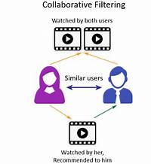

**Figure1** Collaborative Filtering

1. **Content - Based Filtering:**

Content based Filtering is a technique that uses item features to recommend other items similar to what the user likes, based on their previous actions or explicit feedback. Content-based filtering makes the appropriate recommendations by using keywords and attributes assigned to objects in a database (e.g., items in an online marketplace) and matching them to a user profile. The user profile is created based on data derived from a user’s actions, such as purchases, ratings (likes and dislikes), downloads, items searched for on a website and/or placed in a cart, and clicks on product links. Recommending products based on their characteristics is only possible if there is a clear set of features for the product and a list of the user’s choices. The recommender system stores previous user's data like clicks, ratings, and likes to create a user profile. The more a customer engages, the more accurate future recommendations will be given. To understand this better let us take an example, suppose you’re recommending accessories to a user that just purchased a smartphone from your website and has previously bought smartphone accessories. Aside from keywords such as the smartphone manufacturer, make, and model, the user profile indicates prior purchases include phone holders with sleeves for credit cards. Based on this information, the recommender system may suggest similar phone holders for the new phone with similar attributes

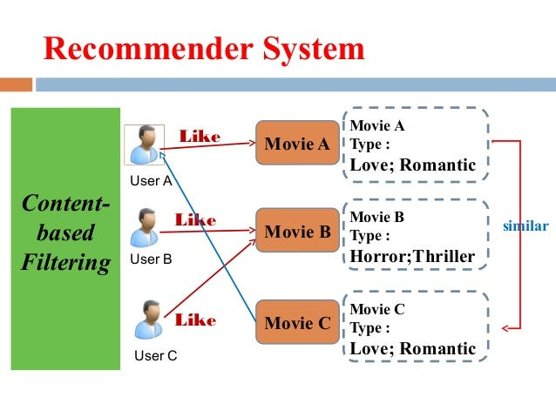

**Figure 2**: Content - Based Filtering

The figure given above shows the preferences of 3 users A, B and C. The arrows in red colour are the movies liked by the user. The blue coloured line is the recommended movie. The user A has watched/liked a movie A from the romantic genre so the system recommends the movie C with the similar genre instead of suggesting the second movie i.e., movie B. Movie B belongs to a different category.

1. **User-Based vs Item-based:**

Collaborative filtering recommendation can be done in the following ways:

User-based collaborative filtering.

Item-based collaborative filtering.

User-Based Collaborative Filtering is a technique used to predict the items that a user might like on the basis of ratings given to that item by other users who have similar taste with that of the target user. Collaborative Filtering is a technique or a method to predict a user’s taste and find the items that a user might prefer on the basis of information collected from various other users having similar tastes or preferences.

In the user-based filtering, we find out the similar users. Whereas in the item-based filtering, we find out the similar items.

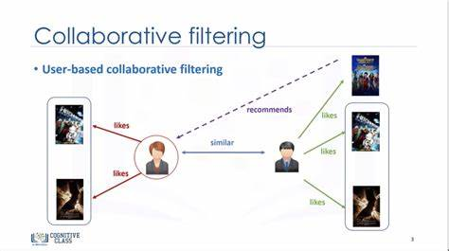

**Figure 3:** User-Based Collaborative Filtering

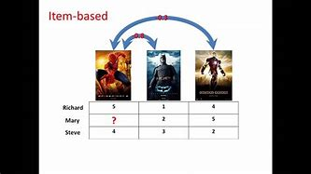

**Figure 4:** Item-Based Collaborative Filtering

**Evaluation Metrics:**

There are many evaluation metrics used for Recommender systems but for this system we are going to discuss only four of them.

1. Mean average precision at K.

2. Coverage.

3. Personalisation.

4. Intralist similarity.

**1. Mean average Precision at K:**

This evaluation metric gives us an insight about the relevance of the items recommended. The precision at K is the proportion of recommended items in the top-K set that are relevant to the users.

**2. Coverage:**

The coverage is the generating the percentage of items from the training data existing in the model that are capable of being recommended on the test set. It is the percentage of possible recommendations that the system can predict.

**3. Personalisation:**

Personalisation is a great way to assess if a model recommends many of the same items to different users. It is the dissimilarity (1-cosine similarity) between user’s lists of recommendations.

**4. Intralist similarity:**

Intralist similarity is the average cosine similarity of all items in a list of recommendations. Calculation uses features of the recommended items to calculate the similarity.

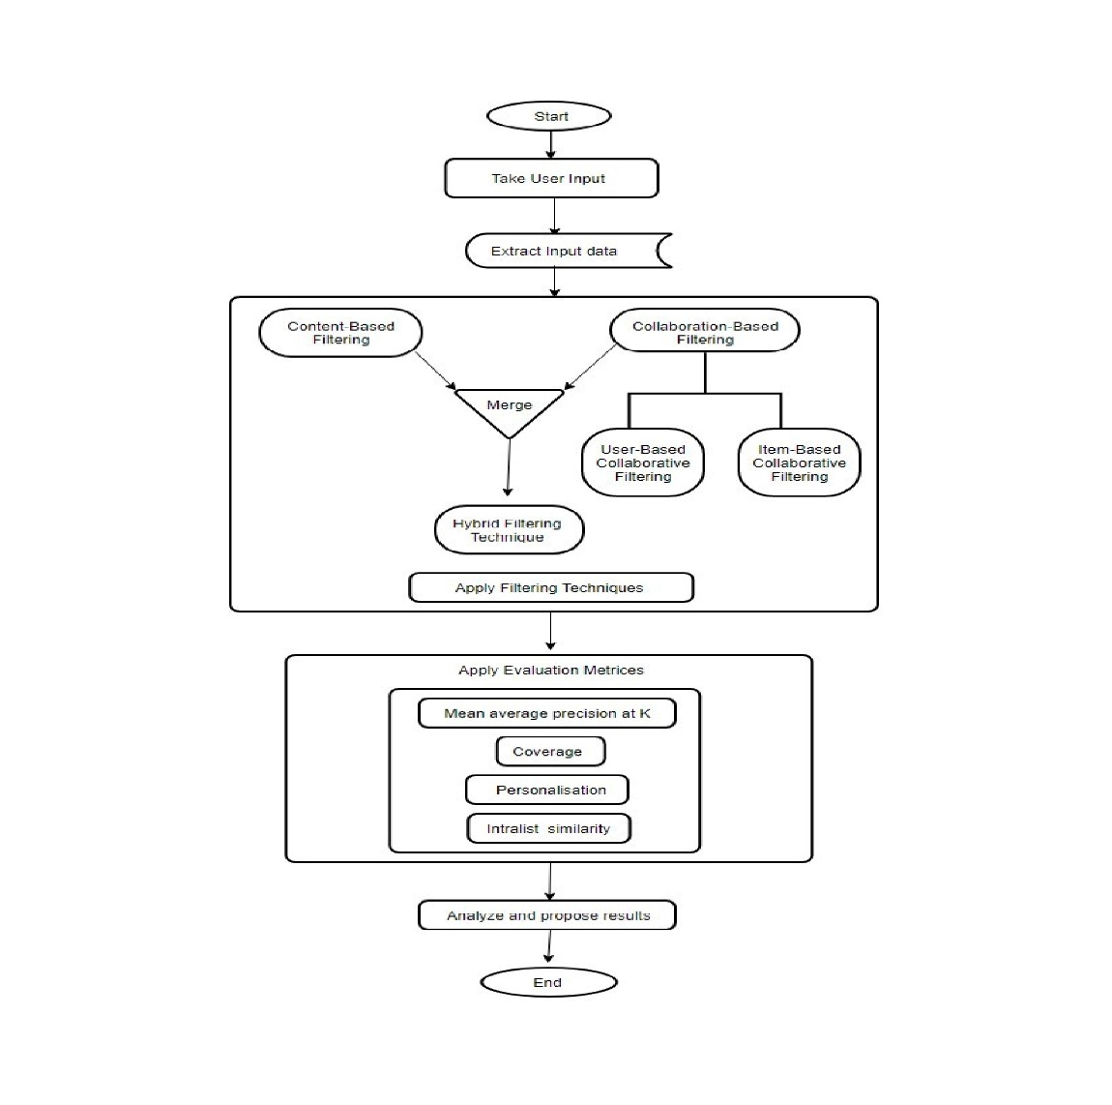

**Figure5 :** Flowchart

1. **CONCLUSION**

The above paper is an implementation paper that has mentioned about the usage of two filtering algorithms used. Precisely Collaboration Filtering and Content based filtering techniques. The Hybrid filtering technique is a combination of both the techniques mentioned. The implementation of these filtering is seen to an effective and requires algorithm used mainly for recommender systems. The similarity measure has to be applied to with the evaluation metrices on the results generated by the filtering techniques. The Hybrid has an important role in the implementation of the system. The aim of the entire system is to derive user preferred recommendations. It is concluded that the system will generate recommendations based on users’ prior usage of the system. This system has used SVD algorithm as well. This is to achieve suggestions or recommendations based on the previous behaviour and activities. The previously used recommender system had some shortcomings. If a certain user is completely new to the system environment, he/she would not get the appropriate recommendation as the system does not have any previous database of the user. if the data extends more than the algorithm can handle. The system had limited ability to process the only limited amount of data but the proposed system has tried to overcome these challenges by expanding the ability to handle to the data. As mentioned previously about the SVD algorithm, this algorithm is helpful in fulfilling this challenge and generate recommendations even more efficiently.

**ACKNOWLEDGEMENTS**

With an immense pleasure and satisfaction, I am presenting this Project report as part of the curriculum of Degree Information Technology. I wish to express my sincere gratitude towards all those who have extended their support right from the stage this idea was conceived.

I am profoundly grateful to Dr. D. Hirolikar, Project Guide, for her expert guidance and continuous encouragement throughout to see that the project work rights its target since its commencement to its completion.

I am very thankful to Prof. R.M. Kawale, Project Coordinator, for conducting and supporting such research activities.

I am also grateful to Dr. D. Hirolikar, HOD, Department of Information Technology, for her support and encouragement.

Finally, I am also grateful to Honorable Dr. R. V. Patil, Principal, PDEA’s College of Engineering, Pune, for his support and guidance that have helped me to expand my horizons of thought and expression.

We would also thank all staff members of Information Technology department for showing us the way for achieving the project target we want. It would not have been possible to complete the project without the support and motivation from our family and friends.

.

1. **REFERENCES**
2. Francesco Ricci and Loir Roach and Brachia Shapira, “Introduction to Recommender Systems Handbook Recommender Systems Handbook,” Springer, 2011, pp. 1-35J.
3. playboy Lead Rise of Recommendation Engines - TIME". TIME.com. 27 May 2010. Retrieved 1 June 2015.
4. R. J. Mooney & L. Roy (1999), “Content - based book recommendation using learning for text categorization in Workshop Recommendation Sys. Algo. and Evaluation.”
5. Husein Jafar Karimi; A.T.H. Sim and R. Saadat Oost “A Naïve Recommendation Model for Large Databases,” International Journal of Information and Education Technology, June 2012.
6. Prem Melville and Vikas Sindh Wani, Recommender Syse mms, “Encyclopedia of Machine Learning,” 2010.
7. M. M. Reddy, R. S. Kamani and B. Surendra, "Analysis of Movie Recommendation Systems; with and without considering the low rated movies," Vellore, India, 2020
8. Naga Manjula. R.; Geethalakshmi, A., “A Novel Scheme for Movie Recommendation System Using User Similarity and Opinion Mining,” International Journal of Innovative Technology and Exploring Engineering, vol: 8, 2019, pp: 316-322.
9. Shaik, I.; Nutella, S.S.; Diwakar, T.; Nalla, S.; “K-means Clustering Algorithm Based on E-Commerce Big Data”, International Journal of Innovative Technology and Exploring Engineering, vol: 8, 2019, pp: 1910-1914.