**HELPING HEARING IMPAIRED PEOPLE IN EMERGENCY SITUATION TRANSLATING SIGN LANGUAGE TO SPEECH AND VICE VERSA USING DEEP LEARNING**

**Prof. Sneha A. Khaire1, Sayyed Hashim2, Abhishek Vyavahare3, Priyanka Sarode4, Prathmesh Bothe5**

Assistant Professor1 BE Students2,3,4,5

Department of Information Technology,

Sandip Institute of Technology and Research Centre, College of Engineering, Nashik - 422213

**ABSTRACT**

Sign language is the way through which deaf and dumb people can communicate with each other. It has been observed that, impaired people find it very difficult to interact with the society. Normal individuals can’t be able to understand their sign language. To bridge this gap, the proposed system acts as the mediator between impaired and normal people. This System uses Kinect camera to capture the signs. The Kinect camera captures 3D dynamic gesture. Thus, the method is proposed for feature extraction of dynamic gesture of Indian Sign Language (ISL). As American Sign Language (ASL) is popularly used in the field of research and development, ISL on the other hand has been standardized recently and hence its ISL recognition is less explored. The proposed method extracts feature from the sign and converts it to the intended textual form. The method then integrates local as well as global information of the signs. This integrated feature improves the performance of the system, the system serves as an aid to disabled people. Its application includes hospitals, government sectors and some multinational companies.

**Keywords:** Sign, Language, recognition, communicate, textual.

1. **INTRODUCTION**

Humans have been endowed by nature with the voice capability that allows them to interact and communicate with each other. The spoken language becomes one of the main attributes of humanity. Unfortunately, not everybody possesses this capability due to the lack of sense, i.e., hearing or speaking. Loss of hearing or speech can cause people to become isolated and lonely, having a tremendous effect on both their social and working life. To reduce this gap between the normal people and the impaired ones Sign language is introduced. Sign Language is the well-structured code gesture language, every gesture has meaning assigned to it. This is the most important communication way between impaired community and normal person. It is observed that ordinary people do not understand the sign language. So, to overcome this problem and make the communication possible this system is introduced. When the impaired person wants to communicate with ordinary person then at that time, he performs action in front of Kinect camera. The camera will recognize the actions being performed by the user and gives the skeleton of human body. Kinect camera gives accuracy while performing actions, draws the skeleton of human body when user stand in front of Kinect sensor. These actions are then compared with actions stored in dictionary. A dictionary is maintained where all the actions and related text are stored. If the match is found, then appropriate text is displayed on the screen. On the other side if the ordinary person wants to communicate then he will give audio input. This input is captured through Kinect sensor. Then the output will be displayed in the form of animated images and text. When the impaired user performs some actions which are not stored in the dictionary, then at that time we can dynamically add that action into the dictionary. So, there is no need to change in source code every time. Also, dynamic actions get stored along with its corresponding values in the dictionary. Thus, in the following way an interactive communication will take place. This system works with two-way communication. With this system impaired person can communicate with ordinary person and vice versa. It means it recognizes the actions performed by impaired people and converts into language understood by ordinary persons and vice versa. This system uses special hardware and maps that with software to produce the required result.

1. **OBJECTIVES**

* To focus on supporting the neurorehabilitation process that patients with upper limb dysfunction must carry out at home. For this goal, propose system develop and evaluate a computer application based on Magic Mirror and Natural User Interfaces (NUI).
* To make exercise interesting and comfortable for patients.
* To designing it like a game may help to encourage users.
* To provide visual (e.g., text, images) and hearing instructions (e.g., speech synthesis) that lead the user to a successful training routine.
* To generate motivational instruction to encourage the patient to continue with his/her task.

1. **METHODOLOGY**

**3.1 Architecture**

The purposed system is a type of gaming application that follows the Expert Virtual Exercise and uses Uls. According to Zyda, a serious game is "a mental contest, played with a computer in accordance with specific rules, that uses entertainment to further government or corporate training, education, health, public policy, and strategic communication objectives". Serious games may help in cases where a user must achieve a specific goal that is more than simply entertainment (e.g., rehabilitation).

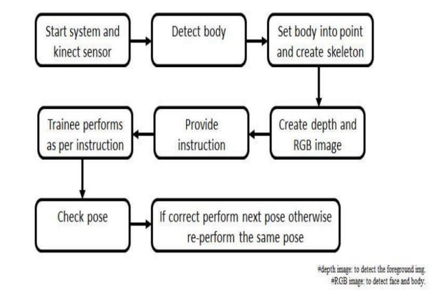

**Figure 1:** System Architecture.

**3.2 Significance of the project**

Communication is most important part of daily life. Through communication one can interact with the society. Communication with family, friends, at work and public place is vital. But if someone lack with this ability then it becomes serious issue. Deaf and Dumb people use sign language for communication. It is difficult for normal user to understand the sign actions. so, communication gap is increased. So, in this situation a mediator is required to translate the languages. It becomes difficult to find a well experienced and educated translator for sign language every time and everywhere when needed which results in lack of communication between the ordinary and impaired people. So, it becomes necessary to have such system which will help for impaired person to convey their messages in society. So, there is a need of a System which acts as a mediator between impaired and normal people. The need of such system is in government sector where either the customer or the client may be impaired and wants to communicate with each other. Also, in Hospitals where the impaired patient wants to communicate with the doctor regarding the disease. In Multinational companies this system is most useful where the impaired employee will get the platform to showcase his talent. For long distance education courses and to provide the Education material, this system can be useful. Thus, the need of this Project is to make the communication easy for impaired people and taking this project to the level of serving to the society.

1. **MODELING AND ANALYSIS**

**4.1 Implementation**

**Mode 1: Sign to Text/Audio Conversion**

1. Skeleton Recognition
2. Joint Recognition
3. Distance Calculation
4. Maintaining Dynamic Dictionary

**Mode 2: Audio to Sign conversion.**

1. Animated Sign Actions
2. Audio to text conversion
3. Text to sign conversion.
   1. **Scope of the Project**

Communication is most important part of daily life. Through communication one can interact with the society. Communication with family, friends, at work and public place is vital. But if someone lack with this ability then it becomes serious issue. Deaf and Dumb people use sign language for communication. It is difficult for normal user to understand the sign actions. so, communication gap is increased. So, in this situation a mediator is required to translate the languages. It becomes difficult to find a well experienced and educated translator for sign language every time and everywhere when needed which results in lack of communication between the ordinary and impaired people. So, it becomes necessary to have such system which will help for impaired person to convey their messages in society. So, there is a need of a System which acts as a mediator between impaired and normal people. The need of such system is in government sector where either the customer or the client may be impaired and wants to communicate with each other. Also, in Hospitals where the impaired patient wants to communicate with the doctor regarding the disease. In Multinational companies this system is most useful where the impaired employee will get the platform to showcase his talent. For long distance education courses and to provide the Education material, this system can be useful. Thus, the need of this Project is to make the communication easy for impaired people and taking this project to the level of serving to the society.

1. **RESULTS AND DISCUSSION**

* **System Input**

**Exercise motions using Microsoft Kinect:** In this the user will do the exercise motions in front of the Kinect sensor and proposed system. The rules utilized Kinect Skeletal Tracking, which contains 20 body joints, to provide custom verbal corrections. The 20 joints will recognize by the Kinect SDK. SDK will provide information about their X, Y, and Z position. Because we were able to calculate the distance between any two skeletal points, we could calculate the different body angles using the Law of Cosines.

**Voice input for start the exercise session**: In this user will give the instructions to the system to select the user exercise mode, e.g., User wants to perform exercise for hand then he should have to give instructions for selecting exercise mode of hand.

* **System Output**

**Voice feedback:** System gives instruction to the user for performing the correct exercise in sequential manner. The system will also give the feedback whether the user is performing correctly or not. Graphical

**skeleton:** The proposed system also shows the graphical skeleton of the user.

* **Screen Shots**

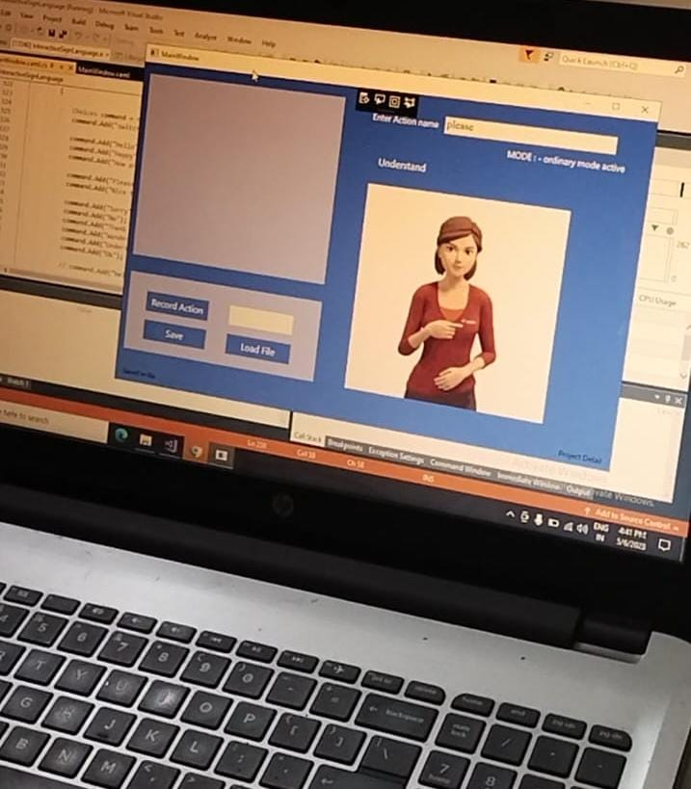

**Figure 2:** Ordinary Mode Activation. **Figure 3:** ser Action name: Understand.

**Figure 4:** Recorded Action.

1. **CONCLUSION**

The imitation-based virtual trainer could provide an assistive tool as an alternative to traditional face-to face clinic-based interventions, reducing the need for clinic visits. system proposed the use of Kinect technology, enabling full body movements to become the gameplay input and to be analyses quantitatively for feedback. Such techniques underpin the development of com- plex exergames that encourage patients’ engagement with their physiotherapy regimes. Developing motivation-driven functional games with appealing gameplay would be a major focus to improve the current design. Machine intelligence will be further explored for quantitative assessment on the similarity and variation of postures and kinematics. Abnormal and risky movements (e.g., risk of fall) could also be a focus of detection, so as to automatically generate risk alerts. Novel methods need to be investigated to interpret high volume data inputs from the sensor, and also possibly inputs from cognitive assessment and medical conditions. By mapping these onto patient profiles, low volume summary will be created for the supervising therapist. Such machine intelligence would be novel and advance to many general exercise/sports games.

1. **REFERENCES**
2. Fernando Cassola, INESC TEC Porto, Portugal: Online-Gym: multiuser virtual gymnasium using RINIONS and multiple Kinect devices COMPETE and National Funds through FCT Foundation for Science and Technology under the project FCOMP-01-0124-FEDER-022701, 978-1-4799-4056-1/14/$31.00 2014 IEEE.
3. Ing-Jr Ding, Che-Wei Chang and Chang-Jyun He Department of Electrical Engineering, National Formosa University: A Kinect-Based Gesture Command Control Method for Human Action Imitations of Humanoid Robots.
4. Kyle Rector, Cynthia L. Bennett, Julie A. Kientz Computer Science and Engineering and 2Human Centered Design Engineering DUB Group-University of Washington Seattle, WA 98195rectorky, bennec3, jkientz@cs.washington.edu: Eye Free Yoga An Exergame Using Kinect Assets 13, October 21-23, 2013, Bellevue, Washington, USA. Copyright 2013.
5. Orlando Erazo, Jose A. Pino, Rosario Pino, Carmen Fernandez: Magic Mirror for Neurorehabilitation of People with Upper Limb Dysfunction Using Kinect, 978-1-4799-2504-9/14 $31.00 2014 IEEE DOI 10.1109/HICSS.2014.329.
6. Microsoft Kinect Sensor and Its Effect Recent Wenjun Zeng University of Missouri.
7. Z. Zhang, "Microsoft Kinect sensor and its effect," IEEE Multimedia, vol. 19, no. 2.