# ONLINE AUDITORIUM BOOKING SYSTEM

# Priya Singh*1, Dr. Santosh Kr. Dwivedi *2, Mr. Aakash Srivastava *3

*1UG Student of Department of Bachelor of Computer Application, Shri Ramswaroop Memorial College of Management Lucknow, Uttar Pradesh, India.

*2Professor, Head of Department of Bachelor of Computer Application, Shri Ramswaroop Memorial College of Management Lucknow, Uttar Pradesh, India.

*3Assistant professor, Department of Bachelor of Computer Application, Shri Ramswaroop Memorial College of Management Lucknow, Uttar Pradesh, India.

# ABSTRACT

The Online Auditorium System is a cutting-edge platform designed to redefine the way we experience and engage with virtual events. With the increasing demand for remote connectivity, this system seamlessly integrates advanced technologies to replicate the immersive atmosphere of a physical auditorium in the digital realm. It offers a dynamic and interactive environment that transce nds geographical limitations, enabling participants to attend conferences, lectures, concerts, and other live events from the comfort of their own homes.

The Online Auditorium System revolutionizes the way we participate in virtual events, enabling individuals and organizations to seamlessly connect, share knowledge, and engage in an immersive digital environment. By combining state-of-the-art technology with interactive features, it offers a compelling solution that bridges the gap between physical and virtual experiences, opening new horizons for global collaboration and engagement.

.

# INTRODUCTION

The Online Auditorium Booking System presents a range of benefits that make it an attractive choice for event planners. Firstly, it offers convenience and accessibility, allowing organizers to reserve auditoriums from anywhere, at any time, eliminating the need for physical visits or lengthy negotiations. Secondly, it provides flexibility, as virtual auditoriums can be easily customized and configured to suit specific event themes and requirements. This versatility enhances the overall experience for both organizers and participants, creating an engaging and immersive virtual environment

In an increasingly digital world, the way we plan and organize events has undergone a significant transformation. The Online Auditorium Booking System is an innovative solution that leverages the power of the internet to revolutionize the process of reserving and managing auditoriums for various virtual events. This system offers a seamless and convenient platform for event organizers to book, schedule, and coordinate online auditoriums, providing a flexible and efficient solution for hosting conferences, seminars, performances, and other virtual gathering

Traditionally, booking an auditorium involved numerous challenges, such as limited availability, logistical complexities, and time-consuming administrative tasks. However, the Online Auditorium Booking System simplifies this process by offering a centralized online platform where organizers can explore a diverse range of virtual auditorium options. With just a few clicks, they can browse through available dates, capacities, and amenities,

# WORKFLOW

The workflow outlined above provides a general overview of the typical process involved in an online auditorium booking system. The specific steps and features may vary depending on the implementation and customization of the system.

1. User Registration

Browse Available Auditoriums

Check Availability:

Reserve Auditorium

Customize Auditorium Setup

# PROPOSED SYSTEM

Our proposed system for the Online Auditorium System aims to provide a comprehensive and user-friendly platform that facilitates the seamless hosting and management of virtual events in virtual auditoriums. The system will incorporate various features and functionalities to enhance the overall event experience for both organizers and participants. Here are the key components of the proposed system:

.

# SYSTEM OVERVIEW

The Online Auditorium Booking System is a comprehensive platform designed to simplify the process of reserving, managing, and hosting virtual events in virtual auditoriums. It provides event organizers with a user-friendly interface to browse available auditoriums, book them for specific dates and times, and customize the virtual environment to suit their event requirements. The system ensures a seamless and engaging event experience for participants by The Online Auditorium Booking System streamlines the process of reserving virtual auditoriums, facilitating seamless event management and providing a captivating virtual experience for participants. By integrating essential features, customization options, and security measures, the system aims to meet the needs of event organizers, enhance participant engagement, and ensure the success of virtual eventsncorporating features such as live streaming, interactive tools, and multilingual support.

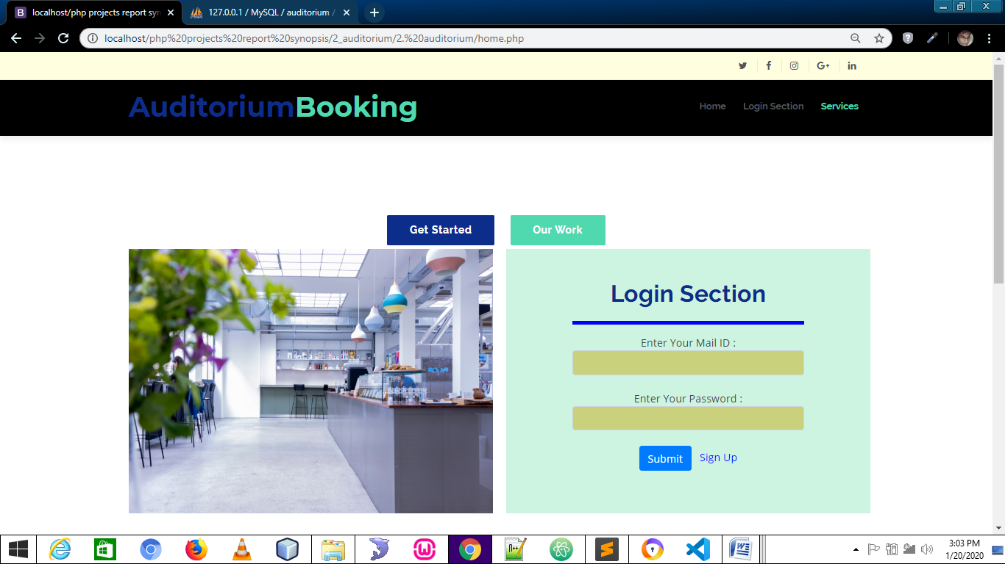

Figure 2: Authentication Page

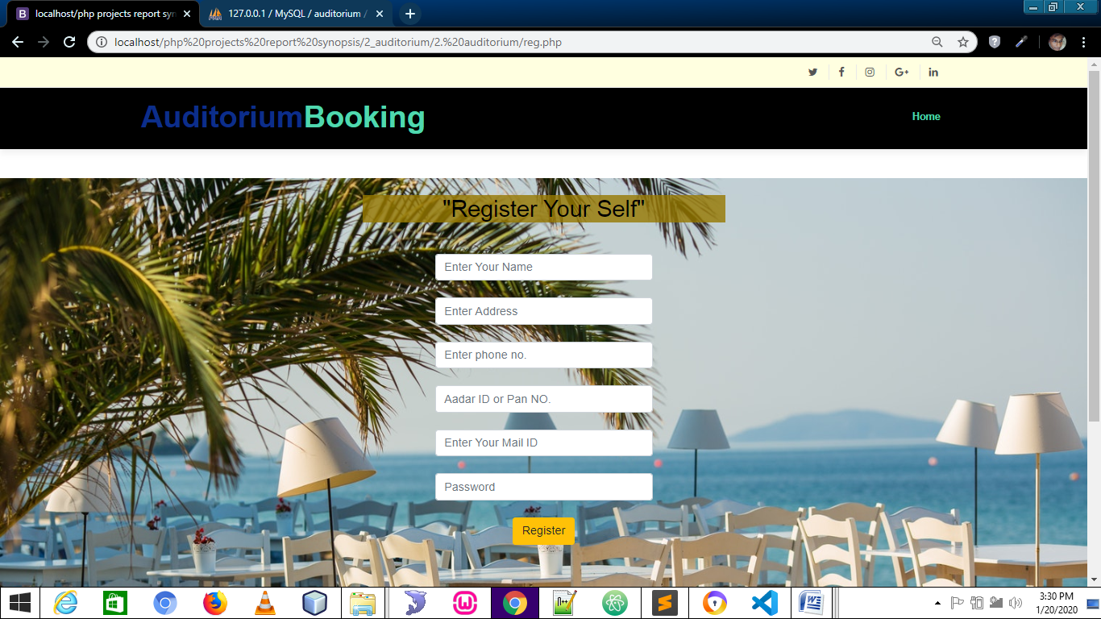

Figure 3: Dashboard

# ANALYSIS

: The Online Auditorium Booking System offers numerous benefits and advantages for event organizers, participants, and the overall event management process. Here is an analysis of the system's key aspects

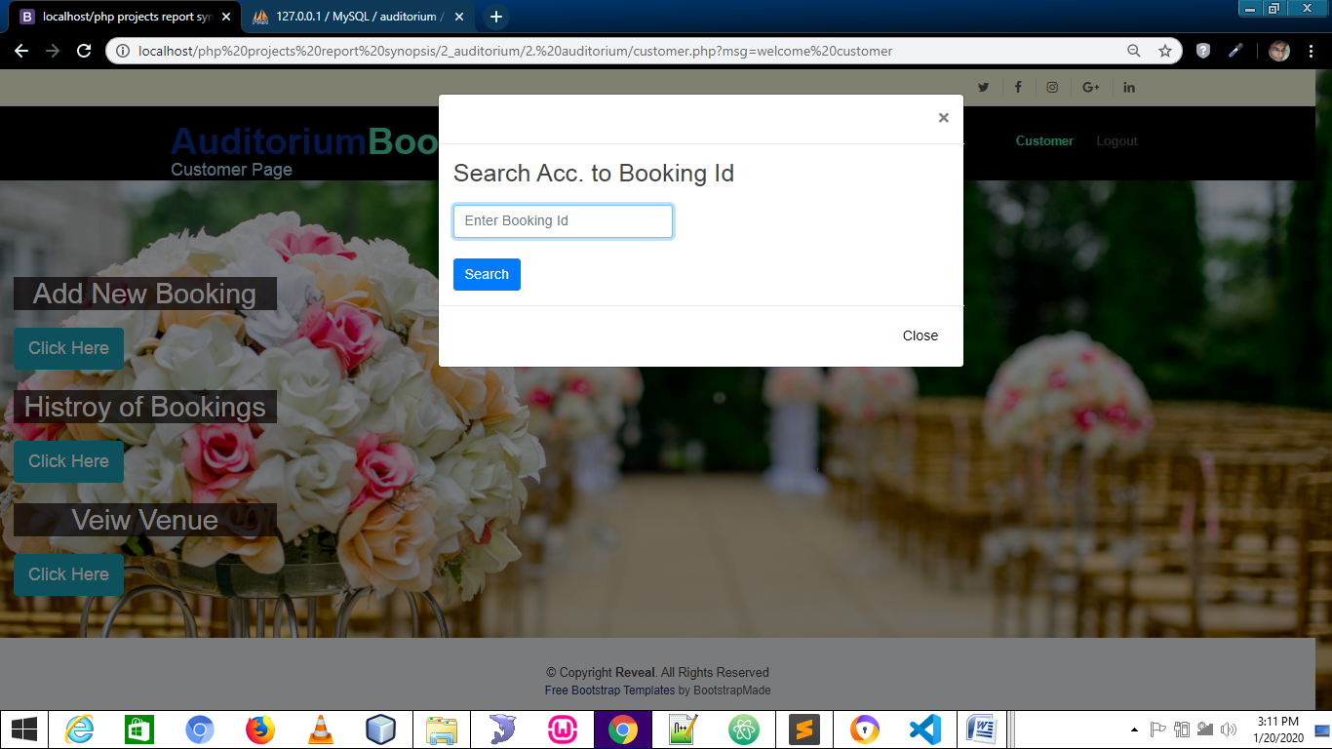

Figure 1: Traditional expense Record

* Simplified Booking Process
* The system streamlines the traditionally complex process of booking physical auditoriums by providing a centralized online platform.
* Users can easily browse through available virtual auditoriums, check availability, and reserve them for specific dates and times.
* This simplification saves time and effort for event organizers, eliminating the need for physical visits and manual coordination.

In conclusion, the Online Auditorium Booking System offers significant advantages for event organizers and participants alike. It simplifies the booking process, enhances accessibility, fosters participant engagement, and provides valuable data insights. By combining these features with customization options, multilingual support, and robust security measures, the system transforms the way virtual events are planned, organized, and experienced.

# CONCLUSION

The Online Auditorium Booking System is a revolutionary solution that transforms the process of reserving, managing, and hosting virtual events in virtual auditoriums. With its user-friendly interface, seamless booking process, and customization options, the system simplifies event planning for organizers and enhances the overall event experience for participants.

By offering a centralized platform, the system eliminates the complexities and limitations associated with traditional auditorium booking processes. Event organizers can easily browse through available virtual auditoriums, check their availability, and make reservations, saving time and effort. The system's flexibility allows organizers to customize the virtual auditoriums to match their event themes and requirements, creating an engaging and immersive experience for participants

In conclusion, the Online Auditorium Booking System revolutionizes the event management landscape by providing a streamlined and efficient platform for reserving, managing, and hosting virtual events in virtual auditoriums. It simplifies the booking process, enhances accessibility, promotes participant engagement, and provides valuable data insights. With its customization options, multilingual support, and security features, the system empowers event organizers and creates memorable and immersive experiences for participants in the digital era.

Top of Form

Regenerate response

Bottom of Form

# FUTURE WORK

These future work areas aim to enhance the capabilities and features of the online auditorium booking system, providing an even more immersive, personalized, and engaging event experience for both organizers and participants. By incorporating emerging technologies, advanced customization options, and enhanced analytics, the system can continue to evolve and adapt to the changing needs of the event industry.

* As hybrid events (a combination of in-person and virtual elements) become more prevalent, expanding the system to support hybrid event management can be a valuable addition.
* The system could facilitate seamless integration between physical and virtual components, allowing event organizers to manage both aspects through a unified platform.

# ACKNOWLEDGEMENT

We would like to express our heartfelt gratitude and appreciation to all those who have contributed to the development and success of the Online Auditorium Booking System. Without their invaluable support, dedication, and expertise, this system would not have been possible. We would like to acknowledge the following individuals and groups:

We deeply appreciate the collective efforts, commitment, and expertise of everyone involved in the development and deployment of the Online Auditorium Booking System. It is through their contributions that we have been able to create a system that simplifies event management, enhances accessibility, and provides an exceptional experience for event organizers and participants.

# REFERENCES

* Eventbrite: Eventbrite is a popular online event management platform that allows you to create and manage events, including booking auditoriums. You can find more information at: <https://www.eventbrite.com/>
* BookMyShow: While primarily known for ticketing services, BookMyShow also provides online venue booking options, including auditoriums. You can explore their services at: <https://in.bookmyshow.com/venue-booking>
* VenueBook: VenueBook is an online platform that connects event planners with various venues, including auditoriums. You can learn more about their services at: <https://venuebook.com/>
* Xola: Xola is a booking and management platform designed for tours, activities, and attractions. It can also be adapted for auditorium booking. You can find more information at: <https://www.xola.com/>
* Aventri: Aventri is an event management software that offers features for venue selection, booking, and event planning. It can be used for auditorium booking as well. More details can be found at: <https://www.aventri.com/>
* Top of Form