**e – GRAM PANCHAYAT**

**Yash Gupta *1, Dr. Santosh Kr. Dwivedi *2,**

**Mr. Aakash Srivastava *3**

*1UG Student of Department of Bachelor of Computer Application, Shri Ramswaroop Memorial College of Management Lucknow, Uttar Pradesh, India.

*2Professor, Head of Department of Bachelor of Computer Application, Shri Ramswaroop Memorial College Of Management Lucknow, Uttar Pradesh, India.

*3Assistant professor, Department of Bachelor of Computer Application, Shri Ramswaroop Memorial College Of Management Lucknow, Uttar Pradesh, India.

# ABSTRACT

# E-gram Panchayat, also known as electronic gram panchayat, refers to the implementation of digital technologies and information systems in the functioning of traditional gram panchayats, which are local self-governing bodies in rural areas of India. The aim of e-gram Panchayat is to leverage technology to improve the efficiency, transparency, and accessibility of governance at the grassroots level.

# The e-gram Panchayat system involves the digitization of various administrative processes and services provided by the gram panchayats. This includes digitizing records and documents related to land, property, birth and death certificates, taxation, and various entitlements. By digitizing these processes, e-gram Panchayat enables faster processing, reduces paperwork, and minimizes the scope for corruption and malpractices.

# INTRODUCTION

E-gram panchayat is a comprehensive digital platform aimed at revolutionizing the

functioning of gram panchayats in India. The project is designed to provide an

efficient and transparent administration that caters to the needs of the rural

population. Our primary objective is to bridge the digital divide in rural India by

leveraging Information and Communication Technology (ICT) to create a citizen

centric governance model.

The project aims to offer a user-friendly platform that is easy to navigate, thereby

ensuring that all citizens can access essential services and participate in the decision-making process. With e-gram panchayat made by me, citizens will be able to access a range of services such as birth and death certificates, income certificates, property records, and grievance redressal mechanisms, among others. The platform will also provide an online payment gateway that will facilitate the payment of utility bills, taxes, and other dues, making it easier for citizens to conduct transactions.

# WORKFLOW

# The workflow of an e-gram Panchayat typically involves several stages and processes. Here is a general overview of the workflow:

# Digitization of Records

# Online Citizen Services

# Application Processing

# Approval and Issuance

# Monitoring and Reporting

# Grievance Redressa

# Training and Support

It's important to note that the specific workflow may vary depending on the e-gram Panchayat implementation and the technological infrastructure in place.

# PROPOSED SYSTEM

The proposed system would aim to streamline governance processes, enhance transparency, improve service delivery, and empower citizens through digital technologies. It would leverage the potential of e-governance to transform the functioning of gram panchayats and promote inclusive development in rural areas.The proposed system would integrate with higher-level government systems, such as state or national databases, to ensure levels of governance seamless data exchange and interoperability. This integration would enable efficient data sharing and collaboration between different.

# IV. SYSTEM OVERVIEW

The e-gram Panchayat system is an integrated digital platform designed to transform the functioning of gram panchayats, the local self-governing bodies in rural areas of India. It leverages technology and digital solutions to enhance governance, improve service delivery, and empower citizens. Here is a system overview of e-gram Panchayat:

* User Interface
* Citizen Services
* Administrative Processes
* Financial Management
* Grievance Redressa
* Data Security and Privacy
* Connectivity and Infrastructure

The e-gram Panchayat system aims to enhance transparency, accountability, and efficiency in local governance. By leveraging technology, it empowers rural communities, improves service delivery, and promotes inclusive development at the grassroots level.

.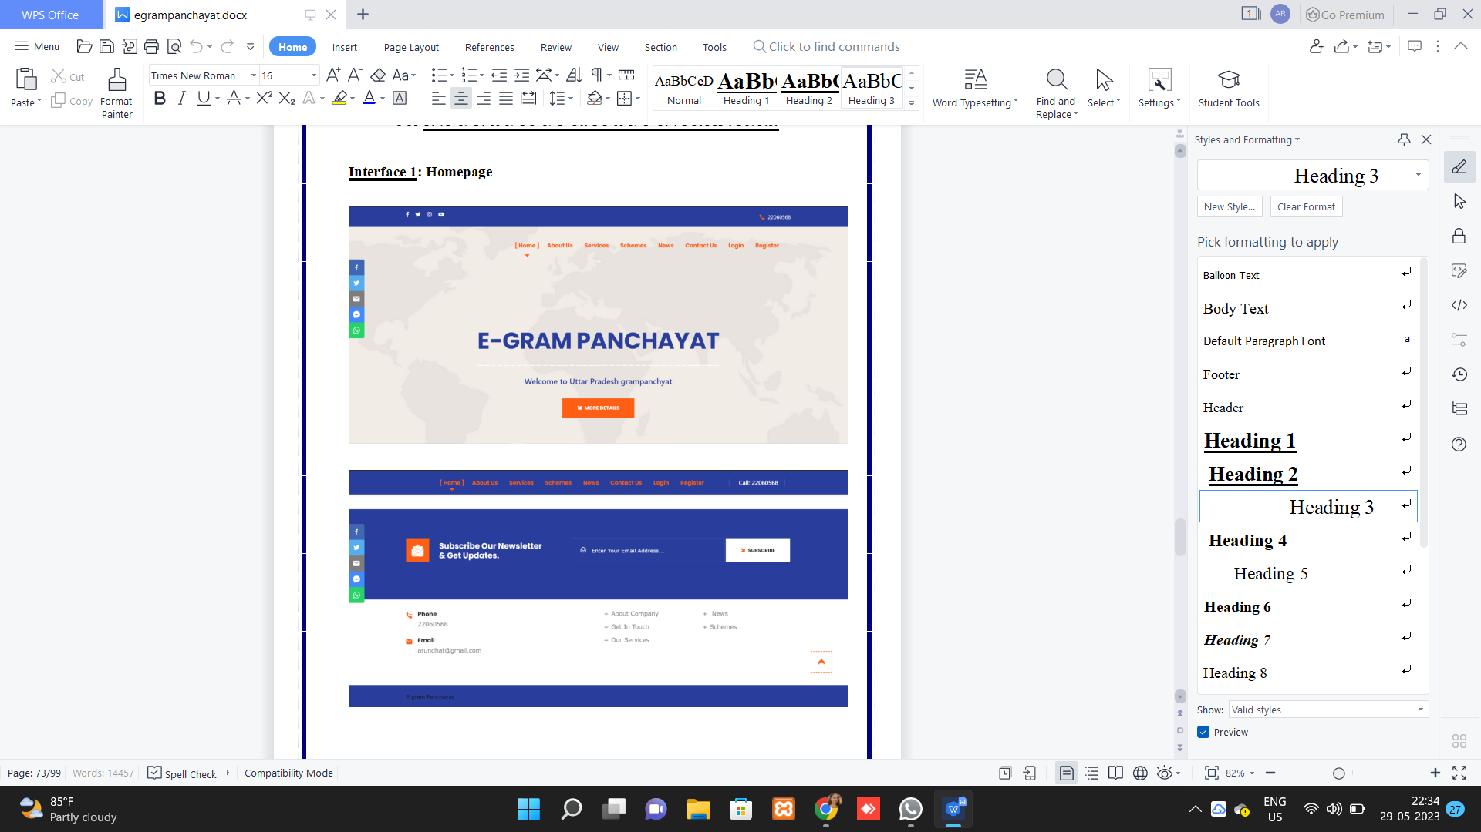

Figure 1: Authentication Page

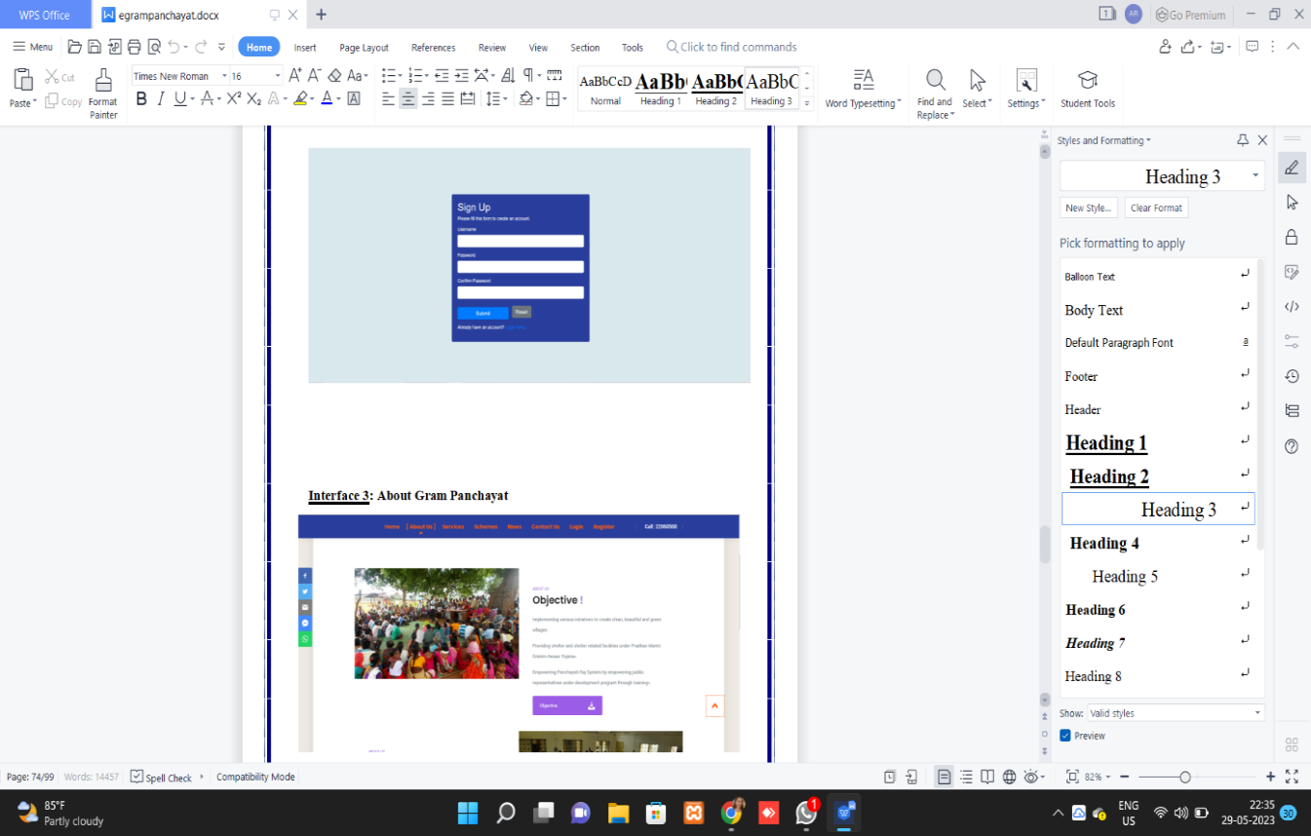

Figure 2: Dashboard

# V. ANALYSIS

E-gram Panchayat, with its implementation of digital technologies in local self-governance, brings several benefits and challenges. Here is an analysis of e-gram Panchayat:

* Benefits:

1. Improved Efficiency
2. ransparency and Accountability

* Challenges:

1. Data Security and Privacy
2. Resistance to Change

e-gram Panchayat offers numerous benefits such as improved efficiency, transparency, and citizen empowerment. However, challenges related to the digital divide, infrastructure, capacity building, data security, and resistance to change need to be addressed for effective implementation and widespread adoption of the system.

# VI. CONCLUSION

# E-gram Panchayat represents a transformative approach to local governance by leveraging digital technologies and information systems. It offers a range of benefits, including improved efficiency, transparency, accessibility, and citizen empowerment. By digitizing administrative processes, providing online citizen services, and enabling real-time monitoring and reporting, e-gram Panchayat enhances the functioning of gram panchayats and promotes inclusive development in rural areas.

# Overall, e-gram Panchayat holds tremendous potential to transform local governance, making it more efficient, transparent, and citizen-centric. It fosters a participatory approach, empowering citizens to access government services conveniently and actively engage in decision-making processes. By embracing e-gram Panchayat, gram panchayats can harness the benefits of technology and drive inclusive development in rural communities, ensuring a more equitable and empowered society.

# 

# VII. FUTURE WORK

As technology advances, e-gram Panchayat systems should evolve to incorporate the latest tools and technologies.

With the increasing penetration of smartphones and mobile internet access, developing mobile applications specifically tailored for e-gram Panchayat can further enhance accessibility and citizen engagement. Continuous research and evaluation of the e-gram Panchayat system are important to measure its impact, identify areas for improvement, and adapt to changing needs. Research can explore the socio-economic impact of e-gram Panchayat, user satisfaction, and identify best practices for implementation and governance.

By focusing on these future areas of work, e-gram Panchayat can continue to evolve as a robust and inclusive digital governance system, effectively addressing the needs of rural communities and driving sustainable development at the grassroots level.

# VII. ACKNOWLEDGEMENT

E-gram panchayat is a comprehensive digital platform aimed at revolutionizing the

functioning of gram panchayats in India. The project is designed to provide an

efficient and transparent administration that caters to the needs of the rural

population. Our primary objective is to bridge the digital divide in rural India by

leveraging Information and Communication Technology (ICT) to create a citizen

centric governance model.

The project aims to offer a user-friendly platform that is easy to navigate, thereby

ensuring that all citizens can access essential services and participate in the

decision-making process. With e-gram panchayat made by me, citizens will be able

to access a range of services such as birth and death certificates, income

certificates, property records, and grievance redressal

mechanisms, among

others. The platform will also provide an online payment gateway that will facilitate

the payment of utility bills, taxes, and other dues, making it easier for citizens to

conduct transactions.

Our project also emphasizes financial management, with the platform providing a

secure and efficient way to manage funds allocated to gram panchayats. This feature

will help improve transparency and reduce corruption in the system, ensuring that

funds reach their intended beneficiaries.

# 

# VIII. REFERENCES

Book References:

• Beginning HTML, XHTML, CSS and JavaScript by Jon Duckett.

• HTML, DHTML, Java, Script; CGI by Ivan Bayross.

• Web Technology and Design by Xavier.

WEBSITE REFERENCES

• https://www.upgov.com/aquaculture

• https://www.geeksforgeeks.org/php-tutorials

• https://www.w3schools.com/tags/default.asp /

• https://www.w3schools.com/cssref/default.asp

• https://www.w3schools.com/js/default.asp

• https://www.w3schools.com/sql/default.asp