CITYVETS

# Pooja Thakur*1, Dr. Santosh Kr. Dwivedi *2, ,

# Mr. Aakash Srivastava *3

*1UG Student of Department of Bachelor of Computer Application, Shri Ramswaroop Memorial College of Management Lucknow, Uttar Pradesh, India.

*2Professor, Head of Department of Bachelor of Computer Application, Shri Ramswaroop Memorial College Of Management Lucknow, Uttar Pradesh, India.

*3Assistant professor, Department of Bachelor of Computer Application, Shri Ramswaroop Memorial College Of Management Lucknow, Uttar Pradesh, India.

# ABSTRACT

The city veterinary system is a comprehensive framework designed to provide veterinary services and care to the animal population within an urban environment. This abstract provides an overview of the key components and objectives of a typical city veterinary system.

The primary goal of a city veterinary system is to promote the health, well-being, and welfare of animals residing in urban areas while also addressing public health concerns and maintaining a harmonious coexistence between humans and animals. To achieve this, the system incorporates various elements such as veterinary clinics, animal shelters, public awareness campaigns, and regulatory measures. The city veterinary system encompasses a network of veterinary clinics strategically located throughout the city. These clinics offer a wide range of services including routine check-ups, vaccinations, surgical procedures, diagnostics, and emergency care. They are staffed by qualified veterinarians and support personnel who ensure the delivery of high-quality veterinary care to both companion animals and stray animals. the city veterinary system aims to achieve several outcomes, including reducing the number of stray animals, preventing the spread of zoonotic diseases, promoting responsible pet ownership, and enhancing the overall health and well-being of animals within the urban environment.

# INTRODUCTION

The city veterinary system is an integral part of urban infrastructure that focuses on ensuring the health and well-being of animals residing in cities. With the rise in urbanization and the growing number of pets and stray animals in urban areas, the establishment of a comprehensive veterinary system has become essential. This system encompasses various components such as veterinary clinics, animal shelters, public awareness campaigns, and regulatory measures to address the unique challenges and needs of animals within an urban environment.

The primary objective of the city veterinary system is to provide quality veterinary care to both companion animals and stray animals, while also addressing public health concerns related to zoonotic diseases and promoting responsible pet ownership. By offering a range of services such as routine check-ups, vaccinations, surgical procedures, diagnostics, emergency care, and rehabilitation, the system aims to enhance the overall health and welfare of animals.

The city veterinary system serves as a crucial framework that aims to address the unique challenges of urban areas, provide essential veterinary services, promote animal welfare, and foster a harmonious coexistence between humans and animals. By integrating veterinary clinics, animal shelters, public awareness campaigns, and regulatory measures, the system seeks to create healthier and happier communities for both animals and the residents of the city.

# WORKFLOW

The workflow of a city veterinary system typically involves a series of interconnected steps and processes aimed at providing veterinary services, ensuring animal welfare, and promoting responsible pet ownership within an urban environment. While specific workflows may vary depending on the city and its resources, here is a general overview:

* login
* Registration page
* Appointment
* Ask veterinary
* Approved/reject appointment
* Pet detail
* Update
* Emergency appointment

the city veterinary system aims to provide comprehensive veterinary services, ensure animal welfare, and create a community that values responsible pet ownership and the well-being of animals within the urban environment.

# PROPOSED SYSTEM

The primary purpose of the city veterinary system is to promote and safeguard the health and welfare of animals residing in cities. It provides essential veterinary care, including routine check-ups, vaccinations, and medical treatments, to ensure that animals are healthy and free from suffering.

The system plays a crucial role in preventing and controlling the spread of zoonotic diseases, which are infections that can be transmitted between animals and humans. By implementing vaccination programs, promoting proper hygiene practices, and conducting disease surveillance, the city veterinary system helps protect both animal and public health.

.

# SYSTEM OVERVIEW

The city veterinary system is a comprehensive framework that encompasses various components and processes to ensure the health, well-being, and welfare of animals within an urban environment. This system involves the integration of veterinary clinics, animal shelters, public awareness campaigns, and regulatory measures to address the unique challenges of urban areas.

Veterinary clinics are strategically located throughout the city to provide a range of services to both companion animals and stray animals.

Services include routine check-ups, vaccinations, surgical procedures, diagnostics, and emergency care.

Qualified veterinarians and support staff staff the clinics, ensuring the delivery of high-quality veterinary care.

The city veterinary system aims to achieve several outcomes, including reducing the number of stray animals, preventing the spread of zoonotic diseases, promoting responsible pet ownership, and enhancing the overall health and well-being of animals within the urban environment. By integrating veterinary clinics, animal shelters, public awareness campaigns, and regulatory measures, the system strives to create healthier and happier communities for both animals and residents.

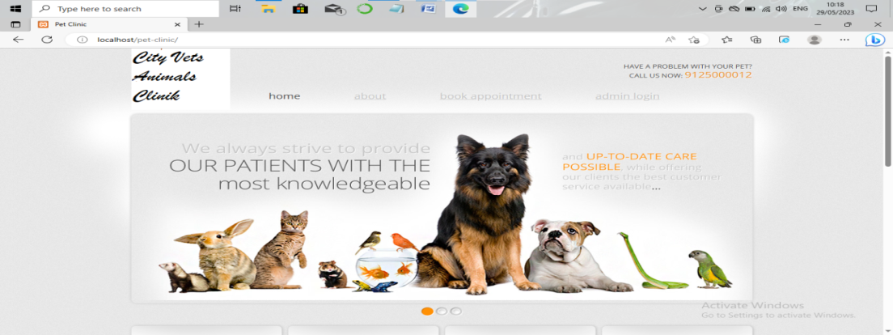

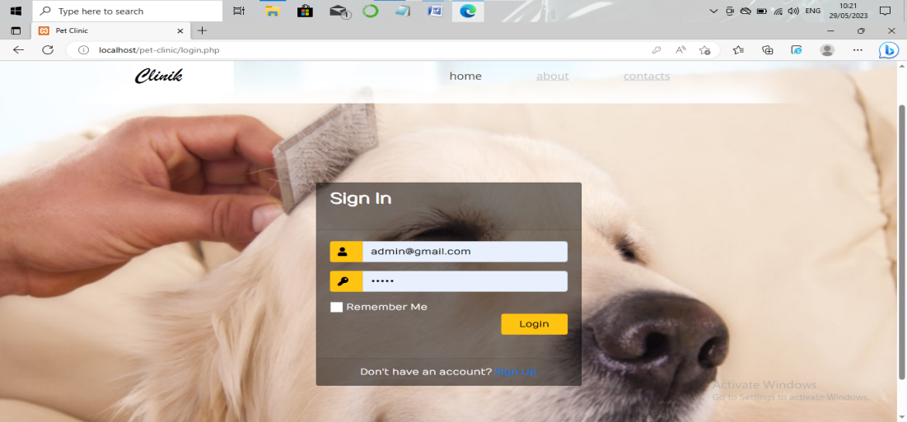

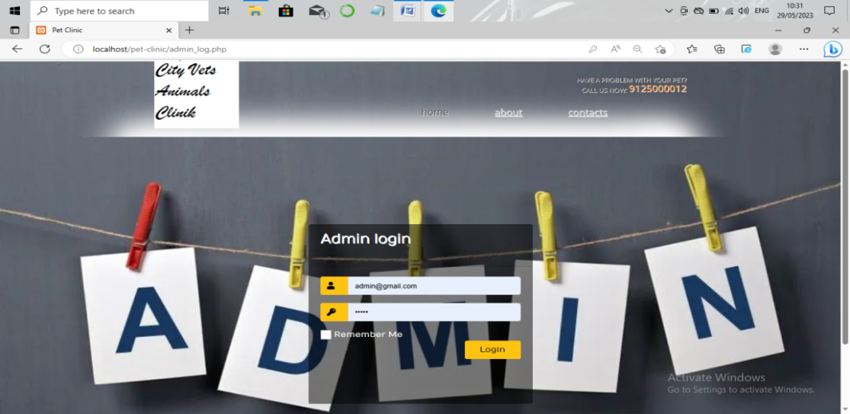

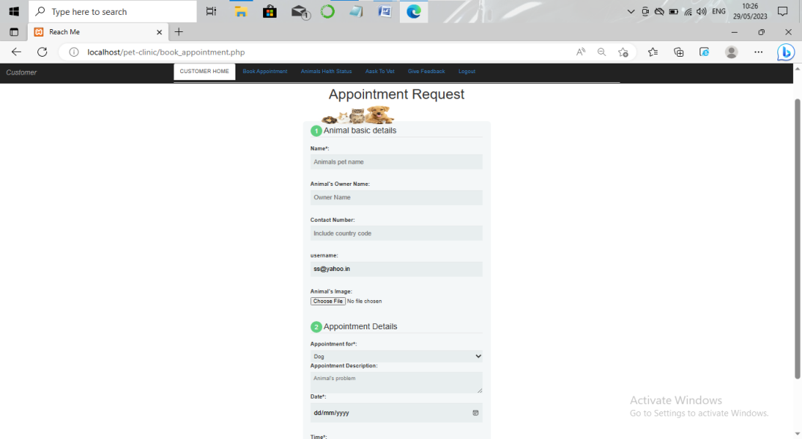

# ANALYSIS

To analyze the City Veterinary System project, let's consider several key aspects:

1. Project Objectives:

* Improve the efficiency and effectiveness of veterinary services within the city.
* Enhance patient care and ensure accurate and accessible medical records.
* Streamline appointment scheduling and management processes.
* Optimize inventory management for veterinary supplies and resources.
* Enable accurate billing and payment processing for veterinary services.
* Provide reporting and analytics capabilities for performance monitoring and decision-making.

1. Requirements:

* Appointment management: The system should enable pet owners to schedule appointments, view available time slots, and receive appointment reminders.
* Medical records management: It should provide veterinarians with a user-friendly interface to create, update, and retrieve accurate and comprehensive medical records for each pet.

1. Implementation Considerations:

* System architecture: Determine the appropriate architecture (e.g., client-server, cloud-based) and technologies to support the system's functionality and scalability.
* User interface: Design an intuitive and user-friendly interface that caters to the needs of both veterinarians and pet owners.
* Database design: Establish a secure and reliable database structure to store and manage pet information, medical records, and other relevant data.
* Security measures: Implement robust security mechanisms to protect sensitive data, such as encryption, access control, and regular security updates.
* Integration: Consider integrating the system with other existing systems or external APIs, such as laboratory systems or payment gateways, for seamless data exchange and functionality.
* Training and support: Provide adequate training and support to veterinarians, staff, and pet owners to ensure successful adoption and utilization of the system.

It is important to conduct a detailed analysis of the specific requirements, resources, and constraints of the City Veterinary System project to ensure its successful implementation and alignment with the goals of the city and stakeholders involve.

# CONCLUSION

the city veterinary system is a vital infrastructure that plays a crucial role in ensuring the health, well-being, and welfare of animals within urban areas. By integrating veterinary clinics the system aims to create a harmonious coexistence between humans and animals, while also addressing public health concerns related to zoonotic diseases.

Through veterinary clinics, animals receive essential medical care, including check-ups, vaccinations, and emergency treatments, promoting their overall health and preventing the spread of diseases. Animal shelters provide temporary homes, medical attention, and rehabilitation for stray and abandoned animals, while actively promoting adoption and responsible pet ownership. Through veterinary clinics, animals receive essential medical care, including check-ups, vaccinations, and emergency treatments, promoting their overall health and preventing the spread of diseases.

# FUTURE WORK

This software is very flexible to modify itself with the needs of users and customer in future. Yet the web application is capable of enhancement.

Here we describe some features, which can be later introduced in the software for enhancing it.

1. We can add some new module like online payment gateway module.

2. We can provide an authorization facility. Determining whether client is permitted to access the service. From which we can hide confidential information to other users.

3. More authentications responsibilities can be added in existing system through better automation offer, we can improve several levels of security.

4. We can add some extra utilities like notepad, online help etc. in my software.

5. We can make android, ios application of this project

# ACKNOWLEDGEMENT

We would like to thank our friends, relatives, our faculty, and other staff members of Shri Ramswaroop Memorial College of Engineering and Management for helping and guiding me, and special thanks to my instructor for suggesting me the right and suitable path.

First and foremost, we would like to express our deepest gratitude to my guide, Dr. Santosh Kr. Dwivedi, for their invaluable guidance, mentorship, and support throughout this research project. Their expertise and insights have been instrumental in shaping our research direction and refining our methodology.

Last but not least, we would like to thank our family members, friends, and loved ones for their unwavering support, understanding, and encouragement throughout this research journey. Their constant belief in us has been a driving force behind our motivation and perseverance.

While it is impossible to mention everyone who has contributed in one way or another, we genuinely appreciate all the support we have received.

# REFERENCES

* K.K Agarwal & Yogesh Singh "Software Engineering", 2nd Edition, New Age International 2005.
* Sommerville, "Software Engineering", Addison Weisley, 2002.
* James Peter, W. Pedrycz, "Software Engineering: An Engineering Approach"John Wiley & Sons.
* Roger S. Pressman, "Software Engineering", 34 Edition by McGraw Hill. International, April 2002