**SMART ID FOR STUDENT ACADEMICS (SSA)**

**Kunal Pawar1, Pratik Shinde2, Indrajeet Mane3, Shreyas Chopde4**

**Guide: Mr. C.A. Ghuge**

Progressive Education Society's Modern College of Engineering,

Department of Information Technology,

Savitribai Phule Pune University,

Pune, Maharashtra, India

**ABSTRACT**

We have used technology in every possible way, whether directly or indirectly. With the rise in class bunking or poor academic progress of students or many weaknesses in the administrative system in student entrance verification and to maintaining branch-wise classified accurate data of students. It is more important than ever to take proper action against lecture or practical bunking to ensure the student’s progress. Unfortunately, this does not always happen. Initially, all the basic data of students is stored in the central database of the college administrative section, which is then also shared with the student’s bouncer guards. Since the QR code is generated by providing the student information, so when any student is going to enter the college campus, first he/she’ll show the QR code to the guard after the guard scan that QR code, and they’ll verify the name and photo with that student also verify his/her face with the college data as a second step. All scanning processes will be GPS locked so no one can make entry points other than the college campus latitude longitude will be set according to the college campus area considering error. The key issues with the conventional system are administrative section is struggling to know the exact number of students who are present on the campus but not attending lectures, so developing a system like this would provide a corruption-free system for the student’s college. Using ML, Java, and Python, an attempt was made to prevent students from class bunking and to provide classified data of all students to the administrative department.

**Keywords:** Academic progress, Entrance verification, QR code, GPS.

1. **INTRODUCTION**

We’re generating an application for students’ admin section where they can sign up with some basic details like name, phone number, and email id, academic details, etc. In this same application, there is another function just for the college admin section where they can edit and verify the entrance verification of students where they can view an Excel sheet with all academic data of all the students directly through the QR code which present on student smart ID and many more functions to filter it. All scanning processes will be GPS locked so no one can make entry points other than the college campus latitude and longitude will be set according to the college campus area.

1. **IMPORTANCE OF “SMART ID FOR STUDENT ACADEMICS (SSA)”**

Students are required to attend the lectures or practicals or any other college work after entering the college campus using the SSA program. This will increase the academic progress of the students. The administrative department gets the exact number of students who are present on the college campus at any time. At the college campus entrance, guards can easily verify the student profile from the SSA smart ID card & College will get digital analytics of students or department-wise students list many more filters to analyze. Students do not need to carry physical ID cards every time they come to college. An alert system can connect to it so parents will automatically get up- dated accordingly to student attendance, also parents can check the academic report of their son or daughter.

1. **FEATURES**

**3.1 Security**

To provide better security.

**3.2 Entrance System**

To make the entrance system more convenient and faster.

**3.3 Quick Access**

Generating branch-wise classified data quick access to all academic records.

1. **BENEFITS**

**4.1 Convenience**

Smart ID for student academics (SSA) makes it easier for any organization to manage the faculty as well as the students with proper record keeping.

**4.2 Informational**

Smart ID for student academics (SSA) makes easier representation of all the records.

**4.3 Record Handling**

With the easy availability of details of the person, it will be easier to keep records of each and every person.

1. **LITERATURE REVIEW**

**1) Paper Name: A Review on IoT-based Smart Card System for Students**

Data innovation assumes a crucial job for the advancement of smart cards. They can alter the type of conveyance of administrations and products, through computerized recognizable proof and confirmation of clients, bringing about noteworthy effectiveness gains and at last lower costs for purchasers. Individuals from various occupations of life extricate data from these smart cards. They have the advantage of individuals with, - the right to security and provide clients trust in the reliability of business associations and state foundations. It can likewise give various types of offices to clients and just as associations, for example, access and control. This paper expects to display the utility of an understudy card framework for an instructive foundation utilizing smart card innovation which can be usable in shipping, trade, and instructive segments. Smart cards will be utilized as means for recognizable proof, safety, and money. From that point, we can see the potential and intensity of smart cards their adaptability, common sense, and ease of use.

**2) Paper Name: A Quantitative Case Study in WSNs: Design and Implementation of Student Smart ID Card**

Wireless Sensor Networks (WSNs) is a collection of small nodes which are used to sense physical environmental conditions like temperature, pressure, sound, and motion. Sensor nodes are deployed to carry out various applications such as disaster recovery, industrial control, health monitoring, and environmental monitoring. However, the least work has been done on the school environment application. Therefore, in this research work, a smart system has been developed that replaces the traditional methods of administrating the University with more sustainable and eco-friendly solutions. WSN is used to record the student’s attendance and to track their entry and exit of the classroom. WSN incorporated with the student id card and to check the appropriateness an online survey system has been conducted at AMA University. Incorporation of WSN with a Student id card will be beneficial to record student attendance, in the certificate of registration, to avoid examination clashes, replaces exam permit, and student health care, and eliminate library sign-in and sign-out.

**3) Paper Name: Student Smart Card.**

Radio Frequency Identification (RFID) is used in many applications such as public transport ticketing, campus access, etc. It allows us quick and legit authentication of a person owning an RFID tag. In this paper, we are proposing a system that will use an RFID tag as an ID for students which will be used for day-to-day tasks like marking attendance, taking books from the library, or as a hall ticket in exams. Also, it will be used for payments provided in college including stationary, canteen, and college bus. To identify a student uniquely, this system will use its fingerprint to generate a key which will be used to access the content of the RFID tag. Another part of this project is Analytics. The data collected through different use of RFID tags by students will be stored in the cloud (server). This data will be analyzed to pro- vide insights into data regarding the performance of students and the use of different services provided by the college. It can be used to identify different issues regarding student performance and hence to design and devise a solution to overcome it.

1. **USER INTERFACE**

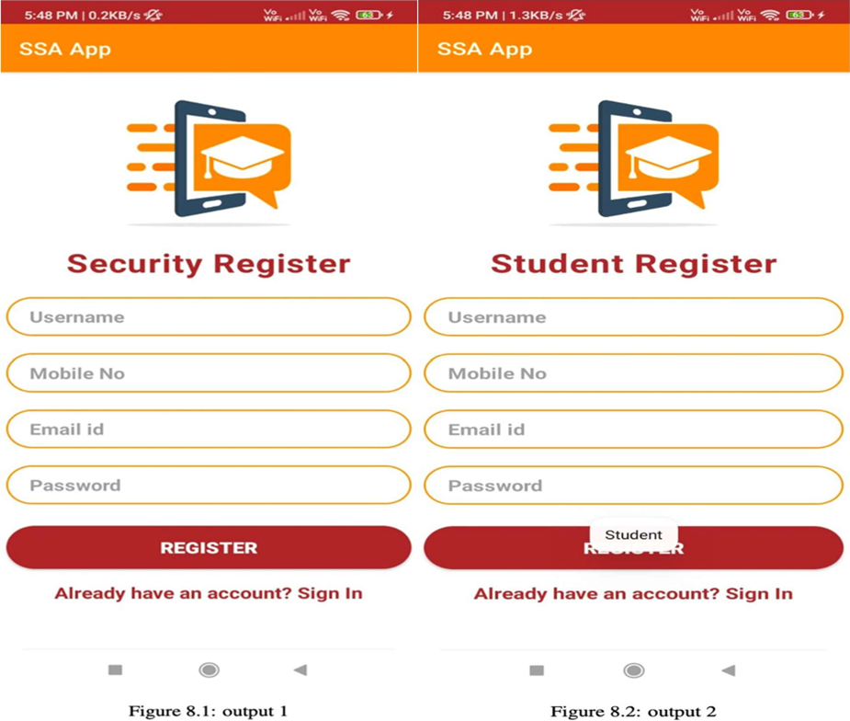

**Fig 1:** User Login Information

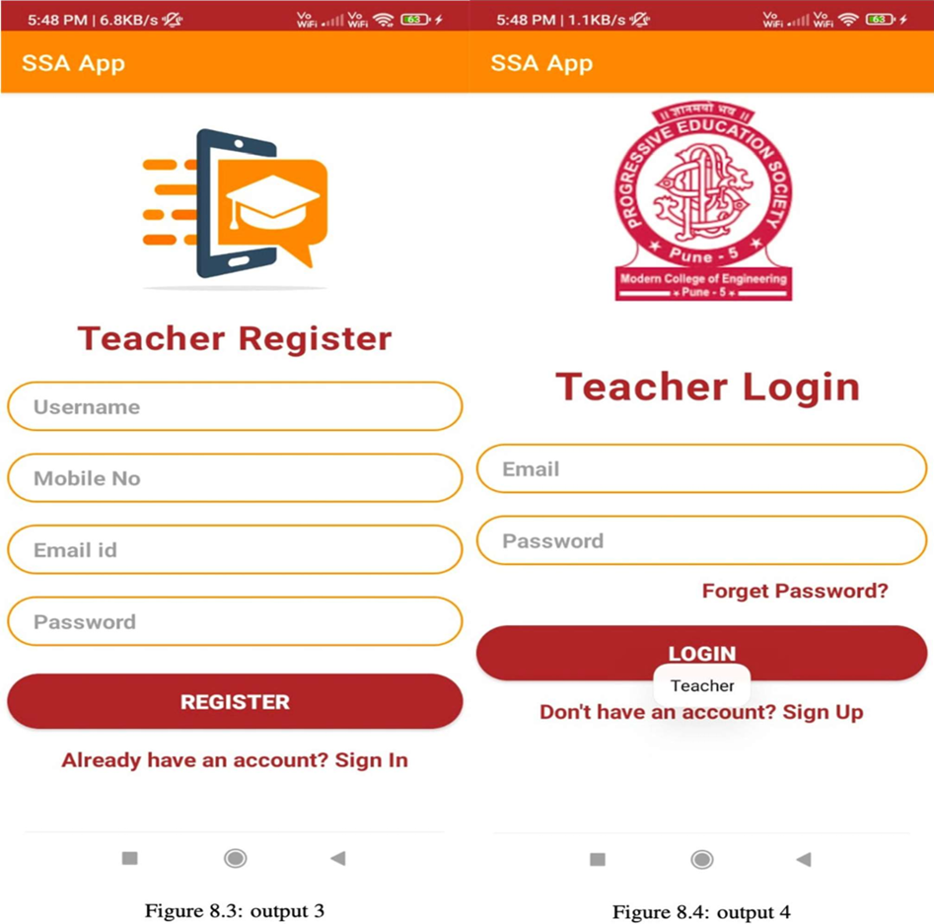

**Fig 2:** Registration & Login of User and Admin

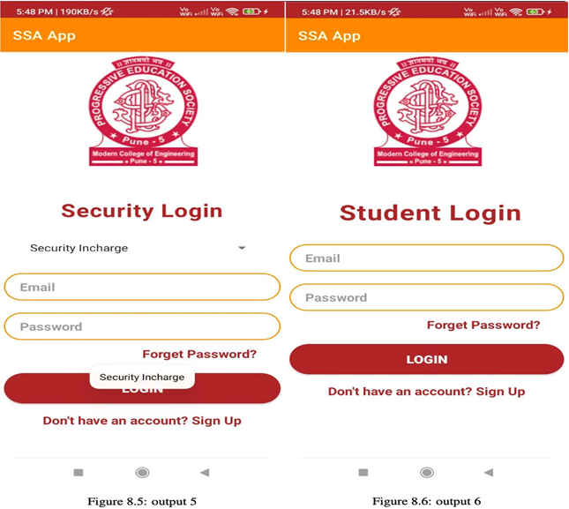

**Fig 3:** Login as User or Admin

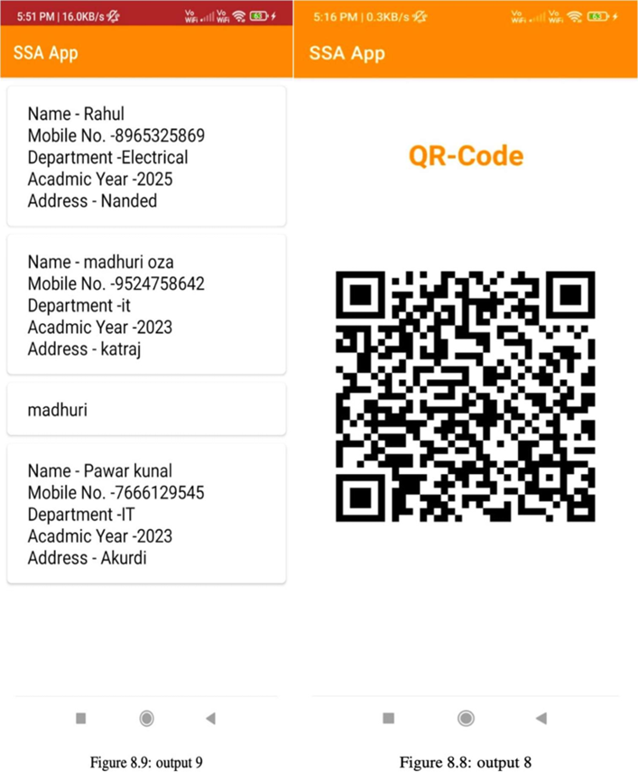

**Fig 4:** Information & QR Code

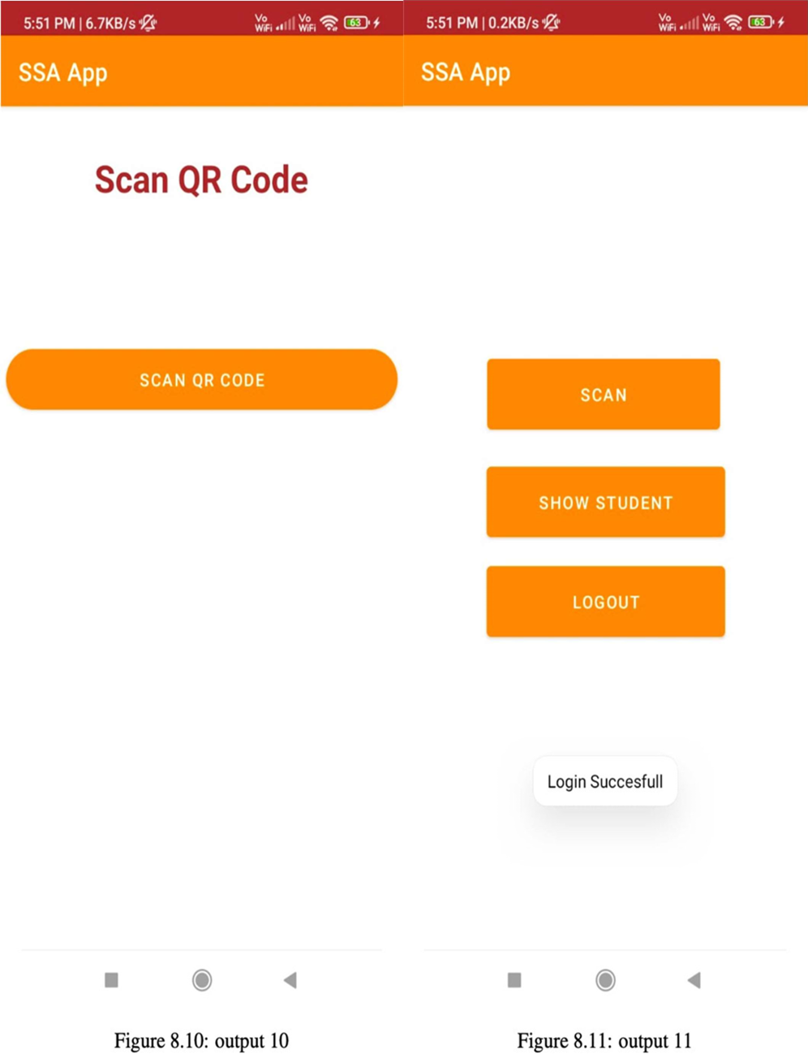

**Fig 5:** Features

1. **METHODOLOGY**
2. **Define the Objectives.**
3. **Research and Requirements Gathering**
4. **System Design**
5. **Data Management**

**Let’s see in detail:-**

1. **Define the Objectives:** Clearly identify the goals and objectives of implementing a Smart ID system for students' academic needs. For example, the objectives could be to enhance security, streamline administrative processes, improve access to resources, and facilitate student identification.
2. **Research and Requirements Gathering:** Conduct thorough research to understand the specific needs and challenges faced by students and academic institutions. Gather requirements by consulting with stakeholders such as students, teachers, administrators, and IT professionals. Consider factors like authentication, data privacy, scalability, and integration with existing systems.
3. **System Design:** Based on the requirements, design the Smart ID system architecture. Determine the components of the system, such as hardware, software, and network infrastructure. Consider factors like card design, biometric features(if applicable), data storage, and system interfaces.
4. **Data Management:** Establish a robust data management plan to handle student information securely. Ensure compliance with relevant data protection regulations. Define data storage protocols, encryption standards, and access controls to protect sensitive information.
5. **RESULTS AND DISCUSSION**

Advantage of the SSA application is ease of use. The application is designed to be user-friendly, with simple and intuitive interfaces. This means that even novice users can easily navigate the application and find the information they need. Additionally, our application can be accessed from a variety of devices, including smartphones and tablets, making it easy for students & administrative systems to access information on the go.

Overall, our main motto is to replace ID cards with Smart ID cards at the institute level. The SSA app is an essential tool for administrative departments, providing a wealth of information that can help them to recognize the progress of students. With features such as search functions, and QR code scanning, the application makes it easier and more convenient for colleges to analyze the attendance report.

1. **CONCLUSION**

In conclusion, We have created a system for colleges and other institutes to automate their day-to-day activities. This will help the normal functioning of colleges more efficiently. Also, leveraging analytics over data collected through different activities in college would help management to understand the needs and interests of students leading to data-driven decisions.

1. **REFERENCES**

[1] S. Augustine, M. K. Mishra and N. Lakshmin arasamma, ”Adaptive Droop Control Strategy for Load Sharing and Circulating Current Min-imization in Low-Voltage Standalone DC Micro grid,” in IEEE Trans- actions on Sustainable Energy, vol. 6, no.1, pp. 132-141, Jan. 2015.

[2] D. Gha deri and M. C elebi, ”Implementation of load sharing with fast voltage regulation inparallel connected cascaded power boost con- verters based on droop coefficients refreshing method,” 2017 9th Inter- national Conference on Computational Intelligence and Communicate- tion Networks (CICN), Girne, 2017, pp. 195-199.

[3] Z. Zhang et al., ”Droop control of a bipolar dc micro grid for loadsharing and voltagebalancing,” 2017 IEEE 3rd International Future Energy Electronics Conference and ECCE Asia (IFEEC 2017 - ECCEAsia), Kaohsiung, 2017, pp. 795-799.

[4] P. Lin, P. Wang, Q. Xu, J. Xiao, I. U. Nutkani and Choo Fook Hoong, ”An integral- droop based dynamic power sharing control for hybrid energy storage system in DC micro grid,” 2017 IEEE 3rd International Future Energy Electronics Conference andECCE Asia (IFEEC 2017 - ECCE Asia), Kaohsiung, 2017, pp. 338-343.

[5] C. Wang, J. Meng, Y. Wang and H. Wang,” Adaptive virtual inertia control for DC microgrid with variable droop coefficient,” 2017 20th International Conference onElectrical Machines and Systems (ICEMS), Sydney, NSW, 2017, pp. 1-5.