A Review on Design And Performance Of Electrical Solar Rotavator

Mr. Bachche Vishal Vijay

D Y Patil technical campus Talsande, Kolhapur,Maharashtra,India [vishalbachche2020@gmail.com](mailto:vishalbachche2020@gmail.com)

Mr. Patil Shubham Pandurang

D Y Patil technical campus Talsande, Kolhapur,Maharashtra,India [shubhampatil2803@gmail.com](mailto:shubhampatil2803@gmail.com)

Mr. Shelake Digvijay Dattatray

D Y Patil technical campus Talsande, Kolhapur,Maharashtra,India [digvijayshelake2010@gmail.com](mailto:digvijayshelake2010@gmail.com)

Mr. Thamke Lahu Ramchandra

D Y Patil technical campus Talsande, Kolhapur,Maharashtra,India [lahuthamake0111@gamil.com](mailto:lahuthamake0111@gamil.com)

Mrs. Puja Shantanu Gurav Assistant Professor (Guide), Department of Electrical Engineering, D Y Patil technical campus, Talsande,Kolhapur, Maharashtra, India [pujagurav14@gmail.com](mailto:pujagurav14@gmail.com)

**Abstract** - In Indian agriculture, the preparation of seedbed for deep tillage using additional machinery and tilling tools are increased. Power Rotavator or cultivator is one of the tillage machines most suitable for seedbed preparation. In a power Rotavator machine the blade is a critical part, which are engaged with the soil to prepare a seedbed and mix to fertilizer. For increasing the maximum weed removal efficiency of tilling blade in new design.There is because to utilize and increase the fertility of land to increasing the crop productivity. In this machine we have added some extra part which is help to improve the maximum weed removal efficiency. The parts are adjustable wheels (for adjusting tilling depth), clearance between two blade etc. Is create a favorable environment for the sustain growth of crop. Commonly used blade shapes are L, J, and C. power Rotavator is useful for maintaining beds already formed. Power Rotavator perform both operations like pulverizing and bed maintaining at same time.

**Keywords** – Solar panel, motor, frame design, battery, wiper motor, tiller blade, controller, tools, etc.

# I - INTRODUCTION

Now a day’s Indian farmers are unhappy to spent money for seedbed preparation because of one reason raise in fuel price. To overcome this problem, we made an electric power Rotavator which is power by electric motor and battery. The battery is eco-friendly and rechargeable. The power Rotavator is mainly used in agriculture sector for preparing a seedbed on upper layer of soil. The power Rotavator is not only the higher soil mixing capacity compared with the other machine but also good weed cutting capacity. Power Rotavator leads to the water air, thermal and nutrient of the soil is improved. In a power Rotavator we provide an adjustable wheel for various working depths for soil bed preparation. Types of blades are available in market. Just like L, J and C shape of blade.

The power Rotavator in a market it is operated on IC Engine. For the running of engine the petrol and diesel is needed it is big problem, because the engine creates a pollution in environment and it is very harmful for human beings. Because of this problem we find a solution and make an electric power Rotavator.

This is economical and no any pollution is creates. In electric power Rotavator we added some more useful accessories, which are adjustable handle is used to adjust the height of handle with respect to operator and adjustable wheel is used to adjust the tilling depth of blades in soil and one more application of wheel is, when it is transport from one place to another place then the total load of machine is on wheel and easily transportable.

# II - LITERATURE SURVEY

One more thing is added in it which is Solar Plate. When battery is discharge in working condition, in this case the solar plate is used for charge the battery and increase the life battery. [7]

Structural design calculates the effects of static/steady loadings conditions by neglecting inertia and damping factors, which are dynamic/time varying loads. [1]

A various virtual design tools are Solid Edge, Solid Works, CATIA, Auto CAD, PRO-E Creo, etc., which have different functions used for specific applications. Many CAD tools includes kinematic simulation and structural analysis along with 2D sketches and three-dimensional models of the assembled parts /equipment’s. [3]

Parminder Kamboj elaborates CAD software facilitates future expansion of geometry model by providing flexible options to modify the existing design. [5]

Kaveh Mollazade discusses analysis tool that can be adopted to predict deflection and induced stress distributions on the surface of Rotavator during tillage operations is very much essential for the design engineers and Farm machine manufacturers in producing sustainable machines. [4]

Structural design calculates the effects of static/steady loadings conditions by neglecting inertia and damping factors, which are dynamic/time varying loads. [2]

CAD design software tools Mohan Kumar At present, foreign farm machinery companies have started to use CAD modern technology, while problems such as not precise enough, long design cycle still exist in domestic agricultural machinery companies. [6]

# III – PROBLEM STATEMENT

We can understand researchers work on the parameters of power tiller machine in India. But to take it to next generation as a solution was a less attentive part.

Researchers proposed their studies and different aspects. We have given focus on increasing efficiency, vibration control to avoid wear and tear thereby increasing life span of machine, weight, portability etc.

Our researches will he carried out on electric power machine on field of agriculture to test parameters of machine. On the field the soil and other weeding factors could affect efficiency or any other. parameters which reduces the efficiency. So it is necessary to use other active machines and analyze properties of the respective parameters.

# I V - BLOCK DIAGRAM & METHODOLOGY

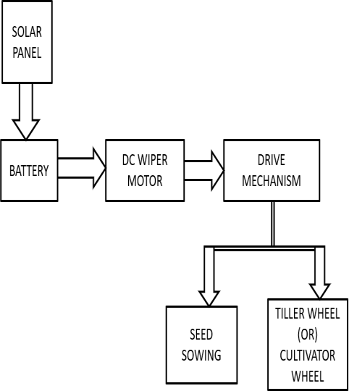

Fig: 1.1 Block diagram of solar rotavator

Rotavator is a tool which is used for un wanted plant removal in wide row spacing crops. Rotavator blades are used to achieve advantages of better weed control and more efficient inversion and trash mixing.

Blades are the main critical parts of rotary Rotavator, engaged with the soil for weeding operation. These blades interact with soil in different ways than normal ploughs which are subjected to impact and high friction that ultimately creates the unbalancing force on the Rotavator resulting in wearing of the blades. The design optimization and manufacturing errors can be minimized by the proper design analysis of the components. Especially, the blades have to be reliable in the field performance against the operating forces. Prediction of stress distributions among the blades is important for the designers and manufacturers to optimize the power requirement.

# V - COMPONANT

1. **Wiper Motor**

Power – 50W

Drive motor voltage - 12V Expected current drawn - 1.1A

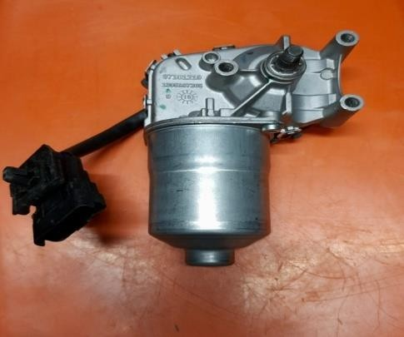

# Battery

Voltage – 12 V Current – 7.5 AH

# Solar plate

Maximum power – 10W

Voltage at maximum power – 17.40V Current at maximum power – 0.58A Tolerance - +_5%

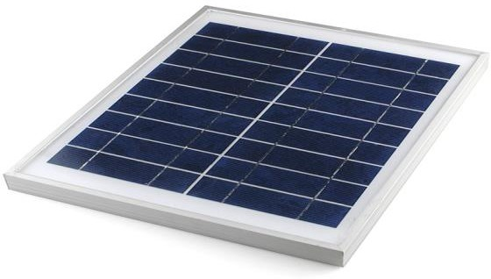

# Blades and specification

Shape of blade – J shape No. of flange – 2

No. of blade on one flange – 4 Thickness of blade – 4 mm Cutting edge thickness – 2 mm Length of blade – 110 mm Outer diameter of hub – 26 mm Inner diameter of hub – 20 mm

Hole on hub – One hole of 9 mm Split pin diameter – 9 mm

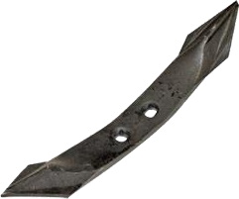

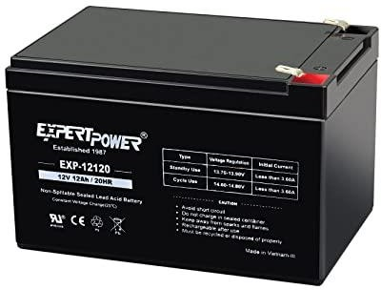 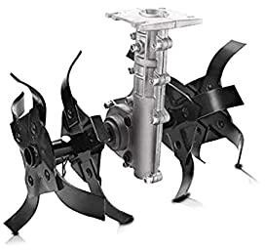

# Adjustable Handle

**VI – RESULT & CALCULATIONS**

Diameter of handle pipe – 35 mm Diameter of small pipe – 33 mm

# Result:

The solar rotavator can weeds in various

Hole on pipe – 10 mm

Distance between three holes – 50 mm

It is adjust the height according to require

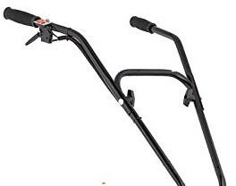

# Controller

Input voltage – 230V Input current – 6A Output voltage – 12V Output current – 2-2.2A

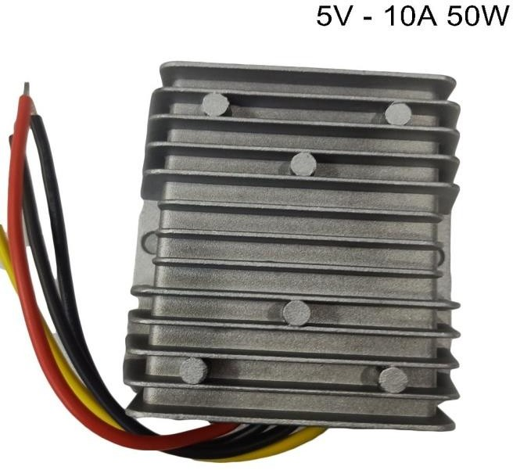

land. The rotavator deep 2inch in land. The rotavator takes 5minutes to cover 50foot distance of land.

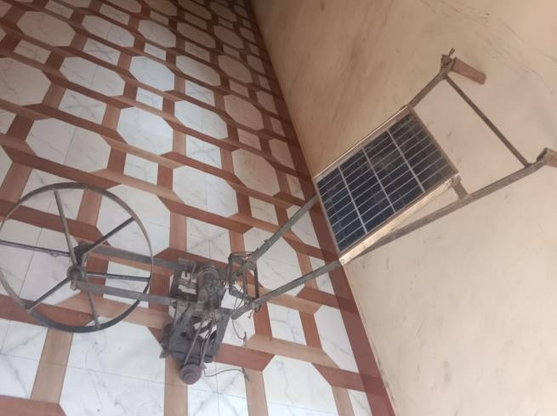

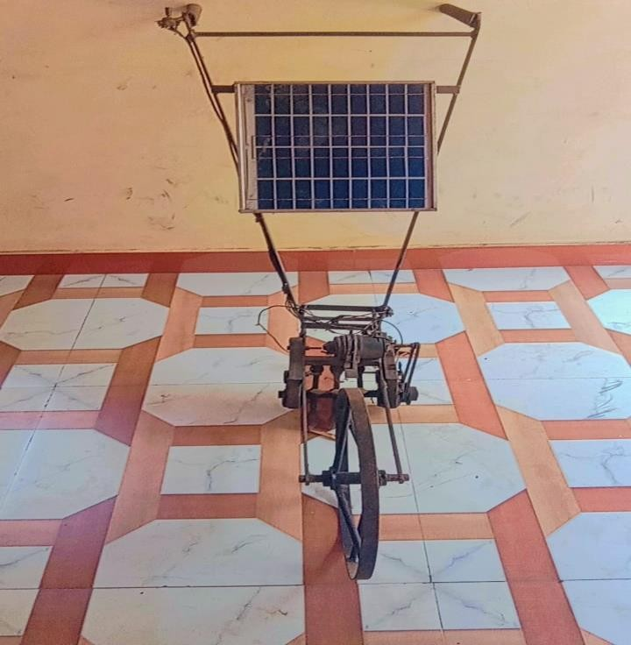

Our project is successfully implemented for emphasizes on minimization of harmful efforts of using the manual rotavator. The new developed battery powered rotavator is operated.

# Calculations:

Motor power = 250 W= 0.25 KW Motor Speed = 300 rpm

250 W = 0.335256 Hp

1. Machine Torque =9.5488 X Power Speed

= 9.5488X 0.25/300

= 7.96 N/m

1. Power (KW) = Torque X Speed /9.5488

= 7.96 X 300/ 9.5488

= 0.25 KW

1. Efficiency (η) = 0.745 X Hp X load/Pi

= 0.745 X 0.335256 X 90 /0.25

= 89.91%

# VII - CONCLUSION

The electric solar rotavator is most suited for usage in hilly locations, moist conditions, and on small farms because it can do both primary and secondary tillage operations. The electric solar rotavator, with the correct set of tools and attachments, can handle most of the field operations in intensive cultivation. The electric solar rotavator's small weight makes it ideal for working in both wet and dry situations. Depending on the type of work, external attachments can be added to the tiller. As a result, the tiller can be utilized for a variety of tasks.

# VIII – FUTURE SCOPE

This project can be reduces risk of accidents with modification of rotavator and this rotavator reduces human efforts .and this rotavator is based on solar that the time is reduces that compare to amount rotavator. But the results and modifications are not up to the expectations. This can be further improved by incorporating the following modifications to obtain better results**.**

# IX - REFERENCES

1. R.S. Khurmi and Gupta, “Machine Design” 14th edition, S. Chand
2. V.B. Bhandari, “Machine Design” 3rd edition,

Tata McGraw Hill

1. Simulation, Design and Analysis of Solar
2. Kaveh Mollazade, PhD. in Mechanical Engineering of Agricultural Machinery Assistant professor of Department of Biosystems Engineering,
3. Parminder Kamboj, elaborates CAD software facilitates future expansion of geometry model by providing flexible options to modify the existing design.
4. CAD design software tools Mohan Kumar K. Sawney, Dhanpat Rai and sons.
5. V. K. Mehta, “Principles of Electrical Battery and Electronics Engineering” S. Chand and company Ltd.