AI based Battery Management with Hybrid Power System
Shrusti Yeshwant Ukey¹, A.R.Sakhare²
¹Mtech Government college of Engineering Chandrapur, Maharastra, India
²Professor, Government college of Engineering Chandrapur, Maharastra, India

Abstract:
The fastest-growing portion of the world's energy demand is being met by renewable energy sources. While traditional energy sources have many advantages over renewable energy sources, the main drawback is the intermittent nature of the latter's supply. By creating a hybrid system with energy sources and battery storage devices that can also be connected to the grid, this problem is partially addressed. This paper focused on design of hybrid PV / Wind power system and its battery management system. The fuzzy logic control based battery management system has been designed for effective power utilization. The non-linear, time-varying, and lengthy battery charging process makes it challenging to use conventional control methods to obtain the greatest energy management performance. The proposed control to operate the battery charging and discharging mode during non-linear power generation. The battery will charge whenever the renewable energy power is greater than to consumer load power as well as the battery will discharge whenever the renewable energy power is lesser than to consumer load power. The intelligence is provided by the fuzzy logic controller. The entire designed system is modeled and simulated using MATLAB/Simulink environment.

Key Words: PV Power, Wind Power, Fuzzy controller, Battery Management.

---------------------------------------------------------------------***--------------------------------------------------------------------

- INTRODUCTION

Two or more energy sources are used in a hybrid system [1]. These sources can be freestanding or integrated with current supply systems via the grid, and they can be either renewable energy sources or conventional energy sources [2]. A power source with a battery storage system can also be part of the hybrid system [3]. When there is an excess of energy or power, these batteries can store it and then supply it when there is an excess of demand. PV, wind, and batteries can all be used in a hybrid system [4], [5]. Due to the intermittent nature of PV or wind systems' power supply, using a hybrid system helps smooth out these variations by drawing power from an auxiliary source when the primary source of power is insufficient for generation [6].
A system of computer-assisted tools used by a grid operator to control, monitor, and improve performance is known as an energy management system [7], [8]. Researchers are interested in the field of energy management or power management for a number of reasons, including cost reduction [10] through direct control and monitoring of energy resources or controllable loads [11], [12] and loss minimization in transmission and distribution systems [9] by the transmission or utility companies to lower operational costs that indirectly help the consumer pay fewer electricity bills. They are also employed to improve the system's frequency, voltage, and stability [13, 14]. Due to the battery's storage capacity limitations, not all surplus energy can be stored, therefore extra energy can be sent to the grid. This will lessen the supply-related stress on the remaining units [15, 16]. Additionally, the system has the ability to draw power from the grid in the event of a generation system shortage [17]. Additionally, it is well-known that PV performance diminishes over time following site deployments and needs to be checked [18]. The fuzzy logic control (FLC) system works best when complicated issues are handled by an effective human operator who is unaware of the dynamics at play. Utilizing a human operator's expert knowledge and experiences to design a controller for controlling an object is the fundamental idea behind fuzzy logic controllers.
- BLOCK DIAGRAM
Renewable resources wind or solar generate dc. Controller is designed to provide control signal to the system. Control signal goes in the form of gate pulses. The gate pulses are input of the IGBT. inverter followed by LC filter which smoothers the signal and after that power is deliver to the load side and connected with grid system.
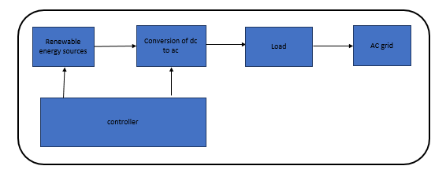
Fig -1: Block Diagram of Proposed System

- Solar Source
The solar source is used to generating power from the sun rays. A photovoltaic system makes use of some or more solar panels to convert the solar energy into electricity. It consists of various components which include the photovoltaic modules, mechanical and electrical connections and mountings and means of regulating and/or modifying the electrical output. The basic operation of PV cell is photoelectric effect. In this effect electrons ejected from the conduction band result of the absorption of sunlight. In a photovoltaic cell, when hits its surface, some portion of the solar energy is absorbed in the semiconductor material. The electrons moves from valance band into the conduction band when absorbed energy is greater than the band gap energy of the semiconductor. By these hole electron pairs are created in the illuminated region of the semiconductor.
The electrons are creates in the conduction band are now free to move. These free electrons are enforced to move in a particular direction by the action of electric field present in the PV cells. The electrons flowing comprise current and can be drawn for external use by connecting a metal plate on the top and bottom of PV cell. This current and voltage produces required power. The photovoltaic system can generate direct current electricity without environmental impact when is

- PITCH ANGLE CONTROL

The pitch control method is a basic approach for controlling the rotational speed of wind turbine. The conventional blade pitch angle control strategies are developed in this part. The pitch angle reference b ref, is controlled by the input values, which may be as follows:
The direct measure of the wind speed makes this control strategy simple; however, this is not a pertinent procedure, because it is difficult to measure the wind speed precisely. In fact, when the rotor speed exceeds the maximum rotor speed of turbine Ω tn, the pitch angle is increased to reduce the turbine torque Ct.
The controlling rotor speed is compared with its reference. The error signal is then sent to the PI controller and produces the reference value of the pitch angle.
The error signal of the generator power is sent to a PI controller. The PI controller produces the reference pitch angle.

- Simulink Model

The design and implementation of smart fuzzy based battery management with solar and PV cell is simulated and shown in figure 2. The main block of proposed system consists of PV, wind and battery management system. To make the optimum battery charging Fuzzy based controller is used. Fig 4 shows the graph of battery. Fig 5 show the simulation of wind, solar and battery. The controller is designed to make the battery management process more optimize and suitable to make the battery health process.

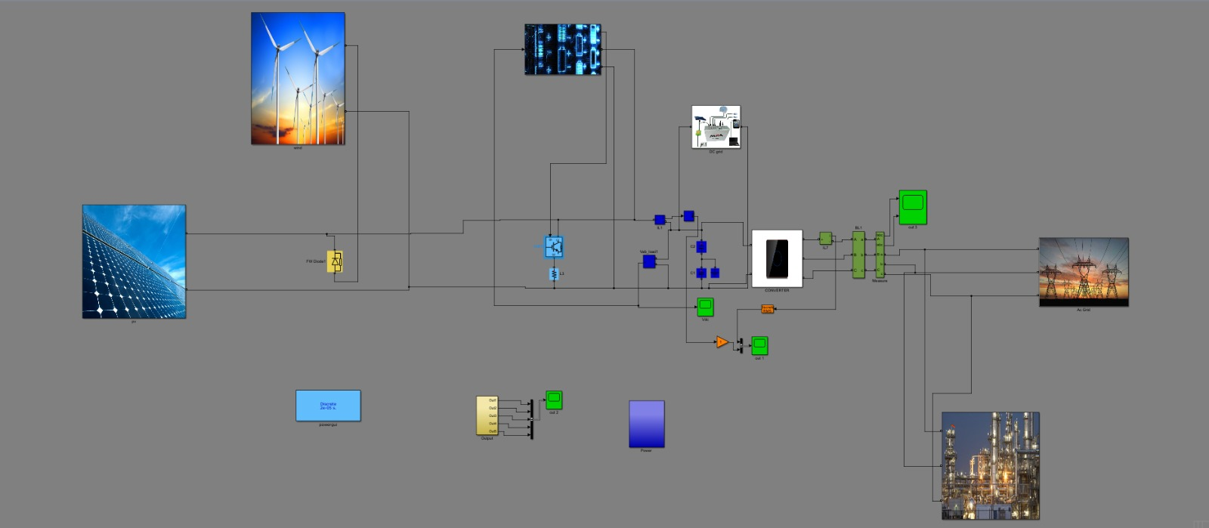
Fig -2: Proposed Fuzzy based System
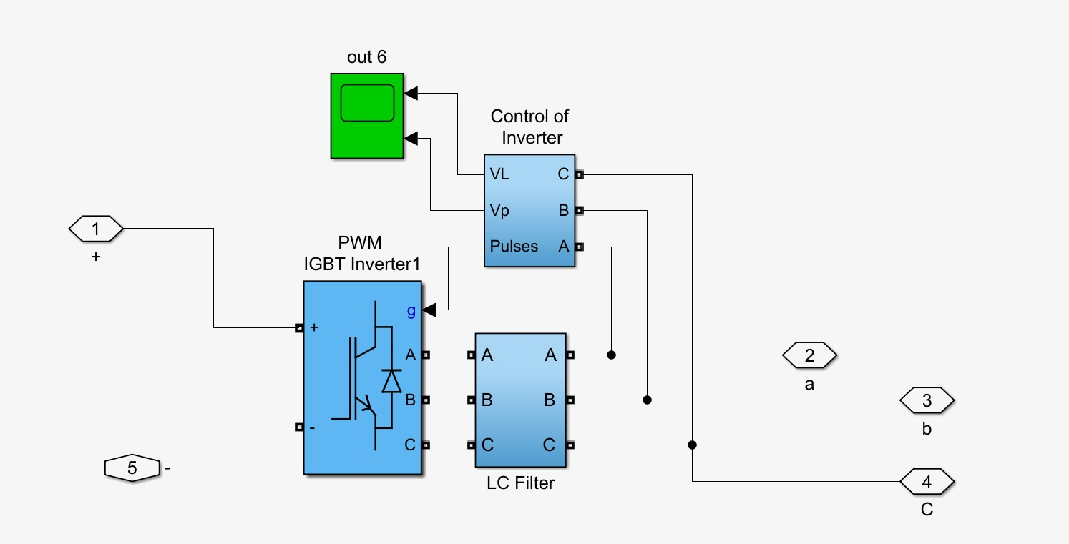
Fig -3: Simulink model of converter

4. Result

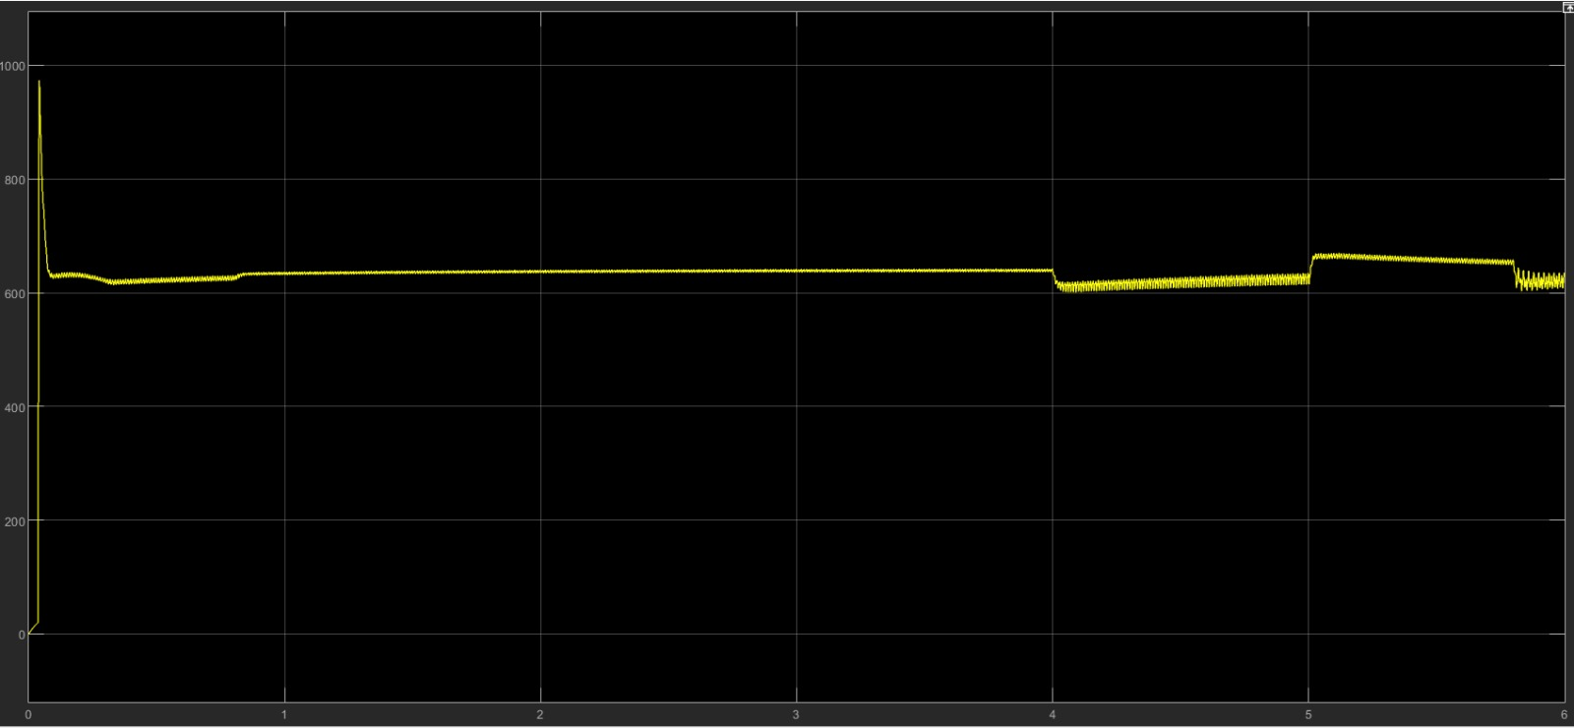
Fig -4: Battery Voltage Waveform
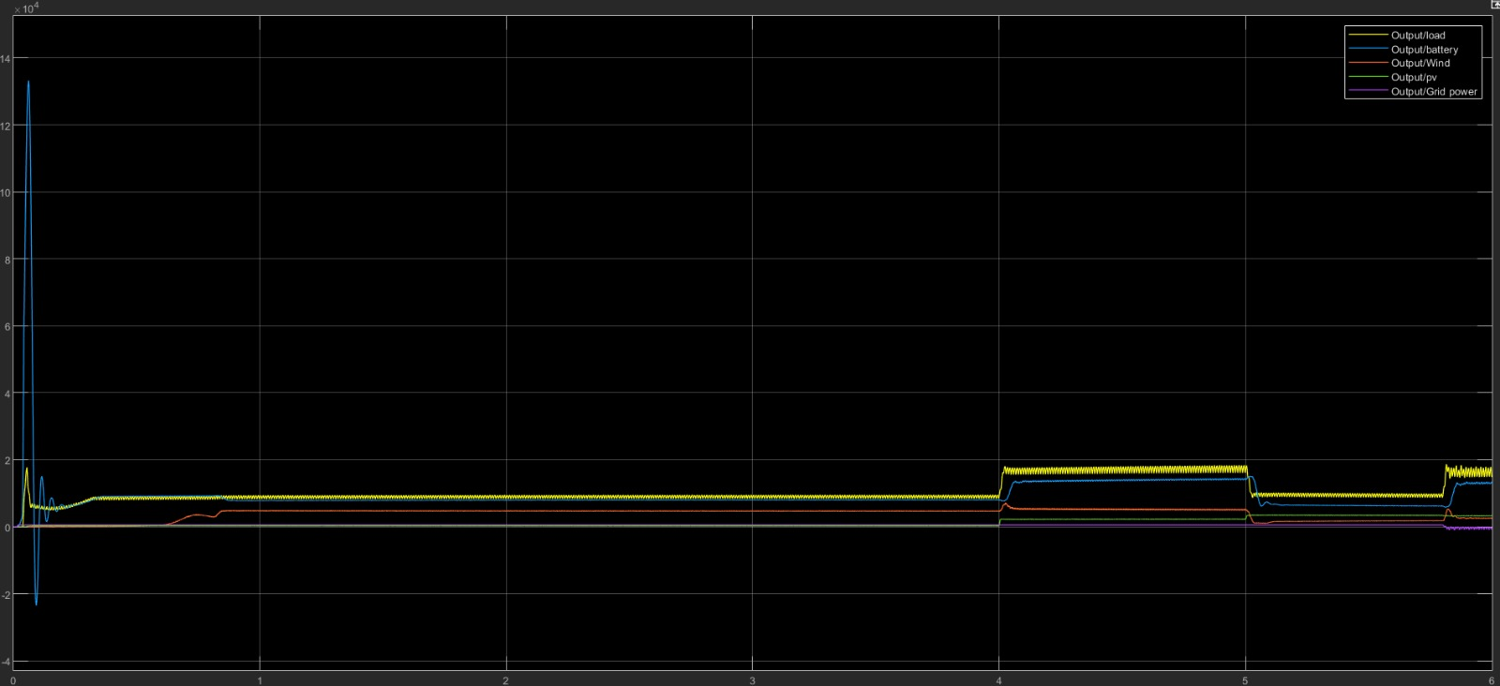
Fig -5: Simulation of Proposed model
From the fig 5 we can see charged battery is providing power to load and battery charged by the renewable resources that is solar and wind power. Extra power is transferred to the grid sometimes it takes power from other sources. At starting the solar wind power is very less this is because of solar data i.e irradiance data has small values at starting time and wind speed too has small values, we can see solar and wind output at middle of simulation is high this is because it has better values of irradiance data and wind speed.
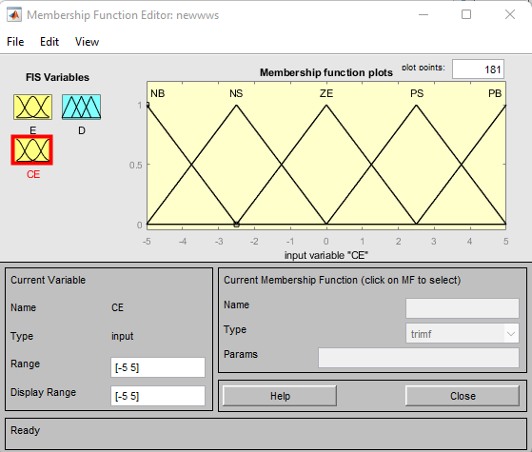
Fig - 6: Fuzzy logic membership function.

Fig. 6 shows the fuzzy logic membership function.

Here NB is Negative big ,Ns is negative small, ZE is Zero, PB is positive big ,PS as Positive small.
The creation of a fuzzy controller can be done in a number of ways. The creation of a membership function and rule base is necessary for the design of a fuzzy controller. Here, we've used the rule basis Mamdani suggested for simulating the fuzzy controller. Table 1 displays these guidelines.

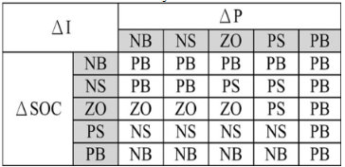

- CONCLUSIONS

The modelling, analysis, and design of fuzzy control are discussed in this study with the goal of optimizing the battery management system for a wind-solar hybrid system.
The fuzzy logic controller used to function well by turning on and off the batteries in response to changes in wind speed, solar isolation, and load demand. By creating a thorough dynamic hybrid system model, simulation results were produced. The system achieves power balance, and the battery SOC maintains the desired value to prolong battery life, according to the simulation results. The battery charging and discharging control process is non-linear, time-varying, and involves time delays. This problem involves several variables and unforeseen external disruptions.

REFERENCES

- T.S. Ustun, The importance of microgrids & renewable energy in meeting energy needs of the Brazilian Amazon, in: 2016 IEEE international conference on power and energy, 2016, pp. 1–6.
- Jinlei S., Lei P., Ruihang L., Qian M., Chuanyu T., Tianru W.
Economic operation optimization for 2nd use batteries in battery energy storage systems IEEE Access (2019)
- A.H. Hubble, T.S. Ustun, Scaling renewable energy based microgrids in underserved communities: Latin America, South Asia, and Sub-Saharan Africa, in: 2016 IEEE PES PowerAfrica, 2016, pp. 134–138.
- Javed K., et al. Design and performance analysis of a stand-alone PV system with hybrid energy storage for rural India Electronics, 8 (2019), p. 952
- Singh S., et al. Cost optimization of a stand-alone hybrid energy system with fuel cell and PV Energies, 13 (5) (2020), p. 1295 Mar View article
- Nadeem F., et al. Virtual power plant management in smart grids with XMPP based IEC 61850 communication Energies, 12 (12) (2019), p. 2398 Jun.
- D. Niyigena, C. Habineza, T.S. Ustun, Computer-based smart energy management system for rural health centers, in: 2015 3rd international renewable and sustainable energy conference, 2015, pp. 1–5.
- Kikusato H., et al. Microgrid controller testing using power hardware-in-the-loop Energies, 13 (8) (2020), p. 2044 Apr
- Ustun T.S., Hussain S.M.S. IEC 61850 modeling of UPFC and XMPP communication for power management in microgrids IEEE Access, 8 (2020), pp. 141696-141704
- V. Kagimu, T.S. Ustun, Novel business models and policy directions based on SE4ALL global framework for minigrids, in: 2016 IEEE international conference on emerging technologies and innovative business practices for the transformation of societies, 2016, pp. 251–256.
- Latif A., et al. Double stage controller optimization for load frequency stabilization in hybrid wind-ocean wave energy based maritime microgrid system Appl Energy, 282 (Part A) (2021), Article 11617115
- Monemi Bidgoli M., Karimi H., Jadid S., Anvari-Moghaddam A. Stochastic electrical and thermal energy management of energy hubs integrated with demand response programs and renewable energy: A prioritized multi-objective framework Electr Power Syst Res (2021)
- Dey P.P., Das D.C., Latif A., Hussain S.M.S., Ustun T.S.
Active power management of virtual power plant under penetration of central receiver solar thermal-wind using butterfly optimization technique Sustainability, 12 (17) (2020), p. 6979 Aug
- Latif A., Hussain S.M.S., Das D.C., Ustun T.S.
Optimum synthesis of a BOA optimized novel dual-stage PI - (1 + ID) controller for frequency response of a microgrid
Energies, 13 (13) (2020), p. 3446 Jul View article
- Liu T., Tan X., Sun B., Wu Y., Tsang D.H.K. Energy management of cooperative microgrids: A distributed optimization approach Int J Electr Power Energy Syst (2018)

- Chauhan A., Upadhyay S., Khan Mohd. T., Hussain S.M.S., Ustun T.S. Performance investigation of a solar photovoltaic/diesel generator based hybrid system with cycle charging strategy using BBO algorithm Sustainability, 13 (14) (2021), p. 8048

- Abdolrasol M.G.M., et al. Energy management scheduling for microgrids in the virtual power plant system using artificial neural networks Energies, 14 (20) (2021), p. 6507.

