# HYBRID AC/DC MICROGRID SYSTEM

# Ashwini Girade1, Prof. Sharana T.M. Zaheer2

*1,2Dept. of Electrical Engineering,* *Gondwana University, Gadchiroli,  
Government College of Engineering, Chandrapur (GCOEC)*

**Abstract:** Micro grids are emerging as one of the promising solutions to integrate various types of distributed renewable energy sources with the utility grid. Though the existing grids are AC grids, today’s electrical loads comprising of power electronic based equipment and distributed renewable energy generation make DC micro grids more attractive. However, an individual AC micro grid and DC micro grid requires multiple conversions of power at the user end for DC loads and AC loads respectively, resulting in less efficient system. Thus, hybrid AC/DC micro grid seems to be the best solution to avoid substantial energy losses in multiple conversions. However, there are several technical challenges in the implementation of hybrid AC/DC micro grid, which need to be addressed. This paper presents a review of hybrid AC/DC micro grid and discusses the important key issues and challenges to be overcome for its practical implementation.

**Keywords:** Hybrid, AC, DC, Micro grid system.

1. **INTRODUCTION**

As the problem of resource depletion due to the reckless use of fossil fuels and environmental problems caused by the generation of greenhouse gases has emerged, interest in new energy sources has also greatly increased [[**1**](https://www.mdpi.com/2079-9292/10/16/1939#B1-electronics-10-01939),[**2**](https://www.mdpi.com/2079-9292/10/16/1939#B2-electronics-10-01939),[**3**](https://www.mdpi.com/2079-9292/10/16/1939#B3-electronics-10-01939),[**4**](https://www.mdpi.com/2079-9292/10/16/1939#B4-electronics-10-01939),[**5**](https://www.mdpi.com/2079-9292/10/16/1939#B5-electronics-10-01939)]. Therefore, policies to reduce the use of fuels such as oil, natural gas, and coal, which are considered the main sources of greenhouse gas worldwide, are also being prepared. For example, the Paris Agreement, which replaced the existing Kyoto Protocol when it expired in 2020, set the target for the supply of renewable energy sources to make up 11% of our energy by 2030. To this end, since 2012, the Renewable Energy Portfolio—a mandatory system for supplying renewable energy sources (RESs) such as wind, tidal, and solar power—has been implemented. Along with this movement, academia defined a microgrid as a small-scale distribution network based on renewable energy that provides network operation control capabilities [[**6**](https://www.mdpi.com/2079-9292/10/16/1939#B6-electronics-10-01939),[**7**](https://www.mdpi.com/2079-9292/10/16/1939#B7-electronics-10-01939)]. A microgrid is a distributed power generation method, and unlike the conventional centralized power generation method, it is efficient because it can reduce power loss due to long-distance transmission. In addition, since the stand-alone operation of distributed power is possible without the microgrid being connected to existing systems, a high energy independence can be obtained [[**8**](https://www.mdpi.com/2079-9292/10/16/1939#B8-electronics-10-01939)]. Such a microgrid can be categorized as DC, AC, and hybrid AC/DC microgrids depending on how the distribution network and loads are connected [[**9**](https://www.mdpi.com/2079-9292/10/16/1939#B9-electronics-10-01939),[**10**](https://www.mdpi.com/2079-9292/10/16/1939#B10-electronics-10-01939)]. [**Figure 1**](https://www.mdpi.com/2079-9292/10/16/1939#fig_body_display_electronics-10-01939-f001)a shows a DC microgrid. A DC microgrid has the advantage of not having to consider problems such as phase, frequency, power factor, and reactive power, and it is expected to reduce system installation cost and increase power transmission efficiency by reducing the power conversion step [[**11**](https://www.mdpi.com/2079-9292/10/16/1939#B11-electronics-10-01939)]. [**Figure 1**](https://www.mdpi.com/2079-9292/10/16/1939#fig_body_display_electronics-10-01939-f001)b shows an AC microgrid. AC microgrids have the advantage of low initial costs, in that we can utilize existing AC systems in current distribution networks. However, due to frequency, AC systems require additional considerations compared to DC systems. In addition, in most distributed power sources such as photovoltaic power generation and fuel cells, power generation has a form of a DC voltage, so an additional power conversion device is required for connection with existing AC systems [[**12**](https://www.mdpi.com/2079-9292/10/16/1939#B12-electronics-10-01939)].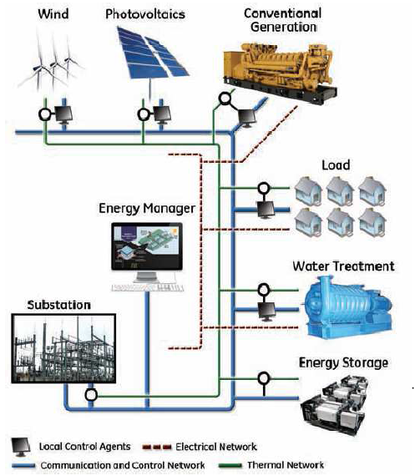

Fig 1.1. Microgrid power system

## LITRATURE SURVEY

Xiong Liu et al. (2011) This paper proposes a hybrid ac/dc micro grid to reduce the processes of multiple dc–ac–dc or ac–dc–ac conversions in an individual ac or dc grid. The hybrid grid consists of both ac and dc networks connected together by multi-bidirectional converters. AC sources and loads are connected to the ac network whereas dc sources and loads are tied to the dc network. Energy storage systems can be connected to dc or ac links. The proposed hybrid grid can operate in a grid-tied or autonomous mode. The coordination control algorithms are proposed for smooth power transfer between ac and dc links and for stable system operation under various generation and load conditions. Uncertainty and intermittent characteristics of wind speed, solar irradiation level, ambient temperature, and load are also considered in system control and operation. A small hybrid grid has been modelled and simulated using the Simulink in the MATLAB. The simulation results show that the system can maintain stable operation under the proposed coordination control schemes when the grid is switched from one operating condition to another.

Guangqian DING et al. (2014) This paper presents control methods for hybrid AC/DC microgrid under islanding operation condition. The control schemes for AC sub- microgrid and DC sub-microgrid are investigated according to the power sharing requirement and operational reliability. In addition, the key control schemes of interlinking converter with DC-link capacitor or energy storage, which will devote to the proper power sharing between AC and DC sub-microgrids to maintain AC and DC side voltage stable, is reviewed. Combining the speciﬁc control methods developed for AC and DC sub-microgrids with interlinking converter, the whole hybrid AC/DC microgrid can manage the power ﬂow transferred between sub-microgrids for improving on the operational quality and efﬁciency.

Dwi Riana Aryani et al. (2015) Interest in DC microgrids is rapidly increasing along with the improvement of DC power technology because of its advantages. To support the integration process of DC microgrids with the existing AC utility grids, the form of hybrid AC/DC microgrids is considered for higher power conversion efﬁciency, lower component cost and better power quality. In the system, AC and DC portions are connected through interlink bidirectional AC/DC converters (IC) with a proper control system and power management. In the stand-alone operation mode of AC/DC hybrid microgrids, the control of power injection through the IC is crucial in order to maintain the system security. This paper mainly deals with a coordination control strategy of IC and a battery energy storage system (BESS) converter under stand-alone operation. A coordinated control strategy for the IC, which considers the state of charge (SOC) level of BESS and the load shedding scheme as the last resort, is proposed to obtain better power sharing between AC and DC subgrids. The scheme will be tested with a hybrid AC/DC microgrid, using the tool of the PSCAD/EMTDC software.

S.Prakesh et al. (2016) The increasing deployment of distributed generation systems in power systems hybrid AC/DC micro grid. Many micro grids are used for interlinking ac/dc converter with proper power management and control strategy. During the islanding operation of the hybrid AC/DC micro grid, the IC is intended to take the role of supplier to one micro grid and at the same time acts as a load to other micro grid and the power management system should be able to share the power demand between the existing ac and dc sources in both micro grids. This paper considers the power flow control management issues among the multiple sources dispersed throughout both ac and dc micro grids. The new method is proposed which is the decentralized power sharing method in order to eliminate the need for any communication between distribution generation or micro grids. This hybrid micro grid allows different ac or dc loads and sources should be flexibly located in order to decrease the required power conversions stages and hence the system cost and efficiency. The decentralized control operation and droop control method is used for better control strategy. The performance of the proposed power control strategy is validated for small signal stability analysis and different operating conditions, using simulation studies in MATLAB software. Enrique Rodriguez-Diaz et al. (2017) This paper proposes real-time Energy Management System (EMS) for a residential hybrid ac/dc microgrid. The residential microgrid is organized in two different distribution systems. A dc distribution bus which interconnect the renewable energy sources (RES), energy storage systems (ESS) and the building’s common facilities; while the apartments are supplied by an ac distribution system connected to the grid. This architecture avoids any modiﬁcations in the electrical installation that supplies energy to the apartments. A pure dc voltage supply is not yet a feasible approach for residential buildings. This architecture increases the overall efﬁciency of the distribution by interconnecting the RES and ESS thorough a dc distribution bus, and therefore avoiding unnecessary dc/ac conversion stages. The real-time EMS performs an 24 hours ahead optimization in order to schedule the charge/discharge of the ESS, and the energy injection/consumption from the grid. The EMS estimates the RES generation based on the weather forecasting, together with stochastic consumption modelling of the building. The EMS architecture and the residential microgrid have been implemented and tested in a laboratory scale setup. The results shown how the operational costs of the system are effectively decreased by 28%, even with non-accurate estimation of the RES generation or building parameters. Pouria GOHARSHENASAN KHORASANI et al. (2017)

Considering the advantages of DC microgrids, the extension of the conventional AC distribution grid can be implemented using a DC microgrid. This justiﬁes the realization of a hybrid AC/DC microgrid. In the present study, a new global solution is presented to improve the power quality and to fully compensate the reactive power of an AC microgrid using DC bus capacity while introducing a new design for a hybrid AC/DC microgrid. In the new design, backto-back connections of two series and parallel converters, as well as the presentation of new controllers and simultaneous utilization of an earthing switch, are proposed. The proposed method guarantees the quality of the delivered voltage to consumers and the drawn current from the network according to the IEEE-519 and IEEE- 1159 standards under diﬀerent power quality problems (e.g., interruptions, sags, harmonics, and any variation in voltage/current signals from pure sinusoidal). Through the proposed design of the new hybrid AC/DC microgrid, as a new feature, the operation of the network in islanded mode can be achieved in accordance with power quality standards even in the worst load quality conditions. It should be noted that in common hybrid microgrids in islanded mode, the delivered voltage quality is proportional to the quality of the consumer’s load current. Another possibility of the proposed design is the instantaneous VAR compensation of nonlinear and induction loads of consumers to keep the power factor of the distribution transformer close to unit value. Simulation results indicate that there are acceptable levels of compensation for diﬀerent types of power quality problems. Total harmonic distortions and total demand distortions are below 3% in both the grid-connected and isolated modes of the hybrid AC/DC microgrid.

Eneko Unamuno et al. (2018) Microgrids have been widely studied in the literature as a possible approach for the integration of distributed energy sources with energy storage systems in the electric network. Until now the most used configuration has been the ac microgrid, but dc-based microgrids are gaining interest due to the advantages they provide over their counterpart (no reactive power, no synchronization, increasing number of dc devices, etc.). Therefore, hybrid ac/dc microgrids are raising as an optimal approach as they combine the main advantages of ac and dc microgrids. This paper reviews the most interesting topologies of hybrid ac/dc microgrids based on the interconnection of the ac and dc networks and the conventional power network. After performing a description and analysis of each configuration, a comparative evaluation has been performed to highlight the most important features of each one. The future trends identified during the study also show that several features such as the scalability, modelling or design require further research towards the integration of hybrid microgrids in the power network.

Moaz Al-Ibrahim et al. (2018) As a new developed concept, microgrids evolved to AC/DC hybrid microgrids where each system, AC and DC, has its own generations, storages and loads. The AC and DC systems are linked with interlink convertor (IC) which transfers the power between the AC and the DC system depending on the specific requirement. In this paper, the control strategy of AC/DC Hybrid Microgrid is modelled using state space representation and regulated using the droop control. The output response which is IC current is simulated using MATLAB as open loop system, with Proportional Integral (PI) controller and with Linear Quadratic Regulator (LQR) controller. The simulation is performed for two cases of power transfer from AC to DC network and from DC to AC network. The LQR controller allows the power transfer in fast, robust and stable manner against various operational modes. In addition, the LQR controller can be implemented for the multiple input/multiple output system more efficiently than the PI controller.

Pemila mani et al. (2018) The major advantage of the DC power systems over the AC system is that it can be integrated with new as well as existing load. The variability of the system allows to integrate and implement various DC

systems into various system. The renewable generation and its effective collaboration with DC systems which makes it more efficient than the conventional AC systems. AC-DC hybrid micro grid has advantages of both AC –DC system and enables user to integrate each power source with one another. In this work the performance of hybrid micro grid with PV system integrated into it for lighting system [LED] for a small industrial site is investigated. Theoretical and experimental results are used for the design of micro grid. The major part of this study involves use of Arduino based bi-directional converter for conversion from AC-DC system.

Sheeba Jeba Malar J et al. (2018) Microgrid is a complex structure which is a localized group of electricity generation, storage and load which usually operates connected to a macrogrid. The quality of power delivered to the grid during interconnection is one of the key factors which determine the reliability of the microgrid and is affected due to various reasons which include electronic components that leads to equipment overheating, excessive neutral currents etc., which can cause voltage dip, flicker and unbalance voltage at the end user. The power quality level in microgrid has to be quantized and necessary analysis has to be done to investigate the power quality impact in microgrid network. In this paper the analysis of THD of the hybrid system with PV and DFIG in grid connected and islanded mode is studied using MATLAB/SIMULINK. It is found that the THD is reduced when both PV and wind are connected to the grid and increases when isolated. The major advantage of this analysis emphasizes that this system can be applied for highly nonlinear and variable PV and wind systems connected together with the grid. Simulation results also shows that this system is effective for microgrid with varying inputs.

**Result**

A hybrid micro grid which consists of solar pv cell , wind turbine and battery is simulated using MATLAB/SIMULINK environment. The operation is carried out for the grid connected mode. Along with the hybrid microgrid, the performance of generator, photovoltaic system is analyzed. The solar irradiation, cell temperature, wind speed are also taken into consideration for the study of hybrid microgrid with battery charging. The performance analysis is done using simulated results which are found using MATLAB. The design of complete and individual Simulink model is shown.

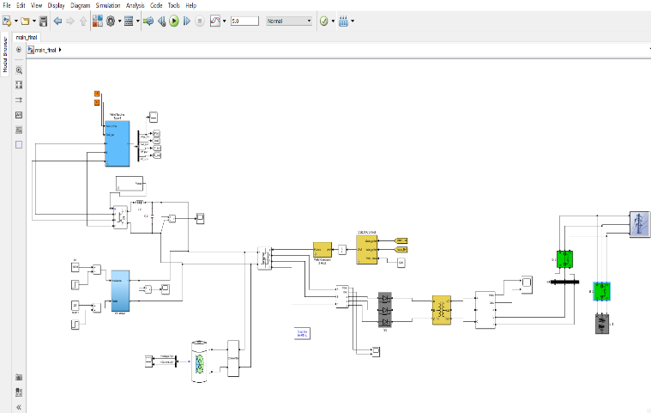

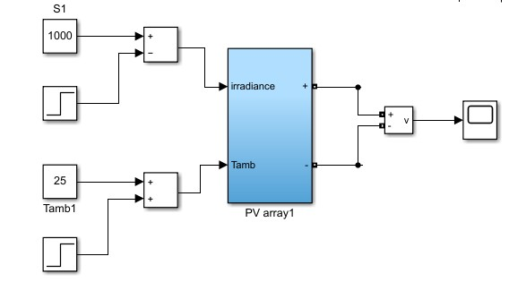 **Fig. Simulink model of Hybrid Micro grid system**

**Fig. Simulink model of PV System**

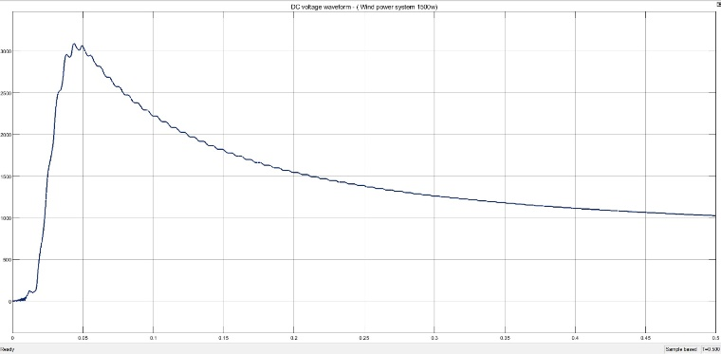

**Fig. Waveform of Wind Energy**

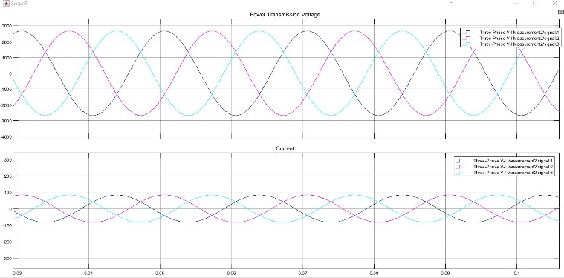

**Fig. Simulation of three phase Hybrid Micro Grid System**

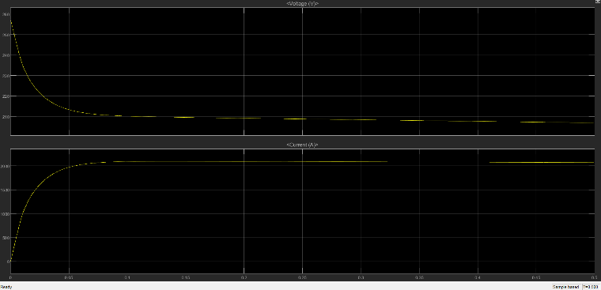

Fig. Simulation of Battery supply Voltage

**Conclusion & Future Scope:**

The modeling of hybrid microgrid for power system configuration is done in MATLAB/SIMULINK environment. The present work mainly includes the grid tied mode of operation of hybrid grid. The models are developed for all the converters to maintain stable system under various loads and resource conditions and also the control mechanism is studied.

In future the system can be implemented using hardware.

The storage battery bank can be added to provide maximum capacity.The control mechanism can be developed for a micro grid containing unbalanced and nonlinear loads.

## References:

1. Atika, Q.; Fayaz, H.; Nasrudin, A.R.; Glenn, H.; Daniyal, A.; Khaled, S.; Khalid, H. Towards Sustainable Energy: A Systematic Review of Renewable Energy Sources, Technologies, and Public Opinions. IEEE Access 2019, 7, 63837–63851. [Google Scholar]
2. Rajvikram, M.E.; Shafiullah, G.M.; Sanjeevikumar, P.; Nallapaneni, M.K.; Annapurna, A.; Ajayragavan, M.V.; Lucian, M.-P.; Jens, B.H.-N. A Comprehensive Review on Renewable Energy Development, Challenges, and Policies of Leading Indian States with an International Perspective. IEEE Access 2020, 8, 74432–74457. [Google Scholar]
3. Ali, S.; Zheng, Z.; Aillerie, M.; Sawicki, J.-P.; Péra, M.-C.; Hissel, D. A Review of DC Microgrid Energy Management Systems Dedicated to Residential Applications. Energies 2021, 14, 4308. [Google Scholar] [CrossRef]
4. European Commission. 2030 Climate & Energy Framework. Available online: https://Ec.Europa.Eu/Clima/Policies/Strategies/2030_en (accessed on 30 September 2020).
5. REN21. Renewables 2021 Global Status Report; REN21 Secretariat: Paris, France, 2021; ISBN 978-3-948393-03-8. [Google Scholar]
6. Ramon, Z.; Anurag, K.S. Controls for microgrids with storage: Review, challenges, and research needs. Renew. Sustain. Energy Rev. 2010, 14, 2009–2018. [Google Scholar]
7. Asano, H.; Hatziargyriou, N.; Iravani, R.; Marnay, C. Microgrids: An overview of ongoing research, development, and demonstration projects. IEEE Power Energy Mag. 2007, 5, 78–94. [Google Scholar]
8. Daniel, E.O.; Ali, M.-S.; Amir, H.E.; Claudio, A.C.; Reza, I.; Mehrdad, Z.; Amir, H.H.; Oriol, G.-B.; Maryam, S.; Rodrigo, P.B.; et al. Trends in Microgrid Control. IEEE Trans. Smart Grid 2014, 5, 1905–1919. [Google Scholar]
9. Farzam, N.; Yun, W.L. Overview of Power Management Strategies of Hybrid AC/DC Microgird. IEEE Trans. Power Electron. 2015, 30, 7072–7089. [Google Scholar]
10. Planas, E.; Andreu, J.; Gárate, J.I.; Martínez de Alegría, I.; Ibarra, E. AC and DC Technology in Microgrids: A Review. Renew. Sustain. Energy Rev. 2015, 43, 726–749. [Google Scholar] [CrossRef]
11. Lie, X.; Dong, C. Control and Operation of a DC Microgrid with Variable Generation and Energy Storage. IEEE Trans. Power Deliv. 2011, 26, 2513–2522. [Google Scholar]
12. Rajesh, K.S.; Dash, S.S.; Ragam, R.; Sridhar, R. A review on control of ac microgrid. Renew. Sustain. Energy Rev. 2017, 71, 814–819. [Google Scholar] [CrossRef]
13. Poh, C.L.; Ding, L.; Yi, K.C.; Frede, B. Autonomous Operation of Hybrid Microgrid with AC and DC Subgrids. IEEE Trans. Power Electron. 2013, 28, 2214–2223. [Google Scholar]
14. Liang, C.; Mohammad, S.; Ahmed, A.; Yusuf, A.-T. Hierarchical Coordination of a Community Microgrid with AC and DC Microgrids. IEEE Trans. Smart Grid 2015, 6, 3042–3051. [Google Scholar]
15. Ajay, G.; Suryanarayana, D.; Kishore, C. Hybrid AC-DC Microgrid: Systematic Evaluation of Control Strategies. IEEE Trans. Smart Grid 2018, 9, 3830–3843. [Google Scholar]
16. Javad, K.; Gerry, M. Simplified Hybrid AC-DC M
17. JiweiSun,et.al. “Voltage Regulation of DC-Microgrid with PV and Battery: A Passivity Method “, IFAC-PapersOnLine Volume 52, Issue 16, 2019, Pages 753-758
18. Shao, L.; Karci, A.E.H.; Tavernini, D.; Sorniotti, A.; Cheng, M. Design approaches and control strategies for energy-efficient electric machines for electric vehicles—A review. IEEE Access 2020, 8, 116900–116913.
19. Nair, R.; Gopalaratnam, N. Emulation of wind turbine system using vector controlled induction motor drive.IEEE Trans. Ind. Appl. 2020, 56, 4124–4133.
20. Khatri, P.; Wang, X. Comprehensive review of a linear electrical generator for ocean wave energy conversion.IET Renew. Power Gener. 2020, 14, 949–958.
21. Salem, A.; Narimani, M. A review on multiphase drives for automotive traction applications. IEEE Trans. Transport. Electrif. 2019, 5, 1329–1348. 5. Li, L.; Liu, Q. Research on IPMSM drive system control technology for electric vehicle energy consumption. IEEE Access 2019, 7, 186201–186210.
22. Li, L.; Liu, Q. Research on IPMSM drive system control technology for electric vehicle energy consumption. IEEE Access 2019, 7, 186201–186210.
23. Rafaq, M.S.; Jung, J.-W. A comprehensive review of state-of-the-art parameter estimation techniques forpermanent magnet synchronous motors in wide speed range. IEEE Trans. Ind. Inform. 2020, 16, 4747–4758.
24. Pemila mani, Shubham Mishra, Akhil Raj, Azhar padiyath, Utshav Raj, “Hybrid AC/DC Microgrid for Solar PV and Battery Storage Integration”, International Journal of Latest Engineering and Management Research (IJLEMR) ISSN: 2455-4847 [www.ijlemr.com](http://www.ijlemr.com/) || Volume 03 - Issue 04 || April 2018 || PP. 99-103.
25. Xiong Liu, Student Member, IEEE, Peng Wang, Member, IEEE, and Poh Chiang Loh, Member, IEEE, “A Hybrid AC/DC Microgrid and Its Coordination Control”, IEEE TRANSACTIONS ON SMART GRID, VOL. 2, NO. 2, JUNE 2011.
26. E S N Raju P, Trapti Jain, “Hybrid AC/DC Micro Grid: An Overview”, Fifth International Conference on Power and Energy Systems, Kathmandu, Nepal | 28 - 30 October, 2013.
27. S.Prakesh, S.Sherine, “POWER CONTROL AND MANAGEMENT STRATEGY IN HYBRID AC/DC MICROGRID”, International Journal of Pure and Applied Mathematics Volume 116 No. 18 2017, 347-353.
28. Sheeba Jeba Malar J, Jayaraju M., “Power Quality Analysis of Hybrid AC/DC Microgrid in Distribution Network”, International Journal of Engineering and Advanced Technology (IJEAT) ISSN: 2249 – 8958, Volume-7 Issue-4, April 2018.
29. Guangqian DING, Feng GAO (&), Song ZHANG, Poh Chiang LOH, Frede BLAABJERG, “Control of hybrid AC/DC microgrid under islanding operational conditions”, J. Mod. Power Syst. Clean Energy (2014) 2(3):223–232 DOI 10.1007/s40565-014- 0065-z.
30. Pouria GOHARSHENASAN KHORASANI, Mahmood JOORABIAN∗, Seyed Ghodratolah SEIFOSSADAT, “A new proposal for the design of hybrid AC/DC microgrids toward high power quality”, Turkish Journal of Electrical Engineering & Computer Sciences, Turk J Elec Eng & Comp Sci (2017) 25: 4033 – 4049 c ⃝ T¨UB˙ITAK doi:10.3906/elk-1609- 74.
31. Eneko Unamuno and Jon Andoni Barrena, “Hybrid ac/dc microgrids—Part I: Review and classification of topologies”, Proc. IEEE, vol. 99, no. 1, pp. 133–148, Jan. 2011. [
32. Moaz Al-Ibrahim, Dr. Abdulla Ismail, “Control and Optimization of Smart AC/DC Hybrid Microgrids”, nternational Research Journal of Engineering and Technology (IRJET) e-ISSN: 2395-0056, Volume: 05 Issue: 04 | Apr-2018.
33. Enrique Rodriguez-Diaz, Emilio J. Palacios-Garcia∗, Amjad Anvari-Moghaddam, Juan C. Vasquez and Josep M. Guerrero, “Real-Time Energy Management System for a Hybrid AC/DC Residential Microgrid”,DOI 10.1109/ICDCM.2017.8001053