**E GREEN GAS**

**Aanchal Srivastava*1, Dr. Santosh Kr. Dwivedi*2,**

**Mr. Raghvendra Singh *3**

*1UG Student of Department of Information Technology, Shri Ramswaroop Memorial College of Engineering

and Management Lucknow, Uttar Pradesh, India.

*2Professor, Department of Information Technology, Shri Ramswaroop Memorial College of Engineering

and Management Lucknow, Uttar Pradesh, India.

*3Assistant professor, Department of Information Technology, Shri Ramswaroop Memorial College of Engineering and Management Lucknow, Uttar Pradesh, India.

# 

# ABSTRACT

In the wake of leading a top to bottom review and investigation of the previously mentioned issue, we have arrived at the resolution that the improvement of a web-based gateway for e green gas booking and the board would carry fulfilment to both the proprietors of e green gas organizations/sellers and their clients. The selective arrangement lies in the execution of a web-based online interface, which successfully addresses the worries of managers and clients the same. With the guide of this online interface, the proprietors of e green gas organizations can easily manage client subtleties and data, while clients can get to significant data regarding the protected use of chambers and effectively acquire associations. The entry gives complete insights regarding the chambers, including estimating, areas, pictures, and sizes. This smoothed out approach guarantees consumer loyalty, as they can rapidly get associations and have their booking subtleties safely put away in the entrance's data set, alongside going with pictures.

.

# INTRODUCTION

E-green gas, or sustainable petroleum gas (RNG), is a type of biogas got from natural waste. It fills in as a perfect and feasible fuel choice, fit for giving intensity to private and business structures, creating power, and driving vehicles. RNG is especially significant in its commitment to diminishing ozone depleting substance emanations and further developing air quality.

The reason for the Undertaking e-green gas Booking Framework is to record client exercises, improving on assignments and limiting desk work. As a feature of the execution cycle, clients will get tweaked preparing to meet their necessities. Moreover, committed help will be accessible at significant achievements all through the scholastic schedule. Ideal preparation will be given as the new Web-based e-green gas framework is acquainted with each separate area of obligation. The upsides of taking on the e-green gas framework envelop upgraded straightforwardness in monetary administration, further developed precision in gas booking, smoothed out repayment methods, better spending plan control, and the capacity to dissect and streamline deals related gas appointments.

Using an e-green gas framework presents various advantages contrasted with customary petroleum products. It tackles a sustainable asset by changing over natural waste into usable energy. Furthermore, e-green gas is a cleaner-consuming fuel, bringing about less outflows when contrasted with petroleum products. Besides, it offers a financially savvy answer for diminishing ozone depleting substance emanations.

In rundown, e-green gas offers a scope of benefits over petroleum products. It addresses a sustainable power source got from natural waste, with lower discharges and worked on ecological effect. Besides, conducting an e-green gas framework brings regulatory productivity, monetary straightforwardness, and upgraded gas booking processes, adding to a more maintainable and monetarily reasonable arrangement.

# 

# WORKFLOW

1. **Natural waste assortment:** The underlying stage includes gathering natural waste from various sources, including food waste, excrement, and sewage. This waste is gathered from families, business foundations, ranches, and different offices.
2. **Pre-processing:** Accordingly, the natural waste goes through pre-treatment to wipe out foreign substances like weighty metals and microbes. Different methods like screening, crushing, and intensity therapy are utilized for this reason.
3. **Anaerobic absorption:** The pre-treated natural waste is then exposed to anaerobic assimilation, a cycle that separates it without a trace of oxygen. This is done in a bioreactor, an enormous tank loaded up with microorganisms and the natural waste. The microorganisms disintegrate the natural waste, creating methane gas, which is caught and put away.
4. **Gas purging:** The methane gas is accordingly refined to eliminate pollutions like carbon dioxide and water fume. Strategies like strain swing ingestion and cryogenic refining are used to accomplish this cleansing.
5. **Dissemination:** The filtered methane gas is then circulated to end-clients like private structures, business foundations, and vehicles. The gas can be used for warming in homes and organizations, power age, and as a fuel for vehicles.

# . PROPOSED SYSTEM

The target of e-green gas is to alleviate ozone harming substance discharges and upgrade air quality. It is gotten from inexhaustible sources and can be created from natural waste, including food waste, compost, and sewage. At the point when natural waste goes through deterioration in an oxygen-denied climate, it creates methane as a side-effect. Methane is a powerful ozone harming substance; nonetheless, when it is caught and used as a fuel, it fails to add to environmental change.

# 

# ANALYSIS

The green gas framework is a gas chromatograph (GC) framework used for examining ozone depleting substances (GHGs). It involves a GC, a sensor, and an information procurement framework. The GC isolates the GHGs into individual parts, while the sensor estimates the centralization of every component. The information obtaining framework keeps the sensor information and presents it in a graphical configuration. This flexible framework can dissect different GHGs like methane (CH4), carbon dioxide (CO2), and nitrous oxide (N2O). Moreover, it is equipped for evaluating different gases like oxygen (O2) and nitrogen (N2). The green gas framework is an important and versatile device for GHG investigation, utilized by research organizations, government offices, and enterprises. It supports checking GHG discharges from various sources, including power plants, industrial facilities, and vehicles. Here are a few vital benefits of utilizing the green gas framework: it offers precision and dependability, is easy to understand, flexible for dissecting different GHGs, and is savvy.

# 

FIGURE 1: PIE CHART

# 

# SYSTEM OVERVIEW

Green gas alludes to a kind of gas got from sustainable sources like biomass, biogas, and hydrogen. It fills in as a more harmless to the ecosystem substitute for petroleum products, offering different applications, for example, fuelling vehicles, warming private and business spaces, and creating power. Also, green gas can be used in the creation of different things like manure and plastics.

The usage of green gas presents numerous benefits. Primarily, it is a cleaner-consuming option in contrast to conventional petroleum products, radiating no hurtful discharges during burning. Besides, it lessens our reliance on petroleum derivatives and adds to the formation of work potential open doors in the environmentally friendly power area.

Notwithstanding, utilizing green gas accompanies specific difficulties. One such test is the significant expense related with its creation, even though headways in innovation are supposed to lessen this cost over the long run. Another obstruction is the restricted foundation for conveying green gas, including the shortage of pipelines and refuelling stations. Thus, the accessibility and availability of green gas might be confined in specific areas.

In rundown, green gas shows extraordinary commitment as a reasonable substitute for petroleum products. It offers cleaner ignition with zero discharges and assumes a part in diminishing our dependence on non-sustainable power sources. By and by, difficulties, for example, creation expenses and framework impediments should be addressed to amplify the advantages of green gas completely.

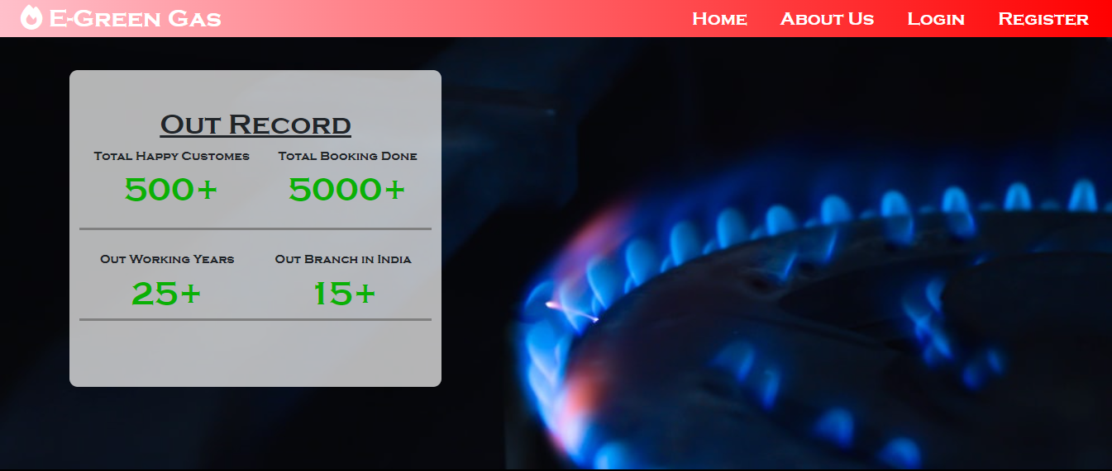

FIGURE 2: HOME PAGE



FIGURE 3: DASHBOARD

# 

# CONCLUSION

E-green gas, likewise, alluded to as inexhaustible petroleum gas (RNG), is a type of biogas got from natural waste. It fills in as a clean and harmless to the ecosystem fuel that can be used for warming private and business spaces, creating power, and driving vehicles. RNG holds colossal worth in lessening ozone depleting substance emanations and upgrading air quality. In synopsis, e-green gas displays incredible potential as a sustainable power source, fit for relieving ozone harming substance discharges and further developing air quality. With the heightening interest for sustainable power, it is guessed that e-green gas will turn out to be progressively open and financially savvy.

Here are a few vital focal points about e-green gas:

* It is an inexhaustible asset gotten from natural waste.
* It consumes neatly, emanating less poisons contrasted with petroleum derivatives.
* It can really supplant petroleum derivatives across different applications, including warming, power age, and transportation.
* It presents a financially savvy answer for lessening ozone harming substance discharges.

Regardless of the difficulties, e-green gas holds guarantee as a sustainable power source that can make a critical commitment to combatting environmental change. As the interest for sustainable power keeps on rising, e-green gas is supposed to acquire more extensive accessibility and moderateness.

# FUTURE WORK

# 

Completely reporting tasks can be enormously valuable. Inside a brief period, the assortment becomes obvious, clear, and coherent. It helps people in acquiring an extensive and clear comprehension of past exercises. Moreover, it works with the administration of current errands connected with the chamber. Moreover, it lessens the expense related with gathering and sorting out tasks, guaranteeing a smooth assortment process. The framework intends to limit manual work and advance brief information passage. The plan of the eco-accommodating gas framework is sufficiently adaptable to take exceptional care of the visitors' necessities. Also, this plan incorporates imaginative elements like fast association establishment, internet booking or buying of chambers, association convenience, and assisted help arrangement.

# ACKNOWLEDGEMENT

We extend our heartfelt appreciation to our friends, relatives, faculty members, and staff at Shri Ramswaroop Memorial College of Engineering and Management for their invaluable assistance and guidance. A special mention goes to our instructor, whose insightful advice led us towards the right path.

Primarily, we would like to express our deepest gratitude to our guide, Dr. Santosh Kr. Dwivedi. Their guidance, mentorship, and unwavering support throughout this research project have been indispensable. Their expertise and profound insights have significantly influenced the direction of our research and the refinement of our methodology.

Lastly, we would like to acknowledge our gratitude to our family members, friends, and loved ones for their unwavering support, understanding, and encouragement throughout this research journey. Their unwavering belief in us has been a driving force behind our motivation and perseverance.

Although it is impossible to mention every individual who has contributed in many ways, we genuinely appreciate the support we have received from all quarters.

# 

# 

# REFERENCES

1. Western Power Distribution. SF6 Alternatives—A Literature Review on SF6 Gas Alternatives for Use on the Distribution Network; Western Power Distribution: Wales, UK, 2018; pp. 6–39.
2. United Nations. Kyoto Protocol to the United Nations Framework Convention on Climate Change; United Nations: Rome, Italy, 1998; pp. 1–19.
3. United Nations. Paris Agreement—United Nations Framework Convention on Climate Change; United Nations: Rome, Italy, 2015.
4. Okubo, H.; Beroual, A. Recent trend and future perspectives in electrical insulation techniques in relation to sulfur hexaﬂuoride (SF6) substitutes for high voltage electric power equipment. IEEE Electr. Insul. Mag.
   1. 2011,27, 34–42. [CrossRef]
5. Widger, P.; Haddad, A. Evaluation of SF6 leakage from gas insulated equipment on electricity networks in
   1. Great Britain. Energies 2018,11, 2037. [CrossRef]
6. Christophorou, L.G.; Olthoﬀ, J.K.; Brunt, R.J.V. Sulfur hexaﬂuoride and the electric power industry. IEEE Electr. Insul. Mag. 1997,13, 20–24. [CrossRef]
7. Kieﬀel, Y.; Biquez, F.; Ponchon, P. Alternative gas to SF6 for use in high voltage switchgears: G3. In Proceedings of the International Conference on Electricity Distribution, Lyon, France, 15–18 June 2015; pp. 1–5