**E-Rest House for Psychology**

*1Ayush Bajpai, *2Dr. Santosh Kumar Dwivedi, *3Mr. Aakash Srivastava

*1 UG Student of Department of Bachelors of Computer Applications, Shri Ramswaroop Memorial College of Management Lucknow, Uttar Pradesh, India.

*2 Associate Professor, Department of Bachelors of Computer Applications, Shri Ramswaroop Memorial College of Management Lucknow, Uttar Pradesh, India.

*3Assistant professor, Department of Bachelors of Computer Applications, Shri Ramswaroop Memorial College of Management Lucknow, Uttar Pradesh, India.­­­­

**ABSTRACT**

The following paper highlights the pressing need for a web-based e-Rest House for Psychology in the current era, emphasizing the challenges individuals face in accessing mental health support and the potential of technology to bridge the gap. The paper explores the unique circumstances and factors that make the project particularly relevant and timely.

In recent times, mental health challenges have become increasingly prevalent, exacerbated by various factors such as the COVID-19 pandemic, social isolation, economic uncertainties, and the fast-paced nature of modern life. The demand for accessible and effective mental health services has never been greater.

However, traditional mental health services often face significant barriers. Geographical limitations, long waiting lists, financial constraints, and stigma associated with seeking help can prevent individuals from accessing the support they desperately need. These challenges are especially pronounced in remote areas, underserved communities, and individuals who prefer anonymity or struggle with physical mobility.

The web-based e-Rest House for Psychology addresses these challenges by providing a platform that transcends geographical boundaries and reduces the stigma associated with seeking help. The project leverages technology to create a user-friendly interface that enables individuals to access professional counselling, self-help resources, and a supportive community from the comfort and privacy of their own homes.

The COVID-19 pandemic has further underscored the importance of remote mental health support. Lockdowns, social distancing measures, and the strain on healthcare systems have limited in-person counselling options, making online alternatives crucial for maintaining mental well-being. The project's web-based nature aligns with the changing landscape of healthcare, offering a solution that is adaptable, scalable, and accessible in times of crisis.

­­­­­­­­­­­**INTRODUCTION**

The need for accessible and efficient support is now more important than ever because mental health issues have reached previously unheard-of levels. The e-Rest House for Psychology is a moment web-based project that attempts to meet this urgent need by giving people a comprehensive platform to access information, engage with a supportive community, and seek professional advice.

The COVID-19 pandemic has brought mental health to the forefront of public discourse, as people grapple with increased stress, anxiety, and feelings of isolation. The impact of social distancing measures, economic uncertainties, and the disruption of daily routines has significantly contributed to the deterioration of mental well-being on a global scale. Traditional avenues for mental health support, such as in-person counselling services, have faced challenges in meeting the surging demand and overcoming barriers to access.

The web-based e-Rest House for Psychology comes as a timely and transformative solution to address these challenges. By harnessing the power of technology and the accessibility of the internet, the project aims to bridge the gaps in mental health services, making support readily available to individuals regardless of their geographical location or social circumstances.

The main goal of the initiative is to offer individualised counselling sessions that are catered to each person's particular requirements and concerns. People can interact with certified mental health specialists who can provide direction, support, and evidence-based interventions through safe online venues. A wealth of self-help resources, including articles, videos, and interactive tools, are also available on the portal, enabling users to actively manage their mental health. The development of a caring community is a key component of the e-Rest House for Psychology. People can connect with others who have similar experiences through Internet forums, discussion boards, and peer-to-peer exchanges, which fosters a feeling of community and lessens the isolation that frequently accompanies mental health difficulties.

The project also acknowledges the value of confidentiality and privacy. Users can share their issues and request assistance without worrying about being judged or revealed because of the strong security measures that are in place to protect sensitive information. As a result, the e-Rest House for Psychology stands out as a crucial project in the present, responding to the growing mental health crisis and the particular difficulties that people have while seeking treatment. The initiative intends to increase people's well-being and contribute to the general improvement of mental health in society by utilising technology and offering easily available channels for counselling resources, and community support. This project has the potential to offer people in need a lifeline of support, direction, and hope as we negotiate the complexity of the modern world.

**WORKFLOW**

To ensure the platform's successful development and deployment, the e-Rest House for Psychology project workflow adheres to a set procedure. The project's start is where the goals and scope are established. Following requirement collection is close interaction with stakeholders to ascertain their demands. The architecture and framework for the portal are created during the system design phase, while coding and programming are done during the development phase. To ensure dependability and functionality, thorough testing and quality assurance are carried out. User training and support come after deployment and launch. To maintain the site current and address any difficulties, upkeep and updates are done.

**PROPOSED SYSTEM**

The proposed system for the e-Rest House for Psychology project is a comprehensive and user-friendly web-based platform aimed at providing accessible mental health support. The system offers personalized counselling sessions, a vast library of self-help resources, and a supportive online community. Users can access the portal from any device with an internet connection, eliminating geographical barriers and promoting inclusivity. The system incorporates cutting-edge technologies such as HTML, CSS, JavaScript, PHP, and MySQL to create an intuitive user interface, ensure data security, and facilitate seamless interactions. With a focus on user-centric design, the proposed system aims to empower individuals in managing their mental well-being, foster a sense of community, and provide an effective and efficient platform for mental health counselling in today's digital age.

**ANALYSIS**

The analysis of the need, development, and implications of the e-Rest House for Psychology project involves a comprehensive examination of various aspects related to its necessity, implementation, and potential consequences. This analysis encompasses the following key elements:

* Need Analysis: An in-depth analysis of the existing state of mental health is done to determine the urgent need for affordable and efficient counselling services. Examining the increased incidence of mental health issues, the shortcomings of conventional support systems, and the developing need for remote and practical access to mental health resources are all part of this.
* User requirements: Understanding the unique needs and preferences of the target audience, which includes those looking for mental health help, mental health professionals, and other stakeholders, is a key component of the study. To ensure that the portal effectively meets the needs of its users, user comments and input are gathered and used to guide the design and development of the portal.
* Technology Feasibility: The examination assesses the e-Rest House for Psychology's technology viability. This entails evaluating the accessibility of pertinent technologies, the platform's scalability, and the incorporation of security safeguards to safeguard user data and privacy.
* Implications on Accessibility: The project examines how the portal might affect people's ability to get mental health care. It takes into account obstacles such as distance and cost that can prevent people from seeking conventional in-person counselling. The project intends to offer a more inclusive and accessible solution by providing remote and web-based services.
* Impact on Mental Health Treatment: The analysis investigates how the initiative might affect the state of mental health treatment in general. It evaluates the potential advantages, including expanded service availability and reach, shorter counsellor wait times, and better care continuity. It also takes into account potential difficulties, such as the requirement for strict quality control and the significance of preserving the role of the patient in the therapeutic process.
* Ethical and Legal Considerations: The analysis addresses the ethical and legal implications associated with providing mental health services through an online platform. It considers issues of informed consent, privacy, confidentiality, and data protection. The project ensures compliance with relevant regulations and establishes protocols to maintain ethical standards in counselling practices.
* Impact on Society and Culture: The examination looks at how the project might affect society and culture. It takes into account the portal's contribution to eradicating stigma, raising awareness, and creating a community of support for those with mental illness. The requirement for actions and resources that are culturally relevant is also taken into account.

By conducting a comprehensive analysis of the need, development, and implications of the project, the e-Rest House for Psychology can be designed and implemented in a manner that maximizes its potential to address the identified needs, overcome barriers to access, and positively impact individuals' mental well-being.

The following are the statistical and graphical representations of the mental health status of India based on the prominent states and union territories as per the survey supported by the Ministry of Health and Family Welfare Government of India.

* 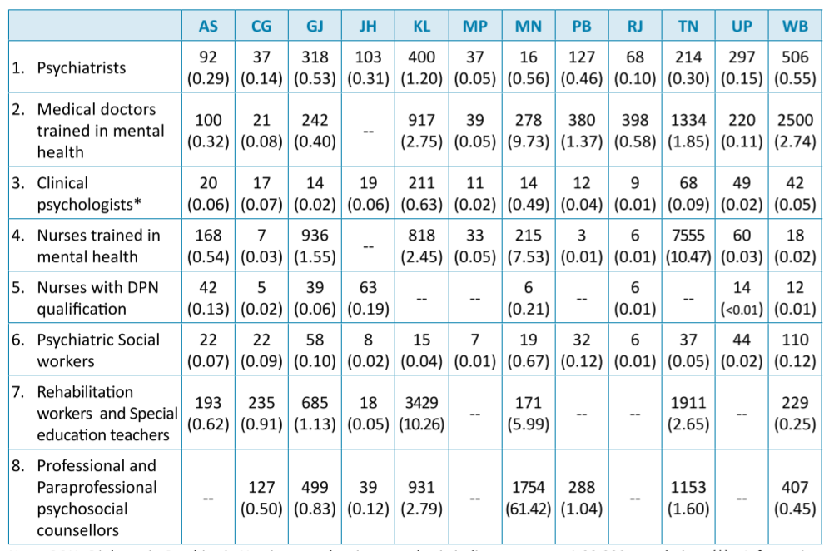Mental health human resources across the NMHS states (per 1,00,000 population)
* raining programme for mental health
* 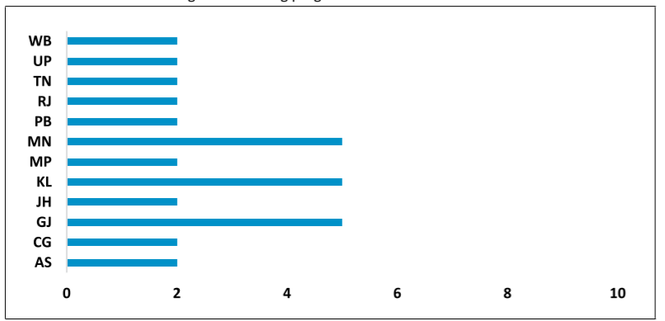Mental health policy across the NMHS states:

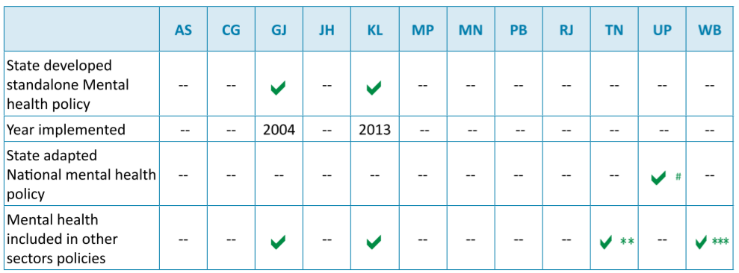

* State Mental health system assessment scores

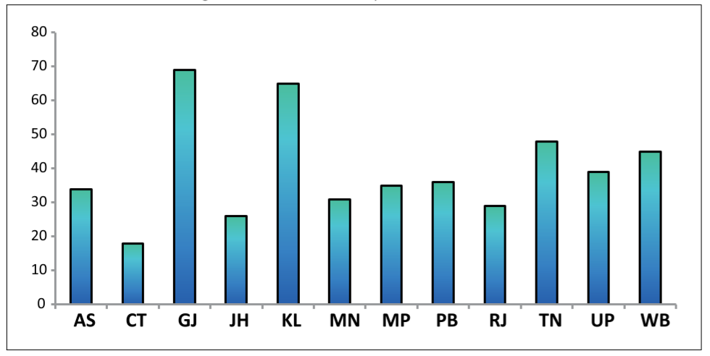

**CONCLUSION**

In conclusion, the e-Rest House for Psychology project presents a timely and valuable solution to address the growing need for accessible and effective mental health support. The project recognizes the challenges faced by individuals in seeking traditional counselling services and leverages technology to bridge the gap. Through the development of a user-friendly web-based platform, individuals can access personalized counselling sessions, self-help resources, and a supportive online community from the comfort of their own homes. The project emphasizes the importance of user-centric design, ethical considerations, and robust security measures to ensure a safe and confidential environment. The implications of the project extend beyond the individual level, aiming to contribute to a broader societal shift in mental health attitudes and support systems. By providing a comprehensive and inclusive platform, the e-Rest House for Psychology project has the potential to improve mental well-being, reduce stigma, and empower individuals to take control of their mental health journey.

**FUTURE WORK**

In terms of future work for the e-Rest House for Psychology project, several areas can be explored to enhance and expand its capabilities. First, continuous improvement and updates should be made to the platform based on user feedback and emerging trends in mental health care. This includes refining the user interface, adding new features, and integrating emerging technologies such as artificial intelligence and machine learning to enhance personalized support. Additionally, collaborations with mental health professionals and researchers can help incorporate evidence-based practices and interventions into the portal, ensuring the highest quality of care. Furthermore, expanding the reach of the portal through partnerships with organizations and institutions can increase accessibility and promote its usage among diverse populations. Finally, ongoing research and data analysis can provide valuable insights into the effectiveness and impact of the platform, enabling evidence-based decision-making and further optimization of services. By continuously evolving and adapting to meet the evolving needs of users and the mental health landscape, the project can make a lasting and positive impact on mental well-being in the future.

**ACKNOWLEDGEMENT**

The completion of any task is a reward to not only persons actively involved in accomplishing it but also to the people involved in this inspiring, guiding, and helping those people. I take the opportunity here to thank all those who have helped me in the completion of this project, without which this indeed would have been a mammoth task. Yet this project wouldn’t have been possible without the unrelenting care and support of many people.

I would like to express my immense gratitude towards Dr Santosh Kumar Dwivedi, HOD(BCA), and my project guide Mr Aakash Srivastava. I am highly indebted to him for his encouraging, motivating, and invaluable support in bringing the work to this shape. I devote my special thanks to all the faculty members of Shri Ramswaroop Memorial College of Management who provide me with great support during the development developing of this project.

**REFERENCES**

* National Mental Health Survey of India, 2015-16: <https://main.mohfw.gov.in/sites/default/files/National%20Mental%20Health%20Survey%2C%202015-16%20-%20Mental%20Health%20Systems_0.pdf>
* National Library of Medicine: <https://www.ncbi.nlm.nih.gov/pmc/articles/PMC8595951/>
* American Psychological Association. (2017). Multicultural Guidelines. Retrieved from

<https://www.apa.org/about/policy/multicultural-guidelines> .

* National Institute for Health and Care Excellence. (2018). Depression in adults: recognition and management. Retrieved from <https://www.nice.org.uk/guidance/cg90>.
* World Health Organization. (2017). Depression and Other Common Mental Disorders: Global Health
* Estimates. Geneva: World Health Organization