OFF BOARD ELECTRIC VEHICLE BATTERY CHARGER USING PV ARRAY

S.Sandya1, A.mounika2, K.kumaraswami3, R Hrithik Reddy4, P.Nagaraju5, K.Hanok6

1Assistant Professor, EEE, Nigama Engineering College, Karimnagar, Telangana, India.

2,3,4,5.6UG Students, EEE, Nigama Engineering College, Karimnagar, Telangana, India.

**ABSTRACT**

During the recent decade, the automobile industry is booming with the evolution of electric vehicles (EV). Battery charging system plays a major role in the development of EVs. Charging EV batteries from the grid increases its load demand. This leads to the proposal of a photovoltaic (PV) array-based off-board EV battery charging system in this project. Irrespective of solar irradiations, the EV battery is to be charged constantly which is achieved by employing a backup battery bank in addition to the PV array. Using the sepic converter and three-phase bidirectional DC–DC converter, the proposed system is capable of charging the EV battery during both sunshine hours and non-sunshine hours. During peak sunshine hours, the backup battery gets charged along with the EV battery and during non-sunshine hours, the backup battery supports the charging of the EV battery. The proposed charging system is simulated using Simulink in the MATLAB software and the results are furnished

**Keywords:** sepic converter, three-phase bidirectional DC-DC converter, electric vehicles.

1. **INTRODUCTION**

Ever increasing effects of greenhouse gases from conventional IC engines lead to environmental concerns. This paved the booming of pollution-free electric vehicles (EVs) in the automobile industry. However, EV battery charging from the utility grid increases the load demand on the grid and eventually increases the electricity bills to the EV owners which necessitate the use of alternate energy sources. Due to inexhaustible and pollution-free nature of renewable energy sources (RESs), it can be used to charge the EV battery. Thus, RES driven EV can be termed as ‘green transportation’. Solar is one of the promising RESs which can be easily tapped to utilize its energy to charge EV batteries. Hence, PV array power is used to charge the EV battery in the proposed system with the help of power converter topologies. Lithium-ion batteries are widely used in the EV due to its high-power density, high efficiency, lightweight and compact size. Also, these batteries have the capacity of fast charging and long lifecycle with low self-discharge rate. They also have low risk of explosion if it is overcharged or short-circuited. During charging, these batteries require precise voltage control. Hence, various power electronic converters with voltage controllers are used for charging EV batteries. Due to the intermittent nature of the PV array, there is a need for power converters to charge the EV battery. Among different converters, multiport converters (MPCs) are preferred in the onboard chargers of hybrid EVs due to its capability of interfacing power sources and energy storage elements like PV array, ultracapacitors, supercapacitors, fuel cells and batteries with the loads in EV like motor, lights, power windows and doors, radios, amplifiers and mobile phone charger. The MPCs have the drawback of increase in weight, cost and maintenance of the EV as all the sources are placed in the EV itself. Also, the complexity of controller implementation increases in these converter-based EV battery charging systems. Hence, an off-board charger is proposed in this paper in which the EV battery is located inside the vehicle unit and PV array and backup battery bank are located in the charging station or parking station. Various converter topologies for off-board charging system are presented in the literature. Among different converter topology, the sepic converter is preferred due to its capability of working in both boost and buck modes. It also has the advantage of the same input and output voltage polarity, low input current ripple and low EMI. However, during low solar irradiation and non-sunshine hours, there is a need for an additional storage battery bank to charge the EV battery. This backup battery bank has to be charged in the forward direction and discharged in a reverse direction depending on the solar irradiation. Hence, a bidirectional converter with power flow in either direction is required. The bidirectional converters are classified into non-isolated and isolated converters. The transformer in the isolated converters provides isolation which increases the price, weight and size of the converter. The main concerns of EV are weight and size and hence, no isolated bidirectional converters are best suited for this application. Among various no isolated bidirectional converter topologies, bidirectional interleaved DC-DC converter (BIDC) is preferred due to its advantages like improved efficiency in discontinuous conduction mode and minimal inductance value, reduced ripple current due to multiphase interleaving technique. Snubber capacitor across the switches reduces the turnoff losses and the inductor current parasitic ringing effect is also reduced by employing zero voltage resonant soft switching technique. These are the added advantages of this bidirectional converter. The system in is an off-board EV battery charging system which charges the EV battery from PV array power through a bidirectional DC-DC converter in stand-still condition and EV battery gets discharged to drive the dc load in the EV during the running condition. It has the drawback of charging EV battery only during sunshine hours. To overcome this disadvantage and to charge the EV battery without any interruption, the proposed charger is developed using PV array integrated with sepic converter, bidirectional DC-DC converter and backup battery bank for charging the battery of an EV with fuzzy.

1. **LITERATURE SURVEY**

Santhosh, T.K., Govinda Raju, C.: ‘Dual input dual output power converter with one-step-ahead control for hybrid electric vehicle applications. The rapid conversion of automotive accessory loads to the electrical domain demands a power converter to interface between the onboard source and storage units with the accessories. This study proposes a simplified structure of dual input dual output (DIDO) with single-stage power conversion for hybrid electric vehicle accessory applications. The topology is synthesized using pulsating source cells. The generic switch model-based DIDO is realized with power switches based on the switch realization technique. Steady-state and equivalent circuit models describing the converter structure are presented. Numerical simulations were performed with the state-space averaged mathematical model. A one-step-ahead controller is used for inductor current control in conjunction with a mode selection logic to utilize its operating modes based on the availability of the sources and its protection. The performance of the proposed converter and its associated control scheme under steady-state, transient conditions are corroborated by simulation and experimental results.

Shukla, A., Verma, K., Kumar, R.: ‘Voltage-dependent modeling of fast charging electric vehicle load considering battery characteristics’ : Electric vehicle (EV) integration into the power grids is increasing rapidly. To analyze the effect of charging of EVs on the distribution system, most of the literature considered EV load as constant power load (CPL) which do not represent the exact behavior of these uncertain loads. An accurate EV load modeling is developed by determining the relationship between power consumption by EV, grid voltage, and state of charges of fast-charging EV load. The derived relationship is validated by simulating a realistic fast charging system to obtain a battery charging behavior characteristic and is curve fitted on a standard exponential load model. Further, the impact of the stochastic 24-h load profile of fast-charging EVs considering the exponential load model is investigated on IEEE 123 bus distribution system and is compared with the constant impedance-constant current constant power (ZIP) load model and CPL model. The stochastic 24-h load is developed using queuing analysis-based method. The results show that the exponential load model is the better representation of fast charging EV load and 10.19% of the reduction in annual energy demand and 11.19% of the reduction in annual energy loss is observed for exponential load model compared to the existing CPL model.

Weerasinghe, S.G., Emadi, A.: ‘Pihef: plug-in hybrid electric factor’, The potential of plug-in hybrid electric vehicles (PHEVs) to operate in electric and hybrid modes and their ability to supplement the energy storage off the grid have made them a front-runner in alternative fuel vehicle development. However, there is currently no widely accepted standard classification that provides an accurate comparison of PHEVs. This paper presents a novel classification for PHEVs: “Pihef: Plug-In Hybrid Electric Factor.” Pihef is the average ratio of the energy provided by the grid to the sum of the energy provided by the grid and fuel. The viability of Pihef is demonstrated via comprehensive simulations and sensitivity analysis. In addition, the relationship between Pihef and emissions, efficiency, hybridization, and electric range is developed.

Kirthiga, S., Jothi Swaroopan, N.M.: ‘Highly reliable inverter topology with a novel soft computing technique to eliminate leakage current in grid-connected transformer less photovoltaic systems’ Grid-connected transformer less [photovoltaic](https://www.sciencedirect.com/topics/engineering/photovoltaics) [inverters](https://www.sciencedirect.com/topics/computer-science/inverters) are widely accepted in the renewable energy market, owing to their high power density, low cost, and high efficiency. However, the [leakage current](https://www.sciencedirect.com/topics/computer-science/leakage-current) is the main issue in these inverters, which is to be investigated carefully. In this study, leakage current analysis of both transformer and transformer-less [bridge inverter](https://www.sciencedirect.com/topics/engineering/bridge-inverter) topologies is widely investigated. Based on that, a new topology and [modulation technique](https://www.sciencedirect.com/topics/engineering/modulation-technique) is proposed to eliminate the leakage current in the system. The mechanism of a creating high-impedance path between the [photovoltaic](https://www.sciencedirect.com/topics/engineering/photovoltaic-modules) [module](https://www.sciencedirect.com/topics/engineering/photovoltaic-modules) and the system, by properly isolating them in the freewheeling state and maintaining a constant [common mode voltage](https://www.sciencedirect.com/topics/engineering/common-mode-voltage) in all the switching states, is elaborately discussed in this paper. The experimental results are finally presented to validate the proposed topology with respect to other conventional topologies.

Badawy, M.O., Sozer, Y.: ‘Power flow management of a grid-tied PV- battery system for electric vehicles charging’ The prospective spread of Electric vehicles (EV) and plug-in hybrid electric vehicles arises the need for fast charging rates. High required charging rates lead to high power demands, which may not be supported by the grid. In this paper, an optimal power flow technique of a PV-battery-powered fast EV charging station is presented to minimize the operation cost. The objective is to help the penetration of PV-battery systems into the grid to support the growing need for fast charging of EVs. An optimization problem is formulated along with the required constraints and the operating cost function is chosen as a combination of electricity grid prices and the battery degradation cost. In the first stage of the proposed optimization procedure, an offline particle swarm optimization (PSO) is performed as a prediction layer. In the second stage, dynamic programming (DP) is performed as an online reactive management layer. Forecasted system data is utilized in both stages to find the optimal solution for power management. In the reactive management layer, the outputs of the PSO are used to limit the available state trajectories used in the DP and, accordingly, improve the system computation time and efficiency. Online error compensation is implemented into the DP and fed back to the prediction layer for necessary prediction adjustments. Simulation and experimental results are successfully implemented to validate the effectiveness of the proposed management system.

Van Der Meer, D., Chandra Mouli, G.R., Morales-Espana Mouli, G., et al.: ‘Energy management system with PV power forecast to optimally charge EVs at the Workplace This paper presents the design of an energy management system (EMS) capable of forecasting photovoltaic (PV) power production and optimizing power flows between PV system, grid, and battery electric vehicles (BEVs) at the workplace. The aim is to minimize charging costs while reducing energy demand from the grid by increasing PV self-consumption and consequently increasing the sustainability of the BEV fleet. The developed EMS consists of two components: An autoregressive integrated moving average model to predict PV power production and a mixed-integer linear programming framework that optimally allocates power to minimize charging costs. The results show that the developed EMS is able to reduce charging costs significantly while increasing PV self-consumption and reducing energy consumption from the grid. Furthermore, during a case study analogous to one repeatedly considered in the literature, i.e., dynamic purchase tariff and dynamic feed-in tariff, the EMS reduces charging cost by 118.44% and 427.45% in the case of one and two charging points, respectively, when compared to an uncontrolled charging policy. Xavier, L.S., Cupertino, A.F., Pereira, H.A.: ‘Ancillary services provided by photovoltaic inverters: single and three phase control strategies: Grid-connected photovoltaic (PV) have been inserted in the power systems mainly at low and medium voltage. PV inverters are power electronic-based converters with fast responses in the range of milliseconds. Besides, due to solar irradiance variation, these converters have excess capacity that can be used to provide ancillary services to the main grid. Traditionally, ancillary services such as reactive power injection and frequency support are provided by hydro and thermal generation. This work is focused on the analysis of how PV inverters can perform ancillary services and support the grid. Control strategies for reactive power injection and harmonic current compensation are explored. Furthermore, the inverter current saturation plays an important role, once high currents can damage the inverter or reduce its lifetime. Case studies for single and three-phase PV inverters are presented. It is observed that the ancillary service priority must be defined in order to guarantee PV inverter operation under nominal

1. **MODELING AND ANALYSIS**

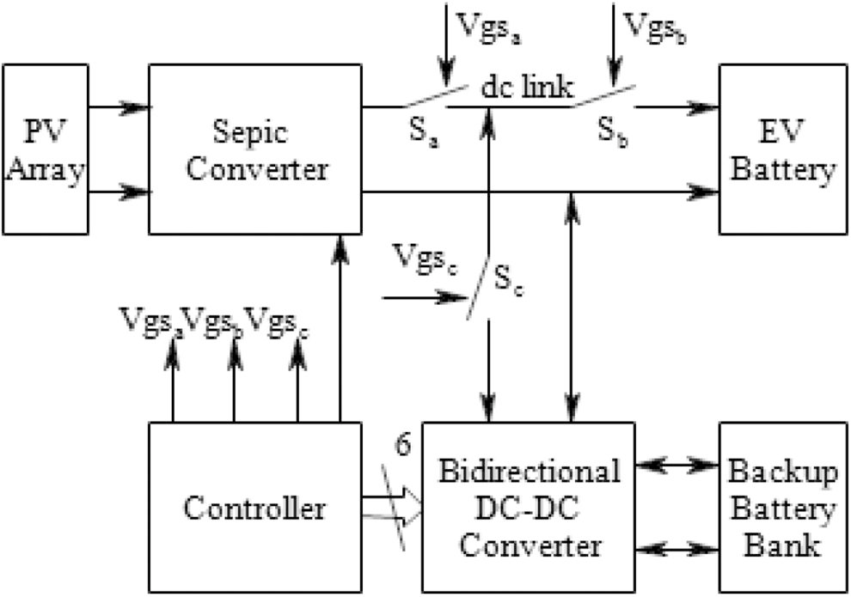

**Fig. 1 Block diagram of the EV battery charger**

The proposed PV-EV battery charger consists of a PV array, a sepic converter, a half-bridge BIDC, an EV battery, a backup battery bank and a controller as shown in Fig. 1. The controller is used to generate the gate pulses to the sepic converter for obtaining the constant output voltage at the dc link. The gate pulses to the switches of BIDC are also generated to operate BIDC in boost mode to charge the backup battery from PV array and in buck mode to charge EV battery from the backup battery. Also, the controller generates the gate pulses to the auxiliary switches *Sa*, *Sb* and *Sc*. During high solar irradiation, all the auxiliary switches are ON to interface dc link with PV array through the sepic converter, dc link with the backup battery through BIDC, and the dc link with EV battery. When solar irradiation is low, switch *Sa* is turned OFF isolating the PV array and sepic converter from the dc link. Whereas the switch *Sc* is turned OFF to disconnect BIDC and backup battery from the dc link when the solar power is insufficient to charge the backup battery. The proposed system operates in three modes viz., mode 1, mode 2, and mode 3 as explained in this section.

**Mode 1**

During peak sunshine hours, when the generated PV array power is higher, all the auxiliary switches are ON to charge both EV battery and backup battery simultaneously from PV array through sepic converter and BIDC, respectively. In this mode, BIDC operates in a forward direction boosting the dc link voltage to charge backup battery.

**Mode 2**

During low solar irradiation conditions and non-sunshine hours, PV array power is insufficient to charge EV battery. Hence, the PV array is disconnected from the dc link by turning OFF the switch *Sa* and switches *Sb* & *Sc* are ON connecting EV battery to the backup battery through BIDC. In this mode, BIDC operates in the reverse direction stepping down the backup battery voltage to charge EV battery.

**Mode 3**

When PV array power generated is sufficient to charge only EV battery, switches *Sa* and *Sb* are ON and switch *Sc* is OFF to disconnect the BIDC and backup battery bank from the dc link

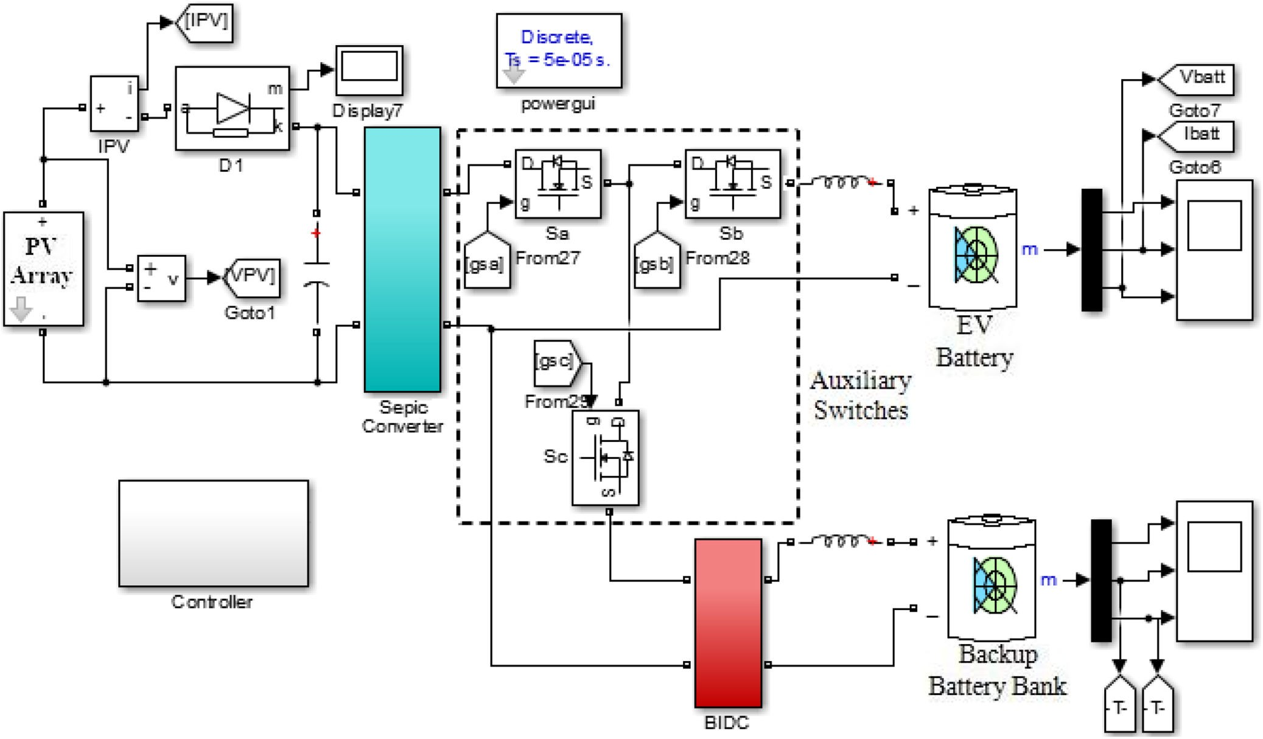

**Fig. 2 Simulation** model of the proposed charger

Simulink in the MATLAB software is used for the simulation studies of the proposed system.

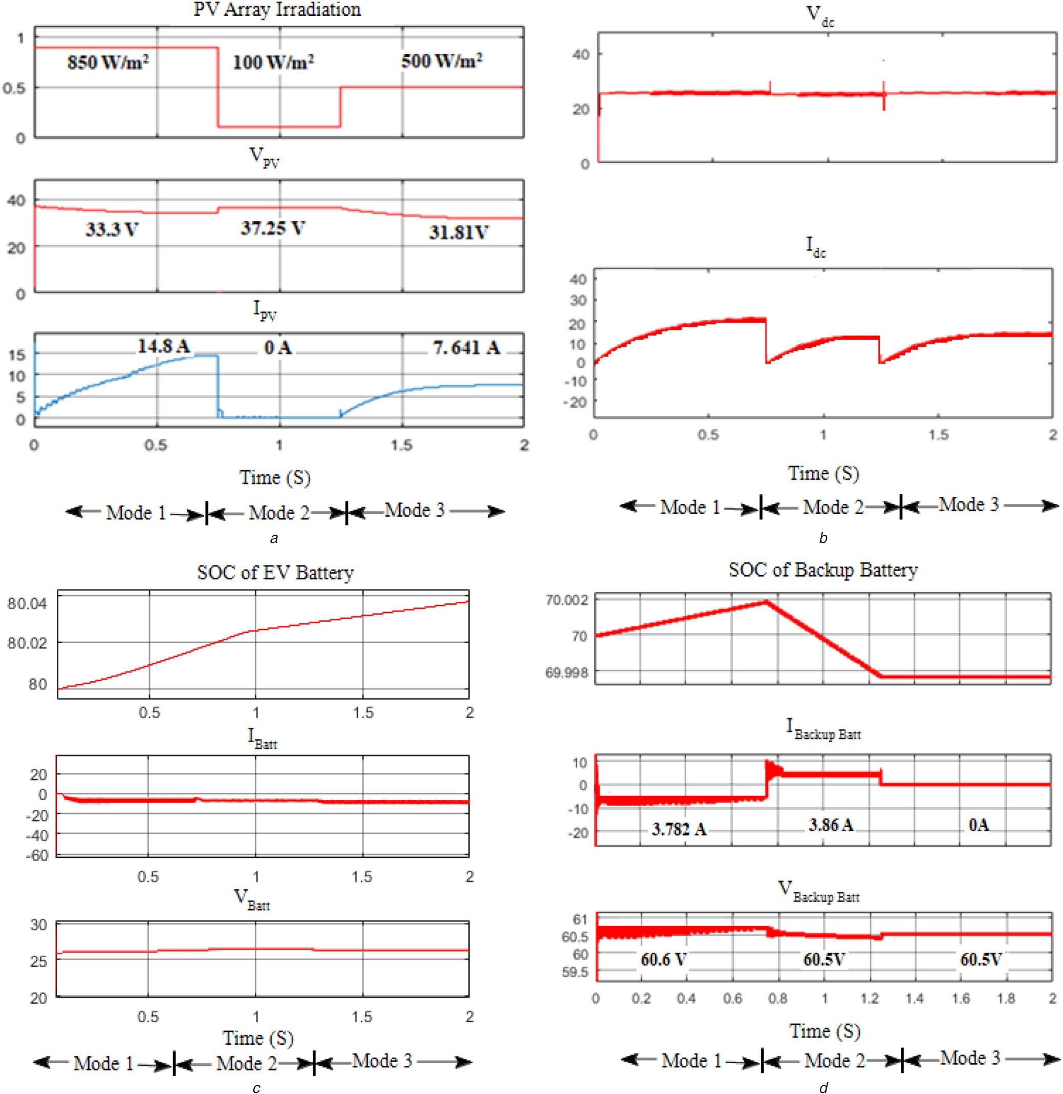

**Fig. 3**Waveforms *of*

***(a)*** PV array voltage, *V*PV & PV array current, *I*PV, ***(b)*** DC link voltage, *V*dc, & current, *I*dc, ***(c)*** EV battery SOC, EV battery current, *I*Batt & EV battery voltage, *V*Batt, ***(d)*** Backup battery SOC, backup battery current, *I*Backup Batt & backup battery voltage, *V*Backup Batt

# **4.CONCLUSION**

In this paper, an off-board EV battery charging system fed from PV array is proposed. This paper discusses the flexibility of the system to charge the EV battery constantly irrespective of the irradiation conditions. The system is designed and simulated in Simulink environment of the MATLAB software. The hardware prototype is fabricated and tested in the laboratory for the three modes of operation of the proposed charging system separately and the results are furnished.

**5.REFERENCES**

1. Santhosh, T.K., Govindaraju, C.: ‘Dual input dual output power converter with one-step-ahead control for hybrid electric vehicle applications’, IET Electr. Syst. Transp., 2017, **7**, (3), pp. 190–200
2. Shukla, A., Verma, K., Kumar, R.: ‘Voltage-dependent modelling of fast charging electric vehicle load considering battery characteristics’, IET Electr.

Syst. Transp., 2018, **8**, (4), pp. 221–230

1. Wirasingha, S.G., Emadi, A.: ‘Pihef: plug-in hybrid electric factor’, IEEE Trans. Veh. Technol., 2011, **60**, pp. 1279–1284
2. Kirthiga, S., Jothi Swaroopan, N.M.: ‘Highly reliable inverter topology with a novel soft computing technique to eliminate leakage current in grid-connected transformerless photovoltaic systems’, Comput. Electr. Eng., 2018, **68**, pp. 192–203
3. Badawy, M.O., Sozer, Y.: ‘Power flow management of a grid tied PV-battery system for electric vehicles charging’, IEEE Trans. Ind. Appl., 2017, **53**, pp. 1347–1357
4. Van Der Meer, D., Chandra Mouli, G.R., Morales-Espana Mouli, G., et al.: ‘Energy management system with PV power forecast to optimally charge EVs at the workplace’, IEEE Trans. Ind. Inf., 2018, **14**, pp. 311–320
5. Xavier, L.S., Cupertino, A.F., Pereira, H.A.: ‘Ancillary services provided by photovoltaic inverters: single and three phase control strategies’, Comput.

Electr. Eng., 2018, **70**, pp. 102–121

1. Krithiga, S., Ammasai Gounden, N.: ‘Investigations of an improved PV system topology using multilevel boost converter and line commutated inverter with solutions to grid issues’, Simul. Model. Pract. Theory, 2014, **42**, pp. 147–159
2. Sujitha, N., Krithiga, S.: ‘RES based EV battery charging system: a review’,

Renew. Sustain. Energy Rev., 2017, **75**, pp. 978–988

1. Farzin, H., Fotuhi-Firuzabad, M., Moeini-Aghtaie, M.: ‘A practical scheme to involve degradation cost of lithium-ion batteries in vehicle-to-grid applications’, IEEE Trans. Sustain. Energy, 2016, **7**, pp. 1730–1738
2. Zubair, R., Ibrahim, A., Subhas, M.: ‘Multiinput DC–DC converters in renewable energy applications – an overview’, Renew. Sustain. Energy Rev., 2015, **41**, pp. 521–539
3. Duong, T., Sajib, C., Yuanfeng, L., et al.: ‘Optimized multiport dc/dc converter for vehicle drive trains: topology and design optimization’, Appl.

Sci., 2018, **1351**, pp. 1–17

1. Santhosh, T.K., Natarajan, K., Govindaraju, C.: ‘Synthesis and implementation of a multi-port dc/dc converter for hybrid electric vehicles’, J.

Power Electron., 2015, **15**, (5), pp. 1178–1189

1. Hongfei, W., Peng, X., Haibing, H., et al.: ‘Multiport converters based on integration of full-bridge and bidirectional dc–dc topologies for renewable generation systems’, IEEE Trans. Ind. Electron., 2014, **61**, pp. 856–869
2. Shi, C., Khaligh, A.: ‘A two-stage three-phase integrated charger for electric vehicles with dual cascaded control strategy’, IEEE J. Emerging Sel. Topics Power Electron., 2018, **6**, (2), pp. 898–909
3. Chiang, S.J., Shieh, H., Chen, M.: ‘Modeling and control of PV charger system with SEPIC converter’, IEEE Trans. Ind. Electron., 2009, **56**, (11), pp. 4344–4353
4. Banaei, M.R., Sani, S.G.: ‘Analysis and implementation of a new SEPIC- based single-switch buck–boost DC–DC converter with continuous input current’, IEEE Trans. Power Electron., 2018, **33**, (12), pp. 10317–10325
5. Singh, A.K., Pathak, M.K.: ‘Single-stage ZETA-SEPIC-based multifunctional integrated converter for plug-in electric vehicles’, IET Electr. Syste. Transp., 2018, **8**, (2), pp. 101–111
6. Du, Y., Zhou, X., Bai, S., et al.: ‘Review of non-isolated bi-directional DC- DC converters for plug-in hybrid electric vehicle charge station application at municipal parking decks’. 2010 Twenty-Fifth Annual IEEE Applied Power Electronics Conf. Exposition, Palm Springs, CA, USA., 2010, pp. 1145–1151
7. Kwon, M., Oh, S., Choi, S.: ‘High gain soft-switching bidirectional DC–DC converter for eco-friendly vehicles’, IEEE Trans. Power Electron., 2014, **29**, pp. 1659–1666