Mathematical Study on the Heat Transfer Phenomenon of an External Wall with Distinct Operating Temperature

M.Vidhya1

1 Master of Engineering, Thermal Engineering, Government College of Engineering, Salem, Tamil Nadu, India

**ABSTRACT**

The heat transfer through external walls plays a crucial role in the energy efficiency and thermal performance of buildings. Understanding the heat transfer characteristics under different outside temperatures is essential for optimizing building envelope design and improving energy conservation measures. This study presents a numerical investigation of the dynamic heat transfer through an external wall subjected to various outside temperature conditions. To investigate the impact of outside temperature on heat transfer, a range of external temperature scenarios were considered, including both steady-state and transient conditions. The transient simulations aimed to capture the time-dependent response of the wall system under changing outside temperatures. The inside boundary conditions were kept constant throughout the simulations to represent a controlled indoor environment

**Keywords:** heat transfer; External wall;

**INTRODUCTION (Font-Times New Roman, Bold, Font Size -12)**

1. As a consequence of economic development and population explosion, the energy consumption of the world steadily increases at an alarming rate. According to US Energy Information Administration (EIA), with the recent growth rate, the world energy demand in 2040 would be 48% higher than the level in 2012. This situation raises a concern about the depletion of energy resources and environmental issues. Globally, the energy usage is classified into three mains economic sectors: building, transportation, and industry, where the building sector constitutes about 40% of total annual energy consumption of the world.
2. **METHODOLOGY**

For a multilayered and external wall, when there is no internal heat source in the wall, a one-dimensional transient conduction equation

.

1. **WALL DESIGN**

Multilayered and external wall presented in this section.

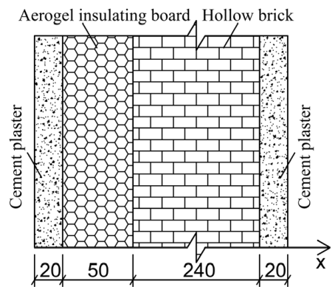**Figure 1:** Multilayered external wall

Cement coating 10 cm; Aerogel insulating layer 100 cm; Hollow brick 300 cm

1. **RESULTS AND DISCUSSION**

Outside sol-air temperature peak, *T* has a big change because of different solar radiation, while outside sol-air temperature through changes small in the ten days. For the change of the peaks and troughs of the interior surface temperature The two changing trends are same and similar as that of the averages of the outside sol-air temperatures, *T*, but the two curves have a delay.

Table 1. Properties for selecting materials

|  |  |  |  |  |  |  |  |  |  |
| --- | --- | --- | --- | --- | --- | --- | --- | --- | --- |
| Material | Thickness (m) | Thermal conductivity  (w/m k) | Specific heat (J/Kg K) | Density (Kg/m3) |  |  |  |  |  |
| Cement coating | 0.01 | 0.87 | 970 | 1600 |  |  |  |  |  |
| Aerogel Insulating layer | 0.10 | 0.048 | 1200 | 250 |  |  |  |  |  |
| Hollow brick | 0.3 | 0.64 | 970 | 1500 |  |  |  |  |  |

**Figure 2** 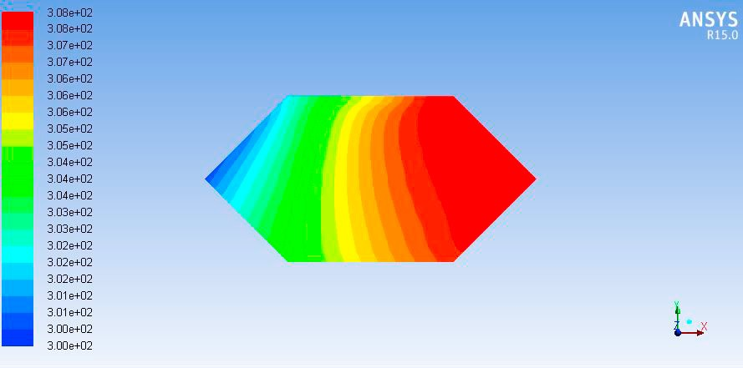Temperature distribution for wall

1. **CONCLUSION**

The results demonstrated that the outside temperature significantly influenced the heat transfer process through the wall. As the outside temperature varied, the heat and temperature distributions within the wall layers changed accordingly. This highlights the importance of considering heat transfer effects in building envelope design and energy conservation strategies. The thermal properties of the wall materials played a crucial role in regulating heat transfer. Materials with higher thermal conductivity facilitated faster heat propagation through the wall, affecting its overall thermal performance. The thickness and thermal resistance of the wall layers also influenced the heat transfer characteristics. The findings of this study have implications for improving the energy efficiency of buildings. By understanding the heat transfer through external walls, architects and designers can optimize insulation materials and strategies to minimize heat loss or gain**.** This can lead to more sustainable and comfortable buildings with reduced energy consumption.

1. **REFERENCES**

[1] L. Pérez-Lombard, J. Ortiz, C. Pout, A review on buildings energy consumption information, Energy and Buildings 40(3) (2008) 394-398.

[2] International Energy Outlook 2016, US Energy Information Administration (EIA) (2016).

[3] A.M. Omer, Energy, environment and sustainable development, Renewable and Sustainable Energy Reviews 12(9) (2008) 2265-2300.

[4] G.J. Lever more, review of the IPCC Assessment Report Four, Part 1: The IPCC process and greenhouse gas emission trends from buildings worldwide, Building Services Engineering Research and Technology 29(4) (2008) 349-361.

[5] Department of building science and technology of Tsinghua University. Meteorological data for Chinese building thermal environment analysis. Beijing: China architecture & building press, Inc. 2005. (in Chinese)

.