CNG GAS BOOKING USING BLOCKCHAIN TECHNIQUE

# Prof. P.V. Nagare*1, Rutik Rahangadale *2, Akash Torne*3

Professor, Department Of Computer, Loknete Gopinathji Munde Institute Of Engineering Education And Research, Nashik, Maharashtra, India.

BE Student, Department Of Computer, Loknete Gopinathji Munde Institute Of Engineering Education And Research, Nashik, Maharashtra, India.

DOI : https:[//w](http://www.doi.org/10.56726/IRJMETS39826)ww[.doi.org/10.56726/IRJMETS39826](http://www.doi.org/10.56726/IRJMETS39826)

# ABSTRACT

The mobile devices are becoming more and more popular and are providing a new notion of communication that only once could imagine. With respect to CNG Cars, one of the major problems faced by the lakhs of people, who use CNG Car is standing in the long queues for an average of 40-45 minutes to fill the Gas. This often leads to people not buying the CNG cars. A transport department official said, “Fluctuations in manufacturing of factory made CNG car models are a probable reason and long queues at CNG gas stations also act as a deterrent for many buyers.”

This project aims to find a remedy for these lakhs of people by using an online application to book appointment on their mobile phone and feedback system for analysing user experience with different pumps regarding service and safety. Customers provide feedback in quantitative ratings and qualitative comments related to service and safety. Analysing and evaluating this qualitative data helps us to make better sense of customer feedback on service. This paper focus on providing qualitative and quantitative feedback to analyse and provide better service

**Keywords:** BlockChain , Encryption , Android Studio , Php MyAdmin , MySQL

# INTRODUCTION

This is really inconvenient for users as days are passing his queue is getting larger and larger. “Auto manufacturers cited long queues at CNG stations as a reason as well. “After court orders, all taxis and public transport in Delhi are now CNG fuelled. This will put consumers off the fuel since it means longer queues and waiting at stations in Delhi. The CNG network is not enough at the moment,” sources in an auto manufacturer said. The existing filling system is causing a considerable increase in the travel time due to a Major drawback “Long Queues”, which absorbs a significant portion of the travelling time. On an average, a customer spends around 45 minutes in the queue at the CNG Station. The aim of our system is to ease the CNG gas filling system by maintaining virtual queue. In this application all the pump owners will be registering their pumps. While registering we will be taking their location, latitude and longitude which will be used while calculating distance of each pump from the current location of customer. As user install the application which is platform independent first user needs to register will registration necessary details will be taken and once the user is register user can use username and password for login. In this application first landing page is the page showing favorite pumps of user which user as marked as favorite for the first time it will be displaying no favorite pumps as there is no pumps in favorite pump list. User can fetch pumps from pump list user need to select city once city is selected it will be showing the list of pumps in that city with distance from current location of users.

# LITERATURE REVIEW

1**.Title: ”Blockchain-based reservation and payment for smart gas station” (2018) Authors: -**

Yanfei Kang, Xuelian Long, Zongmin Wang, et al. Published in: 2018 International Conference on Industrial Internet (ICII) Summary: This paper proposes a blockchain-based reservation and payment system for smart gas stations. It presents a detailed architecture and workflow, highlighting the benefits of blockchain technology in enhancing transparency, security, and efficiency in the CNG booking process.

**2. Title: ”Blockchain Technology: A Review and Its Applications” (2019) Authors:-**

Nisha Kant Ojha, Sonali Agarwal, Vinit Khandelwal Published in: 2019 3rd International Conference on Trends in Electronics and Informatics (ICOEI) Summary: This review article provides an overview of blockchain technology and its applications in various industries. It discusses the potential of blockchain for improving transparency, security, and trust in sectors like transportation, logistics, and supply chain, which can be relevant to the CNG gas booking system.

**3. Title: ”Blockchain for the Internet of Things: A Systematic Literature Review” (2019) Authors:-**

Rafael Sousa Junior, Claudio de Souza Baptista, et al. Published in: 2019 IEEE International Conference on Blockchain (Blockchain) Summary: This literature review focuses on the combination of blockchain and the Internet of Things (IoT). It explores the potential of blockchain for IoT applications, including resource management, supply chain, and payment systems. The findings can be valuable in understanding the integration of blockchain and IoT for monitoring and managing CNG resources.

# METHODOLOGY

## 1 .Pseudo Code 1:-

## 1. Start the CNG gas booking system.

## 2. Prompt the user to enter their account credentials (username and password) to log in.

## 3. Validate the user’s credentials against the stored user database. If the credentials are invalid, display an error message and terminate the program. Once the user is successfully logged in, display a menu with the following options:

## 1. Check available CNG stations

## 2. Book CNG gas

## 3. Cancel CNG gas booking.

## 4. Check booking status

## 5. Logout

## 6. Exit

## 2 .Pseudo Code 2:-

## 1. Based on the user’s selection, perform the corresponding action:

## (a) Check available CNG stations: Fetch the list of available CNG stations from a database or an API. Display the list of CNG stations to the user.

## (b) Book CNG gas: i. Prompt the user to enter the desired CNG station and the quantity of gas required. ii. Check the availability of the selected station and the requested quantity. iii. If the station and quantity are available, book the CNG gas for the user and display a success message. iv. If the station or quantity is not available, display an appropriate error message.

## (c) Cancel CNG gas booking: i. Prompt the user to enter the booking ID or any other identifier for the booking they want to cancel. ii. Verify the booking details and cancellation eligibility. iii. If the booking is eligible for cancellation, cancel it and update the status accordingly. iv. Display a success message upon successful cancellation.

## (d) Check booking status: i. Prompt the user to enter the booking ID or any other identifier for the booking they want to check. ii. Retrieve the booking details from the database based on the provided identifier. iii. Display the booking status to the user.

## (e) Logout:

## (f) Log out the user and return to the login screen.

## (g) Exit:

## (h) Terminate the program.

## 2. After completing the selected action, return to the main menu and prompt the user to choose another option.

## 3. Continue this loop until the user choose “Exit” option.

## 4. End the CNG gas booking system.

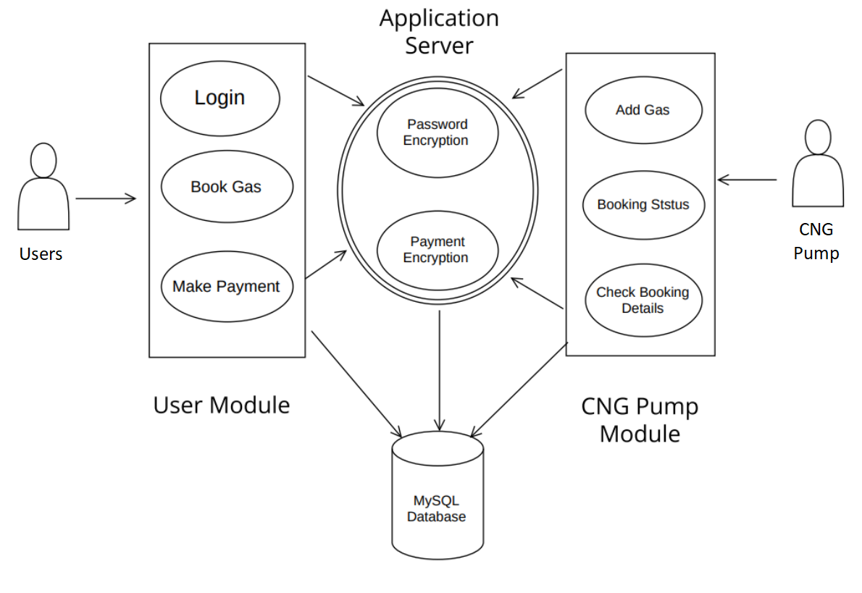

**Figure 1:** System Architecture

# MODELLING AND ANALYSIS

## Purpose:

• Transparency and Trust: The CNG industry can benefit greatly from enhanced transparency and trust in the booking process. Blockchain technology offers a decentralized and immutable ledger that can provide transparent records of transactions, ensuring fairness and accountability in the allocation of CNG resources. By leveraging blockchain, the project aims to instill trust among customers, CNG suppliers, and other stakeholders.

• Security and Data Integrity: Security is a critical aspect of any booking system, especially when it involves financial transactions and customer data. Blockchain’s cryptographic techniques and distributed nature provide a high level of security, protecting customer information and minimizing the risk of fraud, unauthorized access, or data manipulation.

• Industry Innovation and Adaptation: Embracing blockchain technology in the CNG industry demonstrates a commitment to innovation and adaptation to modern technologies. It positions the industry at the forefront of digital transformation, potentially attracting new customers and investment.

**Features:**

**1. User Registration:** Users can create an account by providing their personal details, contact information, and vehicle information.

**2. Booking Management:** Users can schedule CNG gas refills by selecting a preferred date, time, and location for refueling.

**3. Real-time Availability:** The system provides real-time information on the availability of CNG at different refueling stations, allowing users to choose a station with available gas.

**4. Booking History:** Users can view their past CNG refills, including details such as date, time, location, and quantity of gas filled.

**5. Encrypted Payment Integration:** The system allows users to make online payments for their CNG refills using various payment methods, such as credit/debit cards, digital wallets, or other electronic payment options.

**6. Mobile Applications:** To enhance user convenience, the CNG gas booking system may include dedicated mobile applications compatible with both iOS and Android platforms, allowing users to access the system's features from their smartphones.

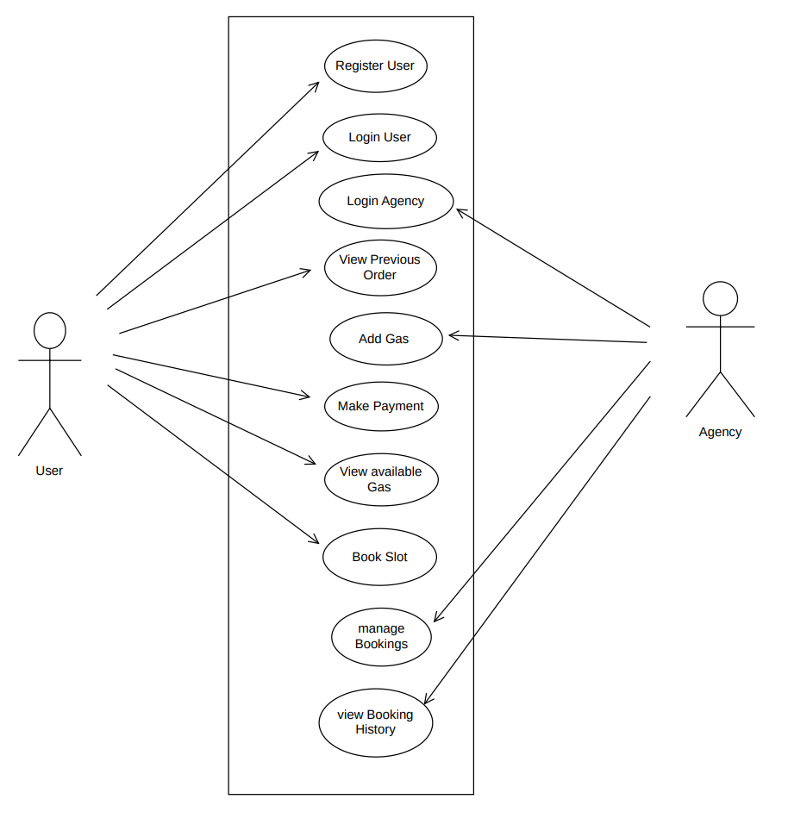

**Figure 2**: Use case Diagram

DFD Diagram:

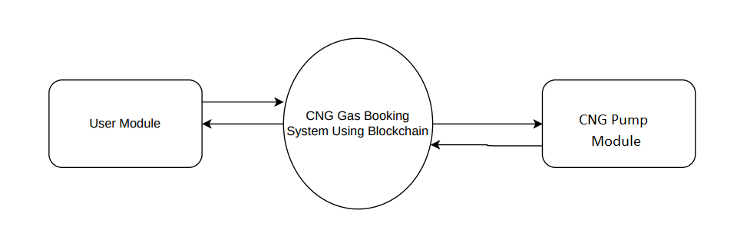

**Figure 3**: DFD level 0

# RESULTS AND DISCUSSION

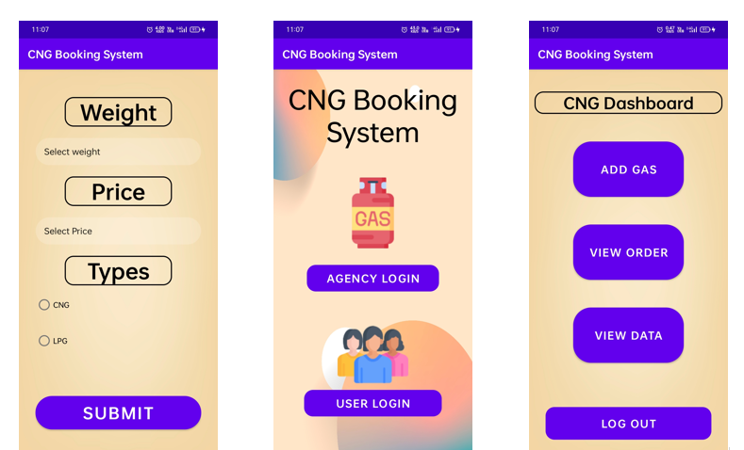

**Figure 4:** Add Gas. **Figure 5:** Main page. **Figure 6:** Dashboard.

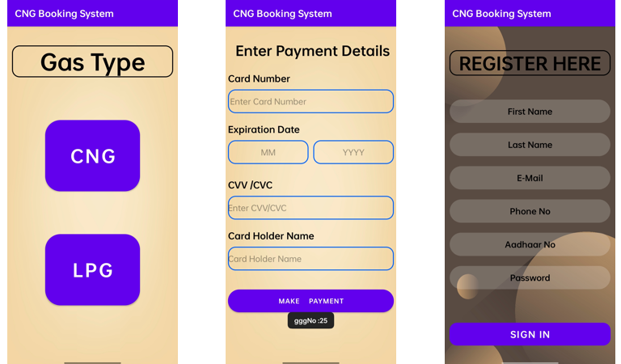

**Figure 7**:Gas type **Figure 8**:Payment **Figure 9**:Registration

# CONCLUSION

Eradicates the need to stand in a queue to fill the gas as well as provide the feedback analysis this feedback could be used to improve the service. Using sentiment analysis for finding sentiments in the comments. Naive bayes is one of most easiest and simple algorithm to find the sentiment of the text. Blockchain is the proficient technology of current years. Structure of blocks, formation of chains, characteristics, some terms or taxonomy of blockchain technology has mentioned in the paper to pull in wonderful consideration in both research studies and enterprise applications. There are various platforms which support this technology to provide attractive feature and add-on in that features in progress.

# REFERENCES

1. Andrea Horch ; Holger Kett ; Anette Weisbecker, “Mining E-commerce Data from E-shop apps” published by IEEE on 3 December 2015
2. Jianxia Chen ; Ri Huang, “A price comparison system based on Lucene” published by IEEE on 15 July 2016
3. Ladislav Beranek ; Radim Remes, “E-commerce network with price comparator sites” published by IEEE on 1 August 2019
4. Ehtesham ul haq Dar, Jurgen Dorn ¨ Classification of job offers of the World Wide Web - International Conference on Computing, Mathematics and Engineering Technologies (iCoMET) on 26 April.
5. M. Filipović Tretinjak The Implementation of QR Codes in the Educational Process - 38th International Convention on Information and Communication Technology, Electronics and Microelectronics on 16 July 2015.
6. Research on an Algorithm of Metasearch Engine Based on Personalized Demand of Users Xue Yun, Shen Xiaoping, Chen Jianbin International Forum on Information Technology and Applications on 18 July 2010.
7. The use of web scraping in computer parts and assembly price comparison LR Julian, F Natalia - 2015 3rd International Conference on …, 2015 - ieeexplore.ieee.org
8. An overview on web scraping techniques and tools AV Saurkar, KG Pathare, SA Gode - International Journal on Future …, 2018 - ijfrcsce.org
9. Web scraping for unstructured data over web GN Chandrika, S Ramasubbareddy, K Govinda… -

Embedded Systems and …, 2020 – Springer

1. Shridevi Swami , Pujashree Vidap ,” Web Scraping Framework based on Combining Tag and Value Similarity” Proceedings of the IJCSI International Journal of Computer Science Issues, Vol. 10, Issue 6, No 2, November 2013.
2. Dr. Rajendra Nath ,Khyati Chopra,” Web Crawlers: Taxonomy, Issues & Challenges” Proceedings of the International Journal of Advanced Research in Computer Science and Software Engineering , Volume 3, Issue 4, April 2013, pp. 944-948.
3. Jos´e Ignacio Fern´andez-Villamor, Jacobo Blasco-Garc´ıa, Carlos ´A. Iglesias, Mercedes Garijo “