**Investigation on the mechanical properties of self-healing concrete used for pavements**

**By**,

Dhanush C S (1DT19CV010)

Naveen Kumar J (1DT19CV030)

Parameshwar T L (1DT19CV034)

Parvez Patel (1DT19CV035)

**Under the guidance of**

Dr. M K Harikeerthan

Associate Professor

&

Dr. Shubhalakshmi B S

Assistant Professor

**DAYANANDA SAGAR ACADEMY OF TECHNOLOGY AND MANAGEMENT –BANGALORE**

**DEPARTMENT OF CIVIL ENGINEERING**

ABSTRACT

Concrete has taken hold of the world of infrastructure incredibly quickly. It has become the most used man-made material in construction industry. Cracks are formed in concrete as concrete is weak in tension. These cracks allow moisture and different types of chemicals into concrete and decrease its durability and strength. Nowadays repair, rehabilitation, and maintenance of structures is expensive and time-consuming. So to overcome this problem autonomous self-healing mechanism is introduced in concrete which helps to repair cracks and also improves the strength of the concrete. To prepare self-healing concrete we have used Biological methods-. In this method, Bacillus Subtilis bacteria and Calcium lactate was added to the concrete mix. The production of calcium carbonate in bacterial concrete is limited to the calcium content in cement. Hence calcium lactate is externally added to be an additional source of calcium in the concrete. When cracks appear the bacteria will produce limestone and fills the cracks. This bio concrete possesses quality to repair itself and thus increasing the sustainability of concrete.

**INTRODUCTION**

**General**

Concrete has become a basic building element for the present world. The versatility of concrete made the world to use the material like any other. It has good fire resistance, adaptability, high compressive strength and it can take any desirable shape or size. But it is a fragile material as it easily cracks because concrete is weak in tension. Once formation of cracks take place in the concrete it leads to decrease in durability and strength of the concrete structure. This in turn causes deterioration of structure so these micro-cracks are prone to concrete structures. To treat these micro-cracks by traditional methods requires constant maintenance, routine inspections, time and energy. Moreover to reduce the damage that is caused by cracks require concrete this makes additional production of cement and this leads to release high amount of carbon dioxide in to the environment. To overcome these cons we have to use an alternative repair method where we can decrease usage of concrete and increase the durability and strength for the concrete structure..

**1.2 Self- Healing Concrete**

Self-healing of concrete to is of various methods to treat cracks. For each method the healing agent which we use will change like capsule-based bacteria, vascular healing, shape memory alloy, chemical based and super absorbent polymers. The inspiration for creating SHC is from, when there is a scratch on the human skin the wound will heal itself without any disturbance and there will be internal mechanism to self-heal. In the same way the cracks will heal by using SHC. The healing agents which we use will change the properties of the concrete and they should have some features like crack repairing should be done automatically, there should not be any negative effect on the materials should have long lasting potential of self-healing, should be economical.

**1.3.1 Bacteria used in Bacterial concrete**

The selection of bacteria for the microbial concrete based on the existence of bacteria in alkaline medium and their metabolic pathways. If the pH value is more than 10 many microorganisms cannot survive. The bacteria belongs to bacillus family are able to survive in the high alkaline medium. It is found out that heterotrophic bacterium precipitate more amount of calcium carbonate (CaCO3) than the autotrophic bacterium. The mechanical properties like compressive strength, flexural strength, split tensile strength and crack healing capability of the bacterial concrete depends up on the bacterium we use in the concrete mix. From the literature review bacterium like B. subtilis, B. pasteurii, B. megaerium, B. sphaericus, B. aerius, and Deleyahalophilia are the some of the bacterium used in their study with different concentrations of bacteria are added to the concrete mixes and it is found that there is improvement in mechanical and durability properties of bacterial concrete and also for crack treating.

**LITERATURE REVIEW**

**2.1 General**

Concrete has become an integral part in the field of construction, and it is mostly used building material. Concrete has extremely high compressive strength, but it has low tensile strength and it leads to the formation of cracks and it leads to decrease in durability of the structure. To treat these cracks traditional methods are used for crack repairing but there will be an increase in the usage of concrete and carbon dioxide. So we have to use a method to treat cracks by reducing usage of concrete and improving durability of the structure. This leads to the development of SHC where crack heal itself without any external disruption. Initial studies were done by H.M.Jonkers, V.Ramakrishanan, and E.Schlange.

**2.2 Review of Previous Studies**

Kim Van Tittelboom et al. 2016 [1] he said that use of synthetic polymers for treating repairs is unfavorable to the environment so in the present investigation he used biological method to repair cracks. For this he used Ureolytic bacteria namely Bacillus sphaericus and this bacteria is used to fill the cracks with calcium carbonate and we have to provide calcium lactate as a calcium source. In the present research the amount of crack healing was compared for biological method and traditional method by using water permeability test, visual examination and ultrasonic pulse velocity test. From the experimental results we can say that crack healing by biological method is more effective than traditional methods. Crack healing by using biological method leads to decrease in water permeability than traditional methods.

Henkm.jjonkers et al. 2010 [2] crack formation is commonly spotted in the concrete structures. The formation of micro-cracks affects the structural properties of the building and decrease the strength of the building. To heal the cracks a novel study was carried out by using the bio-chemical two-component self-healing agent which consists of 6% calcium lactate and bacterial spores concentration of 1.7×10^5. This mixture is inserted in expanded clay particles and these agents will be released from clay particles upon crack formation when water enters into micro cracks..

**MATERIALS AND METHODOLOGY**

**3.1 Methodology**

The different methods utilized in this research include the following:

COLLECTION OF MATERIALS

DETERMINATION OF PHYSICAL PROPERTIES OF MATERIALS

ADOPTING M 40 MIX DESIGN AS PER IS: 10262-2009

CASTING

CURING

TESTING ON HARDENED CONCRETE

ANALYSIS AND DISCUSSION

CONCLUSION

**Collection of Materials :**

1. Cement : OPC 53

2. Fine Aggregate

3. Coarse Aggregate : Crushed Stone of size 20mm

4. Water : Portable water

5. Bacterial Solution : Bacillus Subtilis is a laboratory cultured bacterium

6. Calcium Lactate

7. Super Plastcizers

Physical Properties of Materials

**3.3 Tests on Cement:**

3.3.1 Specific Gravity of Cement

Code of practice – IS 2720(Part3)

Specific gravity = (W2−W1)/(W2−W1)−(W3−W4)×0.79

Where,

W1 =Weight of the empty flask

W2 =Weight of flask + cement

W3 =Weight of flask + cement + kerosene

W4 =Weight of flask + kerosene

The specific gravity of kerosene = 0.79

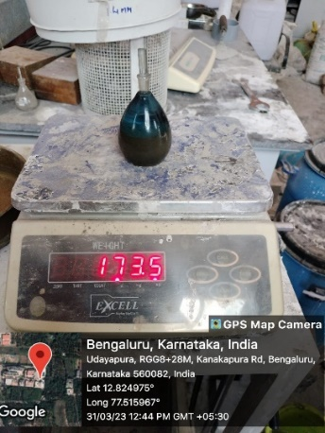

Fig. 3.5. Specific gravity test on cement

Result: Specific gravity of cement is

Table 3.7 – Specific Gravity of Cement

|  |  |
| --- | --- |
| **Description** | **Values (grams)** |
| Weight of the empty bottle (W1) | 128 |
| Weight of bottle + cement (W2) | 178 |
| Weight of bottle + cement+ kerosene (W3) | 432 |
| Weight of bottle + full kerosene (W4) | 398 |

**3.4 Tests on Aggregate**

3.4.1 Specific gravity of Fine Aggregate

Code of practice – IS 2386 (Part3)

Fig 3.6. Specific gravity test of aggregates

Specific gravity (G) = (W2−W1)/(W2−W1)−(W3−W4)

Table 3.8 – Specific Gravity of Fine Aggregate

|  |  |  |
| --- | --- | --- |
| **S.NO** | **Observations** | **Fine Aggregate** |
| 1 | Weight of empty pycnometer (W1) | 640 |
| 2 | Weight of empty pycnometer + aggregate (W2) | 1470 |
| 3 | Weight of empty pycnometer + aggregate + water (W3) | 1975 |
| 4 | Weight of empty pycnometer + water (W4) | 1460 |

**Result**: Specific Gravity of Fine Aggregate = 2.64

**3.4.3 Specific Gravity of Coarse Aggregate**

Code of Practice – IS 2386 (Part3)

Specific gravity (G) = (W2−W1)/(W2−W1)−(W3−W4)

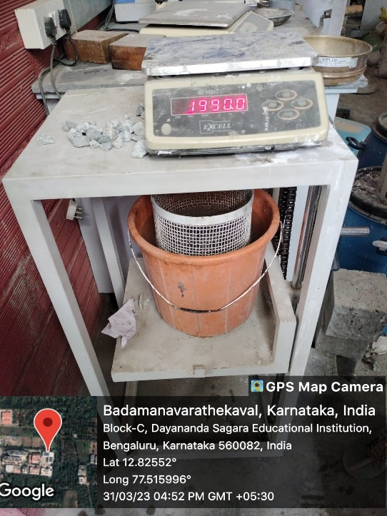

Fig.3.7 Specific gravity test of Coarse aggregate

Table 3.10 – Specific Gravity of Coarse Aggregate

|  |  |  |
| --- | --- | --- |
| **S.NO** | **Observations** | **Coarse Aggregate** |
| 1 | Weight of empty pycnometer (W1) | 640 |
| 2 | Weight of empty pycnometer + aggregate (W2) | 1475 |
| 3 | Weight of empty pycnometer + aggregate + water (W3) | 2060 |
| 4 | Weight of empty pycnometer + water (W4) | 1525 |

**Result:** Specific gravity of coarse aggregate = 2.74

**3.5 Mix Design**

**3.5.1 Stipulations for proportioning**

a) Grade designation M40

b) Type of cement OPC 53 grade

c) Maximum nominal size of aggregate 20mm

d) Minimum cement content 370 kg/m3

e) Maximum water – cement ratio 0.35

f) Workability 50mm (slump)

g) Exposure condition Severe

h) Degree of supervision Good

i) Type of aggregate crushed angular aggregate

j) Maximum cement content 450 kg/m3

**3.5.2 Test data for materials**

a) Cement used OPC 53 grade

b) Specific gravity of cement 3.15

c) Specific gravity of fine aggregate 2.58

d) Specific gravity of coarse aggregate 2.57

e) Water absorption of coarse aggregate 0.50

f) Fineness modulus of coarse aggregate 5.09

g) Fineness modulus of fine aggregates 3.59

**3.5.3 Mix proportions for nominal concrete**

Table 3.8 – Nominal concrete mix proportions

|  |  |  |  |  |  |
| --- | --- | --- | --- | --- | --- |
| **Materials** | **Cement** | **Fine**  **Aggregate** | **C.A**  **20 mm** | **C.A**  **12.5mm** | **W/C** |
| Kg/ $m^{3}$ | 420 | 756 | 678 | 440 | 148 |
| Ratio | 1 | 1.8 | 1.6 | 1.04 | 0.35 |

**3.6 Concreting operations**

**3.6.1 Mixing procedure**

The mixing procedure used in the present experiment was hand fed tilting drum mixer. Mixing was continued until the entire mix becomes homogeneous and uniform in appearance.

**3.6.2 Size of the moulds used for casting specimens**

In the present study, the cube specimens of size 150mm×150mm×150mm are tested to know compressive strength. For determining split tensile strength cylindrical specimens of size 150mm diameter and length 300 mm are tested. The beam specimens of size 500mm×100mm×100mm are tested to know the flexural strength of concrete.

**3.6.3 Placing of concrete**

A uniformly mixed concrete mix was placed in the moulds in three layers. For each layer 25 blows are given using a tamping rod. Before placing the concrete we have to make sure moulds are clean and free from debris.

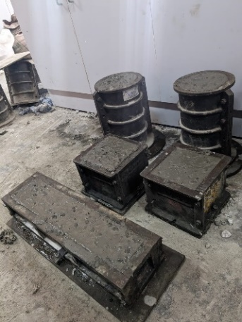

Fig: 3.8 Placing of concrete in the moulds

**3.6.4 Compaction of concrete**

After placing concrete in the moulds it contains entrapped air voids. These air voids are removed by compacting the concrete by using a table vibrator and by compacting we can increase the density of the concrete. The time taken for vibrating is very less and sufficient for concrete to settle uniformly all over the mould. The top surface of mould was smooth finished by using trowel and they are allowed for setting.

**3.6.5 Curing of concrete**

After setting of concrete for 24 hours the moulds are demoulded and concrete specimens are placed in the fresh water. The specimens were tested after 7, 14 and 28 days of curing

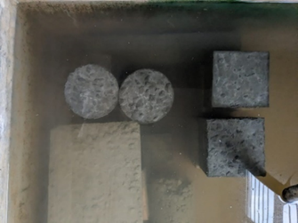

Fig: 3.9 curing of specimens in the water

CHAPTER – 4

EXPERIMENTAL PROCEDURE

**4.1 General**

In this chapter various methods and laboratory tests are used to prepare and test the concrete specimens according to the Indian standard codes. Up to now various tests are performed on cement, coarse aggregate, and fine aggregate to know their properties and to decide the suitability of these materials for use in making the concrete mix. SHC was prepared by using self-healing agents like Bacillus subtilis bacteria. By using these agents bacterial concrete specimens and SHC using chemical specimens are cast to compare the mechanical properties between conventional concrete to self-healing concrete and observing the self- healing of cracks in concrete. For this we need caste and test both the conventional and self-healing concrete cubes, cylinders specimens on compression testing machine for compression strength, split tensile strength, and prisms are tested on a universal testing machine for flexural strength.

The experimental setup and procedure for conducting various tests on nominal concrete and SHC specimens are discussed below.

**4.2 Compression Test**

1. The concrete cube specimens are tested according to IS code: 516-1959. The size of the cubes cast was 150×150×150mm3.

2. The compression test was carried out on nominal concrete, bacterial concrete and SHC using chemical cube specimens.

3. The SHC mixtures were prepared by adding two self-healing agents with different proportions of bacterial solution from 0 to 4 %. The concrete mixing was done until the mix is uniform by using drum mixer.

4. Before casting the cubes make sure the cube moulds are cleaned and inner surfaces of the mould are oiled. Place the concrete in the moulds and compact each layer by using tamping rod and smoothen the top surface by using trowel.

5. The cubes are demoulded after 24 hours and they are marked and submerged in the fresh water for curing. The cubes were tested after 7 and 28 days of curing by using compression testing machine to know the compressive strength of concrete.

6. Remove the cube specimens from the water after completion of stipulated time and take the measurement of concrete specimens by calculating cross-sectional area of the specimen.

7. Clean the base plate of the machine and align the cube specimen in the center of the loading area. Now place the piston on top surface of specimen and apply the load gently without shock still the concrete specimen fails.

8. After specimen fails note down the peak load and peak stress of the specimen. Now release the piston and clean the concrete debris which is on the base plate.

9. The compressive strength of the concrete was calculated by using following equation.

Compressive strength of concrete = Ultimate compressive load (N) / Area of cross section (mm2)

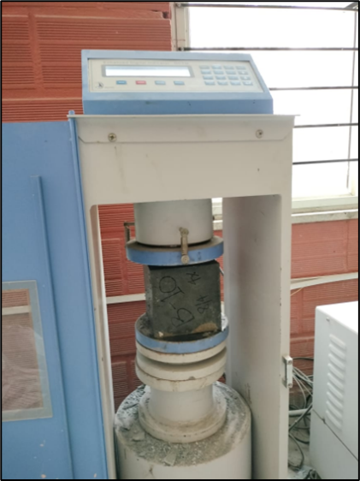

Fig 4.1 Compression Test

**4.3 Split Tensile Test**

1. The cylinder specimens are tested according to IS code: 5816-1999. The cylinder specimens used for testing is of size 150 mm diameter and 300 mm length.

2. Before casting of the cylinders the cylinder moulds are cleaned and oil was applied to the inner surfaces of the mould. The specimen is supported with a base plate which is attached to the cylinder.

3. By applying oil the concrete will not stick on the inner surface of the mould and it helps in easy removal of specimens from the mould without any deformations.

4. The nominal concrete and SHC mixing was done uniformly by using hand tilting drum mixer. These mixes are poured into the cylindrical moulds and they are placed on the table vibrator and compacted the concrete. So that the concrete will be free from air voids and make the concrete denser.

5. The surface of the concrete is finished by using a trowel. After 24 hours the cylinder specimens are demoulded and submerged in the freshwater for curing and these specimens were tested after 7 and 28 days of curing.

6. After curing the specimens are placed in the compression testing machine horizontally. The upper plate is lowered such that it touches the top surface of the specimen.

7. Now apply the load continuously without any jerks and wait for the failure of the specimen at peak load and note down the load. The split tensile strength of the concrete specimen was known by using the following equation.

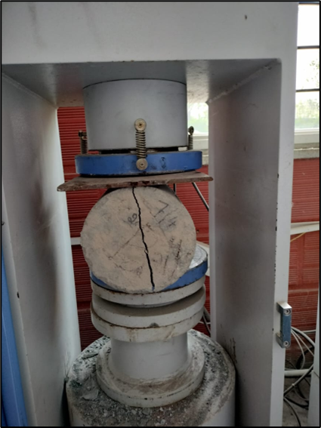

Fig 4.2 Split Tensile test

**4.4 Flexural Strength Test**

1. The concrete beams used for flexural strength are cast and tested according to IS code: 516-1959. Beam mould of size 100mm×100mm×500mm was used.

2. The moulds of the beam are cleaned properly and oiled before casting. By applying oil we will easily remove the specimens without any damage.

3. The self-healing concrete mix and the normal concrete mix were prepared uniformly by mixing in hand tilting drum mixer. These mixes are poured along length of the moulds and moulds are placed on the table vibrator for compacting the concrete.

4. After 24 hours the beam specimens are demoulded and submerged in the freshwater for curing. The specimens were tested after 7,14 and 28 days of curing to know flexural strength or modulus of rupture of concrete.

5. The specimens are placed in the universal testing machine in such a manner that prism is mounted on rollers where the distance between the rollers was 400mm.

6. Before applying the load we have to make sure that the specimen was positioned exactly centered within the UTM and specimen facing is uppermost finishing surface should be normal to the applied load.

7. Now apply the load at a rate of loading of 180 kg/min. The load is increased until the prism fails and the maximum applied load on the specimen is noted.

8. The flexural strength of the specimen is also known as modulus of rupture (fb).

After specimen breaks, we have to measure the distance between the line of fracture and nearer support is denoted by ‘a’.

9. When the distance we measure is greater than 133mm then we have to use the following equation for calculating the modulus of rupture.

fb = p×l / b× $d^{2}$

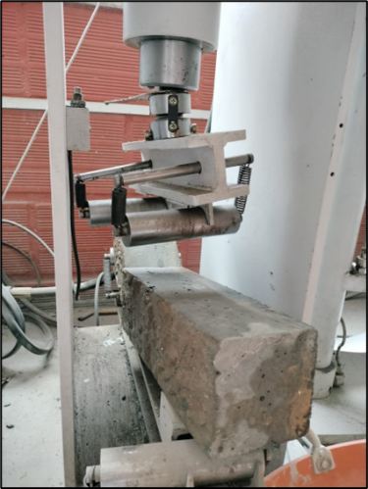

Fig.4.3 Flexural Strength

CHAPTER 5

EXPERIMENTAL RESULTS

**5.1 General**

This chapter deals with the results of the tests performed on conventional concrete and bacterial concrete . Analysis is done based on the test results by using charts. Thus a conclusion is given by studying the analysis of the test results like compressive strength test, flexure strength test, split tensile strength test, self-healing ability of cracked concrete and also future scope of the project is discussed in here.

**5.2 Tests Conducted**

**5.2.1 Compressive strength test**

The following results show the variation in compressive strength of cubes which are casted by means of biological method with different proportions.

Table 5.1 Compressive strength results of nominal concrete

|  |  |  |  |
| --- | --- | --- | --- |
| **Mix Proportion [M40]** | **7days N/ ${mm}^{2}$** | **14days N/ ${mm}^{2}$** | **28days N/ ${mm}^{2}$** |
| **Nominal (150*150*150)** | 24.4 | 32.1 | 45 |

Table 5.2 Compressive strength results of Bacterial concrete

|  |  |  |  |
| --- | --- | --- | --- |
| **Mix Proportion [M40]** | **7days $N/{mm}^{2}$** | **14 days $N/{mm}^{2}$** | **28 days $N/{mm}^{2}$** |
| **Cube 2%** | 31.8 | 42.0 | 48.7 |
| **Cube 4%** | 36.3 | 44.6 | 54 |

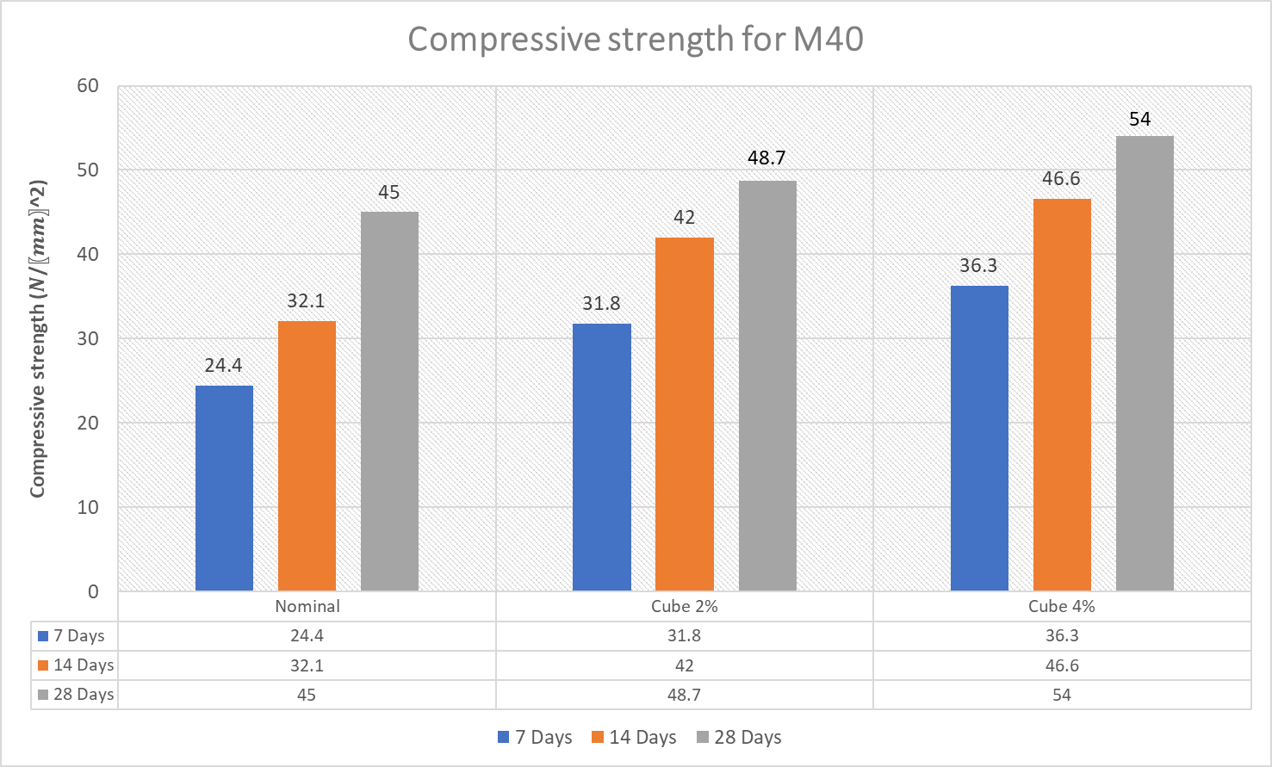

Graph 5.1 Shows variation in compressive strength

Graph 5.1 shows the variation of 7, 14 and 28 days water cured average compressive strength of nominal and Self healing concrete of 2% and 4% . From the graph it was observed that Self healing concrete of 4% has more compressive strength 54 N/ ${mm}^{2}$

**5.2.2 Flexural Rigidity test results**

The following results show the variation in flexural rigidity of specimens for different bacterial concrete.

Table 5.3 Flexural Strength results of nominal concrete

|  |  |  |  |
| --- | --- | --- | --- |
| **Mix Proportion [M40]** | **7days N/ ${mm}^{2}$** | **14days N/ ${mm}^{2}$** | **28days N/ ${mm}^{2}$** |
| **Nominal (500*100*100mm)** | 3.5 | 4.5 | 6.45 |

Table.5.4 Flexural Strength results of bacterial concrete

|  |  |  |  |
| --- | --- | --- | --- |
| **Mix proportion**  **M40** | **7days $N/{mm}^{2}$** | **14 days $N/{mm}^{2}$** | **28 days $N/{mm}^{2}$** |
| **Beam 2%** | 4.60 | 5.8 | 8.62 |
| **Beam 4%** | 6.32 | 8.0 | 9.84 |

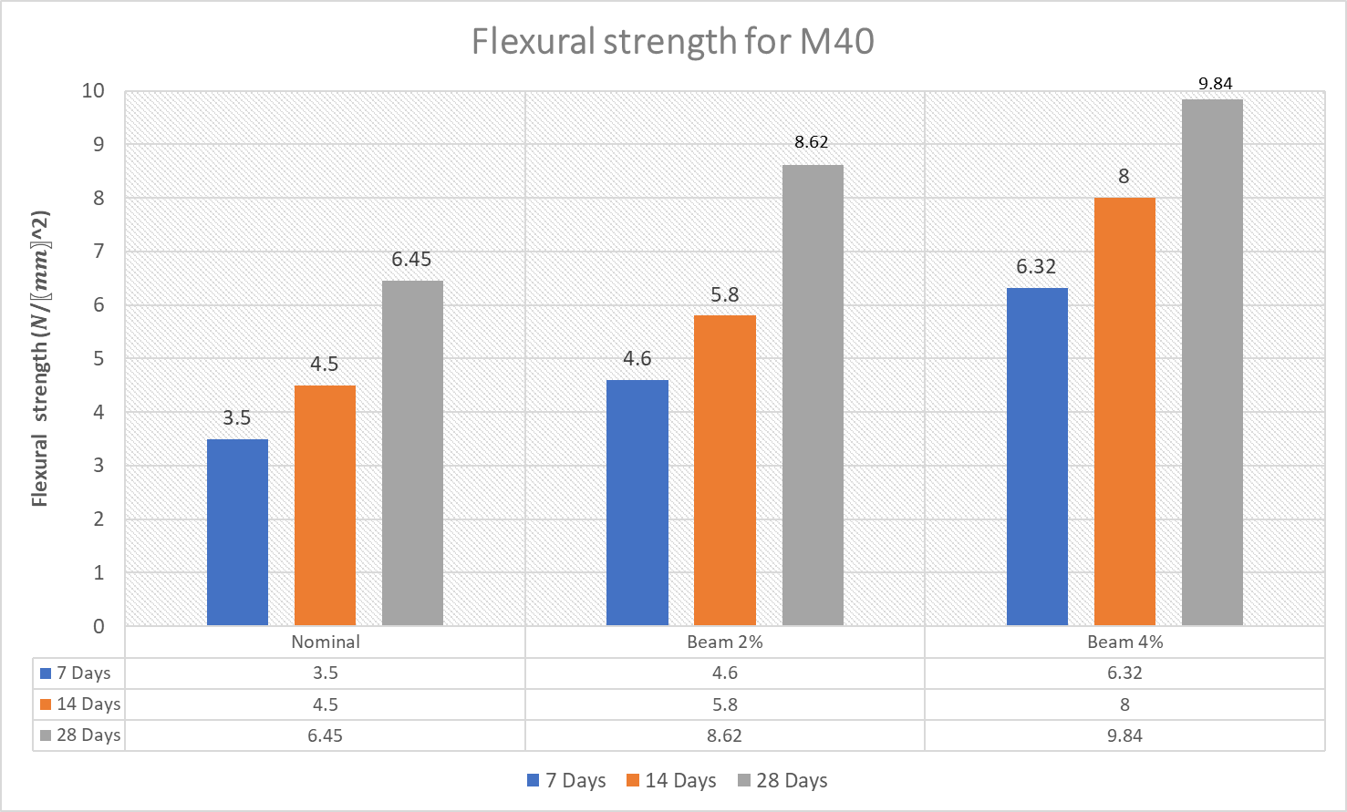

Graph 5.2 Shows variation in Flexural strength

From the experimental graph , shows the variation of 7, 14 and 28 days water cured average Flexural strength of nominal and Self healing concrete of 2% and 4% . From the graph it was observed that Self healing concrete of 4% has more flexural strength 9.84 N/mm^2

**5.2.3 Split tensile strength test results**

The following results show the variation in split tensile strength of specimens for different bacterial concrete with different proportion.

Table 5.5 Split tensile Strength test results of nominal concrete

|  |  |  |  |
| --- | --- | --- | --- |
| **Mix Proportion [M40]** | **7days** N/ ${mm}^{2}$ | **14days** N/ ${mm}^{2}$ | **28days** N/ ${mm}^{2}$ |
| **Nominal (Depth 300mm, Dia 150mm)** | 3.3 | 5.4 | 8.2 |

Table 5.6 Split tensile strength test results of bacterial concrete

|  |  |  |  |
| --- | --- | --- | --- |
| **Mix proportion**  **M40** | **7days $N/{mm}^{2}$** | **14 days $N/{mm}^{2}$** | **28 days $N/{mm}^{2}$** |
| **Cylinder 2%** | 4.5 | 7.3 | 11.7 |
| **Cylinder 4%** | 3.86 | 6.2 | 11.2 |

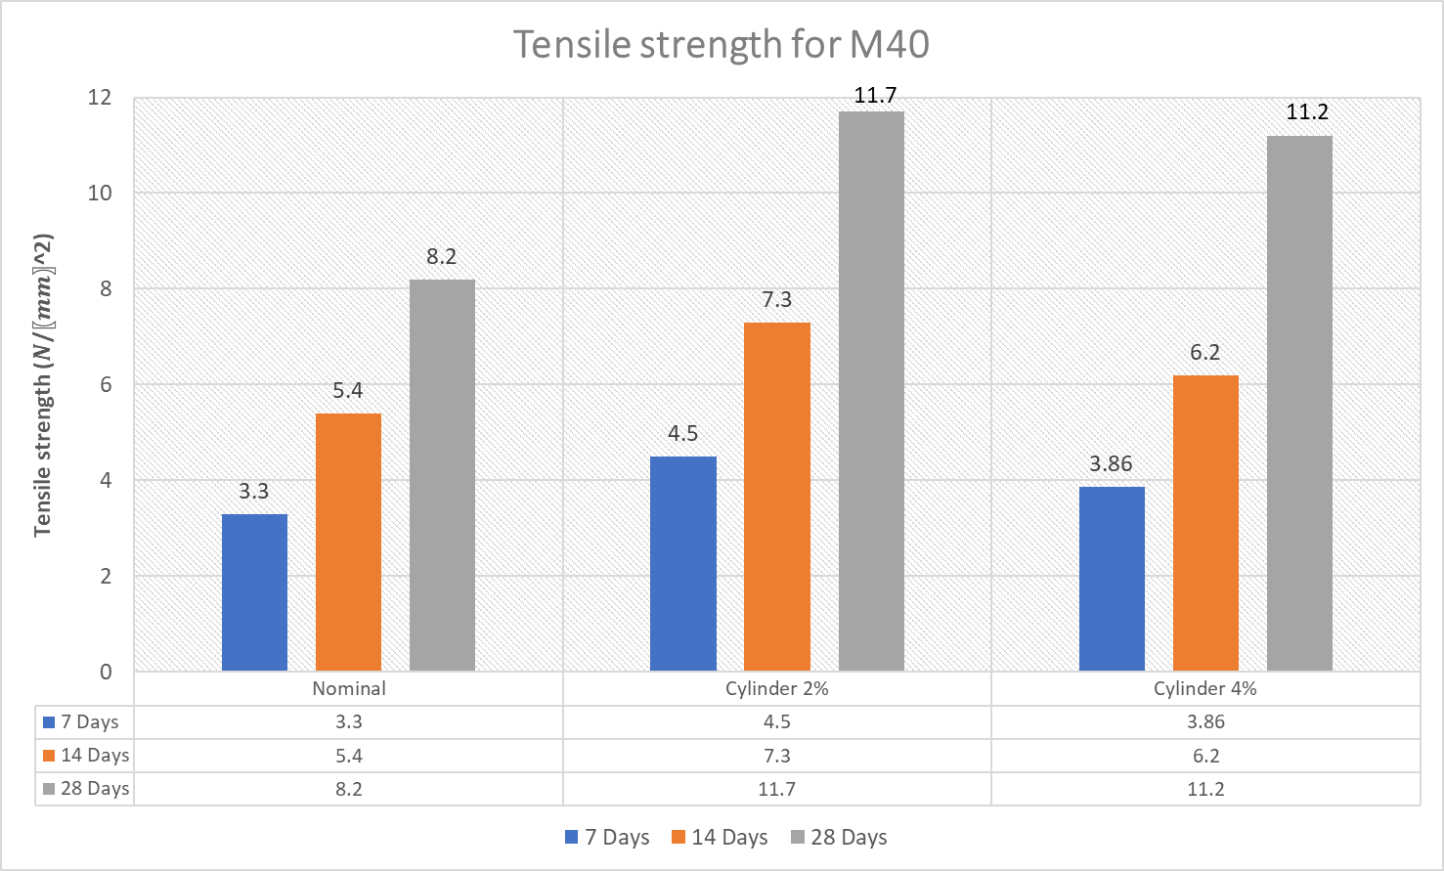

Graph 5.3 Shows variation in Tensile strength

From the experimental graph , shows the variation of 7, 14 and 28 days water cured average Tensile strength of nominal and Self healing concrete of 2% and 4% . From the graph it was observed that Self healing concrete of 4% has more flexural strength 11.2 N/ ${mm}^{2}$

**5.2.4 Self Healing Mechanism**

The 150 mm size cubes of bacterial concrete were pre-cracked at the age of 7 days. By using compression testing machine the cubes are tested at1/3 load for creation of cracks and these cracked specimens are kept in water for curing. Most of cubes of bacterial concrete were healed after 28 days of curing. After healing of cracked specimens again they are tested under compression testing machine.

Table 5.7 Shows values of initial and final stress of Bacillus bacterial concrete

|  |  |  |  |  |
| --- | --- | --- | --- | --- |
| **Mix proportions** | **1/3 load**  **(kN)** | **Initial stress before healing**  **(N/mm2)** | **Finial load**  **(kN)** | **Final stress after healing**  **(N/mm2)** |
| 2% bacterial solution + 0.5% calcium lactate | 365.24 | 16.233 | 1019.25 | 45.3 |
| 4% bacterial solution+ 0.5% calcium lactate | 405 | 18.0 | 1165.05 | 51.78 |

Before After 28 days

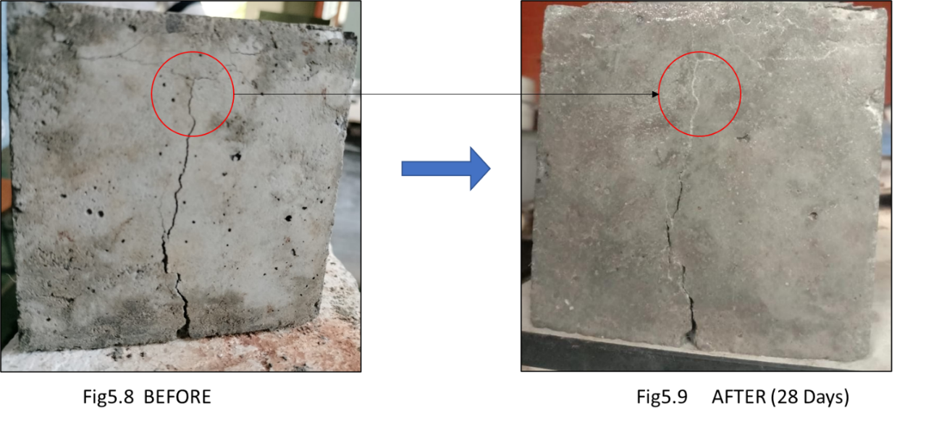

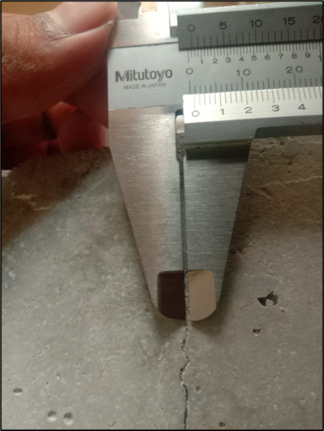

Fig 5.10 Measurement of cracks using Vernier Callipers

**CHAPTER 6**

**CONCLUSION**

Based on the results of this experimental work the following conclusions can be made.

1. Incorporating bacteria improves mechanical qualities because long-term compressive and tensile strength rises depending on the bacteria incorporated.

2. The 28 days compressive strength for nominal mix is 45 MPa. For bacterial concrete specimens there is an increase in compressive strength by 20% compared to nominal concrete.

3. The 28 days split tensile strength for nominal mix is 8.2 MPa. For bacterial concrete specimens there is an increase in tensile strength of 34% compare to nominal concrete.

4. The 28 days flexural strength for nominal mix is 6.45 MPa. For bacterial concrete specimens there is an increase in flexural strength by 52.55% compared to nominal concrete.

5. The addition of 4% of bacillus subtilis to M40 concrete grade results in the highest compressive strength for seven days and 28 days, the compressive strength of bacillus subtilis concrete at seven days, and 28 days are raised.

6. As a result, the addition of Bacillus subtilis causes an increase in compressive strength up to a maximum and subsequently a reduction.

7. From the results based on strength and self-healing of cracks it may be concluded that bacterial concrete gave better results than nominal concrete.

8. Self-healing concrete is the best solution for the demand of sustainable concrete due to its ability of self-repair and durability.

**LIST OF INDIAN STANDARD CODES**

**Sl. No Indian Standard Number Designation of Code**

1. IS:383-1970 Specifications for coarse and fine agg from natural sources of concrete.

2. IS:456-2000 Code of practice for plain and

reinforced concrete.

3. IS 2386 :1963(Part-1) Methods of test for aggregates for concrete.

4. IS 2386 :1963(Part-3) Methods of test for aggregate.

5. IS 516 :1959 Methods of tests for strength of

concrete.

6. IS 1199 :1959 Methods of sampling and analysis of

concrete.

7. IS 10262 :2009 Recommended guidelines for

concrete mix design.

**REFERENCES:**

1. Kim Van Tittelboom, Nele De Belie, “Use of bacteria to repair cracks in concrete”, journal of Cement and Concrete Research 40 (2010) 157–166
2. Virginie Wiktor and Henk M. Jonkers, “Quantification of crack-healing in novel bacteria-based self-healing concrete”, Cement & Concrete Composites 33 (2011) 763–770.
3. Navneet Chahal and Rafat Siddique, “Influence of bacteria on the compressive strength, water absorption and rapid chloride permeability of fly ash concrete”, Construction and Building Materials 28 (2012) 351–356
4. James Gilford III, and Marwa M. Hassan, “Dicyclopentadiene and Sodium Silicate Microencapsulation for Self-Healing of Concrete”, Journal Of Materials In Civil Engineering © ASCE / MAY 2014 26(5): 886-896
5. Suganya Devi K and VigneshKRajapreethi, “Novel Technique of Sodium Silicate in Healing of Concrete”, IJSRD - International Journal for Scientific Research & Development| Vol. 4, Issue 03, 2016 | ISSN (online): 2321-0613
6. M.S. Shetty, “Concrete Technology Theory And Practice”
7. Sandip Mondal and Palash Das, “Application of Bacteria in Concrete”, Journal of Materials Today: Proceedings 4 (2017) 9833–9836.
8. Kunamineni Vijay and Meena Murmu, “Bacteria based self-healing concrete”, Construction and Building Materials 152 (2017) 1008–1014.
9. P Jagannathan and K S Satyanarayanan, “Studies on the mechanical properties of bacterial concrete with two bacterial species”, Journal of Materials Today: Proceedings 5 (2018) 8875–8879.