Feasibility of traffic conflict techniques in traffic safety

Anand Prasad**1,**Mr. Miss Shivani**2**

1M.tech Scholar, Satpriya group of institutions, Rohtak, India.

2Assistant Professor, Satpriya group of institutions, Rohtak, India.

**ABSTRACT**

Consolidation of roads in India has led to accidents and minor accidents, mostly at unmanned intersections. While accidents, deaths and injuries are a direct measure of road safety, reliable data is available on different topics. Road traffic is an indirect way of measuring safety. There are many ways to measure traffic intersections today. The German system provides a simple way to identify and record conflict information using conflict precedents and the types of conflicts that lead to them  
The Swedish system requires a detailed analysis of the ground, such as the speed of the vehicles in conflict, the distance between them and avoidance measures. But this is a way of clarifying the great conflict between the little ones. This article uses both the Swedish method and the German traffic problem method to calculate the rest time and evaluation of the Karkari mor overpass.

Keywords: conflict technique, traffic safety, Swedish method, german traffic problem,

Intersections, co-operation and development

**INTRODUCTION**

The International Traffic Safety Data and Analysis Group (IRTAD 2011) is a permanent working group of the Joint Transport Research Centre of the Organisation for economic co-operation and development (OECD) and the International Transport Forum. It is composed of road safety experts and statisticians from renowned safety research institutes, national road and transport administrations, international organizations, universities, automobile associations, the automobile industry, and others from OECD and non OECD countries. Its main objectives are to contribute to international cooperation on safety data and its analysis. The objectives of the IRTAD Group are to be a forum of exchange on road safety data collection and reporting systems, and on trends in road safety policies. Collect accident data and conduct data analysis to contribute to the work of the OECD, as well as to provide advice on specific road safety issues. Contribute to international cooperation on road accident data and its analysis. Currently, more than 70 organizations from 34 countries are members of IRTAD - representing a wide range of public and private bodies with a direct interest in road safety.

Road safety levels differ widely between IRTAD members. Road safety performance measured in terms of fatalities per 100 000 population varies three fold between the best and the worst OECD IRTAD countries and nine fold across all IRTAD members and observers. The exposure of different classes of road user to crash risks also varies greatly between IRTAD countries. Pedestrians account for more than a third of all fatalities in Korea, Israel, Japan and Poland, whereas this figure is around 10% in New Zealand, the Netherlands and Norway. Cyclists account for a large share of all fatalities in the Netherlands (22%), in Japan (16%) and Hungary (13%) but only 1 to 2% in the USA, Greece and Northern Ireland. Powered two wheeler (PTW) rider fatalities account for a large share of fatalities in Greece (33%), Italy (30%), France (26%) and Switzerland (24%). The bulk of the substantial fatality reductions in IRTAD countries over the last decade has benefited car occupants a fact that can be largely attributed to the increased passive safety features of cars and also speed management and effective drinking and driving policies with fatalities reduced by nearly half between 2000 and 2010. Results have been less satisfactory for vulnerable road users; however, there has been a reduction of only a third in pedestrian and cyclist fatalities over the last decade. The safety of vulnerable road users continues to be a core road safety issue, not least in lower income countries.

Objective of the study  
In this study Swedish and German traffic conflict techniques are applied simultaneously on Karkari mor flyover and the results are analysed. The main objectives of the study are as follows:

To identify the serious conflicts and their occurrence by classification of conflicts using optimal braking time method of Swedish Traffic Conflict Technique.

To introduce a method for the identification of pedestrian/vehicular conflicts using Time to accident (TA) concept an application of Swedish Traffic Conflict Technique.

LITERATURE REVIEW

Traffic conflict techniques have been used in years at the location where the actual number of accidents is too small to develop remedial measures. The greatest aspect of this technique has been its ability to prevent accidents before they actually happen. Thetraffic conflict measuring technique was developed by General Motors Research Laboratories as early as the 1960's, as a method of measuring accident potential. Some twenty specific conflicts were classified for this purpose. The classification of conflicts is based on the evasive manoeuvre of the vehicles. (Hyden 1987):

The next development involved is the modification of General Motors' definition of conflicts by introducing a grading by severity of the evasive manoeuvre. The English have developed the following five categories of conflicts, grouped together under either slight or serious conflicts (Nel 1988). Some effort was made incorporating a quantitative element in the definition of serious conflicts (Nel 1988). In the Netherlands a serious conflict is defined as: "a sudden motor reaction by a party or both parties involved in a traffic situation towards the other to avoid the collision, with a distance of about one metre or less between those involved".

**EXPERIMENTAL INVESTIGATION**

The main aim of the study is to diagnoses and analysis traffic conflict problems at Karkari mor flyover. Additional aim is to discuss whether a new classification between serious and non-serious conflicts be used for an Indian environment, by using optimal braking time.  
  
Data Collection and Analysis

The data collected is analysed in this section and presented in two parts: (i) Traffic Conflicts and (ii) Traffic Volumes.

The conflict study by Swedish traffic conflict technique was carried out for total 10 days i.e. 2 days per week for 5 weeks during November - December 2022. The study was carried out for two hours daily, one during morning rush period (9am-10am) and second for evening rush period (6pm-7pm). In addition to this traffic conflict study is also carried out by German traffic conflict technique, for one day i.c. on December 3 2022. The conflict data is presented in the conflict recording sheet recommended by Hyden (2001) as shown in Table 1.The Traffic volume study was conducted on Feb 11 2023 at Karkari Mor.

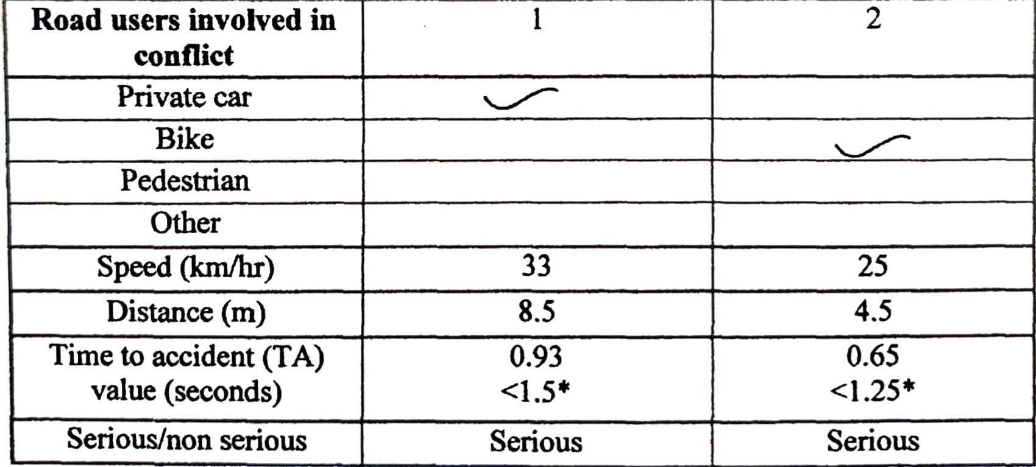

Table 1. Data collection form of Swedish traffic conflict technique

Traffic volume Study

Traffic volume study was conducted on Wednesday Feb 11 2023 during morning one hour i.e. 9-10am and evening one hour i.e. 6-7 pm at Karkari mor flyover.

Traffic volume at morning hour: Results of classified traffic count between 9-10am on Wednesday Feb 11 2023 is presented in Table 2

|  |  |  |  |  |  |  |  |
| --- | --- | --- | --- | --- | --- | --- | --- |
| Road users | Towards karkari road | | | | Opposite road | | |
| 1 hour | AADT | PCU  factors | Total PCU’s | 1 hour | AADT | Total PCU’s |
| Cars | 920 | 9200 | 1.0 | 9200 | 752 | 7520 | 7520 |
| MTW’s | 882 | 8820 | 0.5 | 4410 | 822 | 8220 | 4110 |
| Auto’s | 170 | 1700 | 1.0 | 1700 | 211 | 2110 | 2110 |
| Buses/trucks | 26 | 260 | 3.0 | 780 | 51 | 510 | 1530 |
| Bicycles | 11 | 110 | 0.5 | 55 | 7 | 70 | 35 |
| Total vehicles | 2009 | 20090 |  | 16145 | 1843 | 18430 | 15305 |
| Pedestrians crossing per hour | | | | | 225 | | |

Table 2. Classified Traffic volume in morning hour

**CONCLUSION**

Conclusion on the basis of Swedish Conflict Technique Study:

A total of 60 traffic conflicts were observed during 10 day study, one hour each in morning and evening. Out of these 60 conflicts, 44 conflicts come under the category of serious conflicts and 16 conflicts come under the category of slight conflicts, on the basis of optimal braking time.

Vulnerable road usersare involved in around 77% of the total serious conflicts recorded at the study area Karkari mor flyover > Cars and bike are the most involved (89%) road user groups in most of the conflicts situations.

Most of the road users take braking as avoiding action (70 %). Share of swervingand swerving &braking as avoiding action are 16% and 14% respectively. There was no incidence of acceleration action as the avoiding action. > Bike riders are the major road users involved in the serious conflicts and their share is 66%. Second largest involvement was of cars with a share of 50%.Among the road users taking avoiding action also bike rider are on the top with 41% share followed by cars with 27% share. Around 99% of vehicles are travelling at a speed of below 40-45 km/h at Karkari mor flyover.

**REFERENCES**

1. IRC 86-1983. Geometric design standards for urban roads in plains.

2. NEL, P. W. 1989 b. Traffic Conflict Measuring Techniques: A User's Manual. Division of Road and Transport Technology, Council for Scientific and Industrial Research, Pretoria, South Africa, 1989.

3. TINGVALL, C. 1997.The Zero Vision. A road transport system free from serious health losses. Transportation, Traffic Safety and Health. Springer Verlag, Berlin, pp 37-57.

4. TINGVALL, C. 1997.The Zero Vision. A road transport system free from serious health losses. Transportation, Traffic Safety and Health. Springer Verlag, Berlin, pp 37-57.

5. HYDEN, C. 2001. Conflict studies on urban roads: The Swedish Traffic Conflict Technique, London Institute of Technology, Department of Traffic Planning and Engineering, London, Sweden.

6. PEDEN, M.; SCURFIELD, R. & SLEET, D. 2004. World report on road traffic injury prevention, World Health Organization, Geneva.

7. MARTIN, K. 2006. Traffic calming in Delhi- A feasibility study of traffic safety measures, Department of Development and Planning Aalborg University, Denmark.