**RETAIL MANAGEMENT SYSTEM – REDEMPTION OF SSI**

THIRUMALAI SELVAN.P, SUDHAKARAN.B, SARAVANAN.K, MS. PRINSLIN

Student, Computer Science and Engineering, Agni College of Technology, Chennai – 600 130,

Tamil Nadu, India

Assistant Professor, Computer Science and Engineering, Agni College of Technology,

Chennai – 600 130, Tamil Nadu, India

**ABSTRACT**

In this project, we present a web application for connecting SSI (Small Scale Industries) & LSI (Large Scale Industries) by using the JAVA Spring Framework for the front-end components & back-end components for data processing and storage. The web application provides a user-friendly interface for promoting small scale industries and including GST Calculator UI for easy tax calculation which includes of adding, editing, managing and storing the data, as well as viewing the stocks and trending aspect of the products using pattern analyser. This paves way for the analysation of best-selling products among the customers.

**1.INTRODUCTION**

* Connecting the Small-scale production to retail shops for daily grocery dispense.
* Pattern matching for trending products.
* Managing production and stocks.
* Timely notices for benefits and discounts.
* Promoting small scale industries and including GST calculator UI for easy tax calculation.

**2.BUSINESS ANALYSIS**

* Small scale industries eradicating and not looking for better platform to sell products.
* Lack of knowledge leading to increase in super malls with foreign goods.
* Target audience wants to pay less to publish and subscribe products at low cost.
* Lack of link that promotes indigenous products at quality available to users.

**3. IMPACT OF GST ON SSI**

The Goods and Services Tax is known as the method of Comprehensive indirect Tax which is imposed on the sale, manufacture and consumption of goods and services across India. The Impact of Goods and Services Tax (GST) on Small Scale Industries (SSI) has mixed responses, it has either positive or negative impacts on SSI,

Let’s see some of the positives on impact of GST on SSI

1. **REDUCTION OF TAX COMPLIATIONS**

The GST authority proposes simplified tax compliance which means that GST acts as a company which adheres to the applicable rules and laws for small businesses by doing a replacement of multiple taxes with a single tax. The need for multiple registrations in different states has been eliminated.

**B. INCREASE OF COMPETITIVENESS:**

The cascading effect of taxes on Goods and Services has been reduced due to the GST which does by the reduction of final cost of goods. Due to this effect small businesses have become more competitive in the market.

1. **EASE OF RUNNING A BUSINESS:**

Due to the simplified tax structure by predefined streamlined process of Taxation which makes easier for the small-scale businesses to do business.

Let’s see some of the negative impact of GST on SSI

1. **INCREASE IN COMPLIANCE COSTS:**

As the small-scale businesses need to comply with the various GST rules including timely return filing, invoice matching, and record keeping. This may become a burden for the Small-Scale businesses which runs with limited resources.

1. **PROBLEMS DURING CASH FLOWS:**As the GST Issues deadline for paying GST on the date of Invoice, this may lead to the cash flows problems for the small-scale businesses, this situation arises even When the payment is not received from the customer.
2. **INCREASE IN COMPETITION:**The GST authority has increased competition for small-scale businesses as the all advantages which are enjoyed by the small businesses due to the lower compliance costs under the earlier tax regime has been eliminated.

Apart from these impact of GST on small scale businesses depends on various factors such as their size, sector and location etc.,

**4.CURRENT SCENARIO OF GST ON SSI:**

Previously businesses which have an annual turnover of over 20 lakhs are required to register for GST but now GST Council has raised the minimum threshold for GST Registration from 20 lakhs to more than 40 lakhs.

This 40 lakhs GST system is exceptional for the special category states because of low level infrastructure and minimal amount of turnover. Whereas for Special Category States the businesses which has annual turnover over 10 lakhs are applicable for GST registration but now it has been raised up to 20 lakhs for GST Registration. This System is implemented due to the MSME's Concerns as they have minimal amount of annual turnover.

**5.NEED OF PROTECTING A SMALL-SCALE INDUSTRY:**

Small and cottage industries play a very important role in the economic development of India. Investing capital in small industries helps reduce unemployment and increases self-employment.

**6.PROBLEMS FACED BY THE SMALL-SCALE INDUSTRIES:**

The biggest problems of small-scale industry are low utilization rate of production capacity, ignorance, incompetent management, insufficient financing.

Other problems are lack of marketing support, working capital problem, export problems, lack of technological upgrade, delay in payments

1. **LACK OF MARKETING SUPPORT:**

Small-scale industry lacks market knowledge of competitors, consumer preferences, with the current market trend, the volume of small-scale production is very small and cannot meet the demand of large quantities, their market is very limited. Due to globalization, they have to compete with local industries as well as foreign industries that sell better quality products at low prices. For example, due to heavily subsidized but higher quality imports from China, most Indian SSI units producing toys, electronic products, machine tools, chemicals and locks etc.

1. **LACK OF TECHNOLOGY UPGRADATION:**

Many small-scale industries continue to use primitive, outdated technology, resulting in poor quality and low productivity. They do not have enough money, skills or resources to engage in R&D to develop new technologies. Acquiring technology from other companies is expensive. Therefore, the small industry has no choice but to continue with its old technique.

**C. DELAYED PAYMENTS:**

Small-scale industries buy raw materials in cash, but due to tough competition, they have to sell their product on credit. Buying with cash and selling on credit itself burdens the economy. A bigger problem is the delay in payments, sometimes up to 6 months to 1 year. Not only the private sector is to blame, but even the ministries. Payment delays seriously affect the survival of many small businesses

1. **LACK OF AWARENESS:**

The government has created many organizations to support and help small-scale industries. However, many small business owners are unaware of the various support services available

We try to help small industries to overcome their struggles and problems.

1. **DIRECTORIES OF MODULE:**
2. **AUTHENTICATION AND AUTHORIZATION MODULE:**

This module will handle user and also the SSI (Small Scale Industries) authentication and authorization. It will allow users to register, login, and logout securely.

1. **PRODUCT INFORMATION MODULE:**

This module manages the Product database, including product name, product description, product stock details, product amount details, product category id as well as the product unique id which is assigned to the each and every product of the different categories. It will enable users to add, edit, delete and view the product information.

1. **VENDOR INFORMATION MODULE:**

This module will maintain the information of the materials that the Vendor provides in their vendor authorization and authentication page which includes of Product names, Vendor name, product images, product description which consists of quantity, the active and stocks which are left for the respective products and their trademarks.

1. **RULE ENGINE NOTIFICATION MODULE:**

This module will monitor or checks the E-Mail notifications about the availability of the products and messages will be sent when the stocks are empty.

A rule engine is a software component that is designed to apply a set of predefined rules to data or events and trigger specific actions based on the outcomes of those rules. In the context of notification systems, a rule engine can be used to trigger notifications based on specific criteria or events.

1. **GST MODULE:**

This module is used for calculating the GST for the products based on the category and the type of the product. According to the type of the product the GST is calculated, some of the products are relieved from paying GST, as those products are coming under the category of Tax-free section. The Small-scale industries which are registered for GST are needed to pay the Tax at right amount of Time.

1. **CART MODULE:**

This module will maintain the cart section of the online shopping web application. Whereas the Cart refers to the integral section of the web application, where the total quantity of the products which are about to buy by the customer is mentioned in which it contains the total amount of the products which are going to buy by the customer.

The cart option is an essential feature of e-commerce applications as it allows users to easily manage their purchases, keeps track of the items they intend to buy, and provides a clear summary of the total cost. This feature can improve the user experience by making the shopping process more convenient and efficient, resulting in increased sales and customer satisfaction.

1. **SSI LOGIN AND VENDOR LOGIN:**

This module will maintain the Login page of the both SSI and vendor. For SSI a person who belongs to the SSI can able to access the login page for SSI section and the same steps are followed for the Vendor login section.

1. **SCREENSHOTS:**

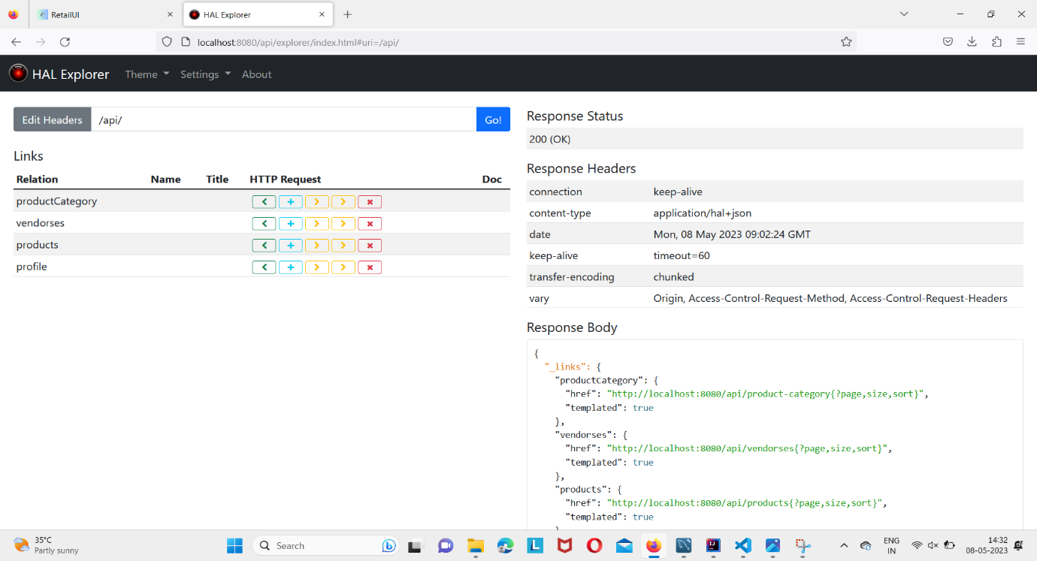

HAL Explorer is a tool designed for interacting with APIs that utilize the Hypertext Application Language (HAL) format. HAL is a hypermedia-driven format used for building APIs that enables clients to dynamically navigate to linked resources.

For users who want to utilize HAL Explorer with a Java-based API, there are several options available. One of the most straightforward methods is to use the HAL Explorer browser extension, which is compatible with any API that employs the HAL format. To use the browser extension, all you need to do is install it on your preferred browser.

If you're working with a Java-based API, there are several options available for integrating HAL Explorer into your workflow. One of the most straightforward options is to use the HAL Explorer browser extension, which is compatible with any API that implements the HAL format. By installing the extension in your preferred browser, you can easily interact with the API and explore its resources using the HAL Explorer interface.

Overall, HAL Explorer is a valuable tool for developers working with HAL APIs, and it offers a user-friendly way to navigate and interact with these APIs. Whether you're a seasoned developer or just getting started with API development, HAL Explorer can help you streamline your workflow and achieve your goals more efficiently.

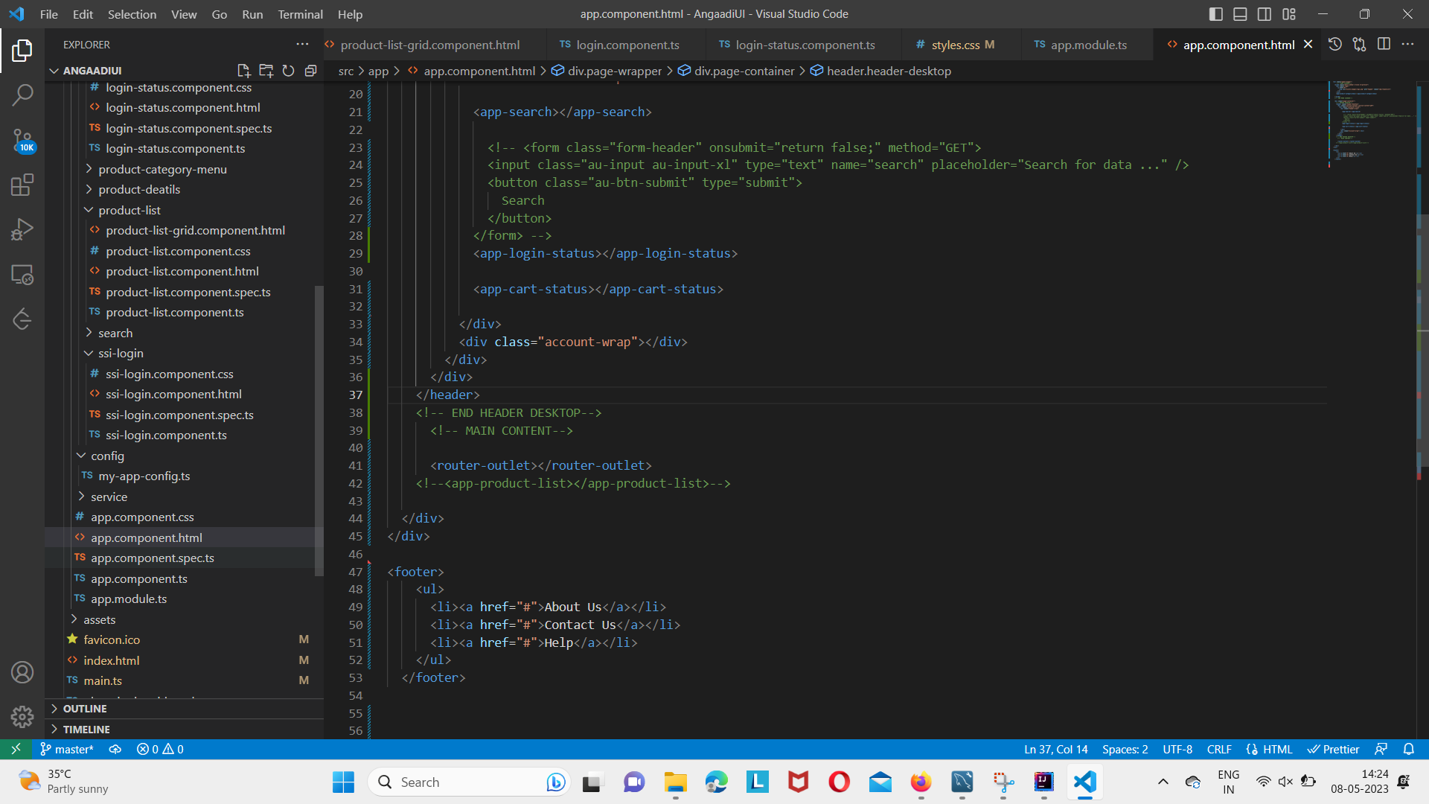

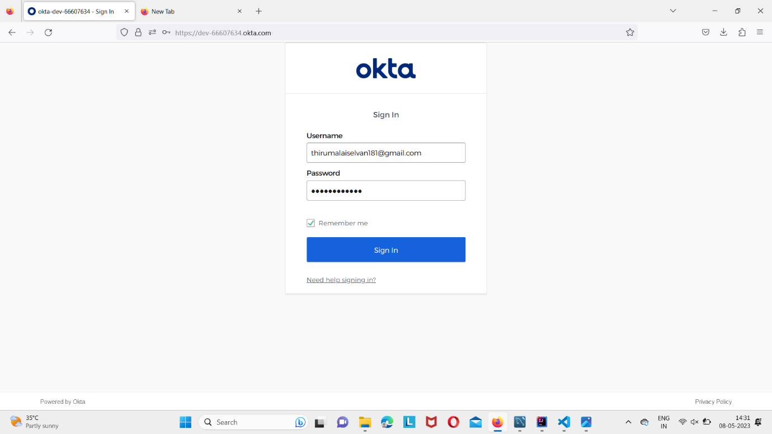

Okta is a widely used identity and access management (IAM) solution designed to enhance application and data security for businesses. Okta offers a variety of application points that allow users to manage their applications and data in a secure manner. Some of the key Okta application points include:

Single Sign-On (SSO): With Okta SSO, users can access multiple applications using a single set of login credentials, making the login process simpler and more secure. This eliminates the need for users to remember multiple usernames and passwords.

Multi-factor Authentication (MFA): Okta's MFA feature provides an additional layer of security by requiring users to provide extra information, such as a code sent to their mobile device or a biometric scan, to verify their identity.

User Provisioning and Lifecycle Management: Okta's user provisioning and lifecycle management features automate the process of granting and revoking access to applications and data based on user roles and permissions, minimizing the risk of unauthorized access.

Access and Governance: Okta offers detailed access and governance reports that allow businesses to monitor and manage user access to sensitive data and applications.

API Access Management: Okta's API access management capabilities enable businesses to secure their APIs by controlling access to them, managing authentication and authorization, and monitoring usage.

Overall, Okta's application points help businesses to enhance their security posture and simplify the management of their applications and data.

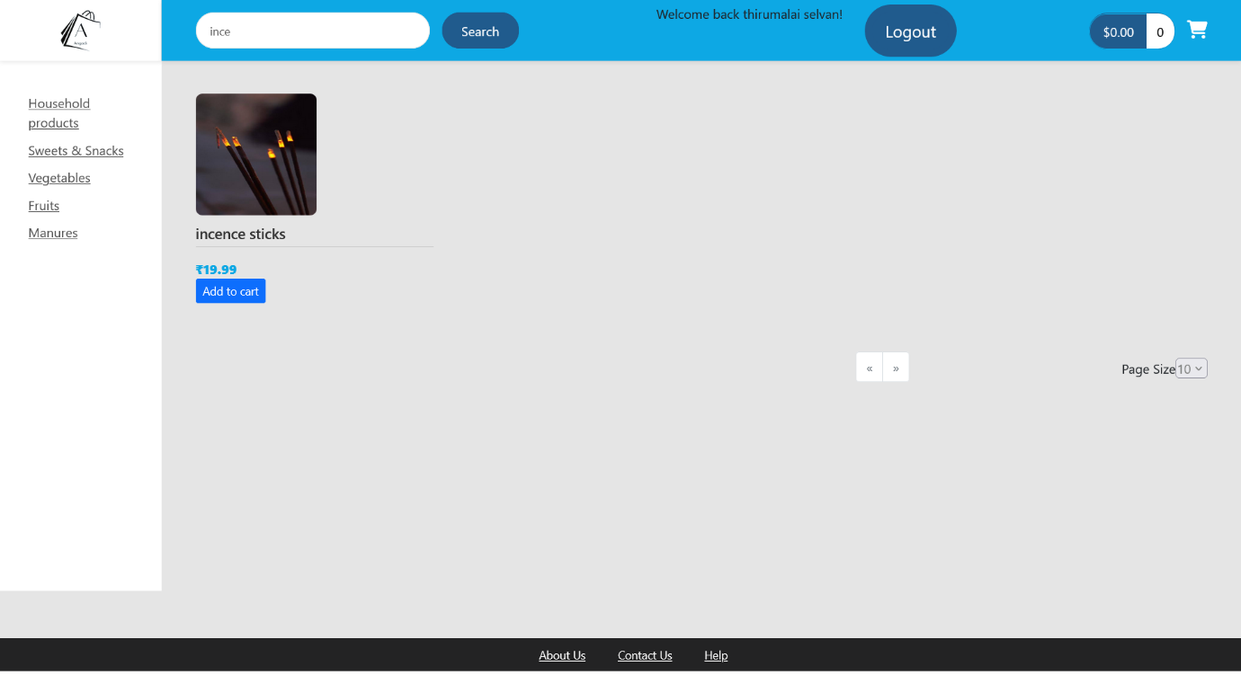

Page segmentation is the technique of dividing a web page into various segments or sections, each with a specific purpose or containing specific types of content. This approach is beneficial in several ways, including enhancing the user experience by making it simpler to navigate and locate information on the page. By implementing page segmentation in web applications, developers can present content in an organized and easily accessible manner, which can enhance usability and user satisfaction.

The cart option in a web application Is a feature that allows users to add Items they Intend to purchase to a virtual shopping cart. It is commonly used in e-commerce applications, where users can browse products, add them to their cart, and proceed to checkout when ready to make a purchase.

Users can view their cart at any time to see the items they have added, modify the quantity or variation of an item, and remove items they no longer wish to purchase. The cart option may also display the total cost of all items, any discounts or promotions that have been applied, and the estimated shipping and handling fees.

The cart option is an essential feature of e-commerce applications as it allows users to easily manage their purchases, keeps track of the items they intend to buy, and provides a clear summary of the total cost. This feature can improve the user experience by making the shopping process more convenient and efficient, resulting in increased sales and customer satisfaction.

1. **CONCLUSION:**

In conclusion we have a presented a web application for the Redemption of Small Scale Industries by creating a joint Venture for Small-Scale Industry with Large Scale Industry .Our application offers several benefits in stock markets which happens by creating a databases for the respective products and it also includes efficiency, scalability& accessibility to the users we believe that our web application represents a valuable tool for businesses looking to improve the Small-Scale Industry production & Marketing abilities, and we hope that our work will Inspire further development in this area.