# Event Management System Using WEB APPLICATION

1.Ramya M,2. Rohan pias A ,3. Renuka T, 4.Mr. Rajesh Kannan

**1,2,3 Student,Department of Computer Science and Engineering, Agni College of Technology, Chennai-600 130,**

**Tamil Nadu, India**

**4 Assistant professor, Computer Science and Engineering, Agni College of Technology,**

**Chennai-600 130, Tamil Nadu, India**

## ABSTRACT

Event management systems are software applications that aid in the planning, execution, and evaluation of events. These systems can be used to manage various types of events, such as conferences, trade shows, and festivals. They offer a range of features that help event organizers streamline their workflows, automate administrative tasks, and enhance communication with attendees.One of the key benefits of event management systems is the ability to centralize event-related data and activities in one platform. This enables organizers to track registrations, ticket sales, and attendance in real-time, making it easier to manage event logistics and make data-driven decisions.

Additionally, event management systems can help organizers create and promote event marketing campaigns, as well as facilitate attendee engagement through personalized messaging and event networking tools. They can also generate post-event reports and analytics that provide insights into event performance and attendee feedback.As the demand for virtual and hybrid events continues to grow, event management systems are evolving to accommodate these formats. They now offer features such as virtual event platforms, livestreaming, and on-demand content access.

## 1.INTRODUCTION

Event management systems are software applications that aid in the planning, evaluation of events. These systems can be used to manage various types of events, such as conferences, trade shows, and festivals. They offer a range of features that help event organizers streamline their workflows, automate administrative tasks, andenhance communication with attendees.One of the key benefits of event management systems is the ability to centralize event-related data and activities in one platform. This enables organizers to track registrations, ticket sales, and attendance in real-time, making it easier to manage event logistics and make data-driven decisions.

Additionally, event management systems can help organizers create and promote event marketing campaigns, as well as facilitate attendee engagement through personalized messaging and event networking tools. They can also generate post-event reports and analytics that provide insights into event performance and attendee feedback.

As the demand for virtual and hybrid events continues to grow, event management systems are evolving to accommodate these formats. They now offer features such as virtual event platforms, livestreaming, and on-demand content access.

Overall, event management systems are a valuable tool for event organizers looking to improve efficiency, engagement, and ROI.

## 2.LITERATURE SURVEY

In present day's,the celebrations like wedding, party's etc are becoming a main part of life in these cases the event that has to be organised system . it contains a detailed description about the event . Events are increasing at large scale it may cause some trouble some to manage in ancient system exploitation

To overcome the drawbacks of old system it is replaced by the best event managing system has introduced which uses the best , easy and understandable technology By using network framework for managing multiple tasks and addition of the frame work it contains info of workers, customer, location, transport By using this system it makes good interact between the client and the managing teams

## 3.EXISTING SYSTEM

There are many existing event management systems available on the market today, each with their own unique features and capabilities. Some of the most popular event management systems include

1. Eventbrite: Eventbrite is a comprehensive event management platform that allows organizers to create, manage, and sell tickets to events of all sizes. With features such as custom branding, social sharing, and attendee management, Eventbrite is a popular choice for events of all types.

1. Cvent: Cvent is an enterprise-level event management system that offers a wide range of tools and features for planning and executing large-scale events. Features include attendee registration, agenda management, sponsorship management, and reporting and analytics.
2. Bizzabo: Bizzabo is a comprehensive event management system that focuses on attendee engagement and networking. Features include custom branding, mobile app integration, and realtime event analytics.

1. Eventzilla: Eventzilla is a simple and easy-to-use event management system that allows organizers to create and manage events quickly and easily. Features include ticketing and registration, email marketing, and attendee management.

1. RegFox: RegFox is a customizable event management system that allows organizers to create a unique event registration and ticketing experience. Features include custom branding, mobile optimization, and real-time reporting.

These are just a few examples of the many existing event management systems available on the market today. The choice of which system to use will depend on the specific needs and requirements of the event, as well as the budget and resources available to the organizer**.**

## 4.PROPOSED SYSTEM

1. User registration and login: Allow users to create an account and login to the system. This will enable them to register for events, view their registration history, and update their profile information.

1. Event listing and registration: Allow event organizers to create events and provide details such as the event name, date, time, location, and description. Users should be able to search for events and register for them.

1. Payment gateway integration: Integrate a payment gateway to allow users to pay for their event registrations online. This will simplify the payment process and reduce the need for manual payments.

1. Event management tools: Provide event organizers with tools to manage their events, such as the ability to track registrations, send email notifications to attendees, and generate reports.

1. Feedback and review system: Allow users to provide feedback and reviews of events they have attended. This will help other users make informed decisions when registering for events.

1. Analytics and reporting: Provide event organizers with analytics and reporting tools to track event attendance, revenue, and other key metrics. This will help them to optimize their events and improve future planning.

1. Mobile compatibility: Ensure that the system is mobile compatible, allowing users to access it from their smartphones or tablets. This will increase accessibility and convenience for users.

1. Security measures: Implement security measures such as SSL encryption, two-factor authentication, and regular backups to ensure the safety and privacy of user data.

## 5.DIRECTORIES OF MODULES

Registration module: This module enables attendees to register for the event, and provides the event organizers with tools to manage the registration process, including tracking attendee information, payments, and communication with attendees.

Agenda and schedule module: This module allows event organizers to create and manage the event schedule, including session times, speakers, and locations. Attendees can view the schedule and create a personalized agenda.

Networking module: This module provides attendees with tools to network with each other, such as creating profiles, messaging, and scheduling meetings.

## 6.WORKFLOW DIAGRAM & SYSTEM ARCHITECTURE

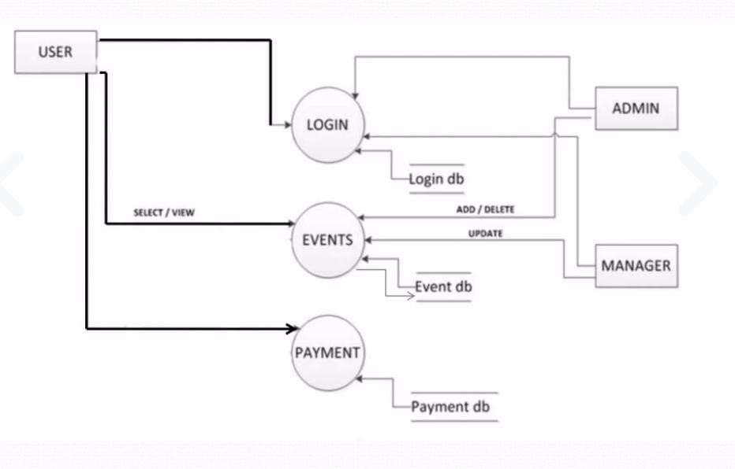

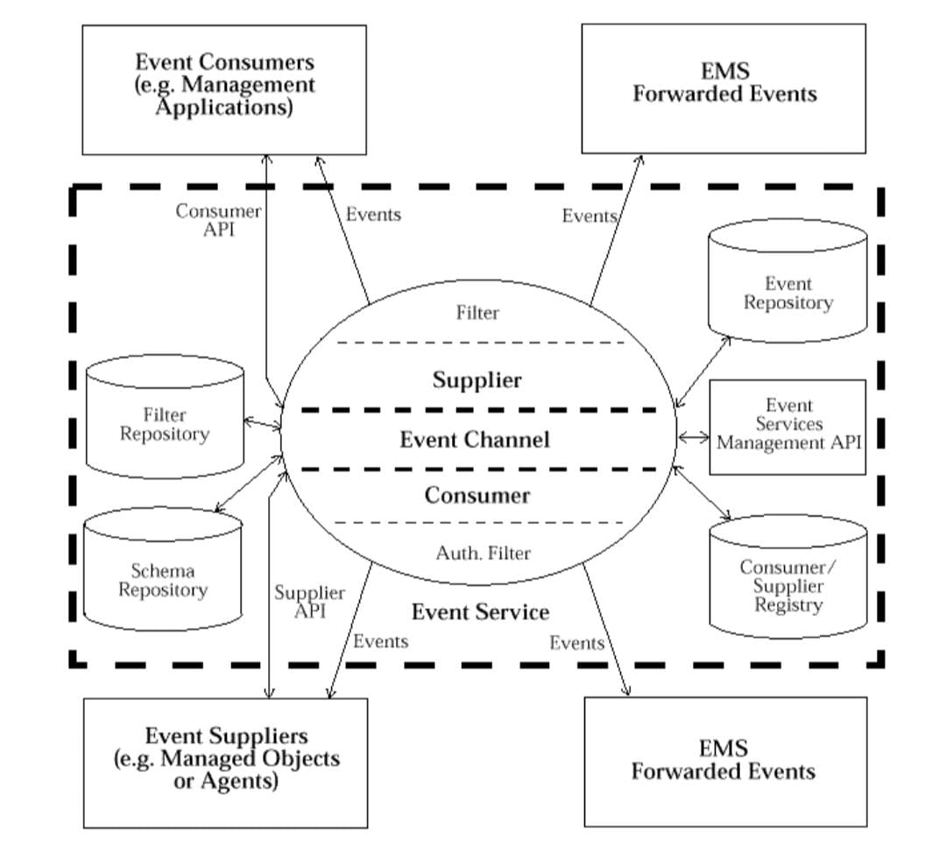

## 7.RESULT AND DISCUSSION

The proposed event management system offers several advantages for both event organizers and attendees. Here are some of the advantages of using this system:

1. Increased efficiency: The system automates many of the processes involved in event management, such as registration, payment processing, and communication, reducing the need for manual intervention and saving time.

1. Convenience: The system provides a convenient and user-friendly platform for event organizers and attendees, allowing them to easily manage and participate in events from anywhere.

1. Improved communication: The system includes features such as email notifications and messaging, allowing event organizers to communicate with attendees more efficiently and effectively.
2. Enhanced event management: The system provides event organizers with a range of tools that help them manage their events more effectively, such as analytics and reporting, event tracking, and attendee management.

1. Increased attendance: By providing a convenient and easy-to-use platform for event registration and management, the system can increase attendance rates and make it easier for attendees to participate in events.

1. Data-driven decision making: The analytics and reporting features of the system provide event organizers with valuable insights into attendance, revenue, and other key metrics, allowing them to make data-driven decisions for future events.

1. Improved user experience: The system provides a positive user experience for both event organizers and attendees, improving satisfaction and increasing the likelihood of future participation in events.

In summary, the proposed event management system offers several advantages that can improve efficiency, convenience, communication, event management, attendance, and decision making. These advantages can benefit both event organizers and attendees, resulting in a positive experience for all users.

8.1 SCREENSHOTS

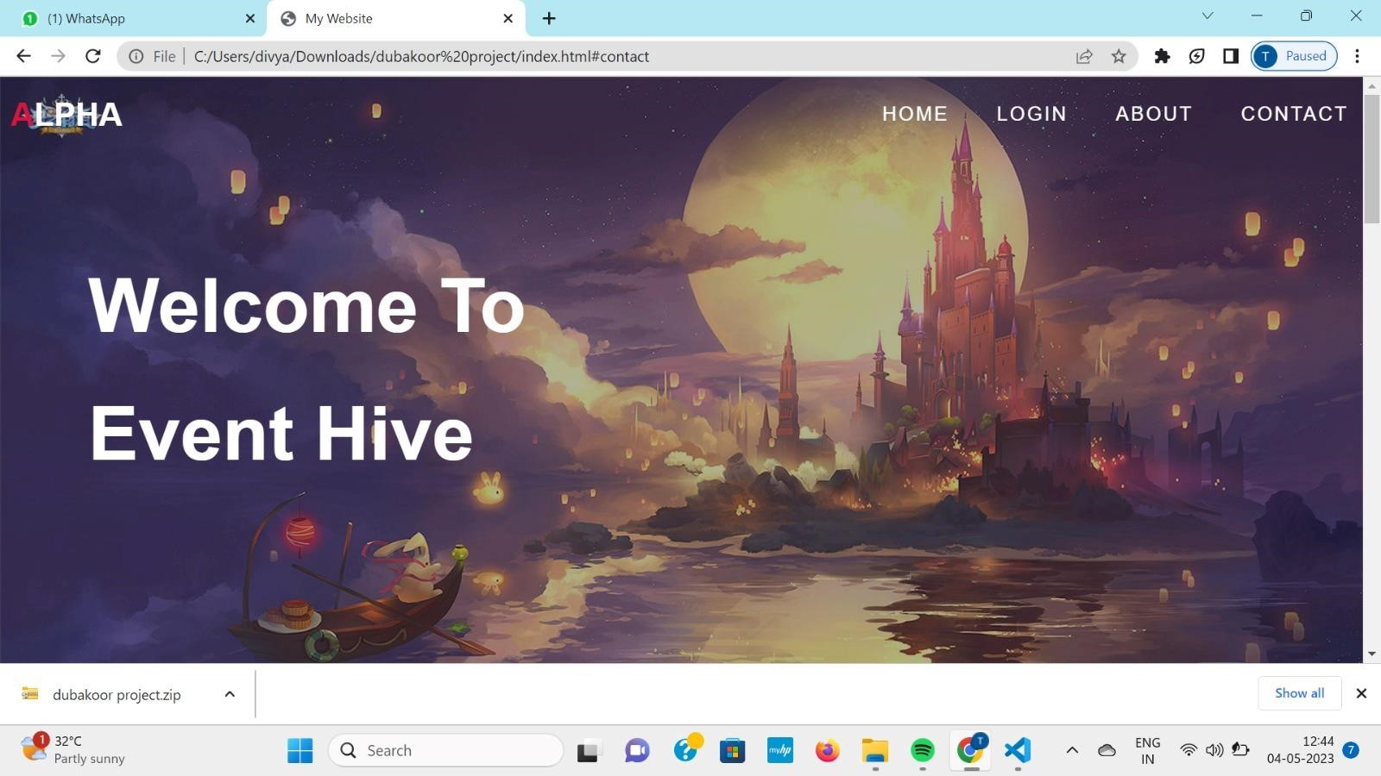

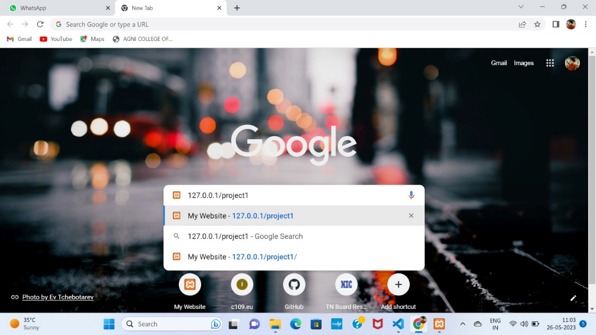

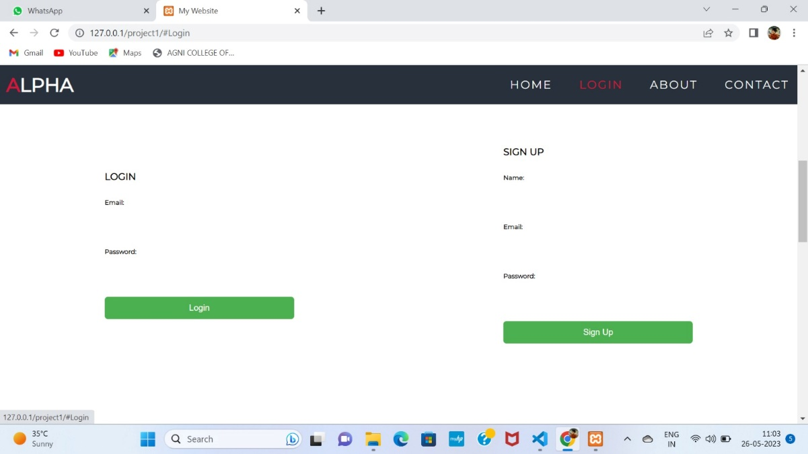

# 9.CONCLUSION

In conclusion, an event management system can be a powerful tool for both event organizers and attendees. By incorporating features such as user registration and login, event listing and registration, payment gateway integration, event management tools, feedback and review systems, analytics and reporting, mobile compatibility, and security measures

To create a successful event management system, it is important to conduct thorough research and analysis to understand the needs and preferences of both event organizers and attendees. This will help to ensure that the system meets their expectations and provides them with a positive user experience.By designing an event management system with original and innovative features, it can stand out from other systems in the market and provide a competitive advantage. Additionally, implementing robust security measures will help to protect user data and ensure that the system is trustworthy and reliable.Overall, an event management system can be a valuable investment for event organizers and a convenient tool for attendees. By developing it with originality and creativity, it can provide a unique and satisfying experience for all users involved

# 10.REFRENCES

* http://www.javaworld.com/javaworld/jw-01-1998/jw-01-Credentialreview.html

* Database Programming with JDBC and Java

* Head First Java 2nd Edition

* http://www.jdbc-tutorial.com/zzzz

Java and Software Design Concepts by Apress

* https://www.tutorialspoint.com/java/

* http://www.javatpoint.com/java-tutorial

* https://docs.oracle.com/javase/tutorial/

* http://www.wampserver.com/en/

* http://www.JSP.net'

http://www.tutorialspoint.com/mysql/

httpd.apache.org/docs/2.0/misc/tutorials.html