**REVIEW PAPER ON STRENGTH AND DURABILITY EVALUATION OF RECYCLED AGGREGATE CONCRETE**

**Porf Vikas R. Bankar1 Nishchay Kamble2 Mrunal Vinod Thakre3 Pranita Manohar Khadse4 Shital Vitthal Awsare5 Sandesh Rajeshwar Ughade6 Balvant Sanjay Hemke7 Shivani Pradip Gode8**

Jagdambha Collage of Engineering and Technology Yavatmal - 445001

12345678 Students, 12345678Department of Civil Engineering

**ABSTRACT**

A large number of new projects are being built today as a result of industrialization and the construction industry's expansion. In the construction industry, natural aggregate plays a significant role, and as a result, demand for aggregate has increased over the past few years, as shown in figure. One alternative source for natural aggregate is recycle aggregate (RCA), which is a used aggregate made from demolished waste. The primary goal of these papers is to determine the durability and strength of RCA.

**Keywords:** Recycled Aggregate, Compressive Strength, M25 Grade

1. **INTRODUCTION**

Sustainable development is presently a major issue all over the world. The concept of sustainable development was first presented at the 1992 Earth Summit in Rio de Janeiro city of Brazil and now it has become a guiding principle for the construction industry worldwide. The recycling and reuse of concrete waste can be an effective way to achieve sustainability in the construction sector. In fact, many governments throughout the world have recently introduced various measures aimed at reducing the use of natural aggregates, and increasing the recycling of concrete waste for reuse as aggregates wherever it is technically, economically or environmentally acceptable

The main goal of the current research project is to investigate variability of aggregate properties and their impact on concrete production. Aggregate strength, gradation, absorption, moisture content, specific gravity, shape, and texture are some of the physical and mechanical characteristics that contribute to the strength and durability of concrete. Therefore, it is necessary to evaluate these properties before utilizing the aggregate

India recycles only 1% of its construction and demolition waste the rest remains strewn across, in landfills, or in plain sight everywhere, leading to air and water pollution Centre for Science and Environment (CSE) on August 25, 2020, has shown. The country generates an estimated 150 million tons of C&D waste every year, according to the Building Material Promotion Council. But the official recycling capacity is a meagre 6,500 tons per day — just about one per cent.

Demolition of old structures and construction of new ones are frequent phenomena due to change of purpose, structural deterioration, rearrangement of a city, expansion of traffic directions, and natural disasters. generated in India is 150 MT and accounts for 35%–40% of the global C & D waste annually India another concern is that India recycles just one per cent of its construction and demolition (C&D) waste, a new report released by Delhi-based non-profit, Centre for Science and Environment (CSE) on August 25, 2020, has shown. Globally, a vast amount of concrete waste is derived from the demolition of old concrete structures. Most commonly this concrete waste is disposed to landfills, thus causing substantial environmental load and health hazard. The utilization of concrete wastes in sustainable development may alleviate such problems. concrete is the premium construction material made from cement, fine aggregate, coarse aggregate and water, a rough estimate says that about 70 million tons of construction and demolition waste and 100 million tons of mining and quarrying waste is being generated every year hence there is need to identify ways and means by which this C &D waste can be use. Basically, aggregates come from a rock and if we want to produce it, we land up destroying a certain part of environment hence Usage of recycled aggregate in concrete reduces the destruction of environment at some extent.

Material Used Different materials were obtained from different sources and the laboratory tests were performed. The recycled aggregates were obtained from a demolished house which was about 30 years old. The concrete used in Mauritius is usually M20 grade one. The slab, columns and beams of the demolished building were made of this grade of concrete and the walls were made of concrete hollow blocks.

**CONCRETE:** Concrete is a composite material composed of water, coarse granular material (fine and coarse aggregate) embedded in a hard matrix (cement or binder) that fills the space among the aggregate particles and glues them together.

**AGGREGATES:** Aggregates used in concrete are divided into three categories:

**FINE AGGREGATE:** These aggregates pass through 4.75 mm I.S. sieve and retained on 150 microns. Coarse sand, it contains 90% of particles of size greater than 0.6 mm and less than 2 mm. medium sand, it contains 90% of particles size greater than 0.2 mm and less than 0.6 mm, Fine sand, it contains 90% of particles of size greater than 0.06 mm and less than 0.2 mm. Proper selection of sand is critical in the durability and performance of concrete mixture

**COARSE AGGREGATE:** These aggregates pass through 63 mm I.S. sieve and retained on 4.75 micron. Coarse aggregates are particles greater than 4.75 mm, but generally range between 9.5 mm to 37.5 mm in diameter. They can either be from Primary, Secondary or Recycled sources.

**MIXED AGGREGATE**: Mixed aggregate is sometimes used for unimportant work without separating into different sizes.

**CEMENT:** Another important material in concrete manufacture is cement. Cement is a fine ground material consisting of compound of lime, silica, alumina and iron.

**DISCUSSION:** The specific gravity of aggregates normally used in road construction ranges from about 2.5 to 3.0 with an average of about 2.68. Though high specific gravity is considered as an indication of high strength, it is not possible to judge the suitability of a sample road aggregate without finding the mechanical properties such as aggregate crushing, impact and abrasion values. Water absorption shall not be more than 0.6 per unit by weight. From the above experiment, it is found that the specific gravity of RCA is smaller than that of normal aggregate. Hence, RCA can be said to have less density than normal aggregate and hence RCA is lighter. And also, it is found that

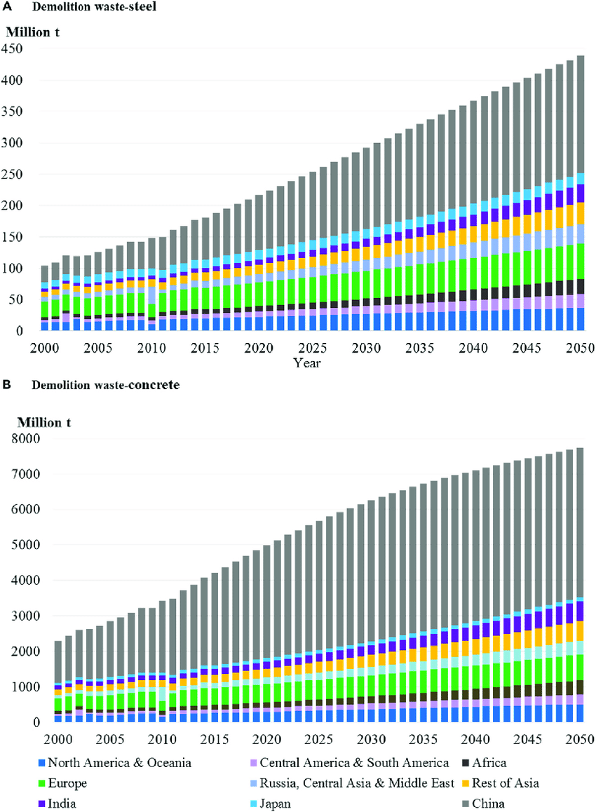

1. **LITERATURE REVIEW**
2. **Patil. Et.al. (2013), - T**his study shows the evaluation of physical properties of concrete using recycled coarse aggregate. In this research for various percentage replacement of recycled aggregate with virgin aggregate (0%, 25%, 50%, 75%, 100%) the compressive strength for recycled coarse aggregate is found to be higher than the compressive strength of conventional concrete when use up to certain percentage. The slump of conventional concrete is less than the recycled aggregate concrete. At the end it can be said that the recycled coarse aggregate up to 50% can be used for obtaining good quality concrete.
3. **4.(ACPA 2009): -** the compressive strength for recycled aggregate concrete is usually lower than that of natural coarse aggregate concrete. most commonly, the compressive strength of recycled coarse aggregate concrete is 5 to 10% lower than that of natural coarse aggregate concrete. But it can also be decreased upto25% depending upon the quality of recycled coarse aggregate.
4. **DUSHYANTH. V.BABU (2018)**: - This research, however, shows that the recycled aggregates that are obtained from concrete specimen make good quality concrete. Concrete waste from demolished structure has been collected and coarse aggregate of different percentages is used for preparing fresh concrete. In this study, for the 28th day cube compressive strength using OPC; the strength for 25%, 50%, 75% and 100% RCA mixes were 23.5%, 33.5%, 32.4% and 10.7%, respectively less than 0% RCA mix whereas for PSC, were 17.8%, 36.7%, 40.6% and 19.1% respectively less than normal concrete. The cylinder compressive strengths at 28 days for 25%, 50%, 75% and 100% RCA mixes, using OPC were 37.7%, 32.0%, 33.7% & 28.4% and using PSC were 20.5%, 27.5%, 25.1% & 30.3% respectively less than that of normal concrete mix. However, in split tensile strength, a continuous decrease in strength was observed with addition of
5. RCA. The values obtained for 25%, 50%, 75% & 100% RCA, for OPC, were 20.6%, 33.0%, 34.9% & 42.5% respectively less than 0% RCA concrete while for PSC, were 1.1%, 16.3%, 26.1% & 27.2% less correspondingly. This study proves that, though the strength of concrete is affected by addition of RCA, the cost saving is up to 16% by 100% substitution of natural aggregates. Moreover, the use of PSC instead of OPC leads up to 29% reduction in cost.
6. **Shailendra Kumar, Dr. A. K. Choudhary (2022)**: - This study used the novel algorithms of machine learning (ML) to forecast the splitting tensile strength (STS) of concrete containing recycled aggregate (RA). The gene expression programming (GEP), artificial neural network (ANN), and bagging techniques were investigated for the selected database. Results reveal that the precision level of the bagging model is more accurate toward the prediction of STS of RA-based concrete as opposed to GEP and ANN models. The high value (0.95) of the coefficient of determination (R2) and lesser values of the errors (MAE, MSE, RMSE) were a clear indication of the accurate precision of the bagging model. Moreover, the statistical checks and k-fold cross-validation method were also incorporated to confirm the validity of the employed model. In addition, sensitivity analysis was also carried out to know the contribution level of each parameter toward the prediction of the outcome. The application of ML approaches for the anticipation of concrete’s mechanical properties will benefit the area of civil engineering by saving time, effort, and resources.
7. **Methodology**
8. In this experimental program different materials from different sources were obtained and laboratory test were carried out into two phases i.e., phase 1 and phase 2. The cubes were casted with M25 grade of mix design of concrete using 0%, 20%, 50%,80%, 100% partial replacement of recycled aggregate with coarse aggregate
9. The ingredients for the M25 mix were weighted and dry mixing is done after that required water were added and mixture is mixed by using pan mixture, in order to prepare the recycled aggregate concrete specimens, coarse aggregate was replaced by recycled aggregate in various percentage (0%, 20%, 50%,80, 100%) for this experiment the standard cubes of size 15X15x15 cm are used. For the determination of compressive strength, the specimen was de molded and placed in water tank for curing. The cubes are tested on 3rd, 7th, 14th, 28th day from the casting.
10. **CONCLUSION**

The research provided in this study assesses how recycled aggregate quality affects the characteristics of concrete. When samples from “Jilha Karagruh Yavatmal “were obtained and their physical and mechanical properties were assessed, the results revealed a tolerable range in attributes. The proportioning step and producing high packing density, however, might be used to overcome restrictions in Gradation requirements, high absorption, and aggregate strength. Additionally, concrete made using various combinations of course and fine aggregate that did not change the particle size or distribution demonstrated that comparable compressive, flexural, splitting, and elastic modulus could be attained.

1. **REFRENCES**
2. Abbas, A., Fathifazl, G., Isgor, O. B., Razaqpur, A. G., Fournier, B., & Foo, S. (2009). Durability of recycled aggregate concrete designed with equivalent mortar volume method. Cement & Concrete Composites, 31(8), 555–563
3. Abdelfatah, A., Tabsh, S., & Yehia, S. (2011). Utlilization of recycled coarse aggregate in concrete mixes. Journal of Civil Engineering and Architecture, 5(6), 562–566.
4. Amorim, P., De Brito, J., & Evangelista, L. (2012). Concrete made with coarse concrete aggregate: Influence of curing on durability. ACI
5. Materials Journal, 109(2), 195.
6. Symonds (1999) European Commission. Construction and demolition waste management practices, and their economics impacts. Report to DGXI, European Commission
7. Hendriks ChF, Pietersen HS, Fraay AFA (2000) Recycling of building and demolition waste. An Integrated approach, Proceedings of the International Symposium on ‘Sustainable Construction: Use of Recycled Concrete Aggregate’, London, UK, pp 419–431
8. Roberto dos Santos J, Branco F, de Brito J (2004) Mechanical properties of concrete with coarse recycled aggregates. Structural Engineering International 3/2004, 213–215
9. Gonza´lez B, Martı´nez F (2004) Shear strength of concrete with recycled aggregates.
10. International RILEM Conference on the ‘Use of Recycled Materials in Buildings and Structures’, Barcelona, Spain, 8–11 November 2004
11. Sogo M et al. (2004) Shear behaviour of reinforced recycled concrete beams. International RILEM Conference on the ‘Use of recycled Materials in Buildings and Structures’, Barcelona, Spain, 8–11 November 2004,
12. European Committee for Standardization. ‘Eurocode 2: Design of Concrete Structures. Part 1: General rules and rules for buildings’. Final Draft, July 2002, p 226
13. Vecchio FJ, Collins MP (1986) The modified compression field theory for reinforced concrete elements subjected to shear. ACI Struct J 86(2):219–231
14. Canadian Standard Association. Design of concrete structures CSA A23.3–2004
15. Cladera A, Marı´ AR (2004) Shear design procedure for reinforced normal and high-strength concrete beams using artificial neural network. Part I: beams without stirrups. Eng Struct 26:917–926
16. Cladera A, Marı´ AR (2004) Shear design procedure for reinforced normal and high-strength concrete beams using artificial neural network. Part II: beams with stirrups’. Eng Struct 26:927–936