HAND GESTURE CONTROLLED PRESENTATION

# Sivaranjini.S1, Gowtham.R 2 , Dhinadhayalan.R3,

Assistant Professor1, UG Scholar2, UG Scholar3,

Department of Information Technology, Loyola Institute of Technology, Chennai, Tamilnadu, India.

# ABSTRACT

In contrast to the conventional approach, in this research study we create a presentation controller that manipulates display using hand gestures as system input and makes use of that information to carry out the Task. Using computer vision or motion sensing technologies, this system detects hand movements and interprets them as instructions to advance through the presentation. It primarily employs the OpenCV module, which is part of the CVzone library, to control the motions. A hand gesture detection technique is already in use and is used by a machine learning framework called MediaPipe.. An application will be created for hand gesture recognition and it will be managing how it should appear on the screen based on input. This system's primary tool for taking pictures and making videos is a web camera, which lowers the cost of investment on external devices or sensors for capturing or recording the images or videos. Although changing the presentation slides depending on input is the system's principal function, I also had access to a pointer that allowed me to write, draw, and remove on the slides. Contrary to conventional approaches, simple computer operations, such as controlling presentations, may be operated with hand gestures, paving the way for intelligent process automation.People won't need to purchase the items frequently in order to carry out these easy duties. By utilising artificial intelligence, this programme will be useful in automating the procedure. Instead of using the outdated methods for manipulating the Presentation slides, people will be drawn to this technology since it is simple to use and everyone will feel more at ease with the automated user interface. A unique user can utilise real-time gesture recognition to control a computer by making hand gestures in front of a system camera that is connected to a computer.For a variety of reasons, including as increasing interaction and engagement, allowing the presenter to move around freely while staying in charge of the presentation, and providing a more natural and intuitive manner to interact with the material, this type of presentation can be useful.

**Keyword*-***OpenCV, CV zone, MediaPipe, Hand Gesture Recognition, Machine Learning,presentation controller, Human Computer Interaction.

# INTRODUCTION

Hand Gesture controlled Presentation is an innovative and interactive way to navigate without the need of conventional input devices like a mouse or keyboard, it is a novel and engaging method to navigate and control slides during a presentation. It makes use of computer vision technology to recognise and translate particular hand motions, enabling presenters to interact with their slides naturally.

This technology has gained popularity as a result of its ability to enhance presenter-audience interaction, create a more dynamic and immersive experience, and do away with the physical restrictions of being attached to a computer or mobile device. The flexibility and involvement it offers raise the interest and impact of presentations. In hand gesture-driven presentations, hardware and software components are regularly used. A camera or a depth sensor is typically used in the hardware to record and turn hand movements into digital data. The programme looks over the information it has gathered, picks out specific hand motions, and then links those gestures to planned actions like moving on to the next slide, going back to the previous slide, scribbling on the slide, or erasing it.

Before employing hand gesture control in a presentation, the presenter must calibrate the system by doing specific actions or following specific guidelines in order to establish a baseline for hand tracking and recognition. Once the gadget has been calibrated, the presenter can control the slides by making specific movements in front of the camera or sensor. Even while hand gestures can boost involvement and engagement, it's important to ensure that the technology is used properly and doesn't take away from the presentation's main points or message. Presenters should practise using the system beforehand to become accustomed to the motions for a flawless presentation. Overall, presentations that are controlled by hand gestures offer an interesting and fun way for audience engagement and slide interaction.

# RELATED WORKS

## ExistingProblem

* + 1. **Title: Survey of Hand Gesture Recognition Systems**

**Author: Ronnell, S. Paulina, Israel Carino,2019** This project focuses on An important area of computer science is the recognition of human gestures, particularly in computer vision and sign language. It seeks to use mathematical models to decipher human gestures. Although gestures can come from several parts of the body, the hand and face are where they most frequently come from. Gestures recognition is a technique that enables computers to comprehend and interpret the human body's language in the best way possible. It also creates a bridge between humans and machines by moving from simple command-line interfaces to graphical user interfaces (GUI), which up until now have restricted input to the keyboard and mouse.Several approaches of hand gesture identification, including Artificial Neural Networks (ANN), Histogram-based features, a fuzzy clustering algorithm, Hidden Markov Models (HMM), Condensation algorithms, and Finite-State Machines (FSM), have been studied and analysed in this research.

## Title: An HMM-based threshold model approach for gesture recognition

**Author Hyeon-Kyu Lee; J.H. Kim.,1999-**The approach of hidden Markov model (HMM) based method is created. We provide the idea of a threshold model to deal with non-gesture patterns, which determines the likelihood threshold of an input pattern and offers a confirmation mechanism for the tentatively matched gesture patterns. Insofar as its likelihood is lower than that of the specialised gesture model for a specific gesture, the threshold model is a weak model for all taught gestures. According to test results, the suggested approach can reliably extract taught gestures from continuous hand motion with a success rate of 93.14%. In the threshold model method, a threshold is established for the probability that a gesture would be recognised in accordance with the HMM model.

## Title: Kinect Based Dynamic Hand Gesture Recognition Algorithm Research

**Author: Youwen Wang, Cheng Yang, Xiaoyu Wu, 2012**-The approach of hidden Markov model (HMM) based method is created. We provide the idea of a threshold model to deal with non-gesture patterns, which determines the likelihood threshold of an input pattern and offers a confirmation mechanism for the tentatively matched gesture patterns. Insofar as its

likelihood is lower than that of the specialised gesture model for a specific gesture, the threshold model is a weak model for all taught gestures. According to test results, the suggested approach can reliably extract taught gestures from continuous hand motion with a success rate of 93.14%. In the threshold model method, a threshold is established for the probability that a gesture would be recognised in accordance with the HMM model.

## Title: Vision based hand gesture recognition for human computer interaction: a survey

**Author: Siddharth S. Rautaray ,Anupam Agrawal, 2012**-Facilitating natural human-computer interaction (HCI) will increase the use of computers as they become more widespread in society. Consequently, there has been an increase in interest in the creation of novel strategies and technologies for breaking down the barrier between humans and computers. Incorporating gestures in HCI is an essential study subject since the ultimate goal is to get HCI to a regime where interactions with computers will be as natural as those between people. Gestures have long been thought of as an interaction strategy that may lead to more organic, inventive, and intuitive ways for us to communicate with our computers. This essay offers a critique of related comparative studies. . The use of hand gestures as a natural interface acts as a driving factor for research into gesture taxonomies, representations, and recognition methods, as well as software platforms and frameworks, which is briefly covered in this paper. The three key stages of hand gesture recognition—detection, tracking, and recognition—are its core focus. Under core and advanced application domains, various applications that use hand gestures for effective interaction have been described. By classifying it according to certain essential criteria, this paper also offers an analysis of previous research on gesture detection systems for human computer interaction. It also goes through the improvements that must be made to the current hand gesture recognition systems in order to improve them in the future and make them more widely applicable for effective human-computer interaction.

## PROBLEM STATEMENT

In the modern world, there is a lot of data that can be accessed from many different sources, such as sensors, social media, internet of things (IoT) devices, and more. However, combining cognitive technologies with artificial intelligence (AI) is necessary to fully utilise these resources. The goal is to develop cutting-edge solutions that make intelligent use of AI to analyse multiple data sources, transform them into insightful data, and increase resource efficiency in a variety of contexts.

# PROPOSED SYSTEM

In today's technologically advanced environment, employing conventional presentation control methods like a keyboard or a remote control can occasionally feel restricted and fragmented. To get over these limitations and provide a more dynamic and interesting presentation experience, we recommend a hand gesture-controlled presentation system. The hand gesture-controlled presentation system uses computer vision, machine learning, and gesture recognition technologies to let presenters control their slideshows using basic hand motions.

Presenters can move between slides, annotate important portions with their hands, draw on the screen, and perform other actions all without touching or using any real objects.The suggested approach has several advantages. First off, it provides a more organic and fluid way to manage presentations, allowing speakers to focus on their content and engage with the audience more effectively.

Hand gestures make it simple for presenters to convey their objectives and directions, creating a seamless and interesting experience.Presenters are no longer bound by a physical location or the range of a remote control. They could move freely and fluidly, drawing attention to important elements and boosting the excitement and engagement of their presentations. The core technology of this system uses machine learning models and computer vision algorithms to precisely distinguish and understand hand gestures. By capturing and studying the presenter's hand motions, the system may recognise predefined gestures and associate them with specific presentation directions or activities..

The suggested system also aims to be versatile and configurable so that presenters can create their own set of gestures or tailor the system to meet their presentation style and preferences. The system's versatility allows presenters to alter it to suit their own needs and improve their presentation experience.

# METHODOLOGIES

The following phases are commonly included in the technique for implementing a hand gesturecontrolled presentation system:

1. **Define the Gestures**: Establish the set of gestures that will be understood and the presentation's related actions. A closed fist can pause the presentation while swiping right can progress to the next slide and swiping left can go back to the previous slide.
2. **Preprocessing**: The preprocessing of the obtained data includes normalising, resizing, and enhancing the images or depth maps of the hand gestures. Preprocessing techniques include reducing noise, eliminating the backdrop, and segmenting the hand region.
3. **Modern and Innovative Image:** Speakers appear modern and inventive when they organise presentations with hand gestures. It demonstrates a willingness to use new technology and keep up with customary presentation methods.
4. **Gesture Recognition Model Selection:**Choose a solid machine learning or deep learning model for gesture recognition. Applying techniques like Convolutional Neural Networks (CNNs) may be necessary for this.
5. **Integration with Presentation Software**: Connect your preferred presentation programme or platform (such as Google Slides or PowerPoint) to the trained gesture detection model. This typically involves writing code to allow the gesture recognition system and the presentation software to communicate with one another and allow the acknowledged gestures to initiate specific actions within the presentation.
6. **Model Training:** Train the selected gesture recognition model using the preprocessed dataset. After being given images or depth maps of the hand motions, the model's parameters must be adjusted for the optimal performance.

# PROJECT DESIGN

## ARCHITECTURE DIAGRAM

* + 1. **FOR HAND GESTURE RECOGNITION**

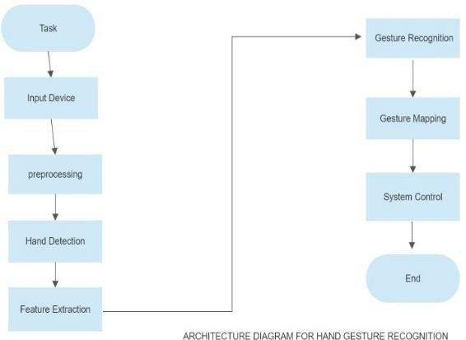

## FOR MEDIAPIPE FRAMEWORK

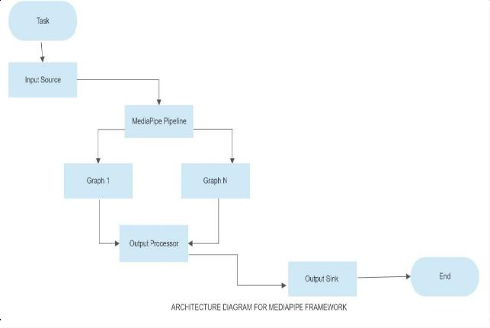

**5.1.1 FOR IDENTIFYING HANDGESTURE BY MEDIAPIPE**

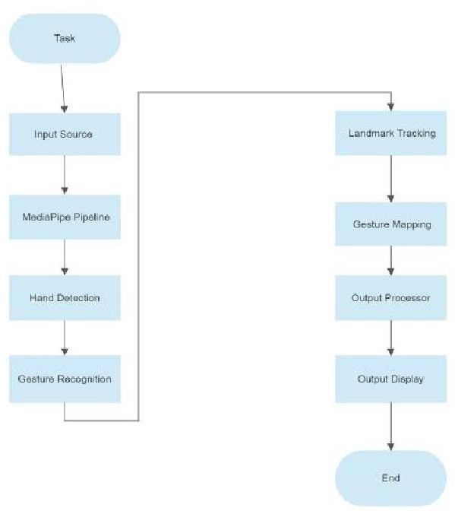

# RESULTS

* 1. **Screenshots**

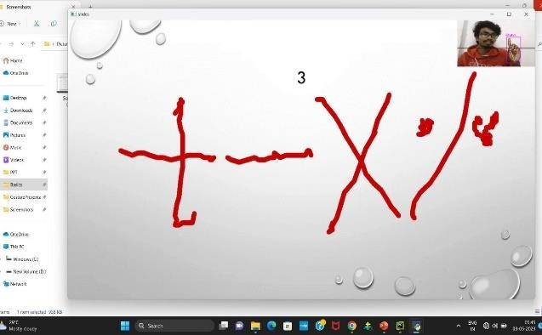

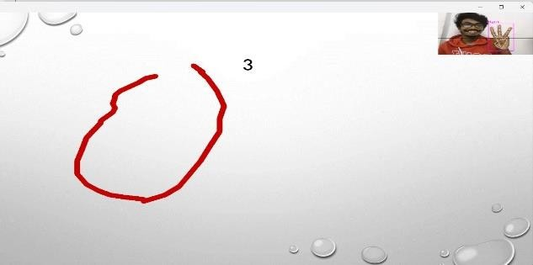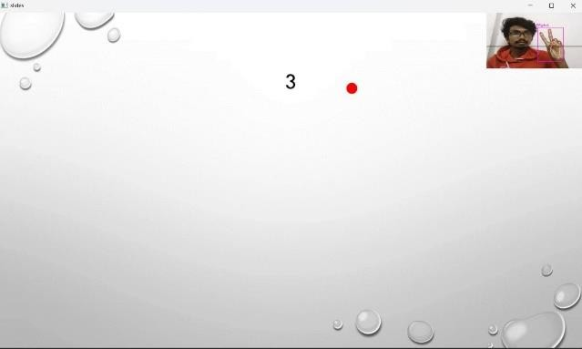

# CONCLUSION

In conclusion, a presentation system that is operated by hand motions offers a unique and straightforward method of interacting with presentation software. The use of computer vision and machine learning algorithms allows users to control presentations using simple hand gestures rather than through the use of traditional input devices. There are many advantages to controlling presentations with hand gestures. The experience is more engaging and participatory for both presenters and viewers, first and foremost. Presenters can quickly switch between slides, highlight important points, and accentuate content with simple hand gestures. This enhances dialogue and promotes more active audience engagement.Hand gesture control also speeds up the presenting process by eliminating the requirement for external hardware like computers or remote controls. Presenters can move around without being restricted to a podium or lectern and focus..

Hand gestures can be used to control presentations, which may make them more accessible to those with physical limitations or disabilities. Simple hand gestures can be used to navigate presentations with ease by those who have difficulty using standard input devices, enabling them to participate more actively in a range of professional and educational settings.

Innovation and progress in the fields of computer vision, machine learning, and human-computer interface are also encouraged by the development of presentation systems that may be operated by hand gestures. By combining algorithms, frameworks, and technologies like Leap Motion, Myo Armband, OpenPose, TensorFlow, MediaPipe, and CVZone, one may create sophisticated and accurate gesture detection systems..

Despite potential challenges and limitations with hand gesture-controlled presentations, such as the need for ideal lighting conditions, training the system for different people, and potential recognition errors, ongoing research and development efforts aim to address these issues and enhance the functionality and user experience.

Overall, using hand gestures to manage a presentation is a creative and modern approach to convey information. Because of their ability to captivate audiences, expedite interactions, and improve accessibility, they have the potential to revolutionise the way we present and transmit information in many professional, educational, and entertainment situations.

# FUTURE ENHANCEMENT

The use of hand gestures to control presentations is a growing subject, and there are a number of potential future developments that could further boost usability and functionality. A few potential directions for future development are listed below:

The creation of a mobile application that is completely capable of hand gesture-based tasks.enhancing performance and quality while also increasing accuracy.Voice instructions can be integrated in addition to Hand Gestures.It is applicable to automobiles

# REFERENCE:

1. MediaPipe: On-Device, Real Time Hand Tracking, In https://ai.googleblog.com/2019/08/on- device real- time-hand-tracking-with.html. 2019. Access 2021.
2. Al Saedi, A. K. H., & Al Asadi, A. H. H. (2020). A new hand gestures recognition system. Indonesian Journal of Electrical Engineering and Computer Science, 18(1), 49–55. <https://doi.org/10.11591/IJEECS.V18.I1.PP49-55>
3. Wu Xiayou, An Intelligent Interactive System Based on Hand Gesture Recognition Algorithm and Kinect, In 5th International Symposium on Computational Intelligence and Design.2012.
4. Wang Y, Kinect Based Dynamic Hand Gesture Recognition Algorithm Research, In 4th International Conference on Intelligent Human Machine System and Cybernetics. 2012.
5. Controlling PowerPoint Using Hand Gestures in Python,December 2021,Webology 18(6):1372-1388 muhammad idrees
6. Dubey, K. K., Jha, A., Tiwari, A., & Narmatha, K. (2019). Hand Gesture Movement Recognition System Using Convolution Neural Network Algorithm. IRJCS:: International Research Journal of Computer Science, VI,154–160.
7. Hamed Al-Saedi A.K, Hassin Al-Asadi A, Survey of HandGesture Recognition System. IOP Conferences Series: Journal of Physics: Conferences Series 1294 042003. 2019.
8. Z.Ren, J.Meng, Yuan J. Depth Camera Based Hand GestureRegconition and its Application in Human-Computer- Interaction. In Processing of the 2011 8th International Conference on Information, Communication and SignalProcessing (ICICS). Singapore. 2011.
9. S.Rautaray S, Agrawal A. Vision Based HandGesture Recognition for Human Computer Interaction: A Survey. Springer Artificial Intelligence Review. 2012

[3] Galveia B, Cardoso T, Rybarczyk, Adding Value to The Kinect SDK Creating a Gesture Library, 2014.