**FLATMATE FINDING APPLICATION**

**[FLATBUD]**

**Miss. Poonam Rakibe*1 ,SaloniYerawar *2, Saloni Salunkhe *3, Rashi Tawri *4, Purvi Porwal*5**

*1Department of Information Technology, P.E.S. Modern Collage of Engineering, Pune, Maharashtra, India

**ABSTRACT**

Roommate services are in high demand these days. With the world getting flattered by the day, people have transcended physical boundaries to look for study and work options in places they haven't visited before. Although a new place throws up its unique challenges, one is today well-equipped to deal with them. The advent of the net has made this possible, with people finding it increasingly easy to relocate to a new apartment and find a suitable roommate in no time. Flatbud is a website that makes sure you find good flat mates with the specific requirements the user has provided. The user will be asked to log in or create an account to enter the website. Then they will be asked a few questions about themselves and the roommate they prefer to be with. With the logistic regression algorithm and recommendation algorithm with collaborative filtering, they will get suggestions as to who can be the perfect fit for their flat buddy, and then if the other end user feels the same way they will enable the option of texting each other and can have a great conversation and see if they are a good fit or not. FLATBUD offers a marketplace where you can search for potential roommates. FLATBUD will use a highly advanced search algorithm to make the search much more effective. With comprehensive search options, this site ensures only results that meet your specific requirements are displayed.

**Keywords:** Roommate, Flatbud, Website, Algorithm, Logistic regression, Recommendation algorithm, Collaborative filtering, Texting, Search, Requirements.

1. **INTRODUCTION**

India is the second most populated country holding 17.70% of the world's share has approximately 67.27 percent of people aged between 18 and 64, which is the peak period of education and the employment for which almost all the people migrate from their homes to either their workplace or for education purposes. This leads to a concept of shared accommodation which is very common for students but also for people who are in corporate world to reduce their rent and financial burden.

In India, more and more people are shifting to A-tier cities for better opportunities, so the demand for affordable housing is also increasing. The best option is to have flat mates which help to reduce the cost and have a more family environment in the house. But finding flat mates is a daunting task and having the wrong flat mates can be a nightmare. Having a flat mate reduces the overall cost of living as the rent, electricity and some other expenses are also shared.

People leave their hometowns and come to cities for jobs and other opportunities, they feel homesick. Having someone to talk to is nice and can be helpful for your mental health. Now if you are living in a shared accommodation then you will surely have to part your space with a roommate, we have observed that the presence of a roommate is equally disturbing as the absence of a roommate. Having a roommate with no compatibility might lead to problems such stress, anxiety, and sometimes depression, but this is a risk to be endured for survival in metro cities where the cost of living alone is very high.

1. **MOTIVATION AND OBJECTIVE**

In today’s modern world almost, every student needs to reallocate his/her residence for a job or education. Few locations are there where most of the company's offices are established. It is a big challenge to spend money in a new city even without having a first salary. This could be easy if we can make sharing rent and food with a roommate. Finding a perfect roommate is essential which must match our preferences or needs. Having a roommate with no compatibility might lead to the problems such as stress, anxiety and sometimes depression, but this is a risk to be endured for survival in metro cities where the cost of living alone is very high.

**OBJECTIVES:**

The objectives of the “Flatbud” can be stated as follows:

1. Develop a website that will find a perfect roommate according to one's requirements.

2. Aim of finding a perfect roommate by accurately matching requirements of one person with other individual using Machine Learning Algorithms along with collaborative filtering as a recommendation system.

3. Make use of Machine Learning algorithms to increase the accuracy of the website

1. **LITERATURE SURVEY**

Relationship Between Mental Health And House Sharing (2021):After COVID mental health has been one of the top priorities in everyone’s life and being stuck in a room with not a good mate definitely adds to the stress and affects the metal health. in this paper they discussed about how important it is to share the room with people as similar as you. They found a survey which they took of 5000 people about how it affects their mental health and what will help them. all of them suggested that if they knew their flat mate prior to shifting it would have been helpful and it would cut down to the stress[1].

Streamlined And Image Focused Platform (2020):Streamlinedand Image Focused platform to help connect flat mates. they develop an app for finding flats and flat mates via a swiping technology which mainly focuses on image classification. This app was made on react native which helped the app to run on both IOS and android. Though they had image focused apps which provided more information than text for analysing they did not have collaborative filtering which means getting required recommendations with filtered accordion to the user’s requirements. the app also showed bad animations and designs at some page[2].

Room Allocation with Capacity Diversity and Budget Constraints (2019): They use non-deterministic polynomial-time hard algorithm which means even if one room’s capacity is larger than 1 and the other rooms’ capacities are all 1. Second, this paper presents a (c∗ + 2)/2 + ε-factor approximation algorithm (with ε > 0) for the case in which the capacity of each room does not exceed a constant c. They also focus on finding budget friendly flats with spacious areas and helping people to connect. the NL hard algorithm makes it difficult to find good flats for people but with only capacity as 1. They also use heuristic algorithms for finding flats without a constant which makes the user confused as to which algorithm they should go for[3].

Web Based Application on Flatmate Searching (2017): They developed a website for finding economic and feasible flats for people who are shifting to A tier cities for work or studies. They use waterfall model for getting the searches or suggestions. They have used HTML, CSS, PHP, Angular and such technologies to implement this project. Waterfall model which was used was not implemented correctly and was left at the development state. testing of the project wasn't done as the load time generated was quite high and the page couldn't handle congestion well. It focused more on putting ads on the flat and not on finding flat mates[4].

**IV. EXPERIMENTAL DESIGN**

Machine learning algorithms used for searching will be Logistic Regression. The goal of Logistic Regression is to discover a link between characteristics and the likelihood of a specific outcome. We will use rendering pages for good recommendation approaches and also use recommendation algorithms for better use of this website. We will also focus more on content-based filtering.

Content based filtering algorithm uses item features to recommend other items similar to what the user likes, based on their previous actions or explicit feedback.

**Algorithm:**

Content-based filtering uses item features to recommend other items similar to what the user likes, based on their previous actions or explicit feedback. Content-based filtering is a type of recommender system that attempts to guess what a user may like based on that user’s activity.

Content-based filtering makes recommendations by using keywords and attributes assigned to objects in a database (e.g., items in an online marketplace) and matching them to a user profile. The user profile is created based on data derived from a user’s actions, such as purchases, ratings (likes and dislikes), downloads, items searched for on a website and/or placed in a cart, and clicks on product links.

**V. WORKFLOW**

SYSTEM ARCHITECTURE DIAGRAM:

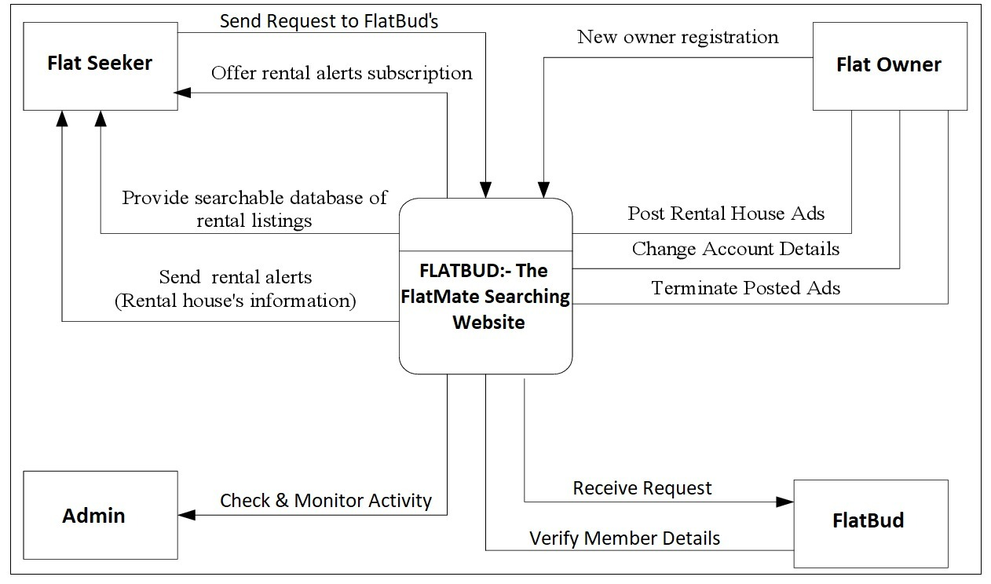

**VI. ENVIRONMENTAL SETUP**

FRONTEND: PHP, WordPress, Figma, Angular, jQuery, CSS, NODE.JS

BACKEND: JAVA

DATABASE: MYSQL

**VII. CONCLUSION**

In this project, we created a web portal using technologies for Front End that are PHP, WordPress, Figma, Angular, jQuery, CSS, NODE.JS and for Database MySQL is used. Additional features of machine learning like Logistic Regression and recommendation system using Content based Filtering is used for searching flat mates. It is a user-friendly website so that users will not face any problems to learn the functionality of website.This project helped me to get a deeper understanding of user personas and get a better understanding of user. I could have improved to build empathy and tried address pain points. This project was a great learning curve and it’s important to always consider user. Moreover, a web-based application resolves the problem that was earlier faced by people in finding a perfect flatmate without any hassle[1].

This paper investigates the room allocation problem with capacity diversity and budget constraints. We mainly focus on finding an allocation that maximizes the social welfare[2].The thesis implements and evaluates a new web application that has as a goal to improve the user experience of the search for flats on the web. The application differs from currently used websites such that users only have to create a single application for all room advertisements[3].This paper emphasis on an analysis of several room allocation systems used to allocate best suitable room to a candidate. So, to accomplish this goal many researchers are approaching with new methods to enhance their proposals with various techniques by evaluating and comparing their performance with the previous researches[4].

**VIII. FUTURE WORK**

* + A bot to solve common problems of flatmates. Automated responses to solve the problems.
  + In future, we can also add section or place where one can put an advertisement of finding a roommate and the advertisement can be visible to all people using this website.
  + Also, we can add the Authentication and image description as two new features in website which will increase the efficiency of this website.
  + We can also add the location of the flats that are available

**IX. REFERNECES**

[1] Sanidhya kuchhal1, Kushagra Saini1, Karan Sharma1, Anjali Kumari1," WEB BASED APPLICATION ON FLATMATE SEARCHING SYSTEM " Department of Computer Science, ABES Institute of Technology, Ghaziabad 201009Uttar Pradesh India, Volume: 09 Issue: 05 | May 2022(Kuchhal et al., 2022)

[2] YUNPENG LI 1,2, YICHUAN JIANG 2, (Senior Member, IEEE), WEIWEI WU 2, JIUCHUAN JIANG 3, AND HUI FAN4," Room Allocation with Capacity Diversity and Budget Constraints "", Received March 2, 2019, accepted March 19, 2019, date of publication March 27, 2019, date of current version April 13,2019(Li et al. 2019)

[3] Dr. Severin Klingler Sumit Kumar Ram Prof. Dr. Markus Gross Prof. Dr. Didier Sornette," A streamlined and image-focused Platform to connect Flat mates ", Ferdinand Wittmann Bachelor Thesis March 2020(Wittmann et al. 2020)

[4]Abhishek Sharma, Amandeep Kaur”Hostel’s Room Allocation System: A framework using single-layer fuzzy logic”,International Conference on Innovative Computing and Communication Lovely professional University, (Sharma)

[5] Jihun Oh and Jongsei Kim,”Relationship Between Mental Health and House Sharing”

Int J Environ Res Public Health. 2021 Mar; 18(5): 2495.Published online 2021 Mar 3(Kim, 2021)