Skin Cancer Cell Detection Using Deep Learning Techniques

**Aniket Bhoknal1, Rohit Ghodke2, Prashant Zirpe3 Renuka Devray4**

1Student, Vishwabharti Academy College Of Engineering, Ahemdnagar, Maharastra, India

2Student, Vishwabharti Academy College Of Engineering, Ahemdnagar, Maharastra, India

3Student, Vishwabharti Academy College Of Engineering, Ahemdnagar, Maharastra, India

4Professor, Vishwabharti Academy College Of Engineering, Ahemdnagar, Maharastra, India

**ABSTRACT**

Skin syndrome is a quotidian in people’s life since of a significant increase in pollution and an unclean way of living. The repercussions of this manage to various skin diseases. Conventionally skin diseases are diagnosed visually by humans. As human’s adjudication can be inexact, we tend to lean on computer-aided diagnostic system, hence in this paper, we have put forward a skin disease prediction system that is built on top of deep neural networks. The dataset is inspired by Harvard’s HAM(Human against machine). Furthermore, data augmentation has been done to enhance the quality of the dataset. A sequential model has been created by using Keras .Numpy The model advanced can achieve an accuracy of 81%, further improvement can be attained by enhancing the model facilitated by good infrastructure

**Keywords:** Skin Syndrome, Deep Learning, Convolutional neural network, Melanoma,benign cancer

1. **INTRODUCTION**

. Diseases are perceived as medical condition that is associated with a specific set of symptoms. The disease can be classified based on how much area of the body they affect that is Localized diseases impact peculiar parts of the body, disseminated diseases spread to different parts of the body and systemic diseases affect the whole body. Skin diseases are disorders that affect the human skin. It has a severe impact on people’s health. This has become ubiquitous and so the need for effective remedies has become necessary. Detection of skin disease is very crucial as it can cause severe loss to people. In today's world, there is a need for an automatic diagnostic system that would help in diagnosing the disease at a faster rate and thereby reduce the manual efforts and time required to recognize the disease. Our proposed system is based on a convolution deep neurons network which is a machine learning algorithm that helps in detecting skin disease by taking an image of the affected area as an input to the system. The system then processes and classifies the images under specific categories. It is capable of deciding 7 types skin diseases particularly.

1. **METHODOLOGY**

Our proposed model incorporates two technologies, they are machine learning algorithms that is convolutional neural network and GUI.

**2.1 Dataset**

This dataset consists of 10000 images of malignant and benign kind diseases, which were formed from The Ham that is Human against machine dataset We grouped images according to the ISIC classification, and all subsets were divided into the same number of images, except for malignancies and moles, whose images are slightly more prominent.

**2.2 Subheading**

The CNN model performs best with large datasets, therefore by increasing the amount of data currently available, extraordinary performance may be attained. With the help of data augmentation, the dataset's size may be extended, which promotes a rise in model accuracy. Among The rotation action turns the picture by the provided amount, in this case, 45 degrees. Shearing is a technique for changing an input image's orientation. It is set at 0.3 for the shear range. Zooming can be done either inside or outward. It is set at 0.2 for the zoom range. The orientation of the picture is flipped via flipping. The two types are horizontal flip and vertical flip. Both values have been set to "True." We can fight variations in lighting by adjusting the brightness level. The brightness level is chosen between 0.7 and 1.3.

* 1. **Deep** **learning**

Deep learning is a machine learning technique that teaches the computer to behave like people do and to learn from experience. Deep learning teaches a model to do text-based and image-based categorization of pictures according to their respective classes. The data, which might take the form of text or images, is categorized using models that have been structured

1. **CONVOLUTION NEURAL NETWORK**

Neural Network and Model which are used is presented in this section. Table and Convolutional neural network is the deep learning algorithm that simulates the visual cortex of the human brain. The idea of the convolution neural network is that filters the image before training the deep neural network. It typically uses four layers i.e convolution, pooling, ReLU, and fully connected layer. Convolutional neural network is the subclass of neural networks that helps in image recognition, image classification, object detections, etc. Convolution neural network consists of different layers such as convolution, ReLU, pooling, and fully connected layer. Convolution layer extracts the features from an input image. It is an operation that takes two inputs that is image matrix and a filter. ReLU stands for the Rectified Linear Unit, the output of this layer is ƒ(x) = max(0,x) where x stands for each value of the matrix. Pooling layer is used to reduce the number of parameters of the image, spatial pooling is of three types namely max pooling, average pooling, and some pooling. A fully connected layer flattens the matrix into a vector. This combines the features to create a model that classifies the image input

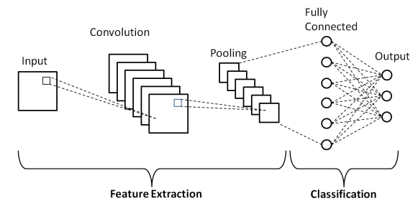

**Figure 1:** Convolutional Neural Network

##### **3.1 Convolution layer Of Deep Learning**

The main purpose of the Convolution layer is to extract the features from the input image. There may be presence of more than one convolution layer in the network. The first convolution layer is responsible for acquiring the low-level features such as edges, color, sharpen, gradient orientation, etc. Further layers acquire the high-level features of the image of the dataset. It works as a mathematical operation that has an image matrix and filter as its two inputs. The image matrix is multiplied with the filter matrix, this process is called a feature map.

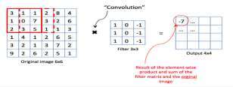

**3.2 Strides**

Strides are the number of pixels that shifts over the input matrix. When the stride is set as 1 then the filters are moved by 1 pixel at a time

* 1. **Padding Working**

When the mesh do not fit the image matrix then either the image is padded with zeros so that it fits, that is called zero paddings or the portion of the image where the filter does not fit is dropped, it is named as valid padding

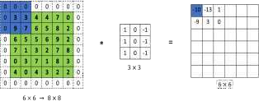

* 1. **Pooling**

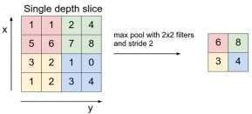

The function of this pooling layer is to reduce the size of the representation to reduce the number of limitations and computations. The most used method is max pooling.In max pooling, for each of the area considered by the filter, the max of that area is taken interested in reflection and the output matrix is created where each element is the max of the area in the Input matrix

* 1. **The fully connected input layer**

The output of the pooling layer is flattened into a single vector of values that represents a chance that a particular feature belongs to a label.As we are using Keras numpy, there are majorly two types of models available in Keras the are the sequential model and the model class used with functional API. Here, we have used the sequential model.

1. **GRAPHICAL USER INTERFACE**

We have developed a graphical user interface, a website, that can be used for detecting diseases by user. Image upload area where the patient can upload a photo of the pretentious area, that image is given to the built model as an input and the result of the CNN model will be displayed to the patient, which will be the sensed disease. Optimizers the augmented dataset to predict the disease as a result. This result is made available to the user An optimizer helps a model minimize its loss function by updating the weight parameter. This model uses the Adam optimizer. There are several other optimizers besides 'Adam', including SGD, RMSprop, Adagrad, Adadelta, Adamax, and Nadam. As a result, the convolution neural network is trained on the augmented dataset to predict the disease. We are provided with this result

1. **CONCLUSION AND RESULT**

In this paper, a model is created using a machine learning algorithm, convolutional neural network, that helps in predicting the skin disease. Data augmentation is done to improvise the accuracy of the model. The suggest model is a successive model with top accuracy of 81%. It is found that by using deep learning algorithm, we can achieve higher

**ACKNOWLEDGEMENTS**

We express our profound gratitude to our project's advisor, professor R.N. Devray, for her invaluable guidance. She was patient and helpful with us during the entire project, and we appreciate that. Without her kind assistance, our endeavour would not have been successful

1. **REFERENCES**
2. Skin cancer classification via convolutional neural networks: systematic review of studies involving human experts volume1 issue 2 2019
3. Classification of Skin cancer using deep learning, ConvolutionalNeural Networks - Opportunities and vulnerabilities- A systematic Review2022.
4. A.A.L.C. Amarathunga, Expert System For Diagnosis Of Skin Dis-eases”, International Journal Of Scientific Technology Research, Volume 4, Issue 01, 2019.
5. Diagnosis of Nonmelanoma Skin Cancer/Keratinocyte Carcinoma: A Review of Diagnostic Accuracy of Nonmelanoma Skin Cancer Diagnostic Tests and Technologies volume 3 irjet
6. Diagnosis of Nonmelanoma Skin Cancer/Keratinocyte Carcinoma: A Review of Diagnostic Accuracy of Nonmelanoma Skin Cancer Diagnostic Tests and Technologies Vol. 2015, No. 1, Jan. 2015.
7. M.Chaithanya Krishna, S.Ranganayakulu, “Skin Cancer Detection and Feature Extraction through Clustering Technique”, International Journal of Innovative Research in Computer and
8. Kawsar Ahmed, Tasnuba Jesmin, “Early Prevention and Detection of Skin Cancer Risk using Data Mining”, International Journal of Computer Applications, Volume 62– No.4, January 2022.