**CAMPING CUBS WEB APPLICATION**

**Mayuri Kohat1, Sharvari Mahale2, Shruti Thorat3, Rutuja Zankar4**

Progressive Education Society's Modern College of Engineering,

Department of Information Technology,

Savitribai Phule Pune University,

Pune, Maharashtra, India

**ABSTRACT**

The internet has revolutionized the way we travel and find information, and campground websites are no exception. These websites provide a centralized location for campers to find all the information they need about campgrounds, including location, facilities, amenities, fees, and reservation procedures. With the growth of the internet and the increasing popularity of camping, campground websites have become essential tools for both seasoned and novice campers. Campgrounds are a popular recreational activity, and with the advent of the internet, web applications have become an increasingly popular tool to book campsites and access information about the camping experience.This paper explores the importance, features, and benefits of campground websites in connecting campers with campgrounds.

**Keywords:** Camping, Features, Amenities, Facilities, Campers Experience.

1. **INTRODUCTION**

Camping is an outdoor activity that is enjoyed by people for decades. It provides an opportunity to disconnect from the fast-paced world and reconnect with nature. However, finding the perfect campground can be a daunting task, especially for novice campers. In the past, campers had to rely on word-of-mouth recommendations, travel guides, or brochures to find information about campgrounds. Today, campground websites have become essential tools for both seasoned and novice campers. These websites provide a centralized location for campers to find all the information they need about campgrounds.

Campground web applications have become a popular tool for both campers and campground staff to access and manage information. These web applications provide a range of features that enable campers to make reservations, access information about campsites and amenities, and interact with campground staff.

1. **IMPORTANCE OF “CAMPING CUBS”**

Campground websites are important because they provide a centralized location for campers to find information about campgrounds. These websites provide detailed information about the facilities, amenities, and activities available at each campground, as well as the location, fees, and reservation procedures. They also provide campers with maps, directions, and photographs of the campgrounds. This information helps campers make informed decisions about where to camp and what to expect during their stay.

1. **FEATURES**

**3.1 Search function**

The function provides searching for campgrounds in a particular state according to the location of the user. Campgrounds are searched according to their names. Our website includes a search function that allows users to search for campgrounds based on specific criteria such as location, price, ratings, distance, rentals and visit count.

**3.2 Maps and directions**

The camping cubs website provides directions to the campgrounds, including information on which roads to take and any landmarks to look out for. The website also provides GPS coordinates that you can use to navigate directly to the campground. Just enter the coordinates into your GPS device or app to get directions. This will help campers plan their route and navigate to their destination.

**3.3 Photos and videos**

The website includes photos of the campgrounds and surrounding scenic beauties, which can help campers get a sense of the facilities and surroundings before they arrive.

**3.4 Reviews and ratings**

The website offers ratings and reviews functionality for their users. The functionality allows previous campers to share their experiences and provide feedback on the campground’s amenities, location, and overall experience.Reviews and ratings provide valuable information for potential campers. Users learn about the quality of the facilities, the level of cleanliness, and the friendliness of the staff. It also helps campers make informed decisions about where to stay. Users use the information provided by previous campers to choose a campground that meets their needs and preferences.

**3.5 Reservation system**

The website provides a static reservation system which allows the user to book the campgrounds by providing the reservation details. The website allows users to make reservations online, which can save time and simplify the booking process.

**3.6 Recommendation System**

The system uses data such as the user’s search history, location, and previous bookings to suggest campgrounds that may be of interest to them. Recommendation system provides personalized recommendations based on the user’s preferences, making it easier for them to find a campground that meets the user’s needs. It helps to improve user experience and helps users find what they are looking for more quickly.

1. **BENEFITS**

**4.1 Convenience**

Camping Cubs make it easy for campers to find and book campsites from the comfort of their own home, without having to make multiple phone calls or visits to different campgrounds.

**4.2 Time-saving**

Camping Cubs saves campers time by providing all the information they need in one place, rather than having to search for information across multiple sources.

**4.3 Cost-effective**

Camping Cubs will help campers find affordable campsites, as the website recommends campgrounds based on different prices, distance, rentals and ratings.

**4.4 Informational**

Camping Cubs provides detailed information about the location, price, ratings, distance, rentals and visit count available at each campground, which can help campers plan their trip and make informed decisions.

**4.5 Community-building**

Camping Cubs include reviews and ratings that can foster a sense of community among campers, as they can share their experiences and provide feedback to others. This can help build trust and credibility within the camping community.

1. **LITERATURE REVIEW**

**User Experience:**

A positive user experience is critical for a successful campground website. Studies have found that site navigation, layout, and content organization are key factors that influence user satisfaction (Alghamdi & Alrasheedi, 2019; Farooq, Hussain, & Saleem, 2019). Additionally, mobile compatibility and fast load times are crucial for users who access websites on their mobile devices (Bailey, 2018).

**Design and Aesthetics:**

The design and aesthetics of a website can also impact user satisfaction. Research has shown that factors such as color scheme, typography, and imagery can influence user perceptions of a website (Cyr, Head, & Larios, 2010; Koo & Ju, 2010). Additionally, a visually appealing website can help to establish a brand identity and promote customer loyalty (Chang, 2010).

**Marketing and Promotion:**

Effective marketing and promotion strategies are essential for driving traffic to a campground website and increasing bookings. Search engine optimization (SEO) can improve a website's visibility in search engine results and increase organic traffic (Li, Wu, & He, 2019). Social media advertising and email marketing can also be effective ways to reach potential customers (Sutton & Gyampoh-Vidogah, 2018).

**Customer Reviews and Feedback:**

Customer reviews and feedback can provide valuable insights into what users are looking for in a campground website. Studies have found that user reviews can influence booking decisions, and that responding to reviews can help to establish trust and build customer loyalty (Bauer & Diamantopoulos, 2019; Spiller, Fitzsimons, & Lynch, 2013). Additionally, feedback from customers can help campgrounds to identify areas for improvement and make changes to their website accordingly (Hillestad & Aydinli, 2018).

**Industry Trends and Best Practices:**

Finally, a literature review on campgrounds websites would also explore current trends and best practices in the industry. This might include topics such as sustainability and eco-tourism, as well as the use of technology to enhance the camping experience (McDonnell & Huybers, 2020; O'Rourke, 2019). Understanding these trends and best practices can help campgrounds to stay competitive and meet the evolving needs and preferences of their customers.

1. **USER INTERFACE**

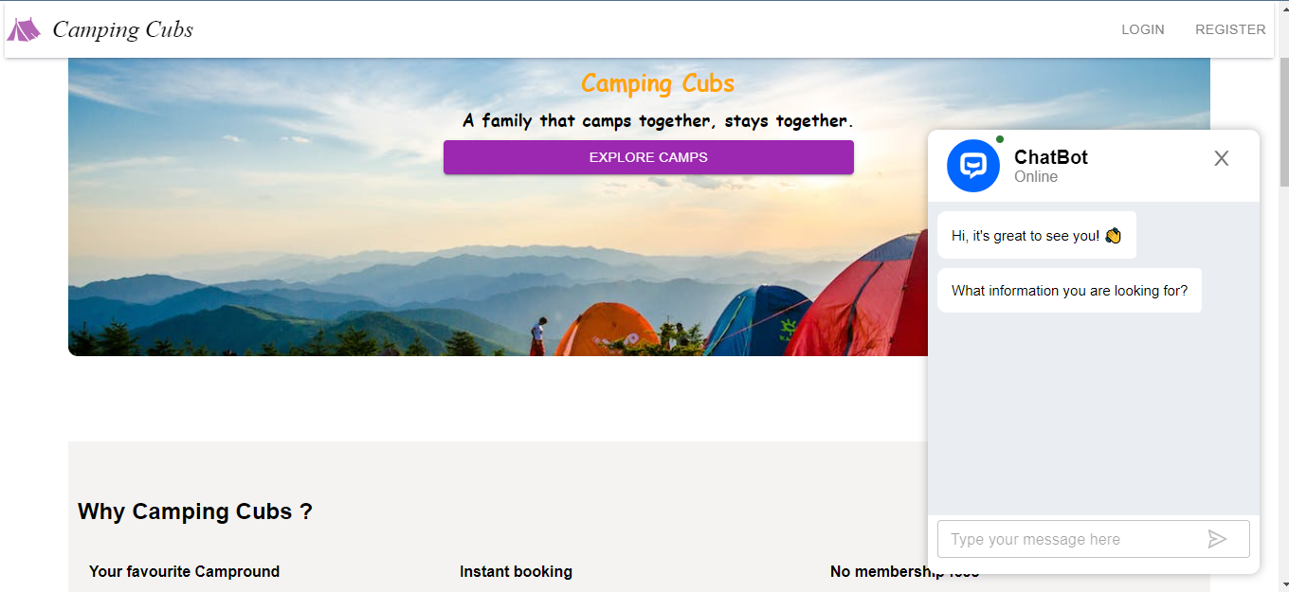

**Fig 1:** DashBoard

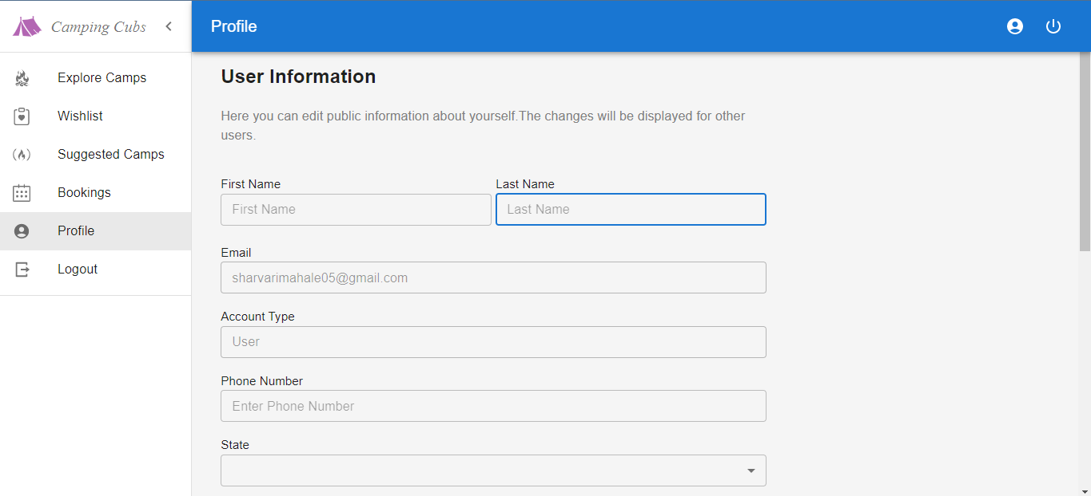

**Fig 2:** User Profile Information

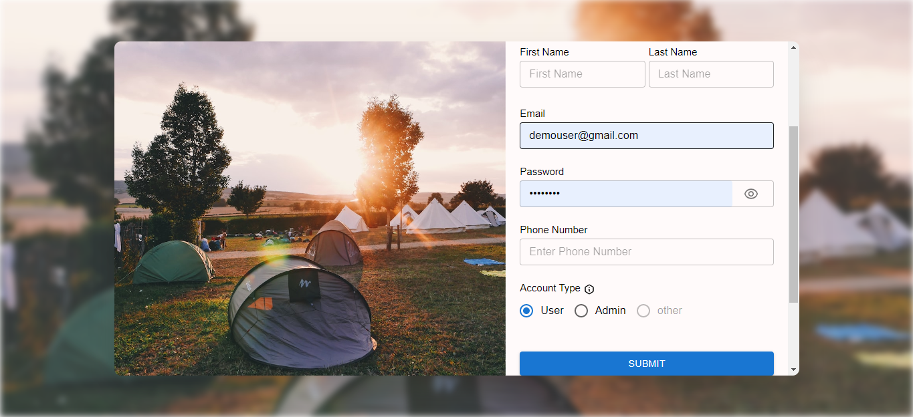

**Fig 3:** Registration as User or Admin

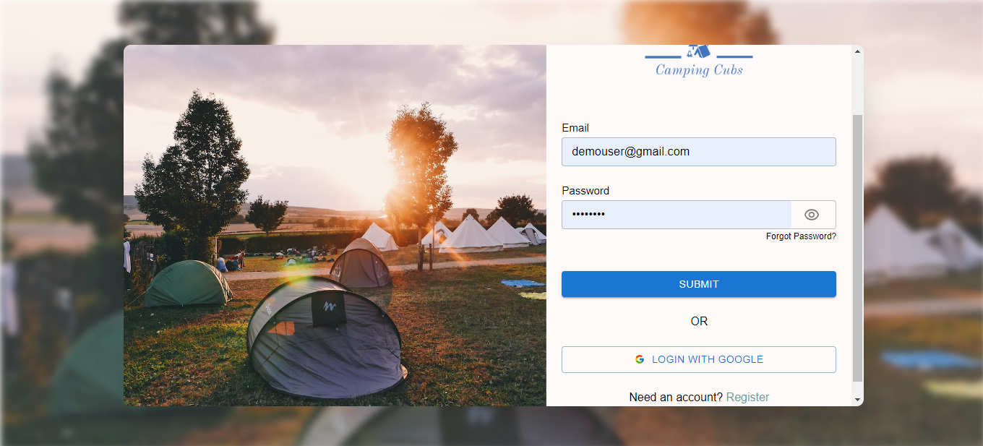

**Fig 4:** Login as User or Admin

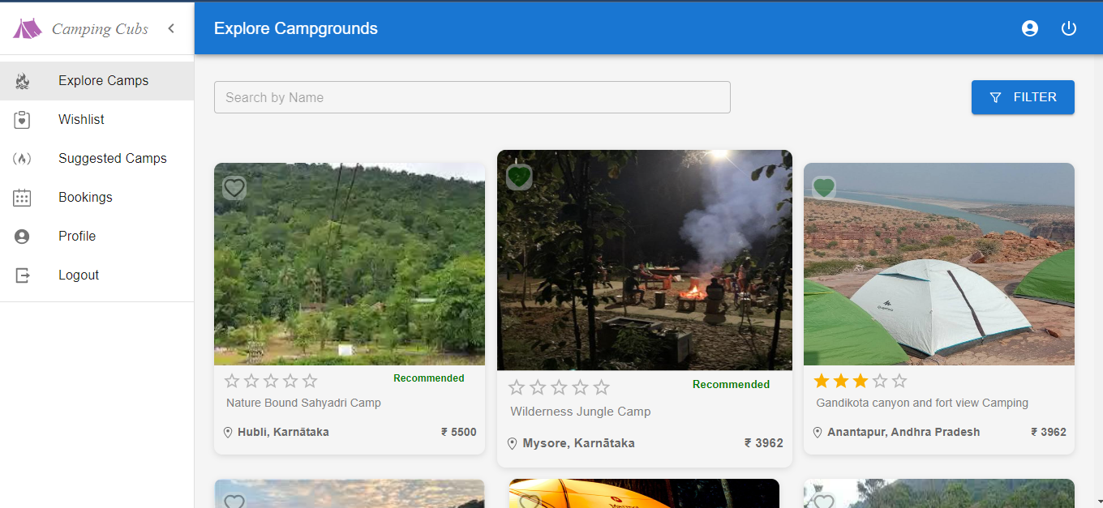

**Fig 5:** Explore Campgrounds

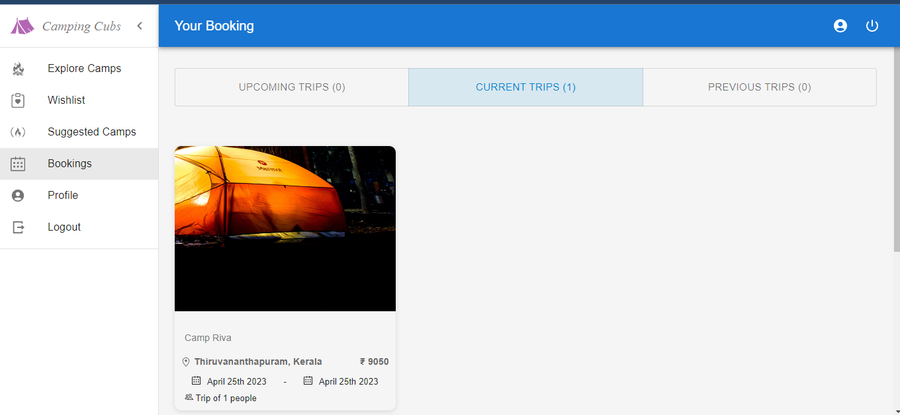

**Fig 6:** Bookings

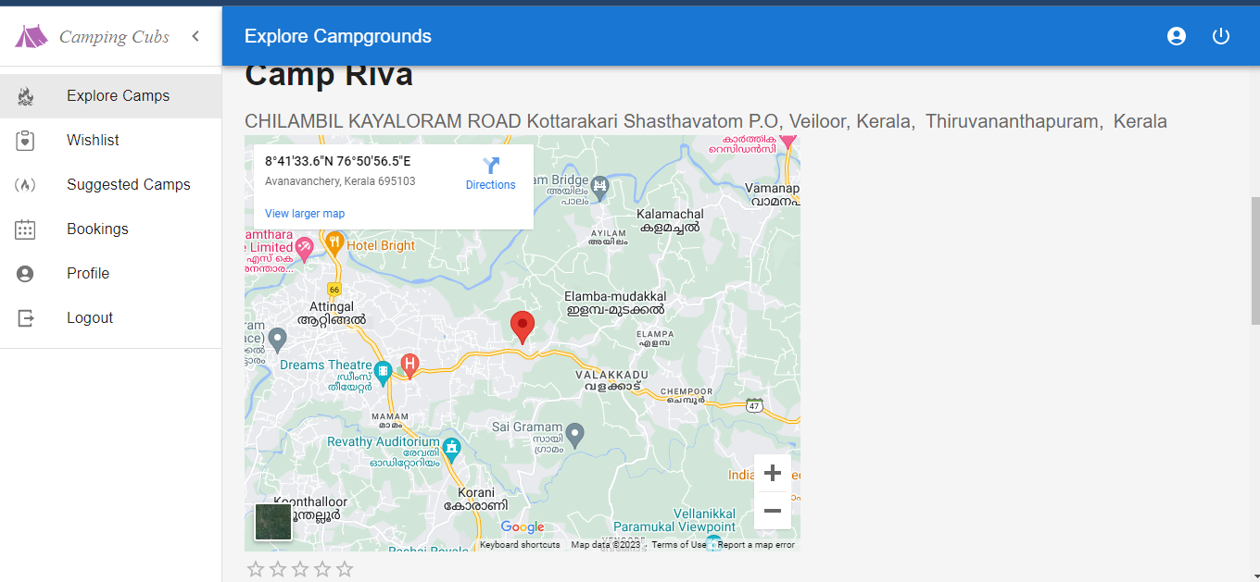

**Fig 7:** Campground Information

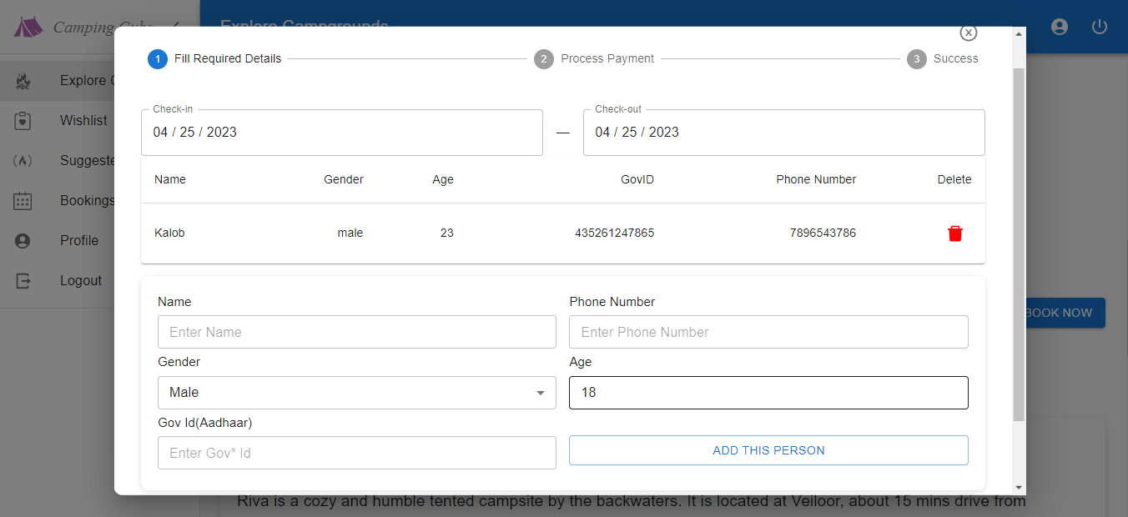

**Fig 8:** Reservation Slot

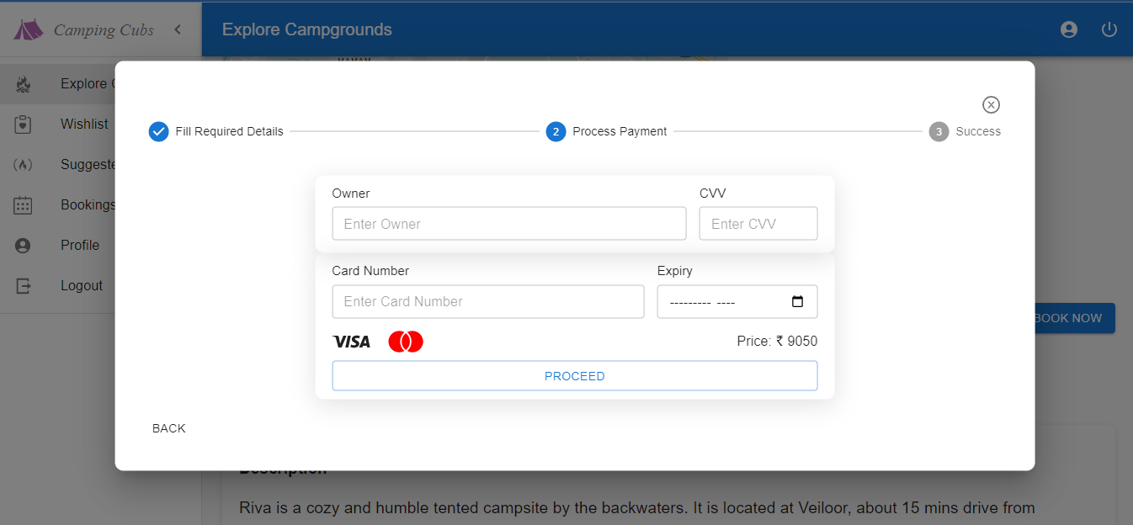

**Fig 9:** Payment Gateway

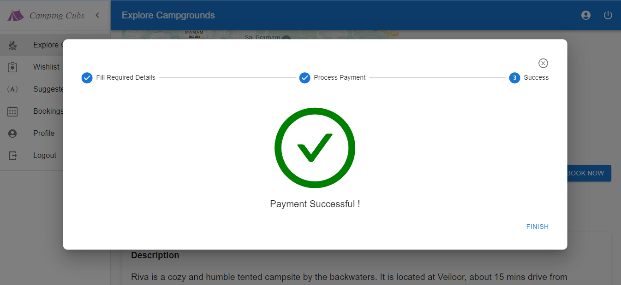

**Fig 10:** Successfully Booking Done

1. **METHODOLOGY**

**The proposed system has the following modules:**

**1.User Authentication**

**2.Add campgrounds**

**3.Wishlist campgrounds**

**4.Explore Campgrounds**

**5.Suggest campgrounds**

**6.Add payment gateway**

**7.Add filters to sort the campgrounds**

**Let’s see in detail:**

**1.User Authentication:** You can sign up as well as sign in using google console as well as by entering authenticated details of the user.

**2.Add campgrounds:** The website provides options to add valid campgrounds which the users can visit through the website.

**3.Wishlist campgrounds:** The user can wish list their favorite campgrounds.

**4.Explore Campgrounds:** The website provides a number of options to select campgrounds from. User can explore campgrounds according to a particular state, location of the user and the campgrounds available in their vicinity.

**5.Suggest campgrounds:** The website will give suggestions to users based on the previous campgrounds visited and by the ratings and reviews of the campgrounds.

**6.Add payment gateway:** The website provides a payment gateway facility it allows users or customers to make payments electronically, typically through credit cards, debit cards, or other online payment methods. The payment gateway securely captures the customer's payment information, encrypts it to protect sensitive data, and then sends the information to the appropriate payment processor for authorization and settlement.

**7.Add filters to sort the campgrounds:** The website provides filters to sort the campgrounds according to the prices, location of the campgrounds, rating of the campgrounds and rentals.

1. **RESULTS AND DISCUSSION**

Advantage of Camping Cubs web applications is ease of use. The website is designed to be user-friendly, with simple and intuitive interfaces. This means that even novice users can easily navigate the application and find the information they need. Additionally, our website can be accessed from a variety of devices, including smartphones and tablets, making it easy for campers to access information on-the-go.

Accessibility is another advantage of Camping Cubs. Campers can access information about campsites and amenities from anywhere with an internet connection. This means that campers can easily research and compare different campgrounds, and make informed decisions about where to stay. Additionally, campground staff can quickly and easily update information about the campground, such as availability and pricing, making it easier to manage reservations and ensure that campers have the information they need.

Enhanced customer experience is another advantage of Camping Cubs. The website provides a range of features to enhance the camping experience, such as detailed information about campsites and amenities, interactive maps, and customer reviews. This will help campers make informed decisions about where to stay, and can improve their overall satisfaction with the camping experience.

Overall, campground websites are essential tools for campers, providing a wealth of information that can help them plan their camping trips. With features such as search functions, reservation systems, maps, photos, and reviews, the website makes it easier and more convenient for campers to find and book campsites, as well as plan their trip and make informed decisions.

1. **CONCLUSION**

In conclusion, campground websites are essential tools for campers, providing a wealth of information that can help them plan their camping trips. With features such as search functions, reservation systems, maps, photos, and reviews, these websites provide campers with the information they need to make informed decisions about where to camp and what to expect during their stay. The benefits of campground websites include convenience, time-saving, cost-effectiveness, informational value, and community-building. As camping continues to grow in popularity, the importance of campground websites is only likely to increase.

1. **REFERENCES**

[1] Yelpcamp: A review based website for campgrounds

Sujay Bodhe1, Arvind Vishwakarma2, Prashant Kamble3, Shrikant Dhamdhere4

1,2,3Student, Dept. of Computer Engineering, PGMCOE, Pune, Maharashtra, India

4Professor, Dept. of Computer Engineering, PGMCOE, Pune, Maharashtra, India

[2] Luo, J. L., Luo, H. J., Li, A. M., & Wang, H. H. (2014,

July). Localized Model to partially Estimate Miles per

Gallon (MPG) for Equipment Engines. In Applied

Mechanics and Materials (Vol. 556, pp. 1069-1074).

[3]R. Heatherly, M. Kantarcioglu, and B. Thuraisingham,

Knowledge and Data Engineering, IEEE Transactions on,

vol. 25, no. 8, pp. 1849–1862, 2013.

[4]K. Jiang, T. Jing, Z. Li, Y. Huo, and F. Zhang, “Analysis of

secrecy performance in fading multiple access wiretap

channel with sic receiver,” in INFOCOM, 2017

Proceedings IEEE, IEEE, 2017

[5]Venkatesh Shinde1, Dhruv Gagare2, Kartik More3, V. S. Phalake4

Students, Department of Computer Technology1,2,3

Lecturer, Department of Computer Technology4

Bharati Vidyapeeth’s Jawaharlal Nehru Institute of Technology, Pune, Maharashtra, India