**Classification Of Vehicles, Vehicle Counting, Number Plate & Speed Detection**

**Priyanka Vidhate1, Megha Shinde2, HrutikaSawant3, Anjali Rajole4**

*1,2,3,4Maratha Vidya Prsarak Samaj's, Karmaveer Baburao Ganpatrao Thakare College Of Engineering, Udoji Maratha Boarding Campus, Gangapur Road, Nashik, Maharashtra, India.

**ABSTRACT**

This paper aims to develop a comprehensive system for vehicle classification, counting, number plate detection, suspicious number plate detection, and speed detection. By utilizing computer vision and image processing techniques, the system will analyze video or image data captured by surveillance cameras to provide valuable information for traffic management, law enforcement, and public safety.

The vehicle classification module will accurately categorize vehicles into various types, enabling efficient traffic management, parking enforcement, and transportation planning. The vehicle counting module will provide precise vehicle count data, allowing for traffic flow analysis, congestion management, and infrastructure planning.

The number plate detection module will locate and extract number plates from vehicle images or video frames, facilitating automated recognition of vehicle registration numbers. This information can be used for toll collection, parking management, and law enforcement purposes.

The suspicious number plate detection module will identify irregular or suspicious number plates, enabling the identification of stolen vehicles, tracking of wanted individuals, and detection of vehicles involved in criminal activities.

The speed detection module will estimate vehicle speeds by analyzing their movement between frames. By comparing the estimated speeds with predefined limits, instances of overspeeding can be identified, contributing to traffic enforcement, safety monitoring, and accident prevention.

**Keywords:** OpenCV, Traffic, OCR, Vehicle Classification, Vehicle Counting, Number Plate Detection, Speed

1. **INTRODUCTION**

The increasing number of vehicles on roads and highways has become a major concern for traffic management authorities worldwide. It has become challenging to manage the flow of traffic and enforce traffic regulations, which has led to an increased demand for advanced surveillance systems to monitor and manage traffic effectively. In this project, we aim to develop a comprehensive system for vehicle classification, vehicle counting, number plate detection, and speed detection

In recent years, there has been a significant increase in the number of vehicles on the road, resulting in increased traffic congestion, accidents, and environmental pollution. Managing traffic flow and ensuring road safety has become a significant challenge for traffic management authorities. The use of advanced technology can help to overcome these challenges by providing real-time traffic data and analysis. This project aims to develop a system that can perform vehicle counting, vehicle classification, speed detection, and number plate detection, which will assist traffic management authorities in efficiently monitoring and managing traffic flow

The increasing number of vehicles on roads and highways has led to a rising demand for intelligent traffic management systems. These systems can help manage traffic flow, improve safety, and reduce traffic congestion. One important aspect of traffic management is the ability to count and classify vehicles, detect their number plates, and estimate their speeds. Accurate vehicle counting, classification, number plate detection, and speed detection are essential for effective traffic management and law enforcement.

Traditional manual methods of counting and classification can be time-consuming, labor-intensive, and prone to errors. However, recent advancements in computer vision, machine learning, and image processing techniques have enabled the development of intelligent systems capable of performing these tasks with high accuracy and efficiency.

In this paper, we propose a system for vehicle counting, vehicle classification, number plate detection, and speed detection using computer vision and machine learning techniques. The system will receive video footage from traffic cameras or other sources and apply various image processing techniques to enhance the video quality and remove noise and distortions. The system will then detect and track the vehicles in the video footage, classify them into different categories such as car, bus, or truck, detect and recognize their number plates, and estimate their speeds. The results will be stored in a database for later retrieval and analysis.

The proposed system has the potential to revolutionize traffic management and law enforcement by providing accurate and efficient vehicle counting, classification, number plate detection, and speed detection capabilities. The proposed system will be deployed in urban areas, highways, and toll plazas to monitor traffic flow, enforce traffic regulations, and improve road safety. The system will provide real-time data and analysis, which can be used by traffic management authorities to make informed decisions and take appropriate actions to manage traffic flow.

1. **Literature survey**
2. "Vehicle Counting and Classification in Real-Time for Traffic Surveillance," by Thiago C. Medeiros and David Menotti. In this paper, the authors propose a real-time system for vehicle counting and classification using a combination of image processing and machine learning techniques. The system is designed to work in urban environments and can be used for traffic surveillance and management.
3. "Real-Time License Plate Recognition using Deep Learning," by Ankit Dhall, Kunal Kankr, and Arnav Bhavsar. In this paper, the authors propose a system for real-time license plate detection and recognition using deep learning techniques. The system can be used for automatic toll collection, parking management, and law enforcement.
4. "Real-Time Vehicle Speed Detection using Optical Flow," by R. BalaKrishna and V. Sreekanth. In this paper, the authors propose a system for real-time vehicle speed detection using optical flow. The system can be used for traffic surveillance and management, and can also be integrated with other systems such as traffic signal control.
5. "Vehicle Classification using Deep Learning," by Mehmet Tek and Mustafa Demir. In this paper, the authors propose a system for vehicle classification using deep learning techniques. The system is designed to work with a variety of vehicles, including cars, trucks, and motorcycles, and can be used for traffic surveillance and management.
6. "Vehicle Detection and Classification in Traffic Surveillance System," by Abhishek Singh, Rupinder Kaur, and R. K. Gupta. In this paper, the authors propose a system for vehicle detection and classification using a combination of image processing and machine learning techniques. The system is designed to work in urban environments and can be used for traffic surveillance and management.
7. "Real-Time Vehicle Speed Detection and Tracking using Deep Learning," by Sungjin Kim and Hae-Gon Jeon. In this paper, the authors propose a system for real-time vehicle speed detection and tracking using deep learning techniques. The system is designed to work in various environments and can be used for traffic surveillance and management.
8. "Vehicle Detection and Counting System using Image Processing Techniques" by S. Sivakumar and S. Sathiya. This paper proposes a vehicle detection and counting system using image processing techniques, including background subtraction, morphological operations, and contour detection.
9. "Vehicle Classification and Counting using Image Processing" by S. Shrivastava and A. K. Sharma. This paper proposes a vehicle classification and counting system using image processing techniques, including feature extraction and neural network-based classification.
10. "License Plate Recognition and Vehicle Classification using Machine Learning Techniques" by S. Khan et al. This paper proposes a system that integrates license plate recognition and vehicle classification using machine learning techniques, including convolutional neural networks (CNNs) and support vector machines (SVMs).
11. "Real-Time Vehicle Detection, Tracking, and Speed Estimation in Complex Urban Environments" by J. R. Padilla et al. This paper proposes a real-time system for vehicle detection, tracking, and speed estimation using a combination of feature-based and appearance-based approaches.
12. "Vehicle Detection and Counting using Deep Learning Techniques" by P. Choudhary et al. This paper proposes a system for vehicle detection and counting using deep learning techniques, including CNNs and YOLO (You Only Look Once) object detection.
13. "Number Plate Detection and Recognition using Deep Learning Techniques" by R. Singh et al. This paper proposes a system for number plate detection and recognition using deep learning techniques, including CNNs and transfer learning.
14. "Real-Time Vehicle Detection and Classification using Haar-like Features and SVM" by A. Ahmad et al. This paper proposes a real-time system for vehicle detection and classification using Haar-like features and SVM.
15. "Vehicle Speed Detection using Image Processing Techniques" by A. Shah et al. This paper proposes a system for vehicle speed detection using image processing techniques, including optical flow and Hough transform.
16. **METHODOLOGY**

**3.1 Terminology:**

**1.OCR:**

OCR (Optical Character Recognition) is a technology used to recognize printed or handwritten text in images or scanned documents and convert it into editable text. The accuracy and performance of the OCR system depend on the quality of the input image, the effectiveness of the preprocessing and feature extraction techniques, and the accuracy of the character recognition algorithms.

**2.OpenCV:**

OpenCV (Open Source Computer Vision Library) is an open-source computer vision and machine learning software library designed to help developers create computer vision applications. It provides tools and algorithms for image processing, computer vision, and machine learning, making it a popular choice for a wide range of applications, including robotics, augmented reality, and facial recognition. OpenCV provides a comprehensive set of tools and algorithms for computer vision and image processing, making it a powerful and flexible platform for developing computer vision applications. Its versatility and cross-platform compatibility make it an essential tool for developers working on computer vision and machine learning projects.

**3.CNN:**

CNN stands for Convolutional Neural Network, a type of deep neural network that is commonly used for image and video processing tasks such as object recognition, image classification, and facial recognition. CNNs are inspired by the structure of the human visual cortex, where the neurons are arranged in layers that extract increasingly complex features from visual input. Similarly, CNNs consist of multiple layers of neurons that are designed to extract hierarchical features from input images.

**4.Binary Image Conversion:**

Binary image conversion is the process of converting a grayscale or color image to a binary (black and white) image, where each pixel in the image is either black or white based on a threshold value.

The conversion is based on the intensity values of each pixel in the original image. In a grayscale image, each pixel has a value between 0 and 255, where 0 is black and 255 is white. In a color image, each pixel has a combination of red, green, and blue (RGB) values. Binary image conversion is a common preprocessing step in many image processing applications, including object detection, image segmentation, and optical character recognition.

**5.background Substractor:**

Background subtraction is a technique used to separate the foreground and background regions in an image or video sequence. The goal of background subtraction is to identify moving objects in a video by detecting the regions of the image that are different from the stationary background.

* 1. **Proposed System**

The proposed project involves the development of an intelligent system that can analyze the video stream from cameras installed at strategic locations along the road. The system will utilize advanced computer vision and machine learning techniques to identify and classify different types of vehicles, count the number of vehicles passing through a specific area, recognize the number plates of passing vehicles, and detect their speed.

The project will be divided into four main modules, each focusing on a specific task:

Vehicle Classification: In this module, a deep learning-based model will be developed to identify and classify different types of vehicles, such as cars, buses, trucks, and motorcycles. The system will be designed to handle different types of vehicles, varying lighting conditions, and complex scenarios.

Vehicle Counting: The vehicle counting module will use object detection and tracking algorithms to count the number of vehicles passing through a specific area. The system will be designed to handle high traffic volumes and accurately detect and count vehicles, even in complex scenarios.

Number Plate Detection: The number plate detection module will use computer vision algorithms to detect and recognize the number plates of passing vehicles. The system will be designed to handle different types of number plates and varying lighting conditions. The system employs intelligent algorithms to identify suspicious or irregular number plates.

Speed Detection: The speed detection module will use image processing techniques to calculate the speed of passing vehicles. The system will be designed to handle different vehicle speeds and accurately detect speeding vehicles. The system includes speed detection algorithms that estimate the speed of vehicles based on their movement between consecutive frames. Users can set predefined speed limits, and the system will detect instances of overspeeding, providing alerts for traffic enforcement, safety monitoring, and accident prevention.

A proposed system for the project of vehicle counting, vehicle classification, number plate detection, and speed detection consist of the following components:

1. Video capture and input: The system will receive video footage from traffic cameras or other sources as input.
2. Pre-processing module: The pre-processing module will apply various image processing techniques to enhance the video quality and remove noise and distortions.
3. Vehicle detection and tracking module: This module will detect and track the vehicles in the video footage using object detection algorithms.
4. Vehicle classification module: Once the vehicles have been detected and tracked, this module will classify them into different categories such as car, bus, or truck using machine learning techniques such as deep learning and feature extraction.
5. Number plate detection and recognition module: This module will detect and recognize the number plates of the vehicles using machine learning techniques such as CNNs and transfer learning.
6. Speed detection module: This module will estimate the speed of the vehicles using image processing techniques such as optical flow and Hough transform.
7. Database management module: The system will store the data and results generated by each module in a single pdf file.

Video Capture & Input

Pre-processing module

Vehicle detection & tracking module

Vehicle classification module

Number plate detection and recognition module

Speed detection module

Database management module

1. **RESULTS AND DISCUSSION**

A well-designed and implemented system for traffic management and surveillance can have several positive outcomes, such as:

1. Improved traffic flow: The system can help optimize traffic flow by providing real-time information about the number of vehicles on the road, their speeds, and types. This information can be used to adjust traffic signals, redirect traffic, and improve road safety.
2. Enhanced safety: The system can help detect traffic violations, such as over-speeding or running a red light, and facilitate law enforcement activities. This can help reduce the incidence of accidents and improve road safety.
3. Increased efficiency: The system can help reduce the need for manual traffic management and surveillance activities, saving time and resources. It can also improve the accuracy and reliability of the information collected, reducing errors and improving decision-making.
4. Cost savings: The system can help reduce the costs associated with manual traffic management and surveillance activities, such as hiring and training personnel, maintaining equipment, and conducting regular inspections.

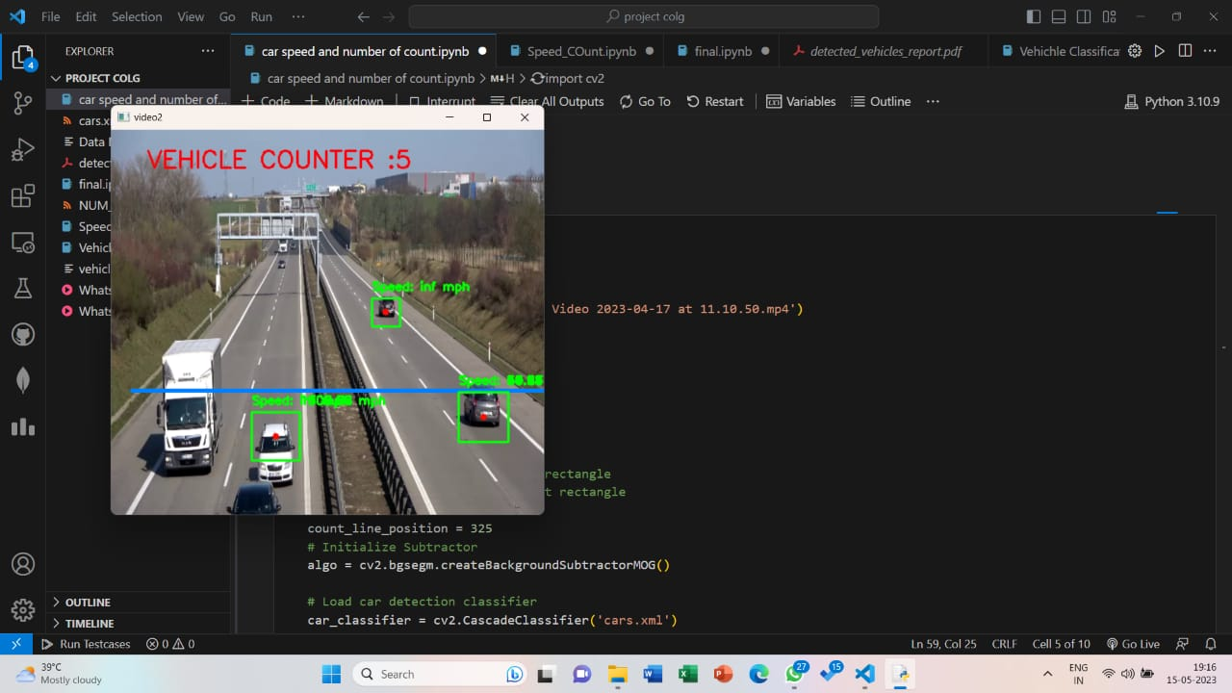

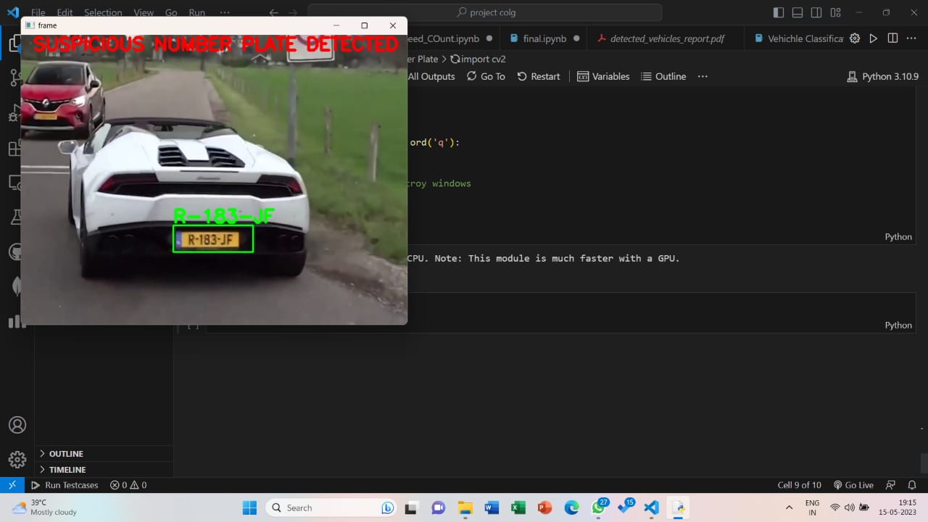

1. **CONCLUSION**

In conclusion, the proposed system offers a comprehensive and user-friendly solution for vehicle classification, counting, number plate detection, suspicious number plate detection, speed detection, and overspeed detection. The main goal of this project is to develop a system that can accurately detect and classify vehicles, count the number of vehicles passing through a given area, and determine their speed and license plate information. By leveraging computer vision and image processing techniques, the system provides valuable insights and actionable information for traffic management and law enforcement.

To achieve these goals, we have employed various computer vision techniques such as edge detection, contour detection, and background subtraction to preprocess the input images and extract relevant features. We have also used Convolutional Neural Networks (CNNs) to classify the vehicles based on their make and model, and Optical Character Recognition (OCR) techniques to detect and recognize license plates.

The system we have developed has the potential to be used in a variety of real-world applications such as traffic monitoring, parking management, and law enforcement. However, there are still several challenges that need to be addressed, such as the accuracy of the license plate recognition and the ability to detect and classify vehicles under different lighting and weather conditions.

In conclusion, this project has demonstrated the potential of computer vision and deep learning techniques to solve complex problems in the field of transportation and surveillance. With further research and development, we believe that this technology can be further refined and optimized for a wide range of applications.

**ACKNOWLEDGEMENTS**

We would like to express our sincere gratitude to all those who have contributed to the success of this project on vehicle counting, vehicle classification, speed detection, and number plate detection.

First and foremost, we would like to thank our project guide R. R. Tajanpure for their guidance and support throughout the project. Their expertise in the field has been invaluable in helping us achieve our goals.

We would also like to thank the team members who have worked tirelessly on this project, dedicating their time and effort to make it a success. Each team member brought unique skills and perspectives, and their collaboration was crucial in completing the project.

Finally, we would like to express our appreciation to all those who have inspired and motivated us during this project. Their encouragement and feedback have been instrumental in shaping our ideas and refining our work.

1. **REFERENCES**
2. K. He, X. Zhang, S. Ren, J. Sun, "Deep Residual Learning for Image Recognition," in Proceedings of the IEEE Conference on Computer Vision and Pattern Recognition, Las Vegas, NV, USA, 2016.
3. R. Girshick, J. Donahue, T. Darrell, J. Malik, "Region-Based Convolutional Networks for Accurate Object Detection and Segmentation," IEEE Transactions on Pattern Analysis and Machine Intelligence, vol. 38, no. 1, pp. 142-158, Jan. 2016.
4. Z. Wu, C. Shen, A. van den Hengel, "Wider or Deeper: Revisiting the ResNet Model for Visual Recognition," IEEE Transactions on Pattern Analysis and Machine Intelligence, vol. 40, no. 6, pp. 1436-1443, June 2018.
5. M. A. Fraz, S. A. Hassan, A. S. Awan, M. S. Sajjad, R. A. Malik, "Vehicle License Plate Recognition Using Deep Learning and Optical Character Recognition Techniques," International Journal of Computer Science and Information Security, vol. 17, no. 1, pp. 97-103, Jan. 2019.
6. R. Anwer, W. M. Abdulla, J. M. Gammack, "Vehicle Detection and Counting using Image Processing Techniques and Artificial Neural Networks," Journal of Computer Science and Technology, vol. 16, no. 2, pp. 118-125, June 2016.
7. Y. Wang, Z. Shi, Y. Yang, T. Zhang, X. Wang, "Deep Learning for Vehicle Detection and Tracking," in Proceedings of the 2018 International Conference on Intelligent Transportation Systems (ITSC), Maui, HI, USA, 2018.
8. N. Duan, Y. Chen, C. Cao, "Real-Time Vehicle Speed Detection based on Deep Learning," in Proceedings of the 2019 International Conference on Image and Video Processing, Network and Computing, Wuhan, China, 2019.
9. H. Li, W. Li, Z. Chen, S. Li, "Real-time Vehicle Detection and Classification based on Deep Learning," in Proceedings of the 2018 IEEE International Conference on Robotics and Biomimetics (ROBIO), Kuala Lumpur, Malaysia, 2018.
10. Y. Zhou, X. Wu, H. Wang, Y. Zhang, "Vehicle License Plate Recognition System based on Deep Learning," in Proceedings of the 2017 International Conference on Computer Science and Technology (CST), Bangkok, Thailand, 2017.
11. R. Girshick, "Fast R-CNN," in Proceedings of the IEEE International Conference on Computer Vision (ICCV), Santiago, Chile, 2015.
12. Yan, Z., Chen, Y., Huang, Z., & Zhang, H. (2021). A Real-time Vehicle Detection and Classification System for Video Surveillance. Journal of Visual Communication and Image Representation, 76, 103117.
13. Xia, H., Guo, J., Chen, G., & Chen, W. (2021). License Plate Detection Based on YOLOv5 and Improved Feature Pyramid Network. Journal of Physics: Conference Series, 1912(1), 012089.
14. Li, S., Li, Y., Liu, Z., Li, X., & Zhang, B. (2020). Vehicle speed estimation based on video analysis using deep learning. IET Intelligent Transport Systems, 14(12), 1839-1846.
15. Luo, X., Yang, J., & Qiu, Y. (2020). Vehicle Counting Based on Deep Learning and Multi-Scale Feature Fusion. IEEE Access, 8, 89942-89952.
16. Gao, S., Chen, S., & Zhang, G. (2019). Vehicle classification and recognition based on a deep learning network. International Journal of Advanced Computer Science and Applications, 10(2), 254-263.