**CHATPLAYER - CHATBOT SONG RECOMMENDATION SYSTEM**

**USING SPOTIFY API**

# PRADEEP JOSHWA. R1, MANOJKUMAR. M2, RAHUL. K3, Mr. PRAVEEN KUMAR.G4

Assistant Professor, Department of Computer Science and Engineering4

Students, Department of Computer Science and Engineering1,2,3

Computer Science Department, Agni College of Technology,

Old Mahabalipuram Road,Thalambur,Chennai-600 130,Tamilanadu,India

# ABSTRACT

The objective of this project is to create a user’s emotion-based music recommendation system use the chatbot interface to suggest personalized music recommendations. The system uses Spotify an API to access user's music preferences and recommend songs based on their reported moods via chat. The chatbot user interface facilitates communication in natural language, which makes a difference the referral process is more engaging and interactive. In addition, the project contains a recommendation system that uses Spotify API to suggest some similar songs what the user’s selected song. The resulting system is a valuable resource for both music lovers and casual listeners allowing them to explore new music based on their mood preferences. The system also offers a sharing feature so that the user can share their favorite music on social media.

# 1. INTRODUCTION

Chatbot music recommendation is a new way to discover music. Powered by Spotify API, users can access a vast library of music, tailored to their preferences and tastes. Through the chatbot, users can quickly and easily find the perfect music for any situation or mood. The chatbot is designed to make music discovery effortless. It can recommend songs based on the user's moods, genre, or artist quickly. With the chatbot, users can easily explore and discover new music by just texting. It has the ability to show similar songs at the same time as track, style performs a sizable position in constructing and showing social identification, the emotional expression of music, and even greater significantly its emotional effect on the listener is often underestimated in the domain of tune choices.

# 2. LITERATURE SURVEY

The music recommendation system developed by Utsav Pati begins with processing the user's image through OpenCV, a Python library for computer vision. The image is then fed into a Convolutional Neural Network (CNN) and Deep Neural Network (DNN) to predict the user's mood as either "happy" or "unhappy." The next step involves an unsupervised machine learning approach using k-means clustering to group songs into two categories: "truly happy" (cluster 0) and "relaxing" (cluster 1). The system then recommends songs based on the current user mood and the song cluster.

David Matsumoto and Hyi Sung Hwang discuss the importance of emotions in human life and the remarkable discoveries that have led to real-world applications in their article, "Exploring Facial Expressions of Emotion." The article focuses on emotions and microexpressions and also tells that how itinfluenced in psychology. The authors also highlight how these findings have been used to develop training programs to improve people's ability to read facial expressions.

The paper "Emotion Recognition from Audio-Visual Data" by Asha Sugave and Sahil Mulani explores the use of audio-visual data to recognize emotions in people. The proposed emotion recognition system uses a fusion algorithm that combines separate emotion classification systems based on voice and facial expressions. The system can automatically identify the user's emotional states based on their voice and facial features. The authors evaluate the performance of the system by separately testing the emotion classification systems based on voice and facial expressions.

# 3. EXISTING SYSTEM

Some existing Music Recommendation Systems use IBM Tone Analyzer API to determine the User's emotions to recommend Songs to the user based on the expression. On the other hand, some systems use Last FM API as Audio Library which provides Audio Files and data to the User according to the User’s Preference. Which has limited music libraries They were implemented with a chatbot and they use Collaborative Filtering and Content-Based Filtering as Machine Learning Algorithms. And some systems recommend songs by the emojis which is given by the user.

# 4. PROPOSED SYSTEM

We are going to Build a Music recommendation system that has a vast number of music libraries and recommends songs by using Spotify API. The Spotify Web API provides access to various features of the Spotify song streaming provider, which includes the audio analysis of given music. This device has no longer covered any system gaining knowledge of algorithms at once however the API employs a few internal algorithms which could determine comparable songs by way of using some of the values which include danceability, valence, power, tempo, and so on. This device also includes Chatbot to ask the songs based on moods. The consumer simply has to tell the chatbot which mood the user has. And it shows the list of songs and if the user again asks for the equal mood of songs, it shows the listing of random songs of the identical temper.

**5. DIRECTORIES OF MODULE:**

## 5.1 MODULE 1: Chatbot

A chatbot is a program designed to pretend verbal exchange with human users, particularly over the internet. in the context of a tune advice system, a chatbot may be used to have interaction with users and advocate songs or playlists based on their preferences. Chatbots can be used in an expansion of methods within a tune advice device. for example, a chatbot can ask users questions about their music possibilities, such as preferred genres or artists, and use these records to signify applicable songs or playlists. Chatbots also can offer personalized suggestions primarily based on a user's listening records or advise songs primarily based on their temper or activity.

Chatbots can be integrated with various track streaming offerings, inclusive of Spotify music, to provide seamless tune suggestions within the chat interface. moreover, chatbots may be used to improve user engagement and retention by providing customized and relevant music suggestions in a conversational manner. basic, chatbots may be a useful devices for improving tune advice revel in through providing personalized, applicable, and conversational song hints to users.

## 5.2 MODULE 2: Spotify API

Spotify API can be included right into a chatbot in a song advice device so as to provide personalized music tips to customers based totally on their preferences and listening history. The chatbot can use Spotify API's recommendation endpoint to fetch endorsed songs or playlists primarily based at the user's present-day temper or song preference. The API also can be used to look for songs, artists, albums, and playlists. The system uses the Spotify API, the chatbot must be authorized to access a consumer's Spotify account. This calls for the consumer to authenticate with their Spotify credentials and grant permission to the chatbot to get admission to their Spotify facts. Once authorized, the chatbot can use the Spotify API to get admission to the user's playlists, lately played tracks, and different listening histories to provide customized hints. The chatbot also can use the API to play songs without delay in the chat interface, permitting users to concentrate on songs without leaving the chat.

## 5.3 MODULE 3: RECOMMENDATION

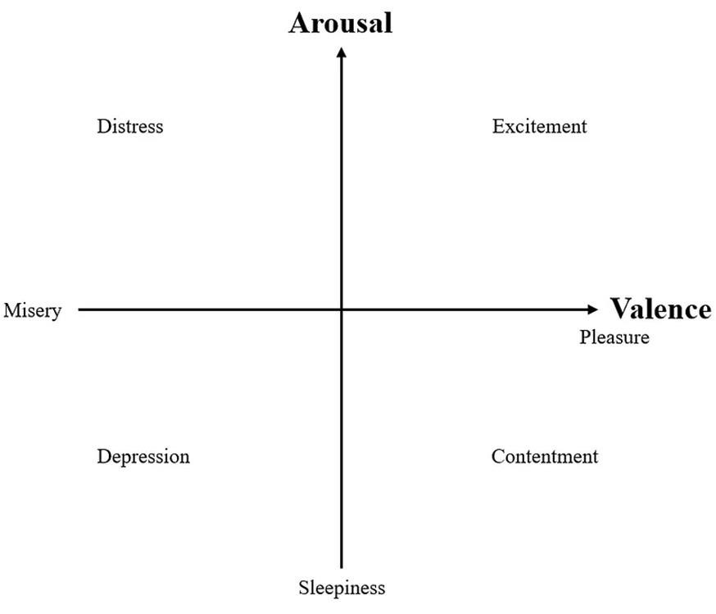

The Spotify internet API gives multiple mood capabilities extracted properly from their internal device learning models. but how in the world are we going to model the complexity of moods with simply “danceability”, “valence”, “strength”, and “pace” absolutely, we handiest need two of those “valence” and “strength” features from the Spotify API to decide the style of the songs.

The energy and valence values of a song can be determined through analysis of its audio features such as tempo, timbre, and rhythm. These features can be extracted using machine learning algorithms and then used to calculate the energy and valence values of the song. Therefore, while the project may not be using a machine learning algorithm directly, it is still utilizing an API that employs such algorithms to calculate the valence and energy values of a song.

**6. MODELING AND ANALYSIS:**

## 6.1 ARCHITECTURE

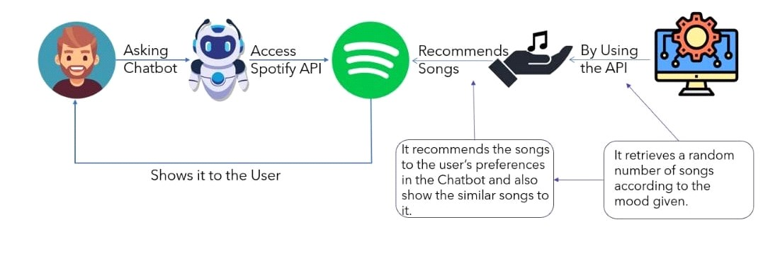

## 6.2 FLOW CHART

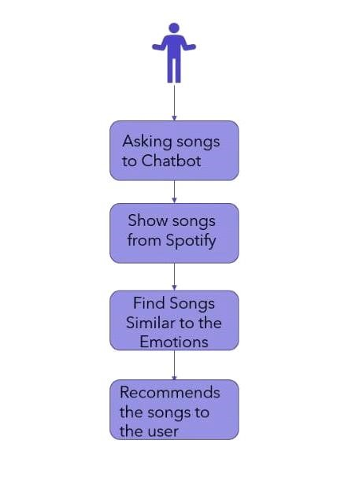

# 7. RESULTS

Finally, we have built a music recommendation system using Spotify API and implemented it with a Chatbot. In this project there are some issues that can be faced, an internet connection is required, it displays many songs that the user can get confused about which song to choose, and the user should know to type in the chatbot to get the required result, by using valence-arousal plane the user could get a similar song which not exactly related to the current song. But it is a simple system with some new features.

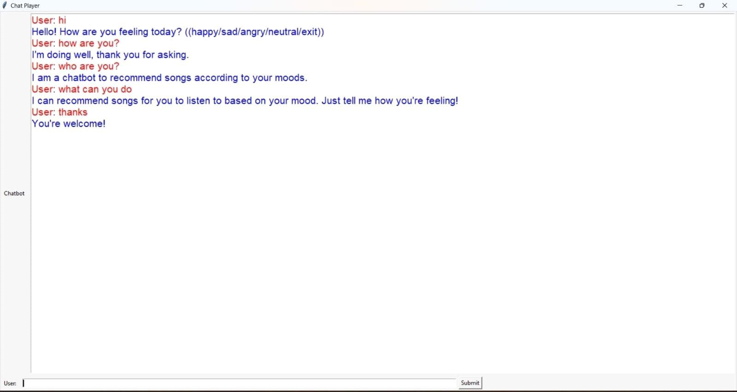

Fig 7.1 Chatting with the Chatbot

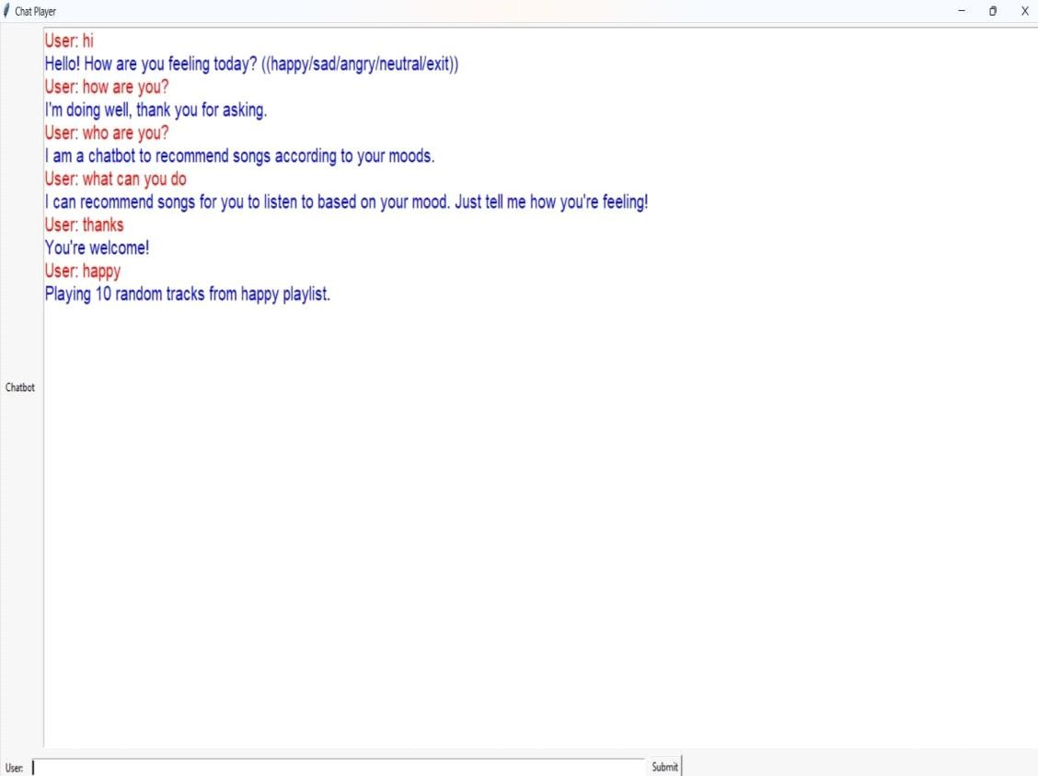

Fig 7.2 Asking happy songs to the Chatbot

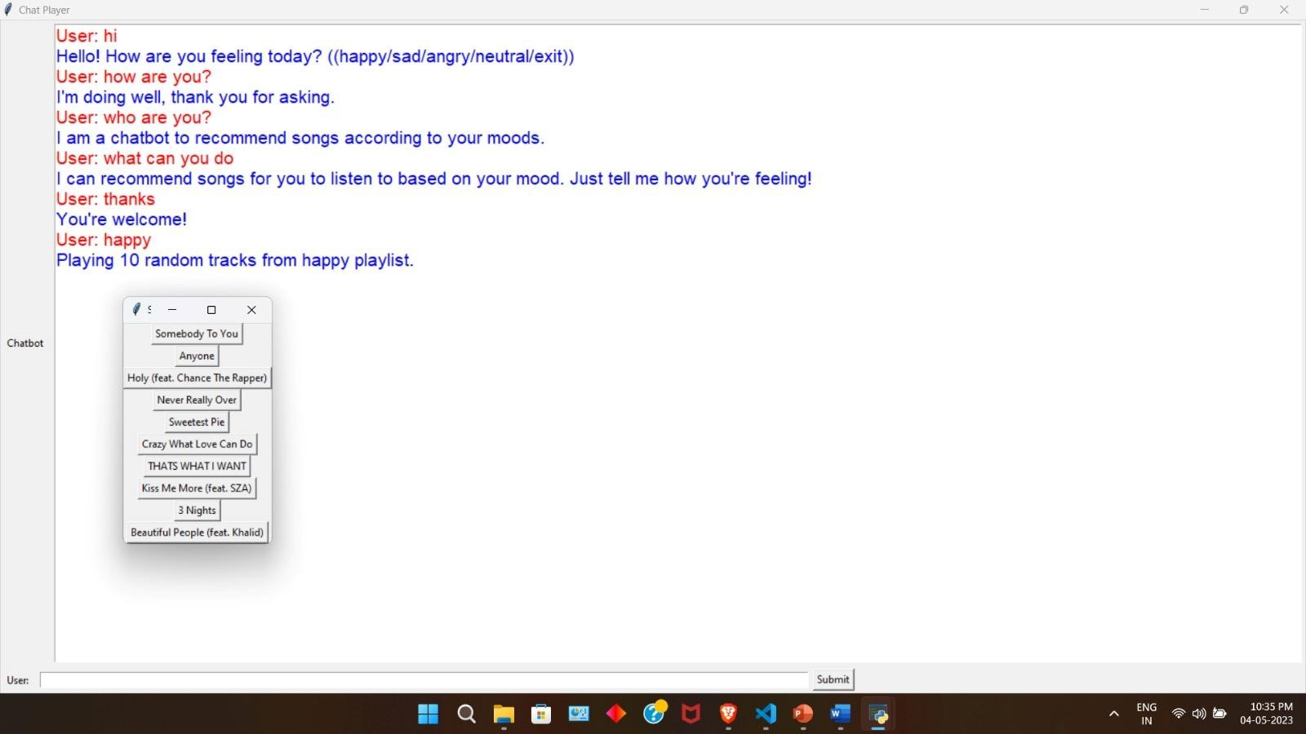

Fig 7.3 Recommends a list of Happy Songs

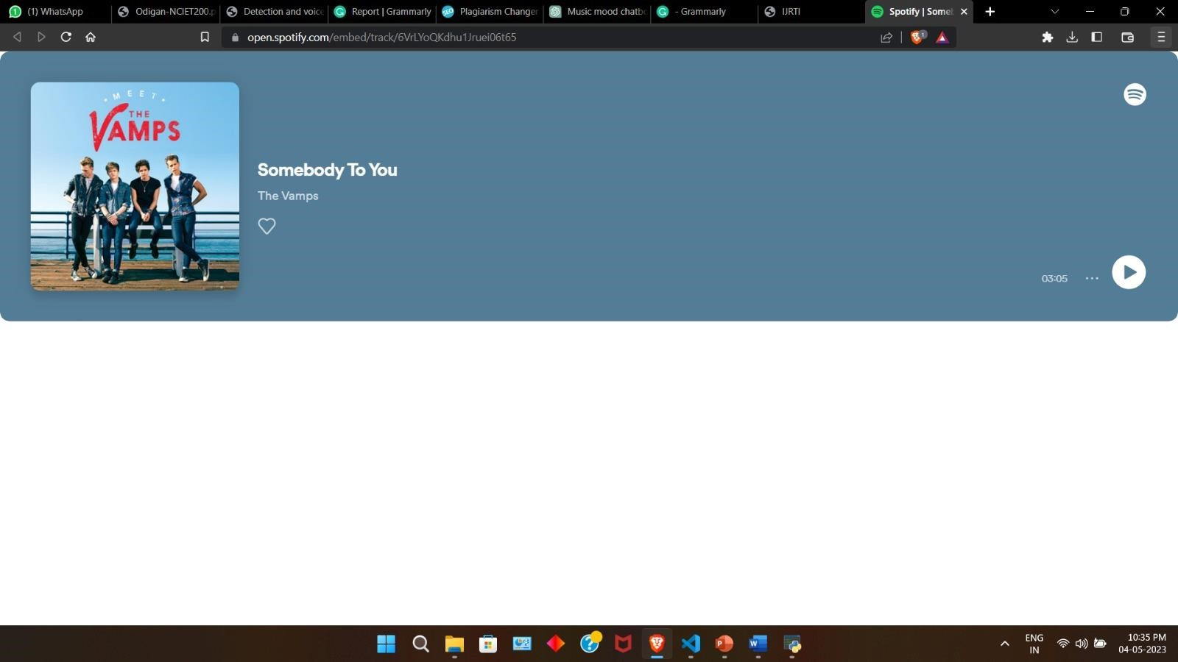

Fig 7.4 Playing the song

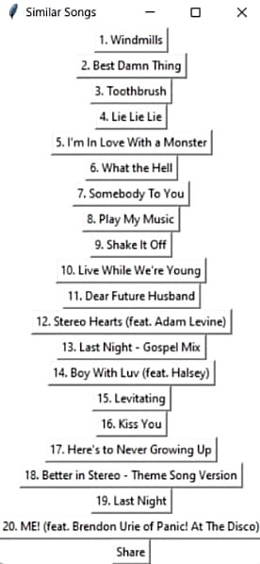

Fig 7.5 Shows Similar songs

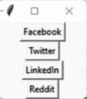

Fig 7.6 Share button to share the songs

# 8. CONCLUSION

This project describes an easy way to build an effective recommendation system without any machine learning. By using Spotify API, which offers multiple mood features extracted from their internal machine-learning models. The Valence-Arousal Plane model is a two-dimensional model that reduces every existing emotion or mood to its arousal component and valence component. We can use the "valence" and "energy" features from the Spotify API to adopt the Valence-Arousal Plane model. And provides code to crawl the data from the API and create a simple and effective recommendation system in a Chatbot.

# 9. REFERENCES

1. Zhao, et al. (2013) proposed a social map-based advice system for content-centric social networking sites.
2. Paul Ekman (1994) explored the fundamental questions related to the nature of emotion.
3. Amelynck, et al. (2012) studied affective gesture recognition in the context of emotion-based music retrieval.
4. Baccigalupo, et al. (2006) introduced a case-based sequential ordering approach for playlist recommendation.
5. Baltrunas, et al. (2009) proposed a context-aware recommender system for time-dependent recommendation.