IOT BASED COLOUR SORTING SYSTEM USING NODEMCU

# Santosh R. Pandit1, Nikhil R. Kandare2, Onkar S. Kapadane3

1Assistent Professor, Department of Instrumentation and Control Engineering, MVPS’s KBT College Of Engineering, Nashik, Maharashtra, India

2,3Student, Department of Instrumentation and Control Engineering, MVPS’s KBT College Of Engineering, Nashik, Maharashtra, India

.

# ABSTRACT

In today’s world of technology and due to speed running industries, the production rate has increased tremendously. Generally, manufacturing industries keep manufacturing same models with little variation in height, color, weight, shape. And here sorting plays an important role. In such cases industries can’t bare human errors for sorting these products. Thus, it becomes necessary to develop Low-Cost Automation (LCA) for sorting these products in accurate manner. Industrial automation mainly focuses on developing automations having low cost, low maintenance, long durability and to make systems user friendly as possible. Finally, here we have developed a LCA system for sorting the light weight objects on the basis of color variation using DC geared motors which is controlled by NODEMCU and the conveyor in the system passes the object in front of sensors and thus sorting logic is decided.

**Keywords:** Automation, NODEMCU, Low, Cost Automation, Manufacturing, Sorting

# INTRODUCTION

Automation is the creation and application of technologies to produce and deliver goods and services with minimal human intervention. The implementation of automation technologies, techniques and processes improve the efficiency, reliability, and/or speed of many tasks that were previously performed by humans. Automation is being used in a number of areas such as manufacturing, transport, utilities, defense, facilities, operations and lately, information technology. The industrial world is facing many technological changes which increased the urgent demand for the premium quality products and services that can only be supplied by a high level of productivity. This requirement needs process engineering systems, automated manufacturing, and industrial automation. Hence, industrial automation plays a key role in solving the requirements of companies.

We are going to present you a system, which saves manpower, give high accuracy. This system takes over the task of sorting color boxes on conveyor belt during process. It uses color sensor for detection of color boxes. System also counts numbers of objects that are passes throughout the process. Connectivity between conveyor system and operating station we use Node MCU which is having In-built WIFI module.

# METHODOLOGY

## Need of Project

An IoT-based color sorting system using a conveyor can have several applications in various industries, such as food processing, recycling, and manufacturing. The primary purpose of such a system is to automate the process of sorting objects based on their color, enabling efficient and accurate segregation of items. The system can significantly improve the sorting speed compared to manual methods, allowing for higher throughput and productivity. It can handle a large number of objects in a short amount of time, streamlining the overall process. The IoT aspect of the system enables real-time monitoring and control. It can collect and analyze data about the sorting process, such as the number of objects sorted, color distribution, and any deviations or anomalies. This data can be used for quality control, process optimization, and performance tracking.

## Existing System

1. **Working of Existing System**

The system consists of conveyor belt which takes the objects like bottles, small boxes or packages in front of sensors and thus sorting logic is decided by NODEMCU. NODEMCU is programmed with different logics, for sorting color product combination. The system consists of color sensors, an inductive sensor and a load cell, all used to detect the color. There is a conveyor line. The function of conveyor belt is to take the boxes in front inductive sensor followed by the color sensors. The color sensor at the start of the conveyor lines will segregate the objects based on their color and send the signal to the NODEMCU, which will initiate the DC motor on which the circular container is mounted, having three compartments, one for each color, in which the objects would be collected. one for the not detected object which is then collected in another box.

## Problem Statement

This IoT based project focuses on building the color sorting system using NODEMCU which sorts the color boxes, balls on conveyor belt and passing object will be count data will be shown digitally.

## Block Diagram

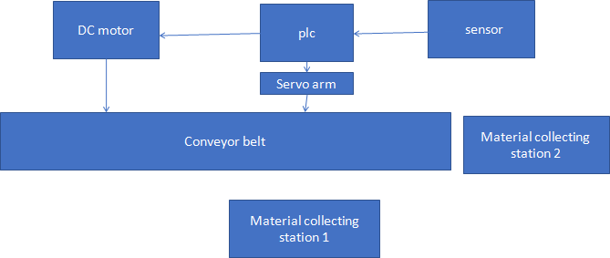

ESP 32

Fig1: Block Diagram

Block description:

ESP 32 is microcontroller used in the system. A 5v regulator power supply is given to this microcontroller, and along with this the components needed for the system such as

* Color sensor
* 16X2 LCD Display
* Servo motor
* Dc motor

## Circuit Diagram

## Fig2: Circuit Diagram

1. **Flow Chart**

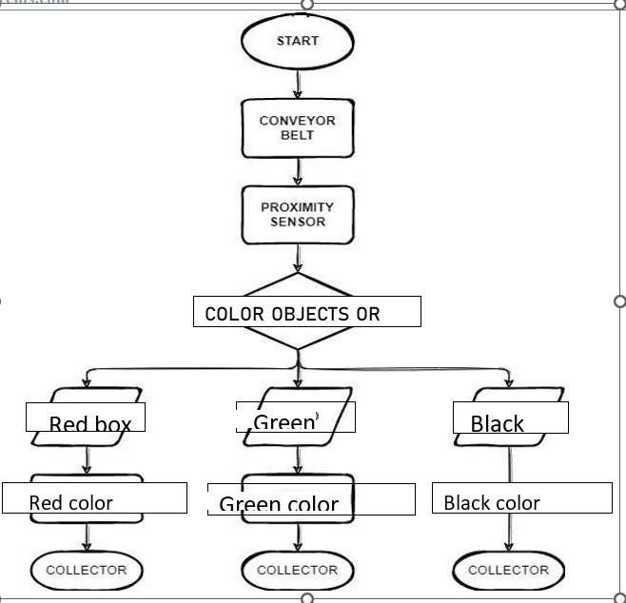

Fig3: Flow Chart

1. **Advantages**
   1. High Precision.
   2. Removes human intervention.
   3. can reduce labor costs and management expenditure.
   4. Faster order processing
   5. Quality - The quality of Color Sorter machines in food items has transformed. Manufacturing companies can easily track product quality and release products for sale.
   6. Control - Manufacturers can quickly assess and refuse the difference in color and texture. This allows the items to be further regulated by sorting the item intomany groups for example.
   7. Speed - Color Sorters from Grain Color Sorter machine manufacturer in India are automatic and the quality control speed is not delayed. In reality, it scales upthe quality assurance process ultimately by eliminating human consequences as tiredness and strike.
   8. Return on Investment - Color Sorter machines have an outstanding ROI because they are almost one-time and require very little maintenance.
   9. Labor - Automated machinery reduces labor costs and managerial problems.
2. **Application**
3. The automatic color sorter can directly replace the manual sorting work to achieve the purpose of improving production efficiency, improving accuracy and reducing labor, and reducing enterprise operating costs and labor costs.
4. The automatic color sorter can select product combinations with different weights, sizes, colors and other characteristics to select the working line, eliminating the financial and time of manual operation, and more accurate and precise.
5. This system widely used in food sorting, fruit sorting, food sorting, ore sorting, garbage sorting and other industrial product sorting industries.

**H. Future Scope**

1. The system can be used as a quality controller by adding more sensors
2. We have constructed the model that sort the objects and count them.
3. More advancement can be done made by We can sense large numbers of color-by- color sensor and sorted more objects using extra hardware and software assembly.
4. Replacing DC motors by stepper motors to increase accuracy. sensors can be replaced by cameras for digital processing which is done using „MATLAB‟
5. Also, we can use such system with some modification for various types of inspection such as holes diameter, Height, Thickness, Surface defect.
6. Using high quality sensor like Laser sensor we can increase the speed of the process.
7. Objects sorted can be distinguished easily by improving extra circuitry. It is also economical.

# RESULTS AND DISCUSSION

Power 3.3v gives to ESP 32, LCD, External power supply gives to servo motors, sensor detect the color sends signal to ESP 32 send data to LCD, ESP 32 send data to server and count object data will be display.

# CONCLUSION

In this project report, we have tried to create a setup that will decrease human effort and succeeded to an extent by using the low-cost automation system (LAC) to avoid risk, improve accuracy, increase speed of production and reduce the cycle time. Limitations will be there due to the practical difficulties in programming of the project according the availability of the materials and components. This setup can be further improved to a sorting system that sorts the items based on the other physical consideration. This can be achieved using the various sensors. In industry it can be used for sorting of various objects, tools, with high degree of accuracy and quality with an automation.

# REFERENCES

[1]. A Review of Automatic Conveyor System, “Avinash L.Nandivale 1 , Omkar D.Kumbhar 2 , Aniket R.Kherade 3 , Amar V.Kolekar4 , Shubham D. Hankare,” Volume No.7, special issue No 1, March 2018

[2]. Sorting of Objects Based on Colour, Weight and Type on A Conveyor Line “S. V. Rautu, P. Shinde, N. R.

Darda,A. V.Vaghule, C. B.Meshram, S.S.Sarawade ,” 6th National Conference RDME2017

[3]. Automatic Color Sorting Machine Using TCS230 Color Sensor And PIC Microcontroller, “Kunhimohammed

C. K, Muhammed Saifudeen K. K, Sahna S, Gokul M. S and Shaeez Usman Abdulla”, International Journal of Research and Innovations in Science and Technology Volume 2 : Issue 2 : 2015

[4]. PLC based Color Sorting Conveyor System, “[1] Amey Dunakhe, [2] Prinal Sakhe, [3] [5]. Anjali Sangale, Mr Anup Dakre”, Vol 8, Issue 8, August 2021

[6]. Utilisation of Colour Sensor and Arduino for Object Sorting Mechanism, “Akshay Kumar Yeulkar1 1Shri Shankaracharya Engineering College, Junwani Bhilai(Department of Electronics and Telecommunication)”,

Volume 5 Issue VI, June 2017