**PESTICIDE SPRAYING DRONE**

**Santosh R. Pandit1, Tejal M. Mali2, Pranav C. Kadam3, Jayshree S. Bhamare4**

1Assistent Professor, Department of Instrumentation and Control Engineering, MVPS’s KBT College Of Engineering, Nashik, Maharashtra, India

2,3,4Student, Department of Instrumentation and Control Engineering, MVPS’s KBT College Of Engineering, Nashik, Maharashtra, India

**ABSTRACT**

The world-wide farming system faces tremendous challenges. The United Nations Food and Agriculture Organization (UN FAO) expects that food production must be raised by 70% throughout the following 40 years to meet increasing demand due to rising economic welfare and population growth. The main challenge of global agriculture is providing a food to the growing population, which is predicted to increase from seven billion people today to approximately nine billion around the year 2050***.*** Whereas India's population, currently estimated at 1.34 billion, is projected to rise to 1.51 billion by 2030 and further to 1.66 billion by 2050. India is categorized by small-scale farmers. Furthermore 80% of the total land in the country is divided into pieces of less than 5 acres. So, drone being a modern technology can be solution for farming to reduce drudgery and with less time lots of data for research can be reported for easiness to bring sustainability in futuristic agriculture.

**Keywords:** Farming, Agriculture, Population.

1. **INTRODUCTION**

Many of the crops are dependent on rain, with around 45% of the land irrigated. It determines that around 55% of the total population in India depends on farming which is dependent on rain. Due to the acute labor shortage and high labor cost, changes in the climatic conditions, crop losses due to pests, poor availability of the funds and agricultural inputs, wastage of inputs, terrible support price structure these are all the problems which are limit the access for good quality of food for the people. Even though agriculture is the major sector of our economy, but still, it is far short of western countries when it comes to adapting latest technologies for better farm output. In order to keep with the challenges, there is need to find ways to improve our current farming practices and processes with improved technologies Agricultural drones provide relief for the modern-day farmer, which are helping to increasing productivity level and declining expenses by reducing the need for human labor and other input recourses.

**[2] METHODOLOGY**

**2.1 Need of advanced technologies in precision farming**

India is categorized by small-scale farms. Furthermore 80% of total agriculture land in the country is divided into pieces of less than 5 acres. The majority of the crops are depending on rain, with just around 45% of the land irrigated. It determines that around 55% of total population of India depends on farming which is dependent on rain. Due to poor availability of funds, agriculture inputs like fertilizers, irrigation, seeds and pesticides, no farm insurance, terrible support price structure for the mass- produce, most of the farming is un-remunerative and more than half of the farmers in India are in debt. This is the vital basis behind the more farmer suicides. Again, in some part of the country, due to intensive production and mechanization in the latter half of the last century it was not possible to take care of the within field spatial variability. So, this developed area required advanced PF technology to be applied. Wealth and security of the nation come from its land and hence its need to be sustainable, innovative, and high- productivity agriculture which will be profitable and provide both food and energy security for the country. Hence, it is believed that some advance farming technologies will help to promote the next green revolution to Indian agriculture. Agricultural drones are used for precision agriculture, which is a modern method of farming that uses big data, aerial imagery, and other means to optimize efficiency. By generating detailed insights, farmers can make data-based decisions that will optimize yield and boost revenue while minimizing expenses and the chances of crop failure.

**2.2 Development and Construction**

The prefix Quad-copter implies (quad =four), is a drone configuration where there are four arms. The main frame is made of Aluminum rod and acrylic plate material with each arm length of 26cm. At each free end of the arm, a motor will be fixed and propeller will be mechanically coupled to the motor. For all eight motors the output side of an ESC will be connected and the input side of the Electronic Speed Controller (ESC) will be connected to the flight controller. The other input of the ESC will be connected to the power distribution board where the power supply is provided by the Li-Po battery. In a similar fashion all the other ESC’s, motors and propellers are connected. A receiver will be connected to the Flight controller to receive signals from the transmitter. A suitable transmitter connected each other is connected to the flight controller. The storage tank is mechanically coupled to the frame, the bottom of the tank will have a slope so that the entire tank gets drained completely. A plastic tube and four nozzles are fixed between each other. A pump is powered from a power distribution board, the inlet of the pump is connected to the storage tank and the outlet is connected to the plastic tube where nozzles are fixed. The landing frame connected to the main frame so that the landing of the drone will be safe and the storage tank will not touch the ground.



Fig1: Block diagram

**[3] WORKING OF DRONE**

Description of block diagram and components:

|  |  |  |  |
| --- | --- | --- | --- |
| Sr No. | Component | Quantity | Specification |
| 1 | Brushless DC Motor | 4 | 1400 KV Rating |
| 2 | Electronic Speed Control | 4 | 30A |
| 3 | Propellers | 4 | 8 inches |
| 4 | Battery | 1 | 2200mah |
| 5 | Power Distribution Board | 1 | - |
| 6 | Flight Controller | 1 | Atmega32 Microcontroller |
| 7 | Fly sky Transmitter and Receiver | 1 | Ct 6b 2.4 Ghz |

Table No. 1: Lists of Parts

The signals will be transmitted from Transmitter and it will be received by the Receiver in the drone. From the receiver the signal goes to the Flight controller where the signal will be processed with accelerometer and gyroscope sensors. The processed signal will be sent to the ESC, which allows the specific amount of current to the motor based on the signal it receives. The propellers are mechanically coupled to the motors so that they rotate and produce thrust. The FPV takes current supply from the flight controller and it records THE signals will be processed by the transmitter and it will be received by the receiver in ground. The pump takes current supply from the Li-Po battery and pressurizes the liquid from the storage tank then the pressurized liquid flows through the pipeline and enters the nozzle then gets sprayed. The flow rate of the pump can be controlled by varying the input current which can be controlled from the transmitter.

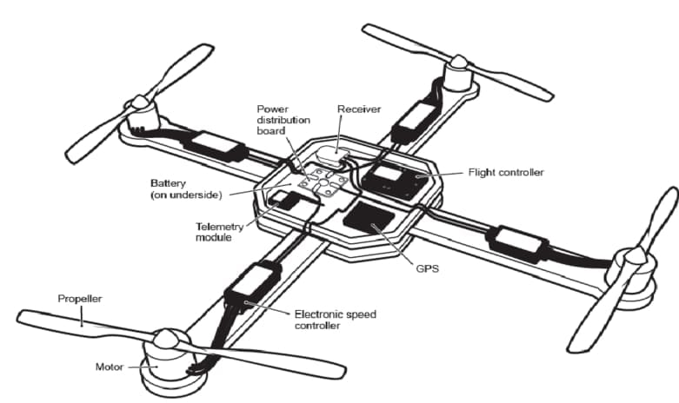

Fig2: Architecture of drone

**[4] FUTURE SCOPE**

* Under the current COVID19 Pandemic situation, it can be used to sanitize large hotspots areas without going there in person.
* Manual control can be changed into autonomous control with GPS technology and auto return home option.
* With image processing techniques, the drone can be involved in surveillance to determine the pest attack on the plants, condition of ripening fruit.

1. **CONCLUSION**

Over the past decade there has been a growing number of examples of applications of drones in farming. However, there are still some crucial limitations related to drones including high initial costs, sensor capability, strict aviation regulations and lack of interest from the farmers may impede adoption of drones. Hence it is clear that the application of drones in farming is still in its early stage and maybe there is a considerable amount of room for further development concerned to both the technology and the various applications. Providentially, it is expected that with the development of drone technology, improved image processing techniques, lower costs and may allow drones to hover like tractors in future farms.

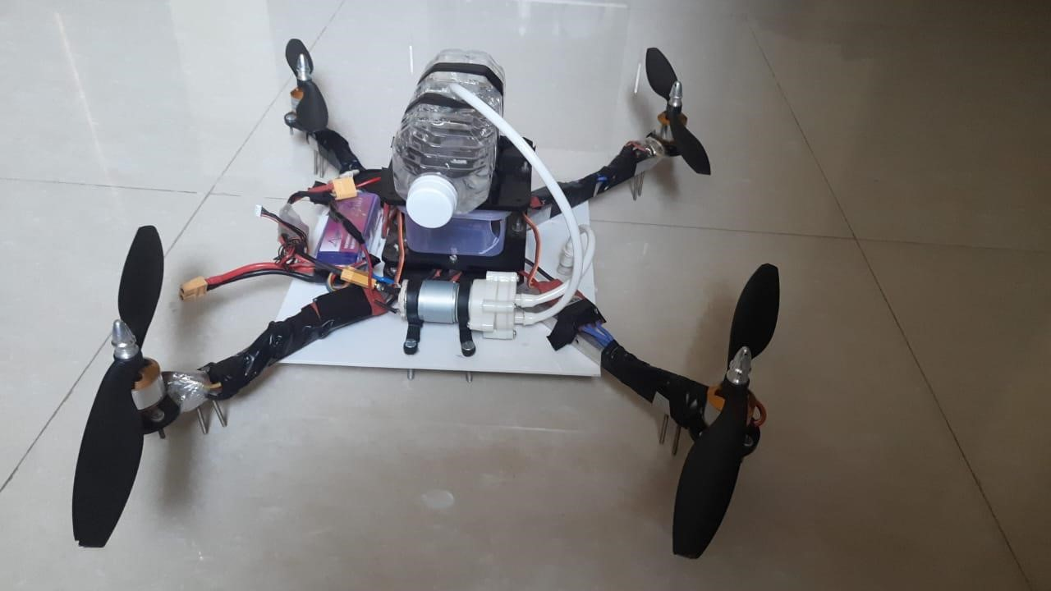

**Figure 3:** Pesticides Spraying Drone

1. **REFERENCES**
2. S.R. Kurkute, B.D. Deore, Payal Kasar, Megha Bhamare, Mayuri Sahane, “Drones for Smart Agriculture: A Technical Report”, April 2018, IJRET, ISSN: 2321-9653.
3. Rahul Desale, Ashwin Chougule, Mahesh Choudhari, Vikrant Borhade, S.N. Teli, “Unmanned Aerial Vehicle for Pesticides Spraying” April 2019, IJSART, ISSN: 2395-1052.
4. Prof. B. Balaji, Sai Kowshik Chennupati, Siva Radha Krishna Chilakalapudi, Rakesh Katuri, kowshik Mareedu, “Design of UAV (Drone) for Crops, Weather Monitoring and For Spraying Fertilizers and Pesticides.,” Dec 2018, IJRTI, ISSN: 2456-3315.
5. Prof. P. Mone, Chavan Priyanka Shivaji, Jagtap Komal Tanaji, Nimbalkar Aishwarya Satish, “Agriculture Drone for Spraying Fertilizers and Pesticides,” Sept 2017, International Journal of Research Trends and Innovation, ISSN 2456-3315, Volume 2, Issue 6.
6. F. G. Costa, J. Ueyama, T. Braun, G. Pessin, F. S. Osorio, P. A. Vargas, “The Use of Unmanned Aerial Vehicles and Wireless Sensor Network in Agriculture Applications,” 2012, IEEE International Geoscience and Remote Sensing Symposium 2012.