LICENSE PLATE DETECTION USING IMAGE PROCESSING

Mrs. Dr.R.Prema (rprema@kanchiuniv.ac.in),

S. Sai Balaji([sattusaibalaji.scsvmv@gmail.com](mailto:sattusaibalaji.scsvmv@gmail.com)),

P. Srikanth([pydikalvasrikanth@gmail.com](mailto:pydikalvasrikanth@gmail.com)),

S. Ajay Kumar(samudralaajaykumar.scsvmv@gmail.com),

CSE Department,SCSVMV,Kanchipuram.

# 

Abstract: The most intriguing and difficult area of study over the past few years has been the identification of vehicle licence plates. In many nations, licence plates come in a variety of sizes, shapes, and colours. The most popular automobile number plate in India has a yellow or white backdrop and a black foreground. In this work, we developed a system for localising automobile licence plates in India and split the numbers so that they could be identified individually. We typically concentrate on two steps: first, finding the number plate, and second, segmenting the letters and numbers to identify each number separately. MATLAB7.4.0 was used to create the project.

Keywords:Number plate localization, Morphological operation, Character segmentation, Thresholding, Edgedetection.

## INTRODUCTION:

Vehicle Number Plate Identification (VNPI) is a type of digital image processing used to classify vehicles in vehicle transportation systems. Numerous applications exist for number plate recognition systems, including automating toll collection, tracking down stolen vehicles, and traffic maintenance. However, managing the traffic management system is the major objective. The traffic control system in India is expanding daily. Private cars in India have number plates with a white background and a black foreground, whereas commercial vehicles have number plates with a yellow background and a black foreground. The number plate starts with two digit letter “state code” followed by two digit numeral, followed by single letter after those four following digits as the below figure1.1.

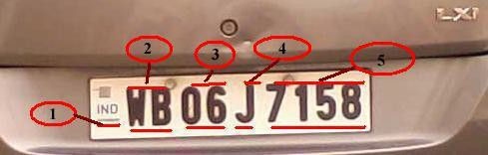

Figure 1.1-sample of number plate

In figure 1.1, 1 indicates the Country code, 2 indicates the state code, and 3 indicates the district code, 4 indicates the type of vehicle and 5 indicates the actual registration number. Locating the number plate is very stimulating work in the field of image processing. The whole system mainly consists of two stages. Initial positioning of the number plate on a certain vehicle must be determined, followed by segmentation of all the digits and characters on the plate. The problem of identification is intriguing due to the characteristics of the light. If the colour of the licence plate is similar to the background, the position inaccuracy will rise. On occasion, errors and poor accuracy can be brought on by noise on the licence plate. Due to the variety of number plate characteristics and the complexity of the natural environment, such as rain, snow, and other elements, there are various restrictions that result in failure in the majority of practical applications. We anticipated a technique based mostly on edge recognition and morphological operations, and we used a mid-filtering noise reduction technique to reduce the noise.

## RELATED WORK

To construct the VNPI system, numerous plate identification and segmentation algorithms have been proposed. The three primary groups of number plate detection algorithms are edge-based, color-based, and texture-based. Based on edge, a licence plate locating algorithm Determine whether any noise is present in the number plate before using detection and morphology to locate it. Number plate segmentation employs a variety of segmentation and identification techniques. More accurate and efficient number plate segmentation will result in moral and effective recognition. Numerous number plate localization techniques have been developed based on the aforementioned method.An improved and effective method based on sobel edge detection and morphological operation is recognised with a high detection rate.

## PROPOSED METHOD

Number plates are a pattern with extremely high contrast differences. It can be difficult to locate a certain location if the number plate is very similar to the background. As the amount of light falling on it changes, so do illumination and contrast.To remove the contrast characteristic from the plate, morphological techniques are utilised.

The work is distributed into several parts:

1. Input raw image
2. Image binarization
3. Reduce noise using mid-filtering method
4. Enhance contrast using histogram equalizer
5. Plate localization
6. Character segmentation

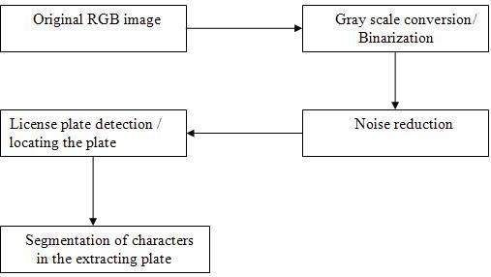

Figure 3.1 shows the basic step diagram of our proposed method.

### Input raw image

Input the image that is taken from the car

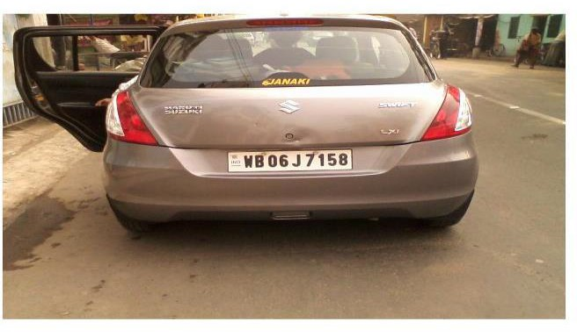

Figure:3.1.1- input car image

### Gray scale conversion

From the input RGB image it has to be convert to gray scale and the 8-bit gray value is intended.

### Noise reduction

We used median filtering method to reduce the paper and salt noise. We have used 3x 3 masks to get eight neighbors of a pixel and their consistent gray value.

### Contrast enhancement using histogram equalization.

Using histogram equalization method the difference of each image is being enhanced. The function used to improvement that is J=histeq(k); histeq enhances the contrast of the images by converting the values in an intensity image. When image pixel intensity of 8-neibourgh connectivity, we supply a preferred histogram, histeq chooses the grayscale conversion T to minimize

│c1 (T (k))-c0 (k) │

In below we state the change of histogram from original image and after smearing the contrast enhancement using histogram equalization.

### Plate localization

Detecting the plate size is the fundamental stage in the recognition of a vehicle number plate. Number plates often have a rectangular shape. Therefore, we must determine the rectangular plate's edges. To find that area, mathematical morphology will be applied.We used the Sobel edge detector to identify locations with a high edge magnitude and high edge alteration. Edge will be detected from the input image depending on the threshold value. Before using the Sobel edge detection technique, the input image is shown in Figure 2.3, and after using the algorithm, it is shown in Figure 2.4.

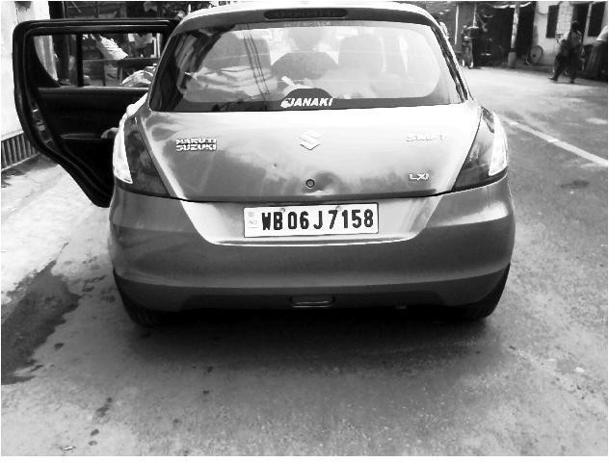

Figure: 3.5.1- Grayscale image after image enhancing.

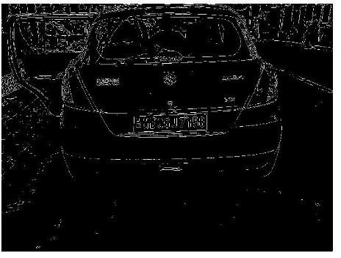

Figure: 3.5.2-After applying Sobel edge detection method

After edge detection eliminates all connected components that have lower than (eight pixel in our method) pixels. Thus it will produce another binary image.

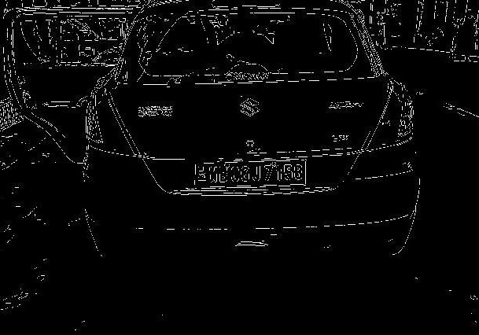

Figure:3.5.3-After removing lower pixels.

Matlab toolbox function deliver a functionimfill(BW,‟holes‟) that fills holes in the binarized image called BW. The set of background pixels are known as hole that cannot be reached by filling the background from the edge of the image. Figure 2.5 shows after remove lower pixels connected components fills the holes

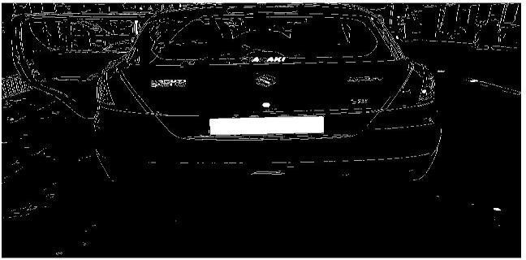

Figure: 3.5.4-After filling the holes



Figure: 3.5.4-After filling the holes

Using flood fill algorithm we fill the hole to trace the plate region. Now neglecting the lower pixel components to gets the actual plate.

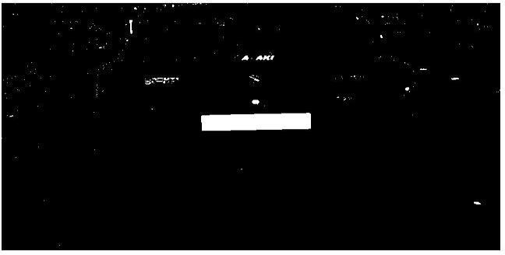

Figure:3.5.5-image after removing components with connectivity less than 1000 pixel.

Using Matlab toolbox function bwareaopen() that stipulates the expected connectivity. All components connectivity lower than 1000 pixel are removed to get the actual location of the number plate. We output the four vertexes coordinates of the last selected region after morphological filtering and extract the number plate .

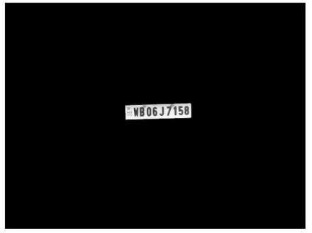

Figure: 3.5.6- License plate before crop

The final positioning of the number plate after cropping.

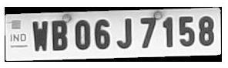

Figure: 3.5.7- The final number plate after the croping.

### Character Segmentation

Matlab toolbox function delivers a function called regionprops(). It measures a set of properties for each labeled region in the label matrix. We use boundingbox to measure the properties of the image region. After labeling the connecting components, the region will be removing from the input image.



Figure 3.6.1- Segmentation of characters

## EXPERIMENTAL RESULTS

We have run our proposed method on desktop computer Several vehicle images are taken using 1.3 mega pixel camera as well as 12 mega pixel cameras. In the experiments, we test our proposed method on the different type car image to identify the location exactly.

Fig: 4.1-Proper light on croppin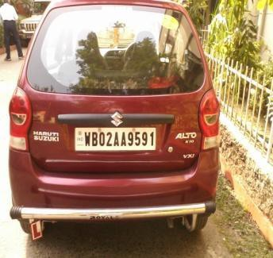g

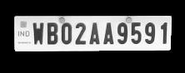

Fig 4.2-Successful number plate.

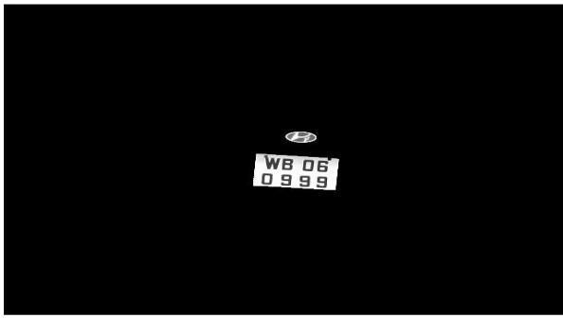

Figure: 4.3-Problem in distinguishing the actual plate position due to light.

## CONCLUSION AND FUTURE WORKS

An efficient less time consuming vehicle number plate detection method is projected which performed on multifaceted image. By using, Sobel edge detection method here detects edges and fills the holes less than 8 pixels only. To removing the license plate we remove connected components less than 1000 pixels. Our anticipated algorithm is mainly based on Indian automobile number plate system. Extraction of number plate accuracy may be increased for low ambient light image.

## REFERENCES

1. Deniing Jiang, Tulu Muluneh Mekonnen, Tiruneth Embiale, Ashenafi Gebrehiwot “Car Plate Recognition System” in Fifth internation conference on Intelligent Networks and Intelligent Systems, IEEE, 978-0-7695-4855-5/12 2012.
2. Huili Han, Runping Han “Method of License plate Location Based on Edge Detection and Color Information”, IEEE, 978-1-4577-1701- 7/11, 2011, pp1477-1480.
3. Ch. Jaya Lakshmi, DrA.Jhansi Rani, Dr. K. Sri Ramakrishna, M.Lantikiran, V.R. Siddhartha,”A novel Approach for Indian License Plate Recognition System”, IJAEST, Vol 2 Issue I, 2011, pp 010-014.
4. ShokriGendy, Clifton L.Smith, Stefan Lachowicz, “Automatic Car registration Plate Using Fast Hough Transform”, IEEE, 0-7803-3913- 4-9/97,1997, pp 209-218
5. S. S. Krishnamoorthi, C. R. Ravikumar, and R. Aravind, "License Plate Recognition Using Image Processing Techniques," International Journal of Advanced Research in Computer Science and Software Engineering, vol. 3, no. 6, pp. 233-238, June 2013.
6. R. Sinha, S. Banerjee, and A. Mukherjee, "License Plate Detection and Recognition using Image Processing and Neural Networks," in Proceedings of the 2015 IEEE Calcutta Conference (CALCON), pp. 54-58, December 2015.
7. Z. Qiu, S. Wang, and X. Wang, "License Plate Detection Method Based on Image Processing," in Proceedings of the 2018 IEEE 3rd International Conference on Image, Vision and Computing (ICIVC), pp. 991-996, June 2018.

Author’s Profile:

1. 

S. Sai Balaji (11199A216), Student, B.E. Computer Science and

Engineering, Sri Chandrasekharendra Saraswathi Viswa Mahavidyalaya deemed to be university, Enathur, Kanchipuram, India.

2.

P. Srikanth (11199A194), Student, B.E. Computer Science and

Engineering, Sri Chandrasekharendra Saraswathi Viswa Mahavidyalaya deemed to be university, Enathur, Kanchipuram, India.

3..

S. Ajay Kumar (11199A212), Student, B.E. Computer Science and

Engineering, Sri Chandrasekharendra Saraswathi Viswa Mahavidyalaya deemed to be university, Enathur, Kanchipuram, India.

4..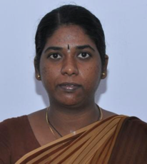

Dr. R. Prema , Assistant Professor , B.E. Computer Science and

Engineering, Sri Chandrasekharendra Saraswathi Viswa Mahavidyalaya deemed to be university, Enathur, Kanchipuram, India.