**Design and Fabrication of Horizontal Axis Wind Turbine**

# Abhishek Shrivastav1, Dr. Hari Parshad2

1,Student, Department of Mechanical Engineering, Ganga Technical Campus Sauldha, Jhajjar, India

## 2Associate Professor, Department of Mechanical Engineering, Ganga Technical Campus Sauldha, Jhajjar, India

ABSTRACT

*One of the potential renewable energy sources utilised to produce electricity is wind energy. In our industrial world, the hunt for sustainable, environmentally friendly energy has gained momentum. The existence of energy is crucial to the current global technological civilization. Power availability is completely dependent on the expansion of industry, agriculture, and transportation, etc. Due to the rise in power demand and depletion of the traditional energy resources that are utilised to produce electricity, energy prices are rising day by day. The utilisation of non-conventional energy sources, such as wind, solar, tidal energy, etc., is thus crucial. One of the most promising forms of renewable energy, according to experts, is wind. By converting the kinetic energy of the wind into the rotational energy of the shaft, the rotor shaft is rotated to produce electrical power. The goal of this endeavour is to create a home wind turbine that operates at low wind speeds and can be purchased by the average person for a very cheap cost. The blades were made using polyvinyl chloride, which is widely accessible. Basic aerofoil sections are taken into account throughout the design process, and different forces acting on the blades are theoretically predicted and optimised to provide the most power. A gear ratio is used to maximise the wind turbine's rotating speed. To get electricity, a DC dynamo that serves as a generator is employed.*

*Keywords*:Renewable sources, Horizontal Axis Wind Turbine, wind Energy, hub, blade, fabrication, Gear Ratio, Dynamo.

INTRODUCTION

Like the majority of forms of energy on Earth, wind energy is created by solar energy. Over territories and seas, solar radiation generates areas of uneven temperature. As a result, areas of high and low pressure are created, which results in the wind. Due to the expansion of industry and population, the has been a dramatic rise in the world's energy consumption in recent years. As a result, the supply of energy is far lower than the actual demand. The main need of the day is enough access to affordable electricity. Energy supply is a key factor in both economic development and industrialisation. However, the current issue is that the world's energy supplies are quickly running out, and as a result, the world is now experiencing an energy crisis. Now is the time to start conserving the traditional energy sources while simultaneously looking for other energy sources to produce electricity, such as solar energy, wind energy, tidal energy, geothermal energy, etc.

One of the most well-known kinds of renewable energy on the planet is wind energy. There is a lot of wind power available for energy generation, and it has already shown that it can provide a significant portion of global electricity demand. Wind serves as both the source of energy and the most significant design restriction for turbines since it generates loads that the turbines must bear. Therefore, the planning, construction, and functioning of wind turbines need precise information of the wind. The method for creating wind turbine blades with the appropriate output suited for household use is described in this article.

**A. ADVANTAGES OF WIND POWER**

* No emissions are produced by wind energy, and it does not run out over time. Based on the typical fuel mix used for utility generating in the US, one megawatt (1 MW) of wind energy may replace approximately 1,500 tonnes of carbon dioxide, 6.5 tonnes of sulphur dioxide, 3.2 tonnes of nitrogen oxides, and 60 pounds of mercury in a year.
* Wind farms may boost local municipalities' property tax collections while giving landowners a consistent stream of cash.
* Numerous configurations are possible, such as massive wind farms, distributed generating, and single end user systems. Additionally, it minimises reliance on foreign governments to provide fossil fuels by reducing imports of such fuels. Additionally, wind energy is superior to other alternative energy sources since it is accessible year-round, 24/7.
* **2. HORIZONTAL AXIS WIND TURBINE**

The analysis is carried out on Horizontal Axis Wind Turbine (HAWT) meant for domestic purposes. Components of this turbine are mentioned below.

Blades: The blades are made up of Poly Vinyl Chloride (PVC). Eight inch diameter PVC pipe is used to fabricate the appropriate wing-shaped curvature. A jig saw is used to cut the PVC pipe. The final blade dimensions are shown in Figure 1.

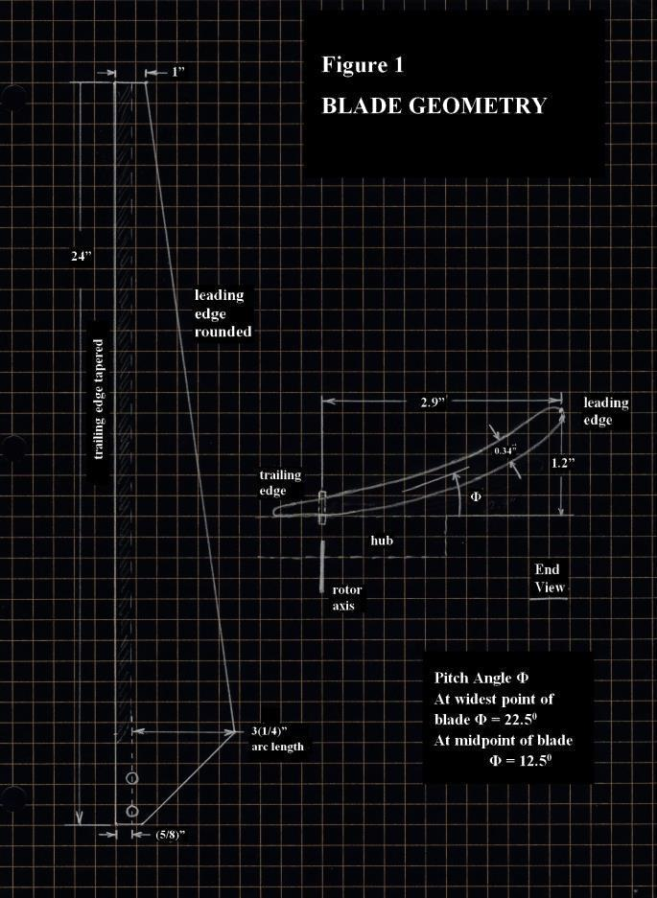The leading edge is rounded and the trailing edge is tapered for each blade so that the shape would approach that of an airplane wing.

Fig1.Geometryoftheturbineblade

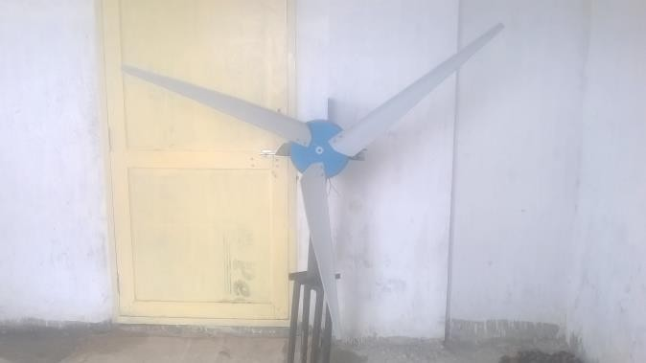

Fig.2.Dynamoactingasgenerator

DESIGN CALCULATIONS

The power in the wind, Pw = 1/2ñAV3

Where V is the velocity of wind at the blades, ñ is the density of the air; A is the area of the blade.

Maximum extractable power from wind, Pmax = 16/27(1/2ñAV3)

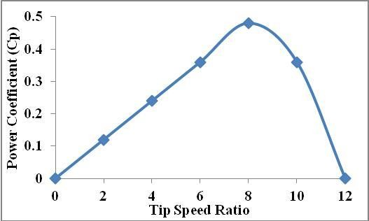Actual power developed by a propeller type wind turbine shows that power coefficient is strongly reliant on tip speed ratio. Tip- speed ratio (TSR) is the ratio of the speed of the rotating blade tip to the speed of the free stream wind. As tip speed ratio of our wind turbine is expected to be 2.5 times that of incoming velocity, whereas for a high speed wind turbine it attains a value of 8.

Fig3. TSR versus Cp for wind turbines.

All wind power cannot be captured by rotor or air would be completely still behind rotor and not allow more wind to pass through. Theoretical limit of rotor efficiency is 59%

Most modern wind turbines are in the 35 – 45% range.

**RESULTS AND DISCUSSIONS**

Winds speeds vary day by day. Readings are taken by connecting the output of the dynamo with a multimeter with a purpose of measuring voltage. We took the readings on two consecutive days. The first day the average wind speed was found to be 15 kmph (4.17 m/s) measured using a Global Positioning System (GPS) tracker. With wind speed as equal to 4.17 m/s, the wind turbine spun at an average speed of 350 RPM.

**Table 1: Rotation of wind turbine blade corresponding to windspeed**

|  |  |  |
| --- | --- | --- |
| **WindSpeed** | **Wind blade rotati onal** | **Voltage (V)** |
| **(m/s)** | **speed(R.P.M)** |
| 4.17 | 350 | 12.6 |

On the second day the average wind speed was found to be 9 to 10 kmph (2.5 to 2.8 m/s), With wind speed as equal to 4.17 m/s, the wind turbine spun at an average speed of 350 RPM. This rotational speed is increased by three times i.e. 1050 RPM by using a bevel gear with a gear ratio 1:3 read from a tachometer and the multimeter read 12.6 V. It is expected to find a very low cut-in speed so that we could capture as much of our small quantities of available wind as possible. The ability to consistently produce 12 volts at around 15 kmph. 12 volts is necessary to push the power into the 12 V battery. The following reading has been observed in practical conditions.

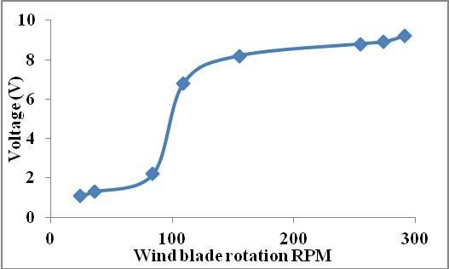

Fig4. Wind blade rotation Vs voltage.

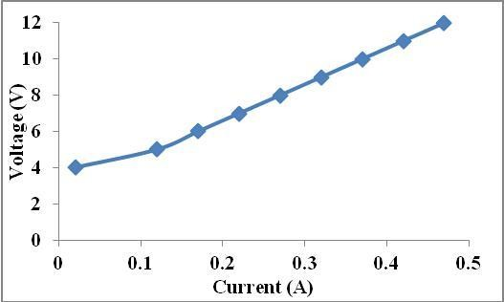

Fig5. V-I Characteristics.

To measure the voltage and current received from the wind turbine, a voltmeter is connected in parallel, and an ammeter is connected in series. We were not able to get a steady output from voltmeter readings with decreased magnitude beginning from zero. As a result, we began keeping track of the readings that persist for a long time. It can be seen in Fig. 10 that current increases as voltage rises. As a result, the relationship between current and voltage is proportional.

CONCLUSIONS

* The analysis is yielding with the following conclusions.
* Rotates the turbine at low wind speeds.
* Manufacture of blades is simple and easy.
* It produces high torque and does not require starting thrust.
* More force is developed from wind energy.
* More mechanical work is developed by the turbine.
* Low cost as manufacture of blade is simple.

**REFRENCES**

1. Z.L. Mahri, M.S. Rouabah(2008), Calculation of dynamic stresses using finite element method and prediction of fatigue failure for wind turbine rotor Wseas Transactions On Applied And Theoretical Mechanics, Issue 1, Volume .
2. Mickael Edon, 38 meter wind turbine blade design, internship report
3. G. Philippe and Selig, Blade Geometry Optimization For The Design of Wind Turbine Rotors AIAA-2000-0045.
4. M. Jureczko, M. Pawlak, A. Mezyk, (2005) Optimization of wind turbine blades, Journal of Materials Processing Technology Vol 167 p.p 463–471 Tingting Guo, Dianwen Wu, Jihui Xu, Shaohua Li, The Method of Large- scale Wind Turbine Blades Design Based on MATLAB Programming, IEEE Carlo Enrico Carcangiu, CFD-RANS Study of Horizontal Axis Wind Turbines, Doctor of philosophy Thesis report
5. K.J.Jackson, et al.(2005), Innovative design approaches for large wind turbine blades, 43rd AIAA Aerospace Sciences Meeting and Exhibit, Reno, Nevada Wang Xudong, et al.( 2009),Blade optimizations for wind turbines, Wind Energy. 12:781–803, Published online in Wiley Interscience
6. Y. Karam, M, Hani((2002)Optimal frequency design of wind turbine blades,
7. Journal of Wind Engineering and Industrial Aerodynamics 90 p.p961–986 Gasch Robert, Twele, Jochen(2007), Wind Power Plants-Fundamentals, Design, Construction and Operation, published by Teubner-Verlag, German. Hills, Richard L (1996), Power from Wind: A History of Windmill Technology,Cambridge University Press.
8. Patel, Mukund R, Patel (1999), Wind and Solar Power Systems, CRC Press. Paul Gipe (2009), Wind Energy Basics: A Guide to Home and Community- scale Wind Energy Systems , published by Chelsea Green
9. Erich Hau(2010), Wind Turbines: fundamentals, Technologies, Application, conomics , published by Springer.
10. Wei Tong(2010), Wind Power Generation and Wind Turbine Design, WIT Press
11. B. C. Cochran, D. Banks, and S.J. Taylor (2004), 23rd ASME Wind Engineering Symposium,, Reno, Nevada, Paper # AIAA-2004-1362
12. R. G Derickson,., and J.A. Peterka (2004,), 23rd ASME Wind Engineering Symposium, Reno, Nevada, Paper # AIAA-2004-1005.
13. G.D. Rai, Nonconventional energy sources
14. E.W. Goldong’s, The generation of Electricity by wind power
15. RWE npower renewable, Royal Academy of engineering, Wind Turbine power calculations
16. Peter J. Schubel and Richard J. Crossley (2012), Wind Turbine Blade Design, Energies, 5, 3425-3449; doi:10.3390/en5093425
17. Alex Kalmikov and Katherine Dykes, Wind Power Fundamentals, MIT wind energy group and Renewable energy projects in action.
18. Peter J. Schubel and Richard J. Crossley, Wind Turbine Blade Design, energies, ISSN 1996-1073, [www.mdpi.com/journal/energies](http://www.mdpi.com/journal/energies).