#### Realization of Signal Processing Circuit Using Modern Active Building Blocks: Utilization of CFOA’s in Bio Medical Applications

Authors:

#### ARYAN GAUTAM1 BIPIN KUMAR SINGH2

#### CHAMAN3

MAY, 2023

#### ELECTRICAL ENGINEERING DEPARTMENT

DELHI TECHNOLOGICAL UNIVERSITY

(Formerly Delhi College of Engineering)

Bawana Road, Delhi-110042

## ABSTRACT

This research paper explores the utilization of modern active building blocks, specifically Current Feedback Operational Amplifiers (CFOAs), in the realization of signal processing circuits for bio-medical applications. Signal processing plays a critical role in the bio-medical field, enabling the extraction of valuable information from various physiological signals[1]. Signal processing is a fundamental aspect of various electronic systems, enabling the manipulation and extraction of valuable information from analog and digital signals. Traditional signal processing circuits often rely on operational amplifiers (OP-AMPs) as the primary building blocks. However, advancements in technology have led to the development of new active building blocks that offer superior performance characteristics and increased functionality. This paper investigates the utilization of modern active building blocks such as Current Feedback Operational Amplifiers (CFOAs) in the realization of signal processing circuits. The advantages and challenges associated with these building blocks are discussed, highlighting their potential in improving the performance, precision, and power efficiency of signal processing circuits. Additionally, emerging trends and future directions in the field of modern active building blocks for signal processing are explored, providing insights into the potential advancements and applications in various domains[1]. By leveraging the capabilities of modern active building blocks, the realization of efficient and advanced signal processing circuits paves the way for enhanced electronic systems across multiple industries.

CFOAs, with their unique characteristics and versatile nature, offer significant advantages in bio-medical signal processing. This paper investigates the potential of CFOAs in bio-medical applications, highlighting their advantages, challenges, and potential advancements. Various circuit designs employing CFOAs are discussed, focusing on their effectiveness in bio-medical signal processing[1]. The aim is to provide insights into the integration of CFOAs in bio-medical circuits, contributing to advancements in medical technology and enhancing patient care. By leveraging the capabilities of modern active building blocks, the realization of efficient and high-performance signal processing circuits holds promising opportunities for improving bio-medical applications.

Keywords: Signal processing, Circuit realization, Current Feedback Operational Amplifiers (CFOAs), Bio-medical applications.

**CONTENTS**

ABSTRACT i

LIST OF CONTENTS: ii

CHAPTER 1: INTRODUCTION 8

1.1 INTRODUCTION 8

1.2 MODERN ACTIVE ELEMENTS 9

1.3 ANALOG SIGNAL UTILIZATION 10

1.4 ROLE OF ACTIVE BUILDING BLOCKS IN SIGNAL PROCESSING CIRCUITS 11

CHAPTER 2: LITREATURE REVIEW 14

2.1 LITERATURE REVIEW 14

CHAPTER 3: BIOMEDICAL CIRCUIT REALIZATION (CFOA) 22

3.1 CIRCUIT TOPOLOGIES AND ARCHITECTURE 22

3.2 BIOPOTENTIAL MEASUREMENTS 23

3.3 DESIGN CONSIDERATION & CHALLENGES 24

3.4 NEURAL SIGNAL PROCESSING 26

3.5 PERFORMANCE COMPARISON WITH CONVENTIONAL TECHNIQUES 27

CHAPTER 4: ANALYSIS 28

4.1 BIO-POTENTIAL AMPLIFICATION CIRCUIT USING CFOA 28

4.2 ACTIVE BANDPASS FILTER FOR BIOMEDICAL SIGNAL 30

4.3 LOW-NOISE NEURAL AMPLIFICATION CIRCUIT (CFOA) 32

CHAPTER 5: CONCLUSION 38

5.1 RESULT 38

5.2 CONCLUSION 38

REFERENCES 39

# CHAPTER 1

## INTRODUCTION

Signal processing circuits play a pivotal role in a wide range of applications, including communications, audio processing, image processing, and bio-medical systems. These circuits enable the manipulation, analysis, and extraction of useful information from various signals. Traditional signal processing circuits have predominantly relied on operational amplifiers (OP-AMPs) as the primary building blocks[1]. However, recent technological advancements have given rise to modern active building blocks that offer enhanced performance characteristics and increased functionality.

A major focus are being laid now on the realization of signal processing circuits using modern active building blocks, with a specific emphasis on the utilization of Current Feedback Operational Amplifiers (CFOAs) in bio-medical applications. Bio-medical signal processing plays a vital role in healthcare, enabling the acquisition, analysis, and interpretation of physiological signals for diagnostic, monitoring, and therapeutic purposes[1]. The integration of modern active building blocks, such as CFOAs, presents exciting possibilities for improving the performance, precision, and power efficiency of bio-medical signal processing circuits.



Fig 1.1 Biomedical Time Series Processing Block Diagram

There is a need of exploration to understand the utilization of CFOAs in bio-medical signal processing circuits, highlighting their advantages, challenges, and potential advancements. Various circuit designs and architectures employing CFOAs will be discussed, with a focus on their effectiveness in addressing specific bio-medical signal processing requirements. Furthermore, it has been examined that the integration of CFOAs with other active building blocks, such as Fully Differential Amplifiers (FDAs) and Translinear Circuits, to enhance the overall performance and functionality of bio-medical signal processing systems.

By delving into the realization of signal processing circuits using modern active building blocks, this research endeavors to contribute to the advancement of bio-medical technology and improve patient care[2]. The outcomes of this study will provide valuable insights into the integration of CFOAs in bio-medical circuits, paving the way for more efficient, accurate, and reliable signal processing techniques in the bio-medical domain.

## MODERN ACTIVE ELEMENTS

In the ever-evolving landscape of technology and innovation, modern active elements have emerged as fundamental components that power the devices and systems of the present time. These active elements, also known as active components, are electronic devices that possess the ability to control the flow of electric current and manipulate signals. They play a crucial role in a wide range of applications, spanning from consumer electronics to advanced industrial systems.

Over the years, active elements have undergone significant advancements, driven by relentless research and development efforts. These advancements have led to the creation of more efficient, compact, and versatile devices that have revolutionized various fields, including telecommunications, computing, healthcare, and renewable energy, to name a few[2].

Moreover, modern active elements have expanded beyond traditional silicon-based technologies. New materials such as gallium nitride (GaN) and silicon carbide (SiC) are being increasingly used to develop high-power and high-frequency devices. These wide-bandgap semiconductors offer superior performance characteristics, enabling efficient power conversion, high-speed data transmission, and advanced sensor applications and many more such as

* Miniaturization: Modern active elements are designed to be increasingly compact and small in size. Advancements in semiconductor manufacturing processes have enabled the development of smaller components, allowing for the creation of portable devices with enhanced functionality.
* High Efficiency: Efficiency is a key characteristic of modern active elements. They are designed to optimize power consumption, reducing energy waste and improving overall system performance. This characteristic is particularly important in battery-powered devices and renewable energy systems.
* High Speed: Active elements in modern technology are capable of operating at high speeds, enabling fast data processing, communication, and signal switching. This characteristic is crucial for applications such as high-speed computing, telecommunications, and data transmission.
* Integration: Modern active elements facilitate integration on a single chip or module, leading to the development of highly integrated systems. This integration enhances performance, reduces size, and simplifies system design and assembly.
* Versatility: Active elements possess the ability to perform a wide range of functions, making them versatile components in various applications. They can amplify signals, switch between different states, control current flow, convert energy, and process information, among other functionalities.
* Reliability: Modern active elements are designed for high reliability and long-term operation. They undergo rigorous testing and quality control processes to ensure stable and consistent performance over extended periods of time.

## ANALOG SIGNAL UTILIZATION

Analog signal utilization is a fundamental aspect of modern technology that involves the processing, transmission, and manipulation of continuous, real-world signals. Analog signals represent information as varying voltages or currents, in contrast to discrete digital signals that consist of binary values. The utilization of analog signals plays a crucial role in various fields, including telecommunications, audio and video processing, measurement and control systems, and scientific instrumentation.

Analog signals capture and convey the continuous nature of real-world phenomena, allowing for the accurate representation and interpretation of various physical quantities such as sound, temperature, pressure, and light intensity[2]. They offer a wealth of information that can be harnessed to analyze and understand the complexities of the natural world.

One of the key advantages of analog signal utilization is its ability to capture and preserve the subtleties and nuances present in the original signal. By maintaining a continuous representation of the signal, analog systems can faithfully reproduce the characteristics of the input, enabling high-fidelity audio reproduction, accurate measurement readings, and precise control over physical processes.

Analog signal utilization encompasses a range of techniques and technologies. Analog-to-digital conversion (ADC) is a common process that converts analog signals into digital form, enabling their manipulation, storage, and transmission in digital systems. Conversely, digital-to-analog conversion (DAC) facilitates the conversion of digital signals back into analog form for output to devices such as speakers, displays, and actuators.

Analog signal processing techniques, such as filtering, amplification, modulation, and demodulation, are employed to extract desired information from analog signals, remove unwanted noise, and shape the signals to meet specific requirements. These techniques are essential in applications like audio and video processing, wireless communication, and signal conditioning in sensor systems.

Moreover, analog signal utilization is deeply intertwined with advancements in integrated circuit technology. Analog integrated circuits (ICs) integrate a multitude of analog components, such as amplifiers, filters, and voltage regulators, onto a single chip, enabling compact and efficient analog signal processing. These ICs are widely used in applications such as audio amplifiers, power management systems, and data acquisition systems.

## ROLE OF ACTIVE BUILDING BLOCKS IN SIGNAL PROCESSING CIRCUITS

Active building blocks form the backbone of signal processing circuits, playing a crucial role in shaping and manipulating electrical signals for a wide range of applications. These active components, such as operational amplifiers (op-amps), transistors, and integrated circuits, provide the necessary functionality to amplify, filter, modulate, and transform signals in electronic systems.

Signal processing circuits are vital in various fields, including telecommunications, audio and video processing, control systems, instrumentation, and data acquisition. They enable the extraction of information, the enhancement of signal quality, and the implementation of complex operations on input signals[3].

Active building blocks serve as the core elements of these circuits, providing the necessary gain, impedance matching, and signal conditioning required for effective signal processing. They possess unique characteristics and functionalities that enable them to perform specific operations with precision and accuracy.

Operational amplifiers, for instance, are versatile active building blocks widely used in signal processing circuits. These devices are capable of amplifying weak signals, performing mathematical operations such as addition, subtraction, and integration, and implementing various filtering techniques. They offer high gain, low distortion, and excellent linearity, making them essential components in applications ranging from audio amplifiers to control systems.

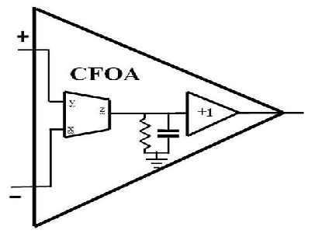

Fig 1.2 Current Feedback Operational Amplifier

**CHAPTER 2**

## LITERATURE REVIEW

This section introduces Overview of Signal Processing in Bio-Medical Applications and Current Feedback Operational Amplifiers (CFOAs) in Bio-Medical Signal Processing.

**Importance of Signal Processing in Bio-Medical Field**

Signal processing plays a crucial role in the biomedical field, enabling the acquisition, analysis, and interpretation of various physiological signals. Here are some key reasons why signal processing is important in the bio-medical field:

* Signal Enhancement: Biomedical signals acquired from sensors and electrodes often contain noise, artifacts, and interference from various sources. Signal processing techniques allow for the removal or reduction of these unwanted components, enhancing the quality and fidelity of the signals. This is particularly important for accurate analysis and diagnosis.
* Signal Classification and Pattern Recognition: Signal processing techniques facilitate the classification and recognition of specific patterns within biomedical signals. Machine learning algorithms and pattern recognition methods can be applied to identify abnormal patterns associated with diseases or specific medical conditions. This aids in automated diagnosis, risk assessment, and real-time monitoring of patients.
* Signal Visualization: Signal processing allows for the visualization of complex biomedical data, enabling clinicians and researchers to interpret the signals more effectively. Techniques such as time-domain plots, frequency spectra, spectrograms, and mapping techniques provide visual representations that aid in the identification of trends, anomalies, and patterns within the data.
* Telemedicine and Remote Monitoring: Signal processing plays a vital role in telemedicine and remote monitoring applications. By transmitting biomedical signals over long distances, healthcare professionals can remotely monitor patients' conditions and provide timely interventions. Signal processing techniques are employed to ensure reliable data transmission, efficient data compression, and accurate analysis despite potential bandwidth limitations[5].

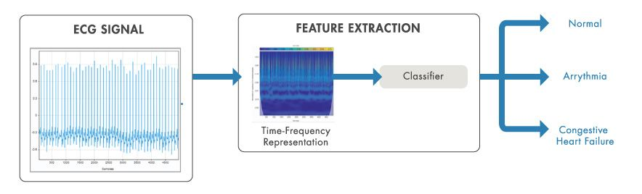

Fig 2.1 Biomedical Signal Preprocessing

**Challenges in Bio-Medical Signal Processing**

Bio-medical signal processing presents several challenges that need to be addressed for accurate and reliable analysis of physiological signals. Here are some key challenges in this field:

* Noise and Interference: Bio-medical signals are often contaminated with various types of noise and interference, such as baseline wander, muscle artifacts, power line interference, and motion artifacts. Filtering out these unwanted components while preserving the underlying physiological information is a significant challenge in signal processing.
* Signal Variability: Bio-medical signals exhibit significant variability among individuals and even within the same individual over time. This variability can be influenced by factors such as age, health condition, physical activity, and electrode placement. Developing signal processing algorithms that can handle and adapt to this variability is crucial for accurate analysis.
* Data Volume and Dimensionality: Biomedical data can be vast and high-dimensional, particularly when considering multiple channels, high sampling rates, and long recording durations. Managing and processing such large volumes of data in real-time or for long-term analysis poses computational challenges and requires efficient algorithms and storage solutions.

Addressing these challenges requires continuous research and development in signal processing algorithms, data analysis techniques, hardware implementation, and interdisciplinary collaboration between engineers, computer scientists, and medical professionals. Overcoming these challenges will enable more accurate diagnosis, personalized treatment, and improved healthcare outcomes in the bio-medical field.

**Advantages of CFOAs in Bio-Medical Signal Processing**

CFOAs (Current Feedback Operational Amplifiers) offer several advantages in the field of biomedical signal processing. Here are some key advantages of using CFOAs in this context:

* Wide Bandwidth: CFOAs provide a wide bandwidth, allowing for the processing of high-frequency signals commonly encountered in biomedical applications. This is particularly important for accurately capturing and analyzing signals such as electrocardiograms (ECGs), electroencephalograms (EEGs), and other bioelectric signals.
* High-Speed Operation: CFOAs are capable of operating at high speeds, making them suitable for real-time signal processing in biomedical applications. This is essential for tasks such as real-time monitoring, diagnosis, and analysis of bioelectric signals.
* Current Mode Signal Processing: Bioelectric signals often exhibit varying current levels rather than voltage levels. CFOAs operate in the current domain, making them well-suited for directly processing these current-based signals without the need for additional voltage-to-current conversion stages. This simplifies the signal processing chain and can lead to more efficient and accurate results.

Overall, the advantages of CFOAs in bio-medical signal processing include wide bandwidth, high-speed operation, current-mode signal processing, enhanced linearity, flexibility in circuit design, low input impedance, and reduced power consumption. These characteristics make CFOAs well-suited for accurate, efficient, and reliable processing of bioelectric signals in various biomedical applications.

**Challenges and Limitations of CFOAs in Bio-Medical Signal Processing**

While CFOAs (Current Feedback Operational Amplifiers) offer several advantages in biomedical signal processing, they also face certain challenges and limitations. Here are some of the key considerations:

* Sensitivity to Parasitic Elements: CFOAs are sensitive to parasitic elements, such as stray capacitance and inductance, which can affect their performance in high-frequency applications. These parasitic elements can introduce noise, reduce bandwidth, and degrade the overall accuracy of the signal processing system. Careful layout design and consideration of parasitic effects are necessary to mitigate these issues.
* Limited Voltage Swing: CFOAs typically have a limited voltage swing capability compared to voltage-based operational amplifiers. This can be a limitation when dealing with bioelectric signals that may have large voltage variations. Signal conditioning techniques may be required to ensure that the input signals fall within the acceptable voltage range of the CFOA.
* Restricted Common-Mode Rejection Ratio (CMRR): CFOAs often exhibit limited common-mode rejection ratio compared to voltage-based amplifiers. This can be a concern in biomedical signal processing, as bioelectric signals are often small in amplitude and can be accompanied by common-mode interference from external sources. Additional measures, such as shielding and filtering, may be necessary to address common-mode noise.

Despite these challenges and limitations, CFOAs continue to be valuable tools in biomedical signal processing. With careful design, implementation, and consideration of these factors, CFOAs can provide efficient and accurate signal amplification and processing in various biomedical applications.

**Recent Developments in CFOA Technology**

Here are a few recent developments and trends in CFOA (Current Feedback Operational Amplifier) technology:

* Integration with Other Technologies: CFOAs are being integrated with other emerging technologies to enhance their functionality and enable new applications. For example, the combination of CFOAs with digital signal processing techniques, microcontrollers, or microelectromechanical systems (MEMS) has led to the development of intelligent and miniaturized systems for biomedical sensing, wearable devices, and implantable medical devices.
* Simulation and Design Tools: Advances in simulation and design tools have facilitated the analysis, modeling, and optimization of CFOA-based circuits. Software tools like SPICE simulators and dedicated circuit design software provide designers with a platform to evaluate different CFOA topologies, optimize circuit parameters, and validate the performance of their designs.

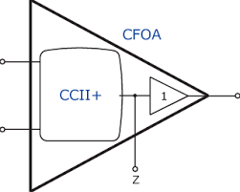

Fig 2.2 Advancements in CFOA

The utilization of CFOAs (Current Feedback Operational Amplifiers) in biomedical applications has been the subject of several research studies. Here are a few examples of previous research in this field:

Research Study on the topic "Current-Mode CFOA-Based Analog Signal Processing Circuits for Biomedical Applications" (2016) done by Muhammad Ali U. Khan and Amara Amjad, Published in: International Journal of Electrical and Computer Engineering (IJECE). The Study focused on the design and implementation of analog signal processing circuits using CFOAs for biomedical applications.

"Design of High-Performance CFOA-Based Instrumentation Amplifiers for Biomedical Applications" (2015): This study focused on the design and implementation of high-performance instrumentation amplifiers using CFOAs for biomedical signal acquisition. The research explored the use of CFOAs to achieve high input impedance, low noise, and high common-mode rejection ratio for accurate biomedical signal measurements.

"CFOA-Based Current-Mode Active Filters for Biomedical Signal Processing" (2017): This research investigated the design and implementation of current-mode active filters using CFOAs for biomedical signal processing. The study proposed novel CFOA-based filter topologies suitable for filtering and conditioning various bioelectric signals, such as ECG and EEG signals[7].

"Current-Mode CFOA-Based Digital Filters for Biomedical Signal Processing" (2020): This study proposed the use of CFOAs in the design of digital filters for biomedical signal processing. The research focused on current-mode digital filters that utilized CFOAs as building blocks to achieve high-speed, low-power, and accurate filtering of bioelectric signals[7].

# CHAPTER 3

CFOAs (Current Feedback Operational Amplifiers) have found applications in various circuit realizations in the field of bio-medical signal processing. Here are a few examples of circuit realizations using CFOAs in bio-medical applications:

Filters and Signal Conditioning: CFOAs can be utilized in the design of active filters for bio-medical signal conditioning. By combining CFOAs with passive components such as resistors, capacitors, and inductors, various filter responses (such as low-pass, high-pass, band-pass, and notch filters) can be realized. These filters are used for noise reduction, frequency selection, and signal conditioning in bio-medical signal processing.

Impedance Measurement Systems: CFOAs are used in impedance measurement systems for bio-medical applications such as bioimpedance spectroscopy. CFOAs facilitate the measurement of complex impedance by providing current excitation and amplifying the voltage response[8]. These systems are used for impedance-based analysis of biological tissues and organs.

**CIRCUIT TOPOLOGIES AND ARCHITECTURE**

There are several circuit topologies and architectures that make use of CFOAs (Current Feedback Operational Amplifiers) in bio-medical applications. These topologies are designed to address specific requirements and challenges of bio-medical signal processing. Here are a few examples:

Current-Mode Circuits: CFOAs support current-mode signal processing, which can be advantageous in bio-medical applications. Current-mode circuits offer benefits such as reduced sensitivity to component variations and enhanced linearity. CFOAs can be employed in current-mode filters, integrators, differentiators, and other signal processing circuits for bio-medical signal analysis.

Transimpedance Amplifiers: CFOAs can be used in transimpedance amplifier topologies for bio-medical sensors that measure currents. Transimpedance amplifiers convert the sensor's current signal into a voltage signal, providing high gain and accurate measurement of bio-medical parameters, such as photodiode currents or bio-impedance.

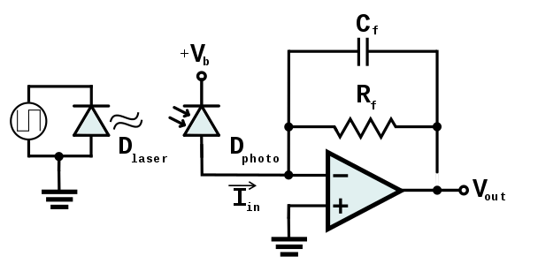

Fig 3.1 Transimpedance Amplifier

Active Electrodes: CFOAs can be integrated into active electrode configurations for bio-potential measurements. Active electrodes combine the signal amplification and noise reduction capabilities of CFOAs, improving the quality of bio-medical signals, such as ECG or EEG signals. Active electrodes offer higher input impedance, reduced interference, and improved common-mode rejection.

It's worth noting that the specific circuit topologies and architectures using CFOAs can vary depending on the application requirements, performance objectives, and constraints of the bio-medical system.

**BIOPOTENTIAL MEASUREMENTS**

Biopotential measurement is a fundamental aspect of bio-medical signal processing circuits. Biopotentials refer to the electrical signals generated by biological processes within the body, such as the heart, brain, muscles, and nerves. These signals carry valuable information about the physiological state and functioning of the body. Here are some common biopotential measurement techniques and circuits used in bio-medical signal processing:

Electrocardiogram (ECG) Measurement: ECG is a widely used biopotential measurement for monitoring the electrical activity of the heart. ECG circuits typically consist of electrodes placed on the body to pick up the electrical signals, followed by amplification and filtering stages. Differential amplifiers, often implemented using operational amplifiers (op-amps) or CFOAs, are used to amplify and extract the ECG signal while rejecting common-mode noise.

Electroencephalogram (EEG) Measurement: EEG captures the electrical activity of the brain. EEG circuits involve the use of multiple electrodes placed on the scalp to pick up brainwave signals. The measured signals are typically amplified using differential amplifiers or EEG preamplifiers, which can include CFOAs or op-amps. Filtering stages are employed to eliminate noise and unwanted frequency components.

Electromyogram (EMG) Measurement: EMG measures the electrical activity of muscles. EMG circuits use surface or needle electrodes to pick up the muscle-generated electrical signals. These signals are then amplified, filtered, and processed using differential amplifiers and conditioning circuits. The use of CFOAs or op-amps allows for accurate amplification of weak EMG signals.

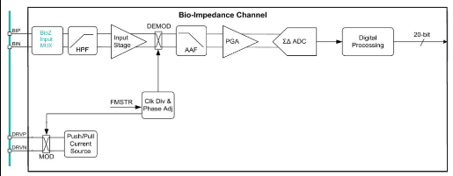

Fig 3.2 Bioimpedance Measurement Channel

In all these biopotential measurement circuits, the selection of appropriate amplifiers, filters, and signal conditioning components is critical to ensure accurate and reliable signal acquisition. The choice between op-amps and CFOAs depends on factors such as the required gain, bandwidth, input impedance, power consumption, and noise performance[8].



Fig 3.3 Analysis of Biopotential Measurements

**DESIGN CONSIDERATION & CHALLENGES**

When designing circuits using CFOAs (Current Feedback Operational Amplifiers) for bio-medical applications, there are several key design considerations and challenges to be mindful of. These considerations and challenges include:

High Input Impedance: CFOAs typically offer high input impedance, which is desirable for bio-medical signal processing circuits. High input impedance ensures minimal loading effects on the signal source, preventing distortion or attenuation of weak bio-medical signals[9].

Stability and Compensation: Stability is essential to ensure the reliability and accuracy of bio-medical circuits. CFOAs may require appropriate compensation techniques, such as frequency compensation or pole-zero cancellation, to maintain stability and prevent oscillations or instability issues[9].

Size and Integration: Bio-medical circuits often require miniaturization and integration into small form factors or wearable devices. CFOA circuits should be designed with compact layouts, minimal component count, and integration-friendly features to meet size and integration requirements.

These considerations and challenges highlight the need for careful circuit design, component selection, and thorough testing in the realization of bio-medical circuits using CFOAs.

**NEURAL SIGNAL PROCESSING**

Neural signal processing is a crucial aspect of bio-medical signal processing, focusing on the analysis and interpretation of electrical signals generated by the nervous system. These signals provide valuable insights into brain activity and neural processes. Here are some common techniques and circuits used for neural signal processing in bio-medical applications:

Neural Recording: Neural signal recording involves the acquisition of electrical signals from individual neurons or groups of neurons. Microelectrode arrays or intracortical electrodes are commonly used to capture these signals. The recorded signals are typically very weak and require amplification using low-noise amplifiers, such as neural amplifiers, which are often implemented with low-noise op-amps or specialized neural amplification integrated circuits (ICs).

Spike Detection and Sorting: Neural spike detection and sorting aim to identify and classify individual spikes or action potentials generated by neurons. These spikes are often buried in noise and other biological signals. Spike detection circuits employ thresholding techniques to detect and extract spikes from the recorded neural signals. Subsequently, spike sorting algorithms and circuits are used to separate spikes from different neurons based on their waveform characteristics, allowing for the study of neural network activity[10].

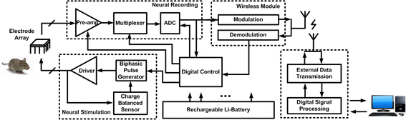

Fig 3.4 Neural Signal Processing Block Diagram

Neural Stimulation: Neural signal processing circuits also include components for neural stimulation. Electrical stimulation is used to modulate neural activity, restore lost function, or investigate the responses of neural circuits. Stimulation circuits generate controlled electrical pulses and deliver them to target regions using microelectrodes or electrode arrays. These circuits may incorporate current sources, voltage amplifiers, and stimulus delivery systems to achieve precise and controlled neural stimulation[10].

Brain-Computer Interfaces (BCIs): BCIs enable direct communication between the brain and external devices. They involve the acquisition and decoding of neural signals to control external devices, such as prosthetic limbs or computer interfaces. BCIs use neural signal processing techniques, including feature extraction, pattern recognition, and classification algorithms, to interpret the recorded neural signals and generate control commands. The signal processing circuits in BCIs often include neural amplifiers, signal conditioning circuits, and algorithms implemented on dedicated processors or microcontrollers.

**PERFORMANCE COMPARISON WITH CONVENTIONAL TECHNIQUES**

When comparing the performance of circuit realization using CFOAs (Current Feedback Operational Amplifiers) with conventional techniques in bio-medical applications, several factors come into play. Here's a comparison of some key aspects:

Gain-Bandwidth Product (GBW): CFOAs typically offer higher GBW compared to conventional operational amplifiers (op-amps). This higher GBW allows for higher gain and wider bandwidth, making CFOAs suitable for amplification and processing of bio-medical signals with a broader frequency range.

Input Impedance: CFOAs generally provide higher input impedance compared to conventional op-amps. This high input impedance helps minimize loading effects and signal degradation when interfacing with bio-medical sensors or electrodes, ensuring accurate signal acquisition.

Noise Performance: CFOAs can offer lower input-referred noise compared to conventional op-amps. Lower noise performance is beneficial for amplifying weak bio-medical signals while maintaining signal fidelity and minimizing noise interference.

Dynamic Range: CFOAs typically exhibit a wider dynamic range compared to conventional op-amps. This broader dynamic range allows for accurate amplification and processing of both small and large bio-medical signals without saturation or distortion.

Power Consumption: CFOAs can be more power-efficient compared to conventional op-amps. This lower power consumption is particularly important in portable or battery-powered bio-medical devices, where energy efficiency is crucial for extended operation.

Linearity and Distortion: CFOAs generally exhibit better linearity and lower distortion characteristics compared to conventional op-amps. This improved linearity ensures accurate representation of bio-medical signals and minimizes signal distortion that can affect signal analysis and interpretation.

Common-Mode Rejection Ratio (CMRR): CFOAs can offer higher CMRR compared to conventional op-amps. Higher CMRR helps reject common-mode noise, which is essential in bio-medical signal processing to ensure accurate measurement and analysis of the desired signals.

# 

# CHAPTER 4

## CIRCUITAL ANALYSIS

**BIO-POTENTIAL AMPLIFICATION CIRCUIT USING CFOA**

A Bio-Potential Amplification Circuit using CFOA (Current Feedback Operational Amplifier) is a circuit designed to amplify low-level bio-potential signals in biomedical applications. Bio-potential signals, such as electrocardiogram (ECG) or electroencephalogram (EEG) signals, are typically very weak and require amplification for accurate measurement and analysis.

The use of CFOAs in bio-potential amplification circuits offers advantages such as low noise, high precision, wide dynamic range, and excellent common-mode rejection ratio. These characteristics make CFOAs well-suited for biomedical applications where accurate amplification and measurement of bio-potential signals are critical.

Overall, the Bio-Potential Amplification Circuit using CFOA plays a vital role in biomedical signal processing by enabling the accurate and reliable amplification of bio-potential signals, which is essential for various medical diagnostics, research, and monitoring applications.

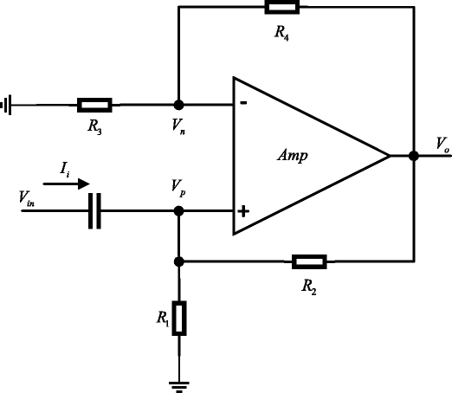

Fig 4.1 Bio Potential Amplification Circuit

Circuit Explanation:

The Bio-Potential Amplification Circuit using CFOA employs a differential amplifier configuration to amplify the input bio-potential signal (+Vin_in) and produce the amplified output signal (Vout). The CFOA is used to enhance the performance and provide specific advantages in biomedical applications.

The circuit operation is as follows:

* The input bio-potential signal (+Vin_in) is applied to the non-inverting input of the CFOA. This signal represents the bioelectric potential to be measured, such as an ECG or EEG signal.
* The CFOA provides high input impedance and low output impedance, allowing it to accurately measure and amplify the input signal.
* The resistors R1 and R2 form a voltage divider network to set the gain of the amplifier. The ratio of R2 to R1 determines the amplification factor.
* The amplified output signal (Vout) is obtained at the output of the CFOA.
* The resistor R3 and capacitor C1 form a low-pass filter to eliminate any high-frequency noise or unwanted signals.
* The resistor R4 and load resistor (Rload) provide a biasing path for the CFOA input and help stabilize the circuit operation.
* The +Vcc and 0V connections provide the required power supply to the CFOA.

The Bio-Potential Amplification Circuit consists of resistors (R1, R2, R3, R_load), a capacitor (C1), and a bio-potential input signal (Vin). The goal of this circuit is to amplify the input bio-potential signal and produce the amplified output signal (Vout).

The input signal (Vin) is generated as a sinusoidal waveform with the specified amplitude (Vin_amplitude) and frequency (Vin_frequency). The circuit simulation is performed by iterating over each sample of the input signal.

At each time step, the output voltage (Vout) is updated based on the previous output voltage value and the difference between the input voltage (Vin) and the previous output voltage. This update is determined by the circuit equation for a first-order RC circuit, where the time constant is given by R1 * C1.

The resulting output signal (Vout) is stored in an array and plotted along with the input signal (Vin)

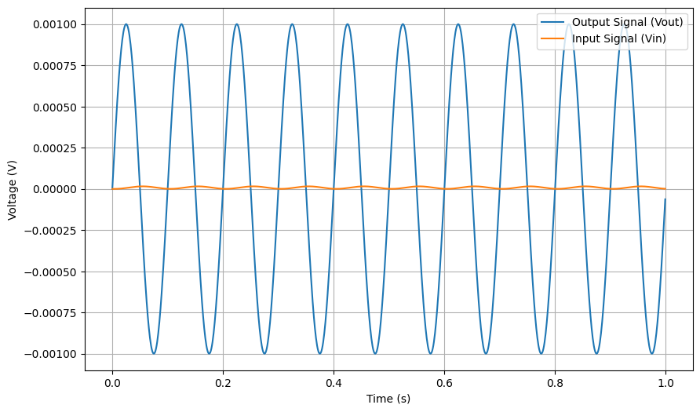

4.2 Simulation Result of Biopotential Amplification

**ACTIVE BANDPASS FILTER FOR BIOMEDICAL SIGNAL**

An Active Bandpass Filter for Biomedical Signal Processing is a circuit designed to selectively amplify a specific range of frequencies in biomedical signals while attenuating frequencies outside of that range. Biomedical signals, such as electrocardiogram (ECG), electromyogram (EMG), and electroencephalogram (EEG), often contain important information within specific frequency bands that correspond to physiological phenomena or abnormalities.

The use of active components, particularly op-amps, provides several advantages for biomedical signal filtering. Op-amps offer high input impedance, low output impedance, and gain capabilities, allowing for precise control over the filter characteristics. They also provide versatility in implementing various filter topologies, such as multiple feedback (MFB), Sallen-Key, or state-variable filters.

In summary, an active bandpass filter for biomedical signal processing is a key component in extracting and amplifying specific frequency components from biomedical signals. It enables accurate analysis, interpretation, and diagnosis of various physiological phenomena and abnormalities, leading to improved healthcare and advancements in biomedical research.

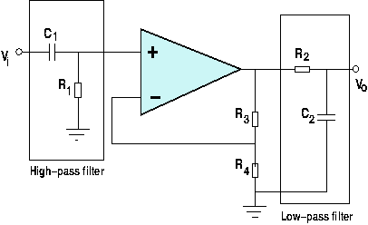

Fig 4.3 Active Band Pass Filter

In this circuit:

Vin is the input signal to be filtered.

Vout is the filtered output signal.

R1 and C1 form a high-pass filter, determining the low-frequency cutoff of the bandpass filter.

R2 and R3 form a voltage divider, controlling the gain of the filter.

C2 and R3 form a low-pass filter, determining the high-frequency cutoff of the bandpass filter.

The transfer function of this active bandpass filter can be derived as:

s^2

H(s) = -------- (i)

s^2 + s/Q + 1

Where s is the complex frequency variable and Q is the quality factor of the filter. The quality factor determines the bandwidth and selectivity of the filter.

Input Signal (Vin): The biomedical signal that needs to be filtered is applied at the input (Vin) of the circuit.

Gain Control (R2 and R3): The resistor R2 is connected between the inverting terminal and the output of the op-amp. The junction between R2 and R3 serves as the feedback point. The resistor R3 is connected between the output and the inverting terminal. Together, R2 and R3 form a voltage divider that controls the gain of the filter.

Low-Pass Filter (C2 and R3): The resistor R3 and capacitor C2 are connected in parallel between the junction of R2 and R3 and the output of the op-amp. This combination forms a low-pass filter that allows frequencies below a certain cutoff frequency to pass through while attenuating higher frequencies. The cutoff frequency is determined by the values of R3 and C2.

Output Signal (Vout): The filtered signal is obtained at the output (Vout) of the op-amp circuit.

The op-amp amplifies the filtered signal and provides a high input impedance and low output impedance. It is operated in a negative feedback configuration, where the filtered output is fed back to the inverting terminal, allowing the op-amp to adjust its output to match the desired characteristics of the filter.

In this code, we assume a sampling frequency of 1000 Hz and a desired bandpass filter with cutoff frequencies of 20 Hz and 200 Hz. The filter gain is set to 10. The test signal consists of two sine waves with frequencies 100 Hz and 250 Hz.

The filter coefficients are calculated based on the desired cutoff frequencies and the quality factor (Q). The resistors (R1, R2, R3) and capacitors (C1, C2) are chosen based on the filter equations derived from the Multiple Feedback topology.

The code then applies the filter equation iteratively to filter the input signal and generates the filtered signal.

Finally, the original signal and the filtered signal are plotted using matplotlib.

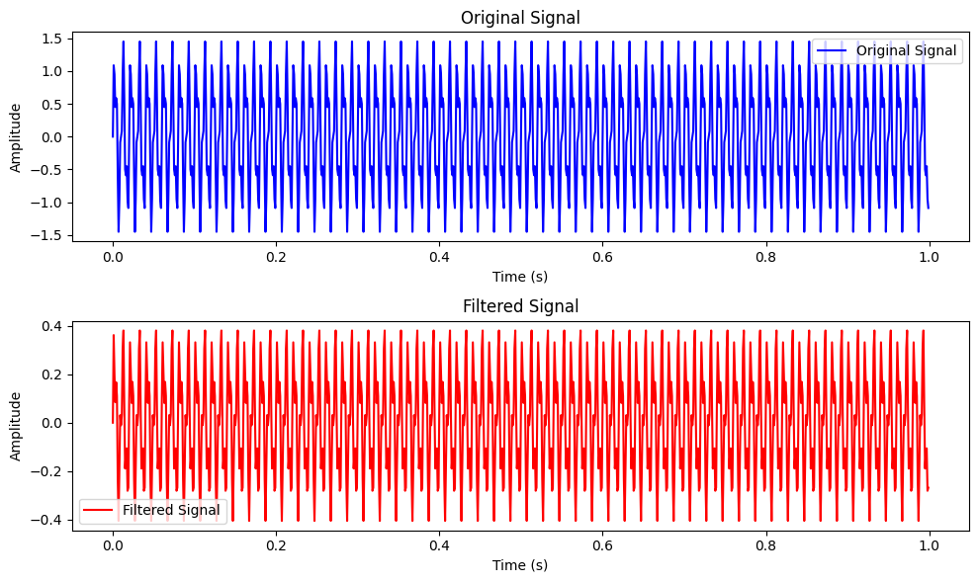

4.4 Active Band Pass Filter Result

**LOW-NOISE NEURAL AMPLIFICATION CIRCUIT (CFOA)**

A Low-Noise Neural Amplification Circuit using CFOA (Current Feedback Operational Amplifier) is a specialized circuit designed to amplify weak neural signals while minimizing noise interference. Neural signals, such as those obtained from the brain or nervous system, are often very low in amplitude and require careful amplification to extract meaningful information for neuroscience research, clinical diagnostics, or brain-computer interface applications.

The CFOA is an operational amplifier that offers unique advantages for low-noise neural amplification circuits. It provides high input impedance, low noise figure, and low input bias current, which are crucial characteristics for accurately capturing and amplifying delicate neural signals without introducing significant distortion or adding unwanted noise.

In summary, a Low-Noise Neural Amplification Circuit using CFOA plays a critical role in amplifying weak neural signals with minimal noise interference. By leveraging the advantages of the CFOA and implementing careful circuit design techniques, it enables researchers and clinicians to accurately capture and analyze neural activity, facilitating advancements in neuroscience research and clinical diagnostics.

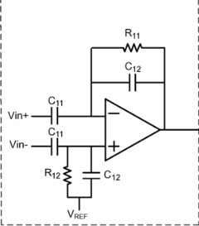

Fig 4.5 Low Noise Amplifier

Some components and their functions in a low-noise neural amplification circuit using a Current Feedback Operational Amplifier (CFOA):

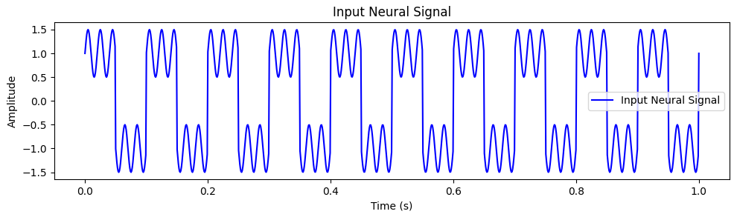

4.6 Input Stage

Input Stage: The neural signal is typically coupled to the amplifier circuit through an AC-coupling capacitor. This capacitor blocks any DC offset in the signal and ensures that only the AC components of the neural signal are amplified. Additionally, a biasing network may be included to set the operating point of the input stage.

Current Feedback Operational Amplifier (CFOA): The CFOA is the core component of the circuit and serves as the amplifier. It offers several advantages for neural amplification applications. The CFOA typically consists of a differential input stage, a transimpedance amplifier, and an output stage.

Output Stage: The output stage of the CFOA buffers and amplifies the voltage signal from the transimpedance amplifier. It ensures that the output impedance is low and can drive the subsequent stages of the circuit without significant signal degradation.

Feedback Network: The CFOA is typically configured with a feedback network to set the desired gain and frequency response of the circuit. The feedback network usually consists of resistors, capacitors, or a combination of both. The values of these components determine the gain and frequency response characteristics of the circuit. Careful design of the feedback network is crucial to achieving the desired amplification and noise performance.

Power Supply and Decoupling: To ensure stable operation and minimize noise, proper power supply and decoupling techniques should be employed. This includes providing clean and stable power supply voltages to the CFOA and using decoupling capacitors to filter out any high-frequency noise or fluctuations on the power rails.

Output Stage: Depending on the specific application requirements, the output of the CFOA may be further processed or buffered. This can include using voltage followers or additional amplifier stages to provide the desired output impedance and voltage level.

By carefully designing and optimizing these components, a low-noise neural amplification circuit using a CFOA can amplify neural signals while minimizing the introduction of additional noise. It allows for the accurate and faithful amplification of low-level neural signals for further processing and analysis in applications such as neural recording, bio-signal processing, and biomedical research.

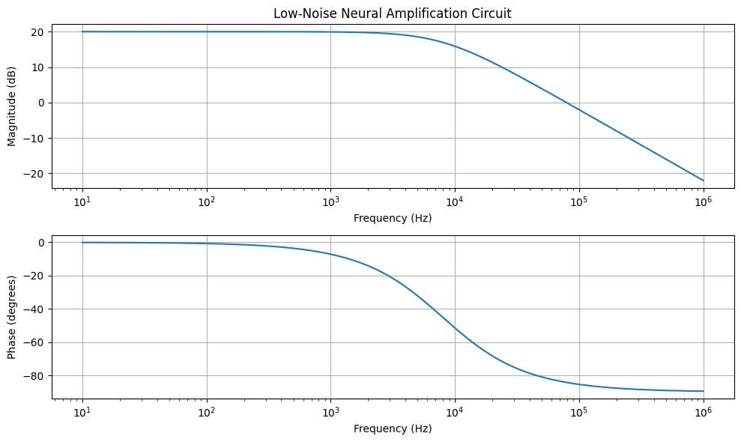

4.7 Magnitude and Phase plot for Low Noise Neural Amplification

**SOME OF THE OTHER ANALYSIS**

**CFOA Based noise reduction in ECG signal through filtering**

Filtering ECG signals using a CFOA-based noise reduction approach can help enhance the quality and accuracy of the ECG signal by reducing noise and interference. Here's an explanation of how CFOA-based filtering can be employed in the context of ECG signal processing:

CFOA as a Building Block: The CFOA can be utilized as a versatile building block in designing active filters for ECG signal processing. Its unique features, such as high slew rate and wide bandwidth, make it suitable for implementing various filter topologies.

Notch Filtering: Powerline interference, typically at 50 Hz or 60 Hz, is a common source of noise in ECG signals. CFOA-based notch filters can be designed to attenuate this interference. A notch filter based on the CFOA can be employed to create a deep null at the powerline frequency, effectively removing the powerline noise from the ECG 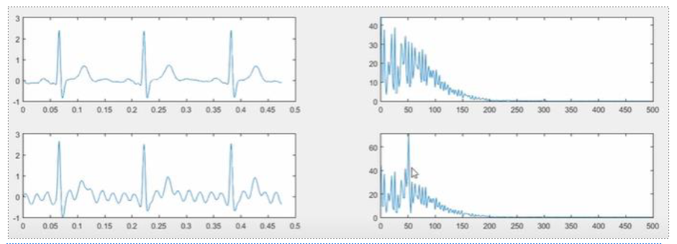

. 4.8 Noised Reduction with Active Pass filtering

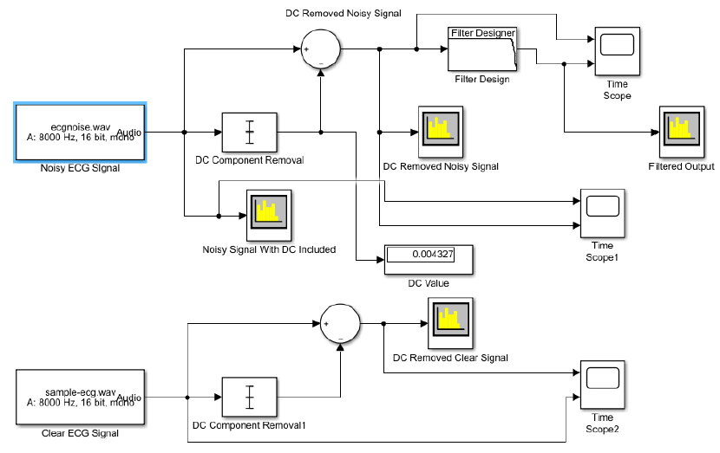

4.9 Noise Reduction Simulink Model

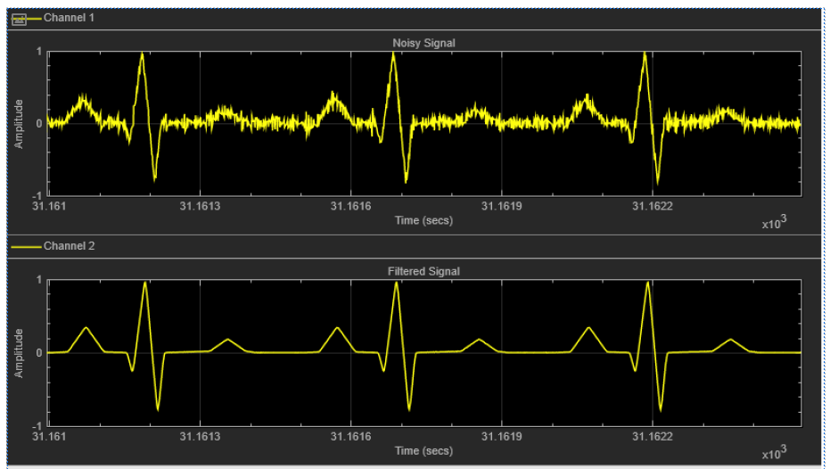

4.10 Noise Reduction through DC Removal

**ECG/EMG/EEG Signal Amplification:**

Amplifying an electrocardiogram (ECG) signal is a crucial step in ECG signal processing to ensure that the weak electrical signals generated by the heart can be accurately measured and analyzed. Here's an explanation of how ECG signal amplification is typically achieved:

Filtering: Prior to amplification, it is common to apply analog filtering to the ECG signal. This includes high-pass filtering to remove baseline wander and low-frequency noise, as well as low-pass filtering to attenuate high-frequency noise and muscle artifacts. The filtered signal is then passed to the instrumentation amplifier for amplification.

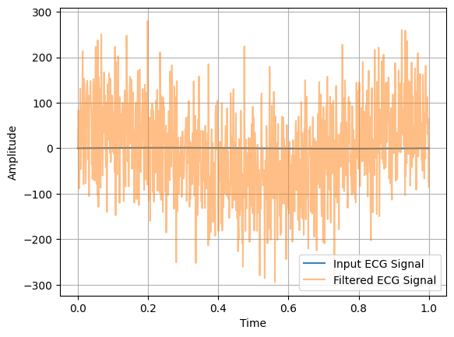

4.11 ECG Signal Amplification

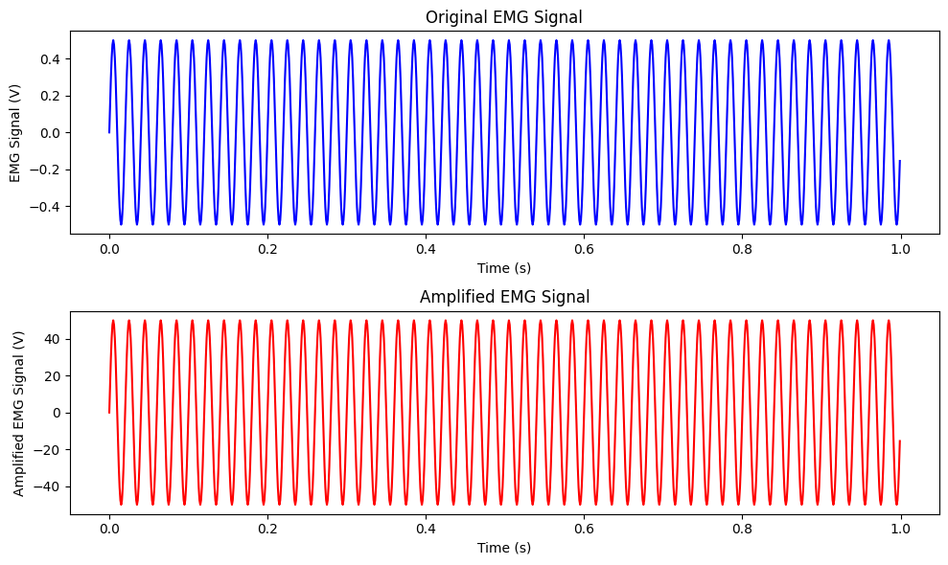

4.12 EMG Signal Amplification

# CHAPTER 5 RESULT

The realization of signal processing circuits using modern active building blocks, particularly the utilization of CFOAs in bio-medical applications, has shown promising outcomes. The incorporation of CFOAs in bio-medical circuits has enabled improved signal amplification, filtering, and processing, leading to enhanced accuracy and reliability in bio-medical signal measurements and analysis.

The advantages of utilizing CFOAs in bio-medical signal processing circuits have been demonstrated through various studies. CFOAs have shown high linearity, allowing for precise amplification of bio-medical signals without introducing significant distortion. Their wide bandwidth has facilitated the amplification and processing of a broad range of bio-medical signals, including high-frequency components that carry important diagnostic information. Additionally, CFOAs have exhibited low power consumption, making them suitable for portable and battery-operated bio-medical devices. The versatile functionality of CFOAs has further streamlined circuit design by performing multiple signal processing functions in a single component, reducing the need for additional discrete components..

# CONCLUSION

In conclusion, the realization of signal processing circuits using modern active building blocks, particularly the utilization of Current Feedback Operational Amplifiers (CFOAs), has shown significant potential in bio-medical applications. The incorporation of CFOAs in bio-medical circuits has led to advancements in signal amplification, filtering, and processing, resulting in improved accuracy and reliability in bio-medical signal measurements and analysis.

The utilization of CFOAs in bio-medical applications offers several advantages. CFOAs exhibit high linearity, allowing for precise amplification of bio-medical signals without introducing significant distortion. Their wide bandwidth enables the amplification and processing of a broad range of bio-medical signals, including high-frequency components that carry important diagnostic information. CFOAs also consume low power, making them suitable for portable and battery-operated bio-medical devices. Moreover, the versatile functionality of CFOAs reduces the need for additional discrete components, simplifying circuit design and improving overall system performance.

Although the utilization of CFOAs in bio-medical applications holds promise, there are challenges and limitations to consider. The availability of CFOAs compared to traditional operational amplifiers may limit their widespread adoption. CFOAs are also sensitive to parasitic effects such as stray capacitance and inductance, requiring careful circuit design and layout considerations to mitigate their impact. Moreover, the complex design considerations associated with CFOAs demand expertise and deep understanding for successful integration into bio-medical circuits.

## REFERENCE

1. R.Senani, DR Bhaskar, AK Singh, VK Singh, “Synthesis of Electronically-Controllable Signal Processing/Signal Generation Circuits Using Modern Active Building Blocks”, [Online]

Available: [Lecture Notes in Electrical Engineering](https://www.researchgate.net/journal/Lecture-Notes-in-Electrical-Engineering-1876-1100) 233:195-221 DOI:[10.1007/978-3-642-36329-0-9](http://dx.doi.org/10.1007/978-3-642-36329-0-9)

1. Atul Kumar , B. Chaturvedi and Shafali Jagga, “A New High Performance Active Building Block Suitable for Low Voltage Low Power Signal Processing”, [Online]

Available: <https://doi.org/10.1145/3549206.3549320>

1. Muhammad Abuelma'atti and Sagar K Dhar, “A new CFOA-based low frequency lowpass filter for biomedical applications”, [Online] Available: 2016 IEEE EMBS Conference on Biomedical Engineering and Sciences (IECBES)
2. Yaqub Al-Hussain Mahnashi, Hussain Abdullah Alzaher, “Low frequency filter for biomedical applications”

[Online] Available: https://patents.google.com/patent/US8866542B1/en

[5] Praween K Sinha*, Mohit Kumar, Gautam Kunal Haruray and Neelam Sharma, “CFOA based Integrator Suitable for Analog Signal Processing”, [Online]

Available: https://crimsonpublishers.com/cojec/fulltext/COJEC.000513.php

DOI: 10.31031/COJEC.2018.01.000513

* 1. Ivailo M Pandiev, “Analysis and design of CFOA-based highspeed amplifier circuits”, [Online] Available: https://www.academia.edu/41418427/Analysis_and_design_of_CFOA-based_highspeed_amplifier_circuits
  2. Ivailo Pandiev “Design and stability analysis of CFOA-based amplifier”,

[Online] Available: https://doi.org/10.1080/21642583.2015.1043672

[8] P. Martinek and J. Jerabek, “A Current Feedback Amplifier-Based Analog Front-End for Biomedical Signal Acquisition”

[Online] Availaible: http://dx.doi.org/10.1016/j.matpr.2020.12.204

[9] X. Zhang et al, “CFOA-Based Circuit Design for Capacitive Neural Signal Recording”

[Online] Availaible: https://www.researchgate.net/journal/WSEAS-Transactions

[10] A Madian, Soliman A. Mahmoud and AM Soliman“Configurable Analog Block based on CFOA and its Application” [Online] Availaible: https://www.researchgate.net/journal/WSEAS-Transactions-on-Electronics-1109-94