Development Of An

# Application For Recipe Recommendation Using

Machine Learning

**[1]Mrudula Nimbarte, [2]Hrushikesh Panchabudhe, [3]Bhautika Dongre, ,[4]Adarsh Tiwari, [5]Aaryan Kukade, [6]Ayush Meshram, [7]Kartik Saroj**

[3, 4, 5, 6, 7] Student, [1, 2] Professor

[1][mrudulanimbarte@sbjit.edu.in](mailto:mrudulanimbarte@sbjit.edu.in) [2][hrushikeshpanchabudhe@sbjit.edu.in](mailto:hrushikeshpanchabudhe@sbjit.edu.in) [3][bhautikad@sbjit.edu.in](mailto:bhautikad@sbjit.edu.in) [4][adarsht.csea19@sbjit.edu.in](mailto:adarsht.csea19@sbjit.edu.in) ,

[5]  [aaryank.csea19@sbjit.edu.in](mailto:aaryank.csea19@sbjit.edu.in) [6] [ayushm.csea19@sbjtit.edu.in](mailto:ayushm.csea19@sbjtit.edu.in) [7][kartiks.csea19@sbjit.edu.in](mailto:kartiks.csea19@sbjit.edu.in)

1, 2, 3, 4, 5, 6, 7 Department of Computer Science and Engineering

1, 2, 3, 4, 5, 6, 7 S.B. Jain Institute of Technology, Management and Research, Nagpur

***Abstract***- Individuals settle on choices regularly. “What should I eat today?”, “What is the most effective show I will watch tonight??”, “Is there something I will do with the leftover chicken and garlic?”. One may find these decisions a bit tricky and confusing to make as the options available are vast and also due to one’s poor decision-making skills. Time constraint also comes into the picture when one needs to make a choice. Recommendation systems assist individuals in settling on choices in these mind-boggling data spaces. Amazon, Netflix, Pandora, and Spotify are some major companies worldwide that rely more upon these recommendation systems. Basically, they look at the client's intrigue obtained from his/her profile with a few reference qualities and then, foresee the rating the client would give. This project uses a content-based recommendation system based on the similarity of foods. The recipe recommendation engine helps us identify multiple types of recipes we can have by not just confined to the same ingredients that we choose but to the various varieties of ingredients. The project also intends to reduce food wastage by making use of the ingredients which the user has currently and suggesting recipes based on those ingredients. Also instead of selecting the ingredients, users can directly search for the recipes. The recipe further displays the ingredients along with cooking directions. The ratings and nutritional values are displayed provided if they are available in the data set.

## I. INTRODUCTION

The conventional food of not only India, but from the other parts of the world has been broadly refreshing for its remarkable utilization of herbs and flavors which makes the people try it every time. Hence people order such delicacies and dishes whenever they want. However, ordering food

online sometimes proves to be a toll on their pockets as a lot of dishes are not cheap to order. Hence, cooking and preparing such dishes at home is a better option as it is cost-effective and is also considered hygienic and healthy. Another issue faced in a lot of families is the problem of food wastage.

A lot of leftover ingredients are just thrown away just because people aren’t aware of the methods of preparing some dishes using the leftover ingredients. Therefore, a thoughtful

recipe recommendation should take all these factors into ac Also, there is a huge percentage of population which live alone and can’t cook. Recipe4U is a recipe recommendation app that learns from the past preferences of a user’s preferred dishes to recommend him/her new cuisines. It recommends recipes to the users based on the selected ingredients.

*Goals or Objectives:* The aim of this project is to find recipes based on the ingredients input.

* To make it easier for people to search for recipes based on available ingredients.
* To simplify the task of choosing appropriate recipes based on the search term using machine learning.
* To recommend personalized recipe based on user’s past choices

## II. LITERATURE SURVEY

Our recipe recommendation system aims to provide a list of recipes for users that meet their personalised needs. For this, a body of literature does exist.

For example, Sano et al. (2015) used some transaction data in a real grocery store which helped in recommending grocery items. Trattner and Elsweiler (2017b) used around nine recommender algorithms from the LibRec2 framework to recommend recipes and diet/meal plans. Although the culinary tastes of the regions are different, there are similar tastes in the cuisines of the surrounding regions. This paper aims in providing a recommendation website to recommend a range of dishes; from various cuisines around the globe. The flavor similarity between the dishes was determined using the algorithm we developed earlier. First we used Term Frequency-Inverse Document Frequency i.e. TFIDF algorithm to find the favourite ingredients of the cuisine and rate each dish of the cuisine on this basis. Then, using cosine similarity we measured the flavor similarity of local foods.

A baseline approach is the Popularity based Recommender Model. This model recommends a number of popular recipes the user may/may not have previously tried . As the popular recipes are for a reason, it usually provides good recommendations, generally interesting for most people.

This is a non-personalized model, which does not consider an individual user's preferences but yes, it does consider what other people around the world have a common liking for which makes the popular recipes get Higher is the probability that the user might like these suggestions.

The recommendation system we built in the previous section has some severe limitations. It gave a similar recommendation to everyone, regardless of the personal taste of the user. It is also calculating the recommendable recipes from the static dataset. It is planned to add a feature of adding one's own recipes to the dataset to make the application more interactive.

To help provide personalization for our recommendations, we have built an engine that computes similarity between recipes based on certain metrics and suggests recipes that are most similar to a particular recipe that a user liked. Since, we will be using recipe metadata to build this engine, this also known as Content Based Filtering.

We have chosen vector space model as it is better in terms of complexity, efficiency, and accuracy.

We have built 3 Content Based Engines based on:

* Recipe Name, Description and Keywords
* Recipe Ingredients, Category and Total Time(Cook & Prep)
* Improved Recommendation Engine(considers Ratings and Reviews too)

**III. RELATED WORK**

* recipebook.io

These websites/apps provide recipe only , without knowing client’s intrigue.

* recipetineats.com

These websites/apps doesn’t provide the feature of recommending recipe according to interest.

* Suyash Maheshwari, Manas Chourey. “Recipe Recommendation System using Machine Learning Models”. ,ISSN: 2395-0056, Volume: 06 Issue: 09 | Sep 2019

In this paper, machine learning algorithms recommends recipe to users. It doesn’t  provide recipe based on remaining ingredients.

**IV. DEVELOPED MODULES**

Nowadays due to the high employment rate, a lot of people have to switch cities and locations which makes it challenging to live alone. Due to this, they have to rely on restaurants which is a challenge for most of the working population, especially for the male population. Also, being dependent on restaurants is a toll on finance as well as on health. Ordering and eating street and restaurant meals are acceptable once in a while but relying on them may cause health issues. Leftover food items and ingredients are often wasted even considering the fact that they could be used for preparing recipes which will prevent the wastage of food. However, there are a lot of recipes that can be prepared using leftovers but people aren’t aware of the same. For this, they could refer to recipes online. This makes the cooking process tedious and time-consuming.

This has been a major problem for working for population away from their home, living by their own. Not only them, but people who want to try new recipes need to go through a lot of web research/books which can cause inconvenience. Recipe4U is a recipe recommendation app that works on multiple machine learning models and the theory of collaborative filtering. The app recommends recipes to the user based on the ingredients he/she has selected. The user first selects the ingredients (which could be leftover food items) from the dropdown list. On clicking ‘search’ a list of recipes will be displayed to the users which can be prepared from the ingredients he/she has selected. Also, users can search for the recipes directly without having the need to select the ingredients. The app also suggests similar recipes to users based on their previous choices/searches (based on collaborative filtering). This solves the earlier discussed problem by making the users avoid outside food and prepare/cook recipes at home using the app which also solves the problem of leftover food wastage simultaneously.

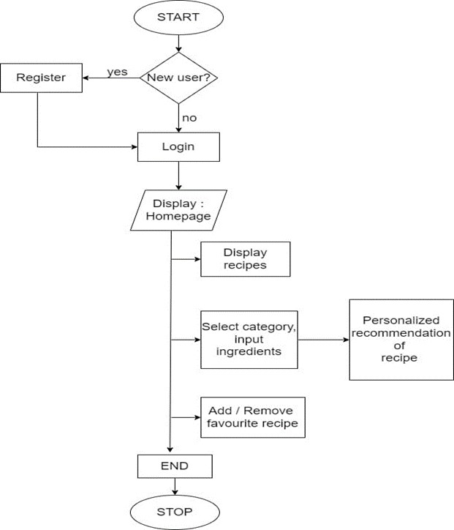

Fig. 3.2 Flowchart for Recipr4U.

*Functional Modules:*

Our proposed system consists of three different modules:

Module 1: User Interface

Users can sign up and register in the app. Users can view and can save them as their favorite recipes. For this module, we will build a cross-platform app on which the user will register themselves. This module encloses all the backend required for the project also storing the user data which can be later used in the other modules. This module will also include the GUI part of the project.

Module 2: Machine Learning Model:

The model will predict the recipe after the user input the ingredients. The model will give personalized recipe recommendations. This module will come into play when the user has detected some ingredients and has interacted with a few of the recommended recipes. All this data will be stored in the database to give the user personalized recipe recommendations. More the data is collected, the more efficient the system to recommend recipes.

Module 3: Integrating UI & Machine learning Model:

To integrate backend and frontend model together.

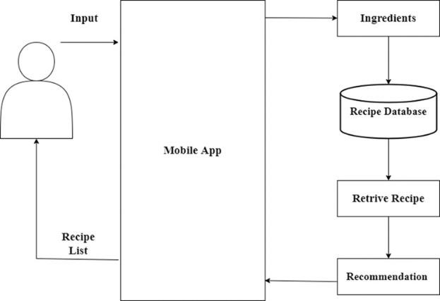

Fig. 3.3 System Architecture - Recipe4U.

Image

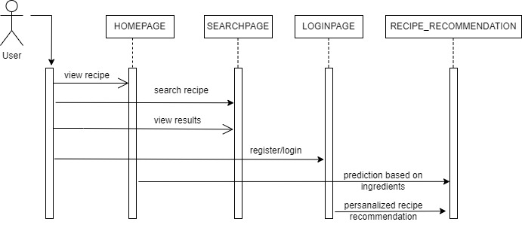

Fig. 3.5 Sequence Diagram - Recipe4U

Fig. 3.6 Use Case Diagram - Recipe4U

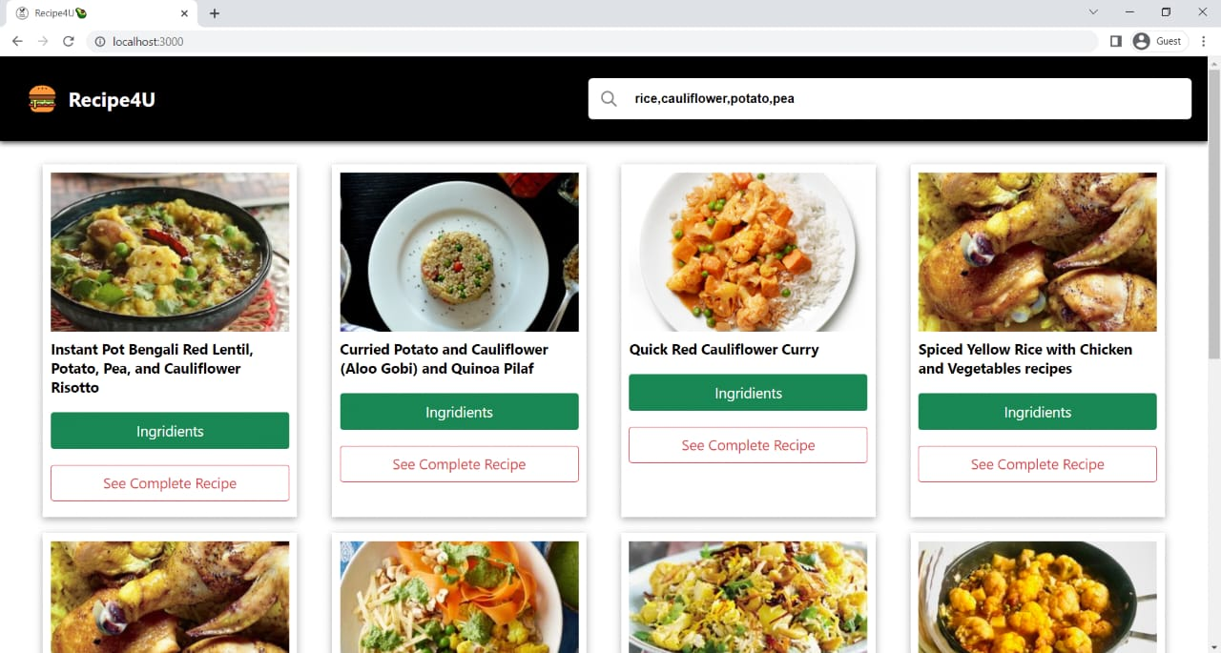

Fig. 3.7 Screenshot – Recipe4U

**V. CONCLUSION**

We have designed the app and completed its development. Our app will be a perfect personalized recipe recommender for those who cannot cook by themselves and need a handy recipe guide as well as for people who want to prepare a number of recipes using leftover food items/ingredients rather than wasting it. We have used modern tools such as Python, Flutter, etc. for the implementation of our application. During the project tenure, we applied professional ethics and understood the importance of teamwork and communication while presenting our project.

**VI. ACKNOWLEDGEMENT**

We would like to express deep sense of gratitude to our Project Guide, Dr. Mrudula Nimbarte, Department of Computer Science & Engineering, for being the cornerstone of our project. It was her incessant motivation and guidance during periods of doubts and uncertainties that has helped us to carry on with this project. We would like to thank our co-project guide Mr. Hrushikesh Panchabuddhe, Department, Computer Science & Engineering for providing necessary guidance, support, motivation and inspiration without which this project would not have been possible.

### VII. REFERENCES

1. Suyash Maheshwari, Manas Chourey. “Recipe

Recommendation System using Machine Learning

Models”., ISSN: 2395-0056, Volume: 06 Issue: 09 | Sep

2019

1. Marlies De Clercq, Michiel Stock, Willem Waegeman, “Datadriven recipe completion using machine learning methods”. Trends in food science and technology, ISSN 0924-2244, Volume: 49, 1-13, 2016.
2. Wang, Haoyu, et al. (2018) "A Stock Recommend

System Using with Distributed Graph Computation and Trust Model-Collaborative Filtering Algorithm." 2018 2nd IEEE Advanced Information Management, Communicates, Electronic and Automation Control Conference (IMCEC). IEEE)

1. Thakkar, Priyank, et al. "Combining User-Based and Item-Based Collaborative Filtering Using Machine Learning." Information and Communication Technology for Intelligent Systems. Springer, Singapore, 2019. 173-180
2. S.T Patil, Rajesh D. Potdar (2019), “Recipe Recommendation Systems”, IOSR Journals.
3. Alkatai Gholve, Nidhi Mishra, Revati Gaikwad, Shruti Patil (2019), “Recipe Recommendation System”, IJARCCE.
4. Washington Post, “Do millennials really not know how to cook? With technology they don’t really have to” washintonpost.com.