**AUTOMATED ANIMAL IDENTIFICATION AND DETECTION OF SPECIES**

I.D.V.Narasimha 1, I. Samuel Moses 2, H.Balaji 3,

Department of CSE, SREENIDHI INSTITUTE OF SCIENCE AND TECHNOLOGY

**Abstract:** *Automated Animal Identification and Detection of Species is a project that addresses the need for a more efficient and accurate method of identifying and detecting different animal species. The project will utilize deep learning techniques, including CNNs, to develop a system that can automatically recognize animal species based on their images. The system will be trained using a large dataset of animal images and fine-tuned using a pre-trained network VGG to optimize the training process and improve classification accuracy. This project has the potential to revolutionize the field of animal research and conservation by providing a more accurate and efficient method of identifying and detecting animal species. Both CNN model and VGG were used in this project, in these two models VGG have got high accuracy in detecting and classifying different types of animals, which can be beneficial in various applications, such as wildlife conservation, animal tracking, and crop protection, with a concise conclusion based on the findings.*

***Keywords:* Automated Animal Identification,Detection of Species, Deep learning techniques, Convolutional Neural Networks (CNNs), VGG16.**

# I.INTRODUCTION

The necessity for wildlife protection and monitoring has made it more important than ever to precisely and successfully identify and track animal species in their natural settings. A rapidly growing area in computer vision and deep learning is automated animal identification and species detection. The old techniques of manual identification and tracking may not always be accurate or efficient, as this text clearly emphasizes.

The research aims to create a system that can automatically recognize and categorize animals using deep learning techniques like CNN and VGG. The project's goal is to keep an eye on and defend animal populations in their natural environments. It also mentions how time-consuming, labor-intensive, and requiring substantial knowledge of animal identification are traditional techniques of animal monitoring. It is used to automate the identification of animals so that researchers and wildlife conservationists may rapidly and effectively gather correct information on animal populations.

The technology used in this work might be improved for uses in safety, monitoring, and other areas. One of the most challenging genres of photography is wildlife photography. It needs strong technical skills, such precise capturing. Photographers of wild animals often need a high level of technical skill as well as a great deal of patience. Some animals, for example, are difficult to approach, thus understanding their behavior is necessary to anticipate their activities. Photographers must sometimes stay calm and silent for many hours until the exact moment arrives. Photographing some animals may need stalking skills or the use of a hide-and-seek device. A stunning wildlife shot is also the result of being in the right spot at the right moment.

1. **LITERATURE SURVEY**

An important field of research in wildlife conservation and monitoring is automated animal identification and species detection. Deep learning and computer vision techniques have demonstrated significant promise in this area in recent years. The review of the literature found that academics have created a few strategies and systems to identify and categorize animals from camera trap photos. Convolutional neural networks (CNNs), Faster R-CNN models, and other deep learning-based techniques such as support vector machines (SVMs) are examples of conventional computer vision techniques. The survey also emphasized the difficulties in carrying out this work, such as changes in lighting, weather, animal position, and behavior. However, the results of these studies suggest that these methods can achieve high accuracy in identifying and detecting different animal species in the wild, using both visual and thermal imaging techniques.

Animal movement and behaviors are frequently tracked by systems for animal identification. Different tools for animal monitoring have been developed by wildlife experts. For ongoing observation,Automated animal Identification of Species: Challenges and Opportunities [1] (Jose Carranza-Rojas and Erick Mata-Montero.28 August 2016.) Other prominent technologies include very high-frequency radio-tracking. Automated wildlife detection with drones: Synthesis, Opportunities and Constraints. [2] (E Corcoran 2021.)

1. **EXISTING SYSTEM**

A brief overview of the existing system, which is the source material that the project is built upon. It notes that the system will utilize computer vision techniques and deep learning algorithms to detect and identify animal species based on their unique physical characteristics. The project is motivated by the need to monitor and protect animal populations in their natural habitats, and that the system will enable conservationists to make more informed decisions on how best to manage and protect wildlife populations, ultimately contributing to the preservation of endangered species and the overall health of our planet's ecosystems. The current approach is very expensive, requires a lot of experience in machine learning, has lower accuracy, and can only detect a limited number of animals.

# PROPOSED SYSTEM

The Automated Animal Identification and Detection of Species suggested system seeks to create an advanced and automated system that can precisely identify and detect various animal species based on their photos. Convolutional neural networks (CNNs) and other deep learning techniques will be used by the system to identify and recognize various animal species. Pre-defined models like VGG and ResNet models may also be applied. A more precise and effective way of recognizing and detecting animal species is provided by this project's modern and automated system, which helps to safeguard and preserve wildlife for future generations. VGG16 is a pre-trained convolutional neural network that can be used for image classification tasks. It is a deep architecture that has been trained on the ImageNet dataset, which contains over a million images. The VGG16 architecture consists of 13 convolutional layers and 3 fully connected layers, making it a powerful tool for recognizing and classifying different animal species. In the proposed system for Automated Animal Identification and Detection of Species, the VGG16 model can be implemented as a pre-defined model to improve the accuracy of species classification. Our proposed solution provides accuracy of 61.7% with CNN and up to 94.9% with VGG16, is cost-free, takes less time, and is more accurate in comparison.

# SYSTEM ARCHITECTURE

The overall layout of the system and all its parts is referred to as system architecture. This includes identifying the various system components and how they interact to carry out the desired purpose. The architecture offers a high-level overview of the system and directs the development process to guarantee that the system complies with the objectives for performance and quality. A CNN and VGG16-based Automated Animal Identification and Classification system typically comprises of many main components. The Predictions user interface, which allows the image's destination to be entered, is the system's first component. This interface is implemented as a Code. The database, which comprises a big dataset of Animals and Categorization, is the system's second component. The database is already filled with information. The third component of the system is the algorithms themselves, which use CVV and VGG16 to compare the input image to the properties of various test data provided, and then run it through the layers of the algorithm and the pre-specified epochs.

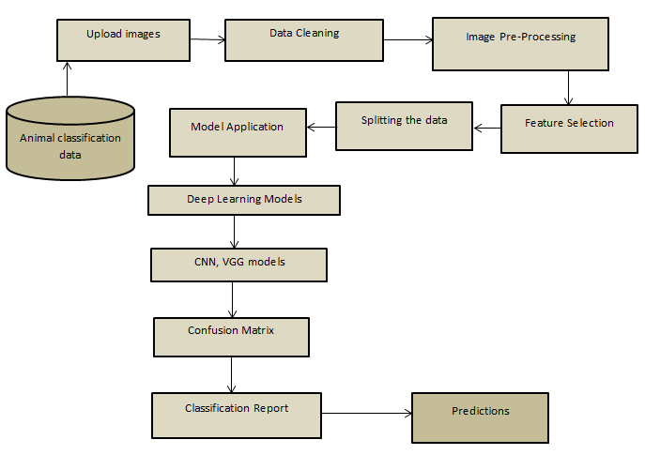

Fig 1: System Architecture

# DATASET

# The dataset consists of pictures of the animals. The dataset is obtained from Kaggle. The animals are categorized into 6 subcategories, each file containing the images of the animals of that category. This data set contains 6 animal categories named 'cow,' 'dog,' 'elephant,' 'horse’, ‘sheep,' and ‘squirrel,' with a total of 11586 photos for training, 1448 images for validation, and 1449 images for testing.

Fig 2: Dataset

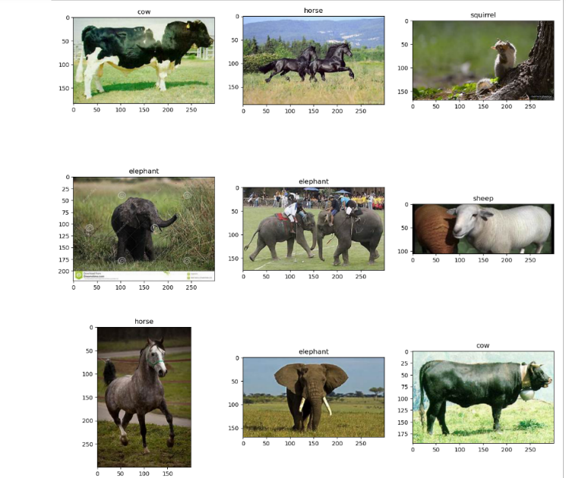

Fig 3: Random images of the dataset

1. **EVALUATION METRICS**

In addition to our new metric, the corona score, the performance of the proposed design is evaluated using many statistical measurements.

* **Accuracy**

Accuracy is a statistic that quantifies the method's ability to forecast the correct cases.

**Accuracy** = $\frac{TP+TN}{TP+TN+FP+FN}$

* **Recall**

Recall is the sensitivity of the method.

**Recall** = $\frac{TP}{TP+FN}$

* **Precision**

Precision is defined as the ratio of unnecessary positive cases to overall positives.

**Precision**= $\frac{TP}{TP+FP}$

* **Specificity**

Specificity is defined as the proportion of correctly anticipated negatives to negative observations.

**Specificity**= $\frac{TN}{TN+FP}$

# OUTPUT

# 

Fig 4: Output

# CONCLUSION

# In conclusion, the use of CNN and VGG models for automated animal identification and detection of species has shown great potential. The models have demonstrated CNN model having 61.7% and VGG 16 model having the accuracy of 94.9% in these two models VGG have got high accuracy in detecting and classifying different types of animals, which can be beneficial in various applications, such as wildlife conservation, animal tracking, and crop protection. The models can also be extended to other areas, such as medical diagnosis and autonomous vehicles. However, there are still some challenges that need to be addressed, such as data imbalance and limited data availability.

# REFERENCES

# [1] Erick Mata-Montero & Jose Carranza-Rojas “Automated animal Species Identification: Challenges and Opportunities” 28 August 2016.

# [2] Porter J, Arzberger P, Braun H, Bryant P, Gage S, Hansen T, Hanson P, Lin C, Lin F, Kratz T, Williams T, Shapiro S, King H, Michener W “Wireless sensor networks for ecology” ,2005.

# [3] E Corcoran, M Winsen, A Sudholz… Methods in Ecology., “Automated detection of wildlife using drones: Synthesis, opportunities and constraints”, 2021.

# [4] ZJ Ruff, DB Lesmeister, CL Appel, CM Sullivan, “Workflow and convolutional neural network for automated identification of animal sounds” 2021.

# [5] Evangeline Corcoran, Megan Winsen, Ashlee Sudholz, Grant Hamilton, “Automated detection of wildlife using drones: Synthesis, opportunities and constraints”, 22 Feb 2021.

# [6] R. Kays, S. Tilak, B. Kranstauber, P. A. Jansen, C. Carbone, M. J. Rowcliffe, T. Fountain, J. Eggert, and Z. He, “Monitoring wild animal communities with arrays of motion sensitive camera traps,” arXiv:1009.5718, 2010.

# [7] A. F. O’Connell, J. D. Nichols, and K. U. Karanth, Camera traps in animal ecology: Methods and Analyses. Springer Science & Business Media, 2010.

# 