**BUS BUDDY: THE ULTIMATE COLLEGE BUS TRACKER**

**Santhosh E1, Prakash Raja C2, Tommy C3, Shimona S4**

Computer Science and Engineering, Agni College of Technology, Chennai – 600 130,

Tamil Nadu, India

**ABSTRACT**

The Bus Tracking Android project is a comprehensive solution for efficiently tracking buses for students and drivers. The system uses a login-based approach with two separate user types: Driver Login and Student Login. With the Driver Login, bus drivers can edit bus details such as the number of passengers, route details, and other relevant information. They can also share the live location of their bus to a database. This feature enables the system to provide real-time tracking of the bus's location. Using their Student Login, students can view a list of buses sharing live locations, along with their statuses, such as live or idle. By clicking on a specific bus, students can view its live location on a Google Map, which is connected to the Google Cloud Map SDK. This feature enables students to track the location of their bus in real-time, reducing wait times and improving the efficiency of their journey.

The Bus Tracking Android project stores the live longitude and latitude of the bus shared by the driver in a database. This data is updated in real-time and is accessible to students through their Student Login. The use of a database also ensures efficient storage and retrieval of data, which enables the system to handle large amounts of data without slowing down. The system provides a simple and user-friendly interface for students to access information about the bus. The interface displays a list of buses with their respective statuses, enabling students to quickly identify the bus they need.

1. **INTRODUCTION**

In today's world, transportation plays a crucial role in everyone's life. Students who commute to college through buses often face the challenge of tracking the real-time location of the bus. This inconvenience can lead to anxiety, stress, and even academic difficulties for students. To address this problem, a Bus Tracking Android project has been developed to provide efficient tracking of buses for both students and drivers. The project is designed with a login system that includes two separate user types: Driver Login and Student Login. The Driver Login allows bus drivers to log in and edit bus details such as the bus number, route, and other essential information. The driver can also share the live location of the bus to a database by updating the longitude and latitude values. By updating these values, students can track the bus's live location, and the application can determine the distance of the bus from the student's location. On the other hand, students can use their Student Login to view a list of buses sharing live locations, along with their statuses, such as live or idle.

1. **LITERATURE SURVEY**

1. "Real-time GPS based vehicle tracking system for school buses" by P. Jaganmohan Reddy, K. Sudheer Reddy, and B. Yeshwanth. This study proposes a real-time GPS-based vehicle tracking system for school buses using an Android-based mobile application. The system allows parents and school administrators to track the location of the bus, the estimated time of arrival, and the route taken by the bus.

2. "Development of RFID-based student attendance system using GSM network" by Mohd Helmy Abd Wahab, Khairul Anuar Mohamad, and Nurul Nadia Mohd Firdaus. This study proposes an RFID-based attendance system for college buses that utilizes a GSM network to transmit attendance information to the server in real-time. The system allows the school to monitor the attendance of students who use the bus, reducing absenteeism.

3. "Design and implementation of an intelligent bus tracking and management system" by Ayobami Akanbi, Akeem Olowofeso, and Emmanuel Olajide Ojo. This study proposes an intelligent bus tracking and management system that utilizes a GPS module and a web-based interface to monitor the location of buses, route optimization, and fuel management. The system also provides realtime information to passengers about bus arrival times and delays.

4. "A framework for college bus transportation system using mobile crowdsourcing" by D. Kavitha and P. Ganeshkumar. This study proposes a framework for a college bus transportation system that utilizes mobile crowdsourcing to gather real-time information about the location of buses, passenger load, and route information. The system also provides a mobile application for passengers to track the location of buses and receive real-time information about their schedules.

5. "Smart Bus Tracking System for School Transportation" by C. Abhinaya and R. Arun Kumar. This study proposes a smart bus tracking system for school transportation that uses GPS and RFID technologies to track the location of buses and students. The system provides real-time information to parents and school administrators about the location of buses, estimated arrival times, and attendance records.

**3. EXISTING SYSTEM**

There are several existing applications for college bus tracking that are available on

the market today. Some of the most popular ones include:

1. TransLoc Rider: This is a popular mobile app that allows students and parents to track the location of college buses in real-time. The app also provides estimated arrival times, alerts for bus delays, and a map of the bus route.

2. BusWhere: This is another popular mobile app that allows students and parents to track the location of college buses in real-time. The app also provides estimated arrival times, alerts for bus delays, and a map of the bus route.

3. DoubleMap: This is a mobile app and web-based system that allows students and parents to track the location of college buses in real-time. The app also provides estimated arrival times, alerts for bus delays, and a map of the bus route.

4. Passio GO!: This is a mobile app and web-based system that allows students and parents to track the location of college buses in real-time. The app also provides estimated arrival times, alerts for bus delays, and a map of the bus route. In addition, the system includes features like bus capacity monitoring and student tracking for enhanced safety.

5. TripSpark: This is a web-based system that allows students and parents to track the location of college buses in real-time. The system also provides estimated arrival times, alerts for bus delays, and a map of the bus route. In addition, the system includes features like automatic notification of schedule changes and student tracking for enhanced safety.

1. **PROPOSED SYSTEM**

The system would consist of two user interfaces: one for bus drivers and one for students. Each interface would require a login to access the features and database is used to retrieve the location. Overall, this proposed model would improve the efficiency of tracking buses for students and drivers while keeping them informed in real-time. The use of GPS tracking technology and a centralized database would ensure that the information provided to users is accurate and up-to-date. The user friendly interface would make it easy for students and drivers to access the information they need, improving their overall experience. The ability for drivers to report incidents would also help improve the overall safety of the system.

1. **DIRECTORIES OF MODULES**

**Student Module**

Students can use their Student Login to view a list of buses sharing live locations,

along with their statuses, such as live or idle. The interface displays a list of buses with their respective statuses, enabling students to quickly identify the bus they need. By clicking on a specific bus, students can view its live location on a Google Map, which is connected to the Google Cloud Map SDK.

**Driver Module**

Bus drivers can easily edit bus details and share the live location of their bus to a

database. This feature allows for real-time updates of bus locations, which is

especially helpful for students who are trying to catch their bus on time. They can edit bus details such as the number of passengers, route details, and other relevant

information. They can also share the live location of their bus to a database. This

feature enables the system to provide real-time tracking of the bus's location. We have implemented an emergency feature which indicates an emergency situation to fellow students, by notifying them and updates whether the emergency situation has been resolved or not.

**Tracking Module**

The map is connected to the Google Cloud Map SDK, which ensures accurate location tracking and smooth navigation. The Bus Tracking Android project enhances the efficiency of tracking buses for both students and drivers. The system provides realtime tracking of the bus's location, which enables efficient planning of journeys and reduces wait times. It also helps drivers to keep track of their buses and ensure that they are on time.

**5. MODELLING AND ANALYSIS**

**5.1 SYSTEM ARCHITECTURE**

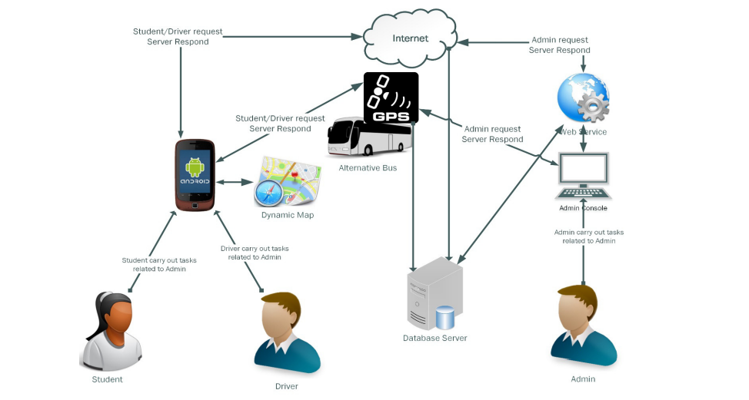

**Figure 5.1 System Architecture**

The bus tracking device communicates with the centralized server over a cellular or Wi-Fi network, sending location updates at regular intervals. The centralized serverprocesses the data and stores it in the bus tracking database, which can be accessed bythe mobile app and web dashboard. The mobile app and web dashboard provide userswith a user-friendly interface for viewing bus locations, schedules, and otherinformation. Overall, this architecture diagram demonstrates how the different

components of a college bus tracking system work together to provide real-time information on the location and status of buses.

**DATABASE**

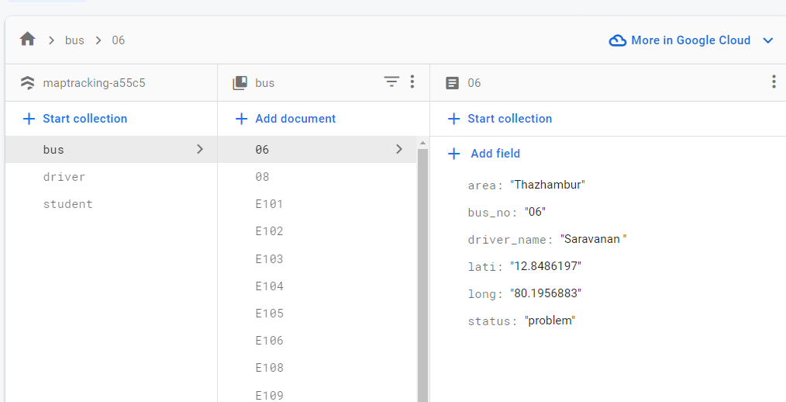

**6. RESULTS**

.

**6.1 SCREENSHOTS**

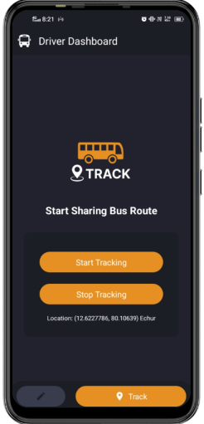

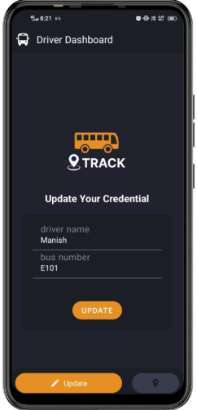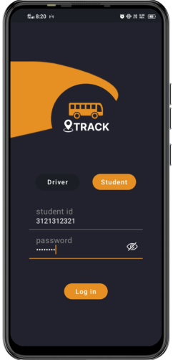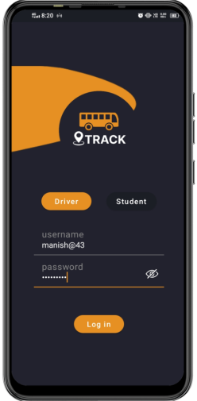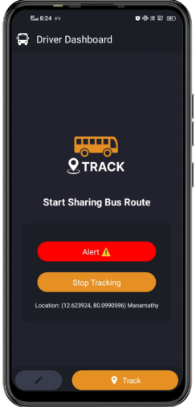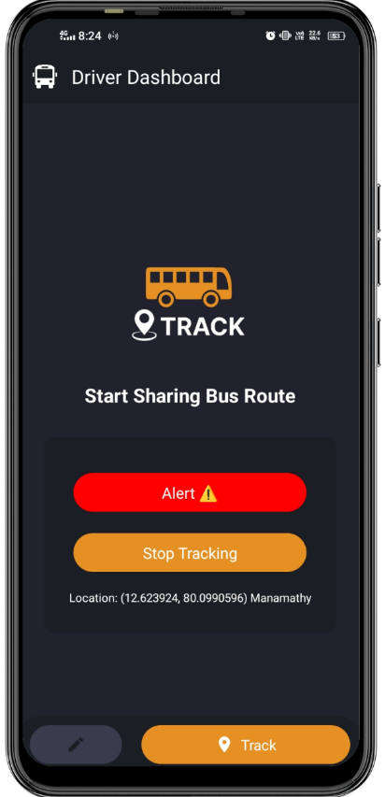

**CONCLUSION**

The Bus Tracking Android project is an efficient solution that enables real-time tracking of buses for both students and drivers. It features a login system with two separate user types: drivers and students. With the driver login, bus drivers can easily edit bus details and share the live location of their bus to a database. On the other hand, students can log in using their student login to view a list of buses that are sharing live locations along with their status such as live or idle. By selecting a specific bus from the list, students can see its real-time location on a Google Map, which is connected to the Google Cloud Map SDK. One of the key features of this project is its use of a database to store the live longitude and latitude of project is designed to provide an efficient and reliable way of tracking buses, which can save time and resources for both students and drivers. The project is userfriendly, with a simple and intuitive interface that is easy to navigate. The app is optimized for use on mobile devices, allowing students and drivers to easily access and use it while on the go.

**REFERENCES**

1. "Development of College Bus Tracking System using GPS and Mobile Application" by V. R. Vijayalakshmi, K. Arun Kumar, and P. Karthikeyan (2021). This paper presents a system that uses GPS technology and a mobile application to track college buses and provide real-time information to students and staff.

2. "Design and Development of a Smart College Bus Tracking System using IoT" by S. K. Aravind, S. A. Harshitha, and S. S. Surya (2021). This paper describes a system that uses IoT devices to track college buses and manage their operations.

3. "Smart College Bus Tracking System using GPS and Machine Learning" by P. Saravanan and M. Subramanian (2021). This paper presents a system that uses GPS technology and machine learning algorithms to predict the arrival time of college buses and provide real-time information to students and staff.

4. "Real-time College Bus Tracking System using GPS and Wi-Fi" by R. Dinesh Kumar, S. Sivaramakrishnan, and V. Vijayalakshmi (2021). This paper describes a system that uses GPS and Wi-Fi technologies to track college buses and provide realtime information to students and staff.

5. "Design and Implementation of a Smart College Bus Tracking System using RFID and GSM" by S. Senthil Kumar and S. S. Sathish Kumar (2021).

6 . "Design and Implementation of Smart College Bus Tracking and Management System Using IoT" by V. P. Naresh Kumar, G. Venkatesh, and R. N. Mukherjee (2020). This paper presents a system that uses IoT devices to track college buses and manage their operations.

7. "Development of a College Bus Tracking System using GPS and GSM" by R. Sivakumar and R. Nanthakumar (2020). This paper describes a system that uses GPS and GSM technologies to track college buses and provide real-time location updates to students and staff.

8. "Real-time College Bus Tracking System using IoT and Machine Learning" by S. Srinivasan and A. Arul (2022). This paper presents a system that uses IoT devices and machine learning algorithms to track college buses and provide real-time information to students and staff.

9. "Design and Implementation of a Smart College Bus Tracking System using Bluetooth Low Energy (BLE)" by K. Rajanikanth and N. V. Ravi Kumar (2022). This paper describes a system that uses BLE technology to track college buses and provide real-time information to students and staff.

10. "Smart College Bus Tracking System using LoRaWAN Technology" by R. Dinesh Kumar and V. Vijayalakshmi (2022). This paper presents a system that uses LoRaWAN technology to track college buses and provide real-time information to students and staff.