## Custom AI Drawing Classifier

**Sanjai Raj S1, Tharun J2, Naveen Kumar M3 , Mrs. Shimona­4**

Student, Department of Computer Science and Engineering,1,2,3

Assistant professor, Department of computer science and Engineering4

Agni College of Engineering, Chennai, Tamil Nadu, India.

## ABSTRACT

A custom AI drawing classifier is an application that classifies your drawing using machine learning. We have three custom-defined classes in our project, and they may classify any type of graphic, such as shapes, etc. We may identify any type of drawing as long as we supply example drawings and then train the models appropriately; our objective is for the model to properly forecast the drawings. To anticipate the drawing, we must first offer a category name and a sample picture, and then train them all separately to recognize the exact artwork for each class. Following that, we must put the model in the check. So that we may confirm its operational correctness and then tweak it based on the class. This program was created utilizing a graphical user interface as well as machine learning. It is simple to use and navigate.

## INTRODUCTION

Artificial intelligence (AI) is a fast-growing field that has the potential to transform how humans interact with technology. Image identification and classification are two areas where AI is already making substantial gains. Researchers and developers have used machine learning algorithms to construct bespoke image classifiers that can properly recognize and categorize photos based on their visual attributes in recent years. Drawing identification is one example of how custom image classifiers may be used.

A bespoke AI drawing classifier is a machine-learning model that can recognize and categorize hand-drawn images based on visual characteristics. It is intended to detect and categorize particular patterns and characteristics in images.

It aims to recognize and categorize particular designs and elements in images. An AI drawing classifier, for example, may be trained to recognize different sorts of pets, such as cats, dogs, and birds, based on their distinct visual qualities.

To train the machine learning model for a bespoke AI drawing classifier, developers often employ a big collection of hand-drawn pictures.

First, the dataset is labeled with the appropriate categories, such as "cat," "dog," or "bird." Following that, the machine learning algorithm learns to recognize patterns and characteristics in the photos that match each category.

After the machine learning algorithm has been trained, it may be used to identify fresh photos that it hadn't seen before. For example, a user can draw an illustration of a dog, and the proprietary AI drawing classifiers would analyze the image accurately and classify it as a cat.

Custom AI drawing classifiers offer a wide variety of uses. They can be used in education to educate children on how to draw and recognize different things, in art galleries to help visitors learn more about the artworks on show, and in online communities to identify and categorize user-generated material.

Finally, bespoke AI drawing classifiers are a strong tool for properly recognizing and categorizing hand-drawn images based on their visual attributes.

## LITERATURE SURVEY

* R. K. Maddox et al. (2017) published "Deep Learning-Based Identification of Hand-Drawn Sketches": This research presents a deep learning strategy using Convolutional Neural Network (CNN) for recognizing hand-drawn drawings. On a set of 10,000 drawings, they tested and trained their model and attained a success rate of 74.3%.
* Ting-Chun Wang et al. in (2018) published "SketchyGAN: Achieving Diverse and Realistic Drawing to Image Synthesis": SketchyGAN, a generational adversarial network (GAN)-based model that can produce realistic pictures from hand-drawn sketches, is introduced in this study. They showed the efficacy of their technique on different datasets and obtained cutting-edge findings.
* V. Jampani et al. 2016 published "Sketch Identification Using Deep Neural Networks Training on Synthetic Data": This study describes a sketch system for recognition that makes use of neural networks that have been trained on synthetic data. They utilized an internet application to produce synthetic doodles, which they then used to teach and evaluate their model. The results demonstrated that their technique may surpass models trained on real-world data.
* D. J. Rezende and colleagues (2016) published "Learning to Recognise Entities by Retaining Additional Sources of Variation": This work presents a model which can recognize items in photos while still keeping information about its drawing technique and other variables. They employed a VAE to create the latent form of the input information and then trained a classification algorithm on top of it. The finished product was able to attain great accuracy while retaining the drawings' artistic information.
* Y. Yu et al. (2017) published "Sketch-A-Net: A Deep Neural Network System That Beats Humans": Sketch-A-Net, a network of deep neural network architecture built for drawing recognition, is presented in this research. They trained and evaluated their model on a huge dataset of doodles, achieving 74.1% classification accuracy, outperforming human beings on the same task.

## EXISTING SYSTEM

There are several approaches and tools available for creating unique AI drawing classifiers. Some of the most popular options include:

1. Google Cloud AutoML The mission is an effective tool for creating unique image classifiers, including those for hand-drawn pictures. It enables you to build your machine-learning algorithms via your dataset and may be applied to a variety of tasks, such as object identification and picture categorization.
2. TensorFlow: You may create unique drawing classifiers using this open-source machine learning framework. It offers a variety of tools and APIs, such as those for data preparation, model training, and more, for working with picture data.
3. IBM Watson Visual Detection: IBM Watson Visual Detection is a cloud-based tool that allows you to create custom picture classifiers. It includes pre-built models for typical use cases along with tools to train your unique models.
4. SageMaker by Amazon is a cloud-based tool for creating and teaching machine learning models. It comprises a variety of tools for handling picture data, such as data labeling, model training, and others.
5. Microsoft Azure Customized Sight: Microsoft Azure Customized Vision is a platform that allows you to create custom photo classifiers. It includes tools to train your algorithms using machine learning and also pre-built models for popular use cases.

## PROPOSED SYSTEM

Using algorithms for machine learning and image processing methods may be used to create a unique AI drawing classifier system. The suggested method may be used to categorize drawings based on several categories as objects, animals, or human figures.

The fundamental steps for creating a unique AI drawing classification system are as follows:

Data Gathering: Compile a collection of illustrations that includes several types of artwork. Either a customized dataset or one that is already publically available may be used.

Data preprocessing: Normalize the picture sizes and eliminate any noise from the photographs before preprocessing. It's crucial to complete this stage to make sure the photos are reliable and can be used as input for a machine learning algorithm.

Extraction for Features: Extract features from preprocessed images. Edge detection, color histograms, and texture analysis are some of the feature extraction addresses available.

Model Training: Apply the features obtained for training a machine-learning model. Support vector machines, support vector machines with k-nearest neighbors, and neural networks are examples of machine learning algorithms.

Model Evaluation: Measure the correctness of the model that was trained by assessing its performance on a validation set.

Deployment: Once a model has been trained and assessed, it may be applied to classify fresh drawings in a production context.

**ALGORITHM USED:** Linear SVC, Gaussian NB, Decision Tree classifier, K Neighbor classifier,

Random forest classifier, Logistic Regression.

**FLOWCHART**

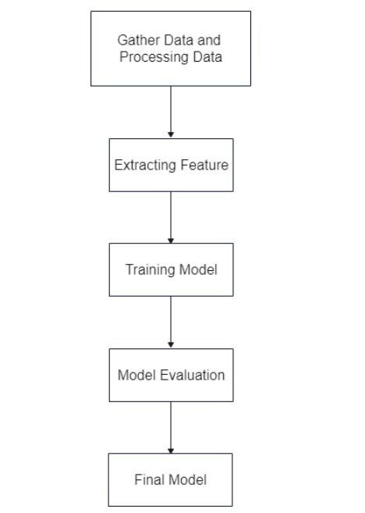

**SYSTEM ARCHITECTURE**

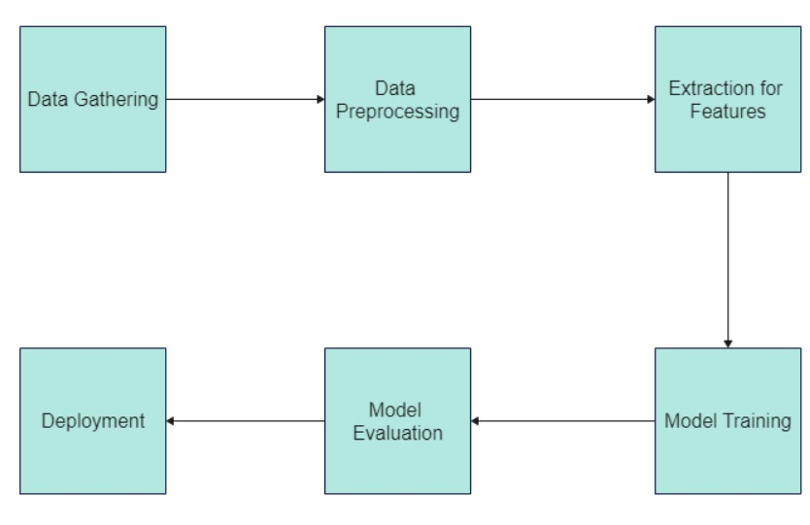

**CONCLUSION**

Finally, bespoke AI drawing classifier are an effective tool for effectively recognising and categorising artwork based on their aesthetic characteristics. As AI advances, we may expect to see additional applications of bespoke image classification algorithms in a range of sectors and areas.

**REFERENCES**

1. https://creator.nightcafe.studio/
2. https://komprehend.io/custom-classifier
3. https://towardsdatascience.com/how-to-create-a-custom-image-classifier-with-customvision-ai-fe3df6fd219b
4. www.github.com