**GESTURE SENSOR TECHNOLOGY FOR UI CONTROL**

**1st Rushikesh Khurpade, 2nd Krishna Jadhav, 3rd Gauri Tajane,4th Pradnya Chavan, 5th Dr. Priti Lahane**

1st MET INSTITUTE OF ENGINEERING, Nashik, Maharashtra, India

**ABSTRACT**

The mouse is one of the wonderful inventions of Human-Computer Interaction (HCI) technology. This research paper focuses on the development of a virtual mouse using gesture sensor technology for user interface (UI) control. With the increasing demand for intuitive and efficient ways to interact with digital devices, the use of gesture recognition has become a popular alternative to traditional input devices such as keyboards and mice. The proposed virtual mouse system is designed to improve the user experience by providing a more natural and intuitive way of interacting with the computer. The system uses an accelerometer and a gyroscope to detect hand gestures, which are then translated into mouse movements and clicks. The system also includes a feedback mechanism that provides users with haptic feedback in response to their gestures. To evaluate the performance of the system, a user study was conducted with 20 participants. The participants were asked to perform a series of tasks using both the traditional mouse and the proposed virtual mouse system.

**Keywords:** **Machine Learning, OpenCV, Mediapipe, Hand Gestures, Web Camera**

**I . INTRODUCTION**

The In recent years, the advancement in technology has brought about significant changes in the way we interact with computers. One of the most innovative developments in this area is gesture sensor technology. This technology enables users to interact with their computer or other electronic devices using hand gestures instead of traditional input methods like keyboards and mice. Gesture sensor technology has great potential for revolutionizing the way we interact with computers, especially in virtual environments. This research paper focuses on the use of gesture sensor technology for UI control on virtual mouse. The virtual mouse is a popular tool used in virtual environments, but it is often limited by the traditional input methods. The integration of gesture sensor technology can enhance the usability and functionality of virtual mouse, making it a more intuitive and natural way of interacting with virtual environments. this research paper aims to contribute to the existing literature on gesture sensor technology and its application to virtual environments.

**II . LITERATURE REVIEW**

Ishika Dhall, Shubham Vashisth,Garima Aggarwal in 2020 [1] proposed “Automated Hand Gesture Recognition of using a Deep Convolutional Neural Network” CNN, Hand gesture recognition system, feature map, DNN.

Bhumika Nandwana, Satyanarayan tazi,Sheifalee trivedi in 2017 [2] proposed “A Survey Paper on Hand Gesture Recognition” Image processing, noise removal, static and dynamic gesture.

Tong Du,Xuemei Ren,Huichso Li in 2018 [3] prposed “Gesture Recognition Method Based On Deep Learning" Gesture recognition, recurrent Neural Network.

Hung-Yuan Chung,wei-feng Tsai in 2019 [4] prposed “An Efficient Hand Gesture Recognition System based on Deep CNN" Hand detection, Hand tracking, Hand gesture recognition.

1. **PROBLEM STATEMENT**

The proposed AI virtual mouse system can be used to overcome problems in the real world such as situations where there is no space to use this physical mouse and also for the persons who have problems in their hands and are not able to control the physical mouse. Also, Conditions in of the COVID-19 situation, it is not safe to use the devices by touching them because it may result in a possible situations of spreading of the virus by touching the devices, so the proposed AI virtual mouse can be used to overcoming these problems since hand gesture and hand Tip detections is used to controlling the PC mouse functions by using a webcam or a in-built camera.

The Main motivation for gesture recognition researchers is to develop a system which can detect the gestures and these gestures are widely used for conveying the information or to control the devices.

The main objective of the proposed AI virtual mouse system is to develop an alternative to the regular and traditional mouse systems to perform and controlling the mouse operations, and this can be achieved with the help of a web camera that captures the hand gestures and hand tip and then processes these frames to performing the particular mouse operations such as left click, right click, and scrolling operations.

1. **OBJECTIVES**

1] To do all mouse operations using hand gestures.

2] To do scroll up/down, zoom in/ out.

3] Voice assistant.

4] Video music player operations.

1. **SYSTEM ARCHITECTURE**

Camera captures a still image and start processing it. Processing involves converting captured image into grayscale and in outlined images. As soon as any object comes under vision of a camera it detects that object shape by converting captured image into above formats. Camera captures the image after some milliseconds of interval, and tracking happens live time

1] One is to build a three-dimensional model of the human hand. The model is matched to images of the hand by one or more cameras, and parameters corresponding to palm orientation and joint angles are estimated.

These parameters are then used to perform gesture hand tip classification.

2] Second one is to capture the image using a camera then extract some feature and those features are used as input for classification and control. In this project the second method for modeling the system. In hand gesture recognition system, the database from standard hand gesture database, Segmentation and filtering techniques are applied on images in pre-processing phase then using detection method

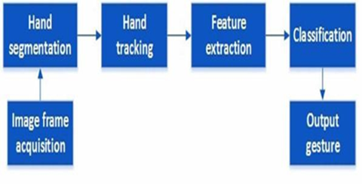

The technique that is used to recognize hand gesture is basis on computer vision. The overall system architecture is shown in figure 3 above. The whole system of hand gesture recognition divided into four phases: Image Acquisition, Image Pre-processing, Feature Extractions and Hand Gestures Recognition. Reading the video, Frame extraction and Pre- processing comes under the first stage i.e., video acquisition module

1. **METHODOOGY**

1] OpenCV: OpenCV is an open-source library that was developed by Intel in the year 2000. It is mostly used in computer vision tasks such as object detection, face detection, face recognition, image segmentation, etc. but also contains a lot of useful functions that you may need in ML

2] MediaPipe: MediaPipe is a framework which is used for apply in a machine learning ML pipelines, and it is an open source framework of Google. The MediaPipe frameworkings is use for cross platforms developing since the frameworks are built using the time series of the data. The MediaPipe framework are multimodals, in this framework can be applied to various on audios and videos. The MediaPipe framework is used by the developers to building and analyzing the systems through the graphs, and it also been using for developing the systems for this application purposes.

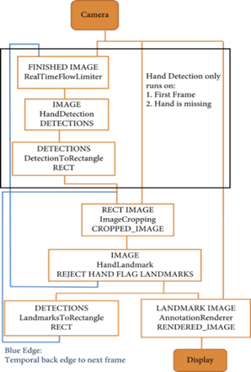

1. **SYSTEM IMPLEMENTATION**

**1.GESTURE**

**1. Natural Gesture 2. Mouse Cursor Moving**

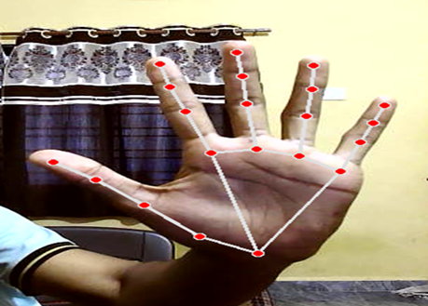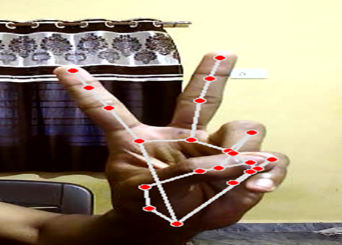

**3.** **Brightness 4.** **Multiple Item Selection**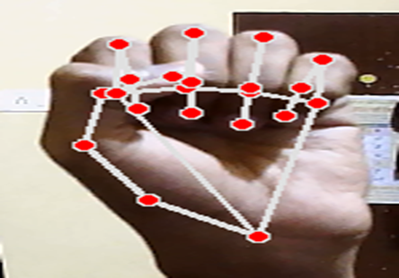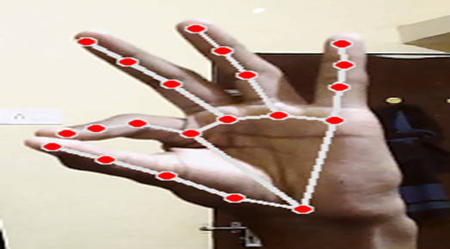

**2. VOICE**

1**.** Proton bye wake up 2. Proton copy

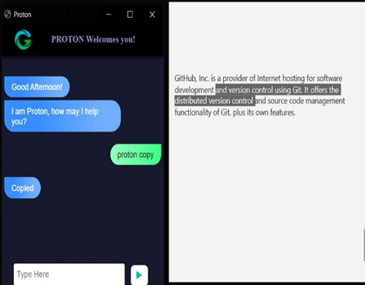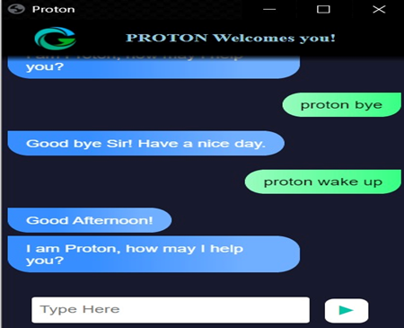

3. Proton search



1. **APPLICATIONS**

The Gesture Sensor System is useful for many applications; it can be used to reduce the space for using the physical device mouse, and it can be used in situations where not use the physical device mouse. The system eliminating the usage of devices, and it improving the human-computer interactions.

1] The proposed model has a greater accuracy of 99% which is far greater than that of other proposed models for more virtual mouse, and it has various applications

2] Admist the COVID-19 situation, it is not safely to use the devices by touching them because it can may result in a possible situations of spreading of the virus by touching the devices, so the proposed AI virtual mouse used to controlling the PC mouse operations without using the physical mouse

3] The system can be used to control robots and automation systems operations without the usage of devices.

4] 2D and 3D images can be drawn using the AI virtual system using the hand gestures

5] AI virtual mouse can be used to play virtual reality- and augmented reality-based games operations without the wireless or physical wired mouse devices

1. **CONCLUSION**

This system has proposed a novel approach to hand gesture recognition which will be utilized in natural interaction between human and computers. We used CV library and Media Pipe concept instead of typical algorithms. The main objective of the system is to control the mouse cursor functions by using the hand gestures instead of using a physical mouse. The proposed system can be achieved by using a webcam or a in-built web cam which detecting the hand gestures and hand tip operations and processing these framings to performing the particular mouse operations.

Hand gesture recognition is of more importance for achieving human computer interaction (HCI) because of its extensive applications operations in virtual reality and sign language for recognition etc. Human hand is very smaller with the complex articulations to comparing with the entire human bodies and therefore the errors can be easily affected by using it. It is thus a very challenging problem to recognizing hand tip gestures. This paper comprises of the existing methods in detecting operations and recognizing hand gestures operations and a detailed study on their performances, accuracy, convenience, operational range and design challenges in performing operations etc

1. **REFERENCES**

[1] Elmezain, M., Hamdy, M., & Sedky, M. (2019). Development of a gesture recognition system for human-computer interaction. Journal of Sensors, 2019, 9186043. doi: 10.1155/2019/9186043

[2] Kim, Y., & Choi, W. (2020). A systematic review of gesture recognition technology for human-computer interaction. Journal of Ambient Intelligence and Humanized Computing, 11, 2643-2658. doi: 10.1007/s12652-019-01432-1

[3] Tong Du,Xuemei Ren,Huichso Li - 2018, “Gesture Recognition Method Based On Deep Learning" Gesture recognition, recurrent Neural

[4] Li, Y., Zhang, Y., Huang, S., & Gao, W. (2017). A gesture-based human-computer interaction system using a 3D depth camera. IEEE Access, 5, 9368-9376. doi: 10.1109/ACCESS.2017.2706079

[5] W.K.Chen,*LinearNetworksandSystems*,Belmont,

CA:Wadsworth,1993, pp. 123-135.