Cloud Computing

[Gaurav Porwal](mailto:gaurav.porwal@genus.in)

*Department of Computer Science and Engineering*

*Arya Institute of Engineering & Technology*

*Jaipur, Rajasthan, India*

*iamgporwal@gmail.com*

*Utpal Kumar*

*Department of Computer Science and Engineering Arya Institute of Engineering & Technology Jaipur, Rajasthan, India*

*utpal.kumar@genus.in*

*Pawan Sen*

*Head of Department*

*Department of Computer Science and Engineering*

*Arya Institute of Engineering & Technology*

*Jaipur, Rajasthan, India*

***Abstract -****” Cloud Computing” has garnered a significant amount of popularity in recent years. Following this poetic rhetoric is a real picture of the future of computing, technically and socially.* Though *the term cloud computing is new, the concept of centralizing computing and storage in data centers distributed by third-party* platform *companies is not as recent as one might assume, it emerged in the 1990s with distributed computing such as grid computing. The main motive behind “Cloud Computing” is to provide IT as a service to cloud users with greater flexibility, availability, reliability, and scalability through utility models. This new concept has great potential for e-government and rural development in developing countries like India.*

***I. Introduction***

Cloud computing refers to a model of delivering computing services over the internet. These services include a wide range of resources such as servers, storage, databases, software, analytics, and more. Instead of hosting these resources on a local server or personal computer, cloud computing allows individuals and businesses to access and use these resources on demand from a remote data center.

Cloud computing offers three primary service models. Infrastructure as a Service (IaaS) provides virtualized computing resources such as virtual machines, servers, storage, and networking. Platform as a Service (PaaS) provides users with a platform for developing, running, and managing applications without having to build and maintain the underlying infrastructure. Software as a Service (SaaS) provides users with software applications that are hosted and managed by a third-party provider and accessed through the Internet.

Cloud computing offers several benefits over traditional computing models. These include cost savings, scalability, flexibility, and increased efficiency. Cloud computing allows businesses to pay only for the resources they need, when they need them, rather than investing in expensive hardware and software upfront. Additionally, cloud computing offers businesses the ability to quickly scale up or down as their needs change, and to access their resources from anywhere with an internet connection.

Cloud is given by expansive dispersed information centers. These data

centers are often organized as a framework and the cloud is built on the beat of the network services.

Cloud clients are given virtual pictures of the physical machines within the data

centers. This virtualization is one of the key concepts of cloud computing as it

constructs the reflection over the physical framework. Numerous cloud applications are platforms picking up ubiquity day by day for their accessibility, unwavering quality, versatility, and utility

model. These applications made dispersed computing uncomplicated as the supplier itself deals with basic platform viewpoints.

Cloud computing is expanding currently within the interest of specialized and business organizations but this could be useful for understanding social issues. In recent times E-Governance is being executed in creating nations to improve the proficiency and viability of governance. This approach can be progressed by using cloud computing rather than conventional ICT.

India's economy is agriculture based and even today most of the citizens reside in provincial zones. The standard of living, agricultural productivity, etc can be improved by fittingly utilizing cloud computing. Both of these applications of cloud computing have mechanical as well as social challenges

to overcome.

That is what are the benefits the supplier and the people groups get utilizing the cloud? Even though its thought has come long back in 1990 what circumstance made

it matter now? What's wrong with the cloud? How is it different from comparable

terms like grid calculation and utility?

What are the different services offered by cloud service providers? Although cloud computing is currently talking about

businesses, not profits;

How can this new approach be applied to services such as e-government and social development issues in India?

***II. Cloud Computing Basics***

Cloud computing is a platform example of distributed computing that provides on-demand, computerized services to customers.

Cloud users can provide more reliable, available, and improved services for their customers. The cloud itself has

physical bodies in the cloud data service provider. Virtualization was provided on

these physical machines. These virtual machines are available to platform cloud users.

Different cloud service providers offer cloud services at different levels of complexity. The

Amazon EC2 allows users to decode very low-level content, while the Google

App Engine equips developers with a platform to build applications. This is why cloud services fall into different types such as software as a service, platform as a service, or infrastructure as a service. These services are available available worldwide

over the Internet with the cloud serving as a single access point for all customers. Cloud computing architecture solves the challenge of handling big data.

***III. Cloud Architecture***

Cloud service providers have physical data centers and can provide virtualized services

to their users over the Internet. Cloud providers Cloud often provides separation of applications and data. The mainframe body is usually platform grid-shaped and often divided by area. Virtualization is extremely important in cloud computing. The host file provides the physical device where the virtual machine (

) resides.

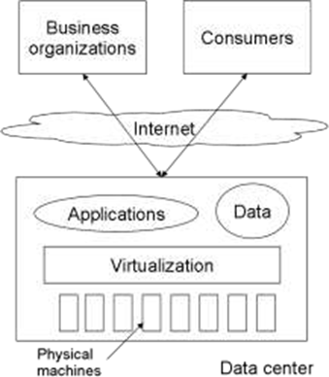

Virtualization enables the migration of the virtual image from one physical machine to another and this feature is useful for the cloud as by data locality lots of optimization is possible also this feature ​​it helps take back up in different locations. This feature also enables the provider to ​​it shut down some of the data center's physical machines to reduce power consumption.

**IV. Popular Cloud Applications: Case Study**

Applications using cloud computing are gaining increasing popularity due to their high platform availability, reliability, and practical service models. Today, many cloud ​​it service providers are involved in the IT industry. S3 ranks first among Google App-Engine, Windows Azure, and Amazon EC2 ​​it due to its popularity and technology prospects.

**1. Amazon EC2 and S3 services**

Amazon Elastic Computing (EC 2) is one of the largest organizations providing infrastructure as a ​​it service. They provide XEN virtual machines for computer architecture. Amazon EC 2 is one of the largest XEN architecture deployments to date. Customers can install the required operating system on the virtual machine.

**2 Google App-Engine**

The Google App Engine is a platform for building and deploying web applications within the framework of Google. This provides a platform as a service for cloud users. In 2008, Google App Engine was first released in beta. Languages ​​supported by Google App-Engine include Python, Java, and an extension of the JVM JVM language. App-Engine requires developers to use only the languages ​​it supports, and this also applies to APIs and frameworks.

Google App-Engine now allows storing and retrieval of data from BigTable's unrelated database. AppEngine apps should be request-response platform based. Google AppEngine provides automatic scalability and ​​it persistent data storage services. The store has a query engine and trading capabilities. These apps scale easily as the traffic ​​it and data storage grow, so cloud users don't have to worry about traffic or data spikes.

These apps are ​​it generally suitable for kickoff meetings, event websites, or institutions (schools, colleges, universities, and government associations) that host seasonal events.

#### **3. Windows Azure** is the middle ground between simple and easy programmers. These systems are used. NET library to support a language-independent ​​it hosting environment. This service falls under the category of Platform-based Services.

#### Azure applications run on ​​it machines in Microsoft's data centers, although it is the real site of the entire application, such as the Google App-Engine, and hardware virtual machines such as EC 2. Customers platform ​​it can use this service to run applications and store data on Microsoft machines with Internet access. The Windows Azure platform provides three main ​​it components - Compute, Storage, and Fabric.

**• Computer Services:**

The main purpose of this platform is to support many users at the same time. To allow applications to scale out, Microsoft uses multiple instances of these applications in hypervisor-provided platform virtual machines. The developer uses the Windows Azure portal via a web browser and logs in to the hosting account or the ​​it storage account, or both using a Windows Live ID.

There are two different types of Azure available: sample web roles and functional roles.

**Web role example:** As the name suggests, this type of example can accept HTTP or HTTPS requests. For this site, Microsoft uses IIS (Internet Information Services) ​​it as the web server in the provided VM. Developers can build applications using ASP.NET, Windows Communication Foundation, or other tools. NET technologies or native code such as C++.

Azure also ​​it supports PHP or Java-based technologies. Azure scales apps by running them multiple times ​​it without connecting them to a specific website. That's why it's critical for an Azure application to have multiple instances to support multiple requests ​​it from a single user. So this requires the user state to be written to Azure Storage after each user request.

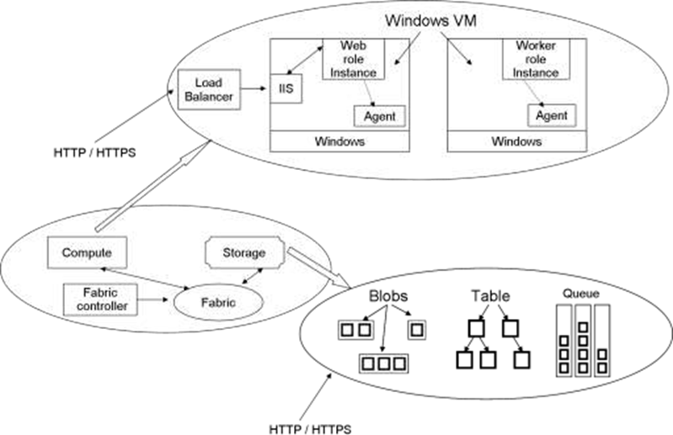

**Figure:**

Azure parts architecture

IIS configuration. They can be configured to run executables with user ​​it permissions. The role of the staff member will often be similar to the background work. The role of the site can be used to accept requests from users and these ​​it requests can then be processed by the role of the Operator. For compute-intensive tasks, multiple task ​​it operators can work in parallel.

**V. Conclusion**

Cloud computing is an interesting interview. Virtualization combined with utility models can have an impact on the IT industry and from a societal perspective. Although ​​it cloud computing is still in its infancy, it is gaining momentum. Organizations like Google, Yahoo, and Amazon platform already provide cloud services.

Products like ​​it Google AppEngine, Amazon EC2, and Windows Azure are dominating the market with their ease of use, availability of features, and utility models. Users do not need to worry about distribution hinges as it is taken care of by the cloud ​​it provider. They can devote more energy to work tasks instead of doing ​​it these tasks. Commercial organizations are also showing increasing interest in ​​it using cloud services. There is a lot of research open. Cloud computing is an advanced computing solution.

The combination of platform virtualization and utility models can make a difference in the IT industry and society. Although cloud ​​it computing is still in its infancy, the growth momentum is clear. Organizations like Google, Yahoo, and Amazon already provide cloud services. Google AppEngine, Amazon EC2, Windows platform Azure, etc. products have captured the market due to their ease of use, availability of features, and utility models. Users do not need to worry about distribution hinges, as it is taken care of by the cloud provider.

They can devote more ​​it energy to business activities rather than these administrative tasks. Business organizations are also showing ​​it increasing interest in ​​it adopting cloud services. there is a lot of open research

**VI. References**

1 Google Application Engine. http://code.google.com/appengine/.

2 Cloud computing for e-government.

White Paper, IIIT-Hyderabad, January 2010. Available online (13 pages).

3 Native Indians. http://en.wikipedia.

org/Wii/Demographics_of_India, April 2010.

4 Indian Economy. http://en.wikipedia.Org/wiki/Economy_of_India, April 2012.five Michael Armbrust, Armando Fox, Rean Griffith, Anthony D. Joseph, Randy H.Katz, Andrew , Gunho , David Patterson, Ariel Rabkin, Ion Stoica,and Matei Paradise: Department of EECS, UC Berkeley, February 2009.

An approach to cloud computing networks. Application of Digital Information and Web Technologies, 2008. CADI WT 2008. , August 2008.

7m do.

Bacchus.E-authorities in growing countries. I I CD Research Brief, 1, 2001.

8Jaijit Bhattacharya and Sushant Vashistha. Government E-Government Environment Based on Service Calculation, p. 303-309.

ACM, New York, NY, ABD, 2008.

9 D. Chappell. Qhia Windows Azure. http://git.

microsoft.com/, December 2009.EC2 and Windows Azure uses