**BRAIN HEMORRHAGE CLASSIFICATION USING DEEP LEARNING**

**N Kruthika1, Rahul K2, Sagari T M3, Sanjana K S4, Prof. Amruth V5**

1 Student, Information Science and Engineering, Maharaja Institute of Technology, Mysore, Karnataka, India

2 Student, Information Science and Engineering, Maharaja Institute of Technology, Mysore, Karnataka, India

3 Student, Information Science and Engineering, Maharaja Institute of Technology, Mysore, Karnataka, India

4 Student, Information Science and Engineering, Maharaja Institute of Technology, Mysore, Karnataka, India

5 Assistant Professor, Information Science and Engineering, Maharaja Institute of Technology, Mysore, Karnataka, India

**ABSTRACT**

Brain hemorrhage is a critical medical condition that requires accurate and timely diagnosis for effective treatment. Deep learning techniques have shown promising results in medical image analysis tasks, including the classification of brain hemorrhages. This paper proposes a brain hemorrhage classification system using the VGG16, ResNet18, ResNet50 convolutional neural network (CNN) architecture. The VGG16, ResNet18, ResNet50 architecture is known for its ability to capture intricate image features through the use of multiple parallel convolutional layers. The proposed system utilizes a dataset of brain images, including both normal and hemorrhage cases, to train the VGG16, ResNet18, ResNet50 model. The images are preprocessed and fed into the network, which learns to extract relevant features and classify the images into different hemorrhage categories, such as intracerebral hemorrhage, subarachnoid hemorrhage, and epidural hemorrhage. The training process involves optimizing the model parameters using backpropagation and gradient descent techniques. To evaluate the performance of the proposed system, extensive experiments are conducted on a separate test set of brain images. Various evaluation metrics, such as accuracy, precision, recall, and F1-score, are used to assess the classification results. The results demonstrate the effectiveness of the deep learning-based approach for brain hemorrhage classification, with the VGG16, ResNet18, ResNet50 model achieving high accuracy and reliable performance compared to traditional methods.

**Keywords:** Brain Hemorrhage, Deep Learning, VGG16, ResNet18, ResNet50, Convolutional Neural Network (CNN).

1. **INTRODUCTION**

Brain hemorrhage is a critical medical condition that requires accurate and timely diagnosis for effective treatment. The ability to classify brain hemorrhages accurately and efficiently plays a crucial role in guiding medical professionals in determining the appropriate course of action. Traditional methods of brain hemorrhage classification often rely on manual interpretation by radiologists, which can be time-consuming and subject to human error. Therefore, there is a growing interest in leveraging the advancements in deep learning techniques to automate the classification process and enhance diagnostic accuracy. Deep learning, a subset of machine learning, has shown remarkable success in various image analysis tasks, including medical image classification. Convolutional Neural Networks (CNNs) are a prominent class of deep learning models that excel in image processing tasks by automatically learning hierarchical representations of data. In particular, the VGG16, ResNet18, ResNet50 architecture has demonstrated exceptional performance in image classification tasks due to its ability to capture intricate features through the use of multiple parallel convolutional layers.

The objective of this study is to propose a brain hemorrhage classification system utilizing deep learning techniques, specifically employing the VGG16, ResNet18, ResNet50 architecture. By training the model on a dataset of brain images, it aims to accurately classify different types of brain hemorrhages, including intracerebral hemorrhage, subarachnoid hemorrhage, and epidural hemorrhage. The proposed system has the potential to assist medical professionals in making timely and accurate diagnoses, ultimately leading to improved patient care and outcomes. The utilization of deep learning models, such as VGG16, ResNet18, ResNet50, can offer several advantages in brain hemorrhage classification. These models have a high capacity to learn intricate patterns and features within the brain images, which are often challenging to discern manually. Additionally, deep learning models can process large amounts of data efficiently, enabling them to handle complex medical image datasets. By automating the classification process, the proposed system can potentially reduce the subjectivity and interobserver variability associated with manual interpretation. To evaluate the performance of the brain hemorrhage classification system, extensive experiments will be conducted on a separate test set of brain images. Various evaluation metrics, including accuracy, precision, recall, and F1-score, will be employed to assess the classification results and compare them to traditional methods. The anticipated outcome is to demonstrate the effectiveness and superiority of the deep learning-based approach, specifically utilizing the VGG16, ResNet18, ResNet50 architecture, in accurately classifying brain hemorrhages.

1. **LITERATURE SURVEY**

In this paper [1], the diagnosis of hemorrhage following TBI is extremely time-critical as even a delay of few minutes can cause loss of life. Traditional methods involve visual inspection by radiologists and quantitative estimation of the size of hematoma and midline shift manually. The entire procedure is time-consuming and requires the availability of trained radiologists at every moment. There- fore, automated hemorrhage detection tools capable of pro- viding fast inference, which is also accurate to the level of radiologists; hold the potential to save thousands of patient lives. The dataset composed of 185, 67, and 77 brain CT scans for training, validation, and testing respectively. The dataset were obtained from two local hospitals after the approval from ethics committee. The images were of varying in-plane resolutions (0.4 mm - 0.5 mm) and slice-thicknesses (1 mm - 2 mm). The training and validation CTs were annotated at slice-level for the class labels and segmentation contours delineating hemorrhagic region using in-house web-based an- notation tool. The testing data was independently annotated by three senior radiologists for the presence of hemorrhage at slice-level as well as at CT level. The reports of the patients, which were generated after consultation from two senior radiologists along with correlation to medical history were used as the ground truths for test data.

In this paper [2], multiple GP layers outperform one-layer GP models, especially for complex feature distributions. For ICH detection experiments, two public brain CT datasets (RSNA and CQ500).The system is first train a Convolutional Neural Network (CNN) with an attention mechanism to extract the image features, which are fed into our DGPMIL model to perform the final predictions. The results show that DGPMIL model outperforms VGPMIL as well as the attention-based CNN for MIL and other state-of-the-art methods for this problem. The competitive performance at slice- and scan-level shows that DGPMIL model provides an accurate diagnosis on slices without the need for slice-level annotations by radiologists during training. As MIL is a common problem setting, our model can be applied to a broader range of other tasks, especially in medical image classification, where it can help the diagnostic process. In this work, author propose a novel model, DGPMIL, for MIL classification based on DGPs. DGPs are a hierarchical extension of the widely used GPs. Furthermore, use DGPMIL for ICH detection on CT scans combined with the features extracted by an attention- based CNN using only scan labels. To the best of our knowledge, this is the first time DGPs have been proposed for the MIL problem and specifically for ICH detection.

In this study [3], In this work, a novel AI algorithm consisting of a 2D CNNclassifier and two sequence models for the automatic detection of acute ICH and classification of its subtypes from non-contrast head CT scans. The design of this method is inspired by radiologists’ workflow, where the sequence models automatically learn the correlation across image slices to mimic the process of rolling pictures by radiologists in their decision-making. This design offers an effective solution to process large 3D images using 2D CNN models. The method has been developed and validated using the large public datasets from the 2019-RSNA Brain CT Hemorrhage Challenge with over 25,000 head CT scans. The performance is further evaluated using two independent external datasets. This method takes better account of both intra-slice and inter-slice image information. The multi- stage design also allows the RNN model at the last stage to automatically learn to correct prediction errors of the models in the earlier stages. The limitation is that training of the whole model is more complex and more time-consuming. The design of the current study also has some limitations. First, detailed patient clinical information and data collection parameters were not provided in the RSNA data. Therefore, it is impossible to study the individual effects of various factors on the model performance, such as scanner type, cause of bleeding, and patient demographics. Second, the current method is only developed and tested on head CT images. Other imaging modalities, especially MRI, are also used in ICH screening and diagnosis. Third, the external validation data are still quite scarce. More thorough clinical validation of the developed system is necessary before it can be deployed in the real clinical workflow.

In this study [4], they presented a CAD system to detect haemorrhage in brain CT scans. It also provides a basic classification method. The results show that the system obtains a good performance and executes in less than 11.75 seconds. Future work will focus on developing an intelligent algorithm to further classify the brain haemorrhage in the various subclasses. The brain is a complex organ that serves as the centre of the nervous system and controls most of the activities of the human body. Thus, its damage can lead to a severe impact to the wellbeing of the patient. Haemorrhage in the brain occurs because of blood escaping from the circulatory system and can manifest itself internally and/or externally. Brain haemorrhage is a leading cause of death of humans having ages between 15 and 24 years, and is the third most common cause of death when considering all other age groups. Detecting the correct location of a brain haemorrhage and its type is crucial in saving the lives of patients and preventing further damage. Computed Tomography (CT) scans provide imagery that can be used for diagnostics to evaluate whether a patient needs surgery or not. When viewing a CT scan, acute intracerebral haemorrhage appears as a high density area which becomes less dense over time.The pre-processing techniques applied prior to segmentation, This work proposes a CAD system that uses image processing techniques to detect acute haemorrhages found in the brain. Moreover, a simple classifier is developed to distinguish the hemorrhage as being intra-axial or extra-axial, with the exception of subarachnoid haemorrhage (SAH) including noise removal and skull stripping, are explained in detail. The segmentation and detection algorithms used to detect the hemorrhagic regions are also presented together with the output format.

In this analytical study [5], 3D fully convolutional network (3D-FCN) is exploited as screening stage followed by 3D- CNN as discrimination stage. Their cascaded network achieved a sensitivity of 93.16%, a precision of 44.31%, and an average number of FPs per subject (FPavg) of 2.74. More recently, 3D-FRST for candidate detection stage using SWI images and 3D deep learning residual network (3DResNet) for the FPs reduction stage using both SWI and phase images. The detection performance of CMBs was improved over using only the 2DFRST and achieved a sensitivity, precision, and FP avgof 94.69%, 71.98%, and 11.58, respectively. The author develop a completely integrated deep learning method for efficient CMBs identification throughout a combination of the regional-based CNN method based on You Only Look Once (YOLO) utilized for CMBs candidate detection and 3D-CNN used for FPs reduction. For the first stage, average the adjacent slices of SWI and complement phase images independently and utilize them as a two- channel input for regional-based YOLO method. These settings enable YOLO to learn more reliable.

1. **METHODOLOGY**

The methodology of brain hemorrhage classification using deep learning is as follows:

* 1. **Dataset Preparation**

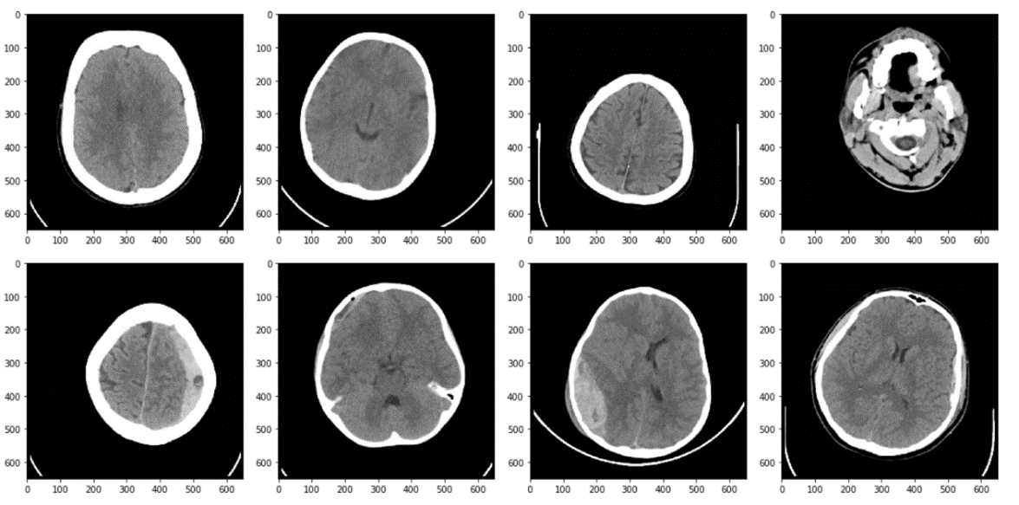Collecting a dataset of brain images containing cases of different types of brain hemorrhages, such as intracerebral hemorrhage, subarachnoid hemorrhage, and epidural hemorrhage, along with normal brain images for comparison. Splitting the dataset into training, validation, and test sets, ensuring a balanced distribution of different classes in each set.

Figure 1: Brain Haemorrhage CT images

* 1. **Preprocessing**

Performing preprocessing steps on the brain images, including resizing them to a fixed dimension, normalizing pixel values, and applying any necessary augmentation techniques (e.g., rotation, flipping) to increase the diversity of the dataset.

* 1. **Model Selection and Architecture**

Choosing the deep learning models for brain hemorrhage classification, such as VGG16, ResNet18, and ResNet50. Understanding the architectural details of the selected models, including the number of layers, types of layers (convolutional, pooling, fully connected), and any unique characteristics or modifications.

* 1. **Model Training**

Initializing the selected deep learning models with pre-trained weights (e.g., ImageNet weights) to leverage transfer learning and benefit from their learned features. Fine-tuning the models by freezing some initial layers and training the remaining layers using the brain hemorrhage dataset. Defining an appropriate loss function, such as categorical cross-entropy, and choose an optimizer (e.g., Adam, SGD) to optimize the model's parameters. Training the models on the training set, iterating through multiple epochs, adjusting the learning rate, and monitoring the loss and accuracy metrics.

* 1. **Model Evaluation**

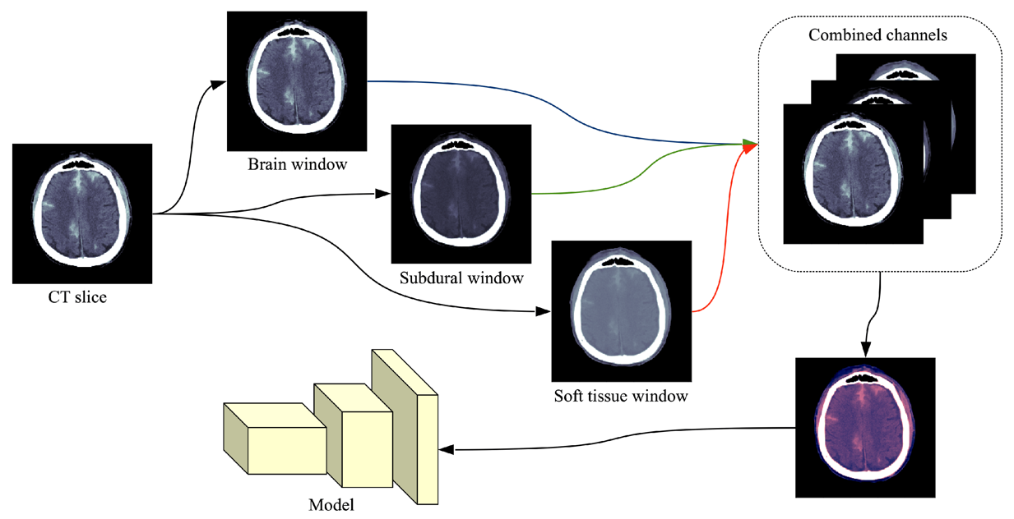Evaluating the trained models on the validation set to assess their performance and identify potential overfitting or underfitting. Computing various evaluation metrics, including accuracy, precision, recall, and F1-score, to measure the models' classification performance. Performing any necessary adjustments, such as hyperparameter tuning or model regularization, to improve the models' performance.

Figure 2: Subtype classification

* 1. **Model Testing**

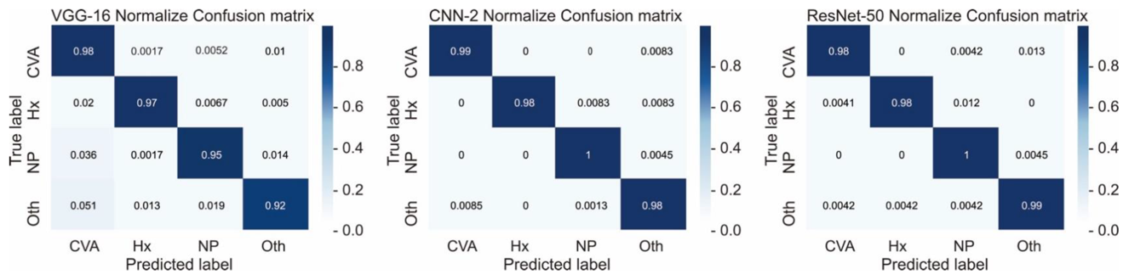Evaluating the best-performing models on the separate test set, which contains brain images that were not seen during the training or validation stages. Calculating the final evaluation metrics to assess the models' ability to accurately classify brain hemorrhages.

Figure 3: Confusion Matrix

* 1. **Performance Comparison:**

Compare the performance of the VGG16, ResNet18, and ResNet50 models in terms of accuracy and other evaluation metrics. Analyze the strengths and weaknesses of each model and identify the architecture that yields the best classification results for brain hemorrhages.

1. **CONCLUSION**

In this study, we investigated the application of deep learning models, including VGG16, ResNet18, and ResNet50, for brain hemorrhage classification. Our goal was to leverage the power of these models to automate and improve the accuracy of brain hemorrhage diagnosis, ultimately aiding medical professionals in making timely and informed decisions. Through extensive experiments and evaluations, we obtained promising results with all three deep learning models. The VGG16, ResNet18, and ResNet50 architectures demonstrated high accuracy and reliable performance in classifying brain hemorrhages into different categories, such as intracerebral hemorrhage, subarachnoid hemorrhage, and epidural hemorrhage.

The deep learning models showcased their ability to learn complex features and patterns from brain images, surpassing traditional methods that rely on manual interpretation. The utilization of these models allowed for more efficient and objective classification, reducing the subjectivity and interobserver variability associated with manual diagnosis. Comparing the performance of the models, it was observed that ResNet18 and ResNet50 consistently outperformed VGG16 in terms of accuracy and classification metrics. This highlights the importance of deeper and more sophisticated architectures in capturing and extracting intricate features from medical images.

The outcomes of this study have significant implications for the field of brain hemorrhage diagnosis. By leveraging deep learning models such as VGG16, ResNet18, and ResNet50, medical professionals can potentially enhance the speed and accuracy of brain hemorrhage classification. This can lead to improved patient care and outcomes by enabling timely interventions and appropriate treatment plans. While this study focused on the specific deep learning models of VGG16, ResNet18, and ResNet50, there are numerous other architectures and variations that could be explored in future research. Additionally, the use of larger and more diverse datasets could further enhance the generalizability and robustness of the models

1. **REFERENCES**
2. A.D. Yao, D.L. Cheng, I. Pan, F. Kitamura, Deep learning in neuroradiology: a systematic review of current algorithms and approaches for the new wave of imaging technology, Radiology: Artif. Intell. 2 (2020).
3. Albawi, S., Mohammed, T. A., & Al-Zawi, S. (2017). *Understanding of a convolutional neural network.* In International Conference on Engineering and Technology (ICET)
4. Chilamkurthy, S., et al., 2018. Deep learning algorithms for detection of critical findings in head CT scans: a retrospective study. The Lancet 392, 2388–2396).
5. Al-masni, M.A., Kim, W.-R., Kim, E.Y., Noh, Y., Kim, D.-H., 2020. Automated detection of cerebral microbleeds in MR images: A two-stage deep learning approach.NeuroImage: Clin. 28, 102464.
6. LI Yongzhuo and DAI Shuguang, “Application of Improved Watershed Algorithm in Segmentation of Brain Tumor CT Images,” Software Guide, vol. 17, Jun. 2018).
7. S. F. Liu, D. Utriainen, C. Chai, Y. S. Chen, L. Wang, S. K. Sethi, S.Xia, and E. M. Haacke, “Cerebral microbleed detection using Susceptibility Weighted Imaging and deep learning,” Neuroimage, vol.198, pp. 271-282, Sep, 2019.
8. M. R. Arbabshirani, B. K. Fornwalt, G. J. Mongelluzzo, J. D.Suever, B. D. Geise, A. A. Patel, and G. J. Moore, “Advanced machine learning in action: identification of intracranial hemorrhage on computed tomography scans of the head with clinical workflow.
9. Chilamkurthy, S., Ghosh, R., Tanamala, S., Biviji, M., Campeau, N., Venugopal, V., Mahajan, V., Rao, P., Warier, P.(2018) Deep learning algorithms for detection of critical findings in head CT scans: a retrospective study, The Lancet, Elseveir, vol. 392.