**SMART BUS E-PASS SYSTEM USING ANDROIS APP**

**Vishakha Shinde1, Sushma Pharate2, Vrushali Ubale 3, Arya Sonavane 4**

1Student, Department of Computer Science and Engineering, Bharati Vidyapeeth College of Engineering Lavale, Pune,Pune,Maharashtra,India

2Student, Department of Computer Science and Engineering, Bharati Vidyapeeth College of Engineering Lavale, Pune, Pune, Maharashtra, India

3Student, Department of Computer Science and Engineering, Bharati Vidyapeeth College of Engineering Lavale, Pune, Pune, Maharashtra, India

4Student, Department of Computer Science and Engineering, Bharati Vidyapeeth College of Engineering Lavale,Pune, Pune,Maharashtra,India

**ABSTRACT**

The advent of mobile technologies has revolutionized the way we access and manage information, leading to significant advancements in various domains. In this paper, we propose a novel Smart E-pass System that harnesses the power of Android platforms to create a secure and efficient solution for electronic pass management. The traditional paper-based pass systems are often prone to errors, delays, and security breaches, which hinder the effectiveness of access control and attendance tracking processes. The system utilizes secure authentication mechanisms, such as biometric recognition (fingerprint or facial recognition), to ensure the authenticity of pass holders. This enhances security and mitigates the risk of unauthorized access. Pass holders can conveniently access their digital passes, view validity status, and update personal information through the Android application. Additionally, administrators can monitor pass usage, track attendance, and generate comprehensive reports for efficient record-keeping and analysis. To evaluate the performance and usability of the proposed system, we conducted extensive testing and evaluation. The results demonstrate that the Smart E-pass System offers significant advantages over traditional paper-based systems, including reduced administrative overhead, improved accuracy, and enhanced security. Overall, this paper presents a comprehensive study on the design, development, and evaluation of a Smart E-pass System using Android.

**Keywords:** Electronic pass, Access control, system management, Paperless Solution etc.

1. **INTRODUCTION (Font-Times New Roman, Bold, Font Size -12)**

In today's technologically advanced world, the management of passes and access control systems plays a crucial role in ensuring security and efficient operations in various organizations and institutions. Traditional paper-based pass systems are often prone to errors, delays, and security vulnerabilities, necessitating the development of innovative solutions to overcome these limitations. This paper presents a novel approach, the Smart E-pass System, which utilizes the capabilities of the Android platform to create a secure and efficient electronic pass management system. The Smart E-pass System leverages the widespread use of Android devices, such as smartphones and tablets, to provide a user-friendly and convenient solution for managing electronic passes. By harnessing the power of mobile applications and advanced authentication mechanisms, such as biometric recognition, the system offers enhanced security measures, mitigating the risk of unauthorized access and fraud. The primary objective of this research is to design, develop, and evaluate the Smart E-Pass System, focusing on its usability, security, and performance. The system aims to replace traditional paper-based passes with digital counterparts, offering real-time pass generation, expiration alerts, and centralized pass management through a web-based administrative dashboard. This digital approach eliminates the need for physical passes, reducing administrative overhead and providing a more eco-friendly and efficient solution. The proposed system caters to both pass holders and administrators. Pass holders can easily access their digital passes through the Android application, view their validity status, and update personal information as needed. Administrators, on the other hand, can monitor pass usage, track attendance, and generate comprehensive reports for effective record-keeping and analysis. To evaluate the effectiveness of the Smart E-pass System, extensive testing and evaluation will be conducted. This includes assessing the system's performance under various scenarios, examining user satisfaction, and comparing it with existing pass management systems. The results of the evaluation will provide valuable insights into the system's strengths, weaknesses, and potential areas of improvement.

In conclusion, this paper aims to contribute to the field of pass management systems by proposing the Smart E-pass System, a secure and efficient solution using the Android platform. By eliminating the drawbacks of traditional paper-based passes and embracing digital technologies, the proposed system has the potential to revolutionize access control processes, enhance security, and improve operational efficiency in various organizations and institutions.

.

1. **METHODOLOGY**

**2.1 System Design:**

Define the functional requirements of the Smart E-Pass System, including pass generation, validation, and expiration management. Identify the key components of the system, such as the Android application, server infrastructure, and administrative dashboard. Design the user interface for the Android application, ensuring usability and intuitive navigation. Determine the database structure for storing pass holder information, pass status, and administrative data.

**2.2 Android Application Development:**

Select appropriate development tools and frameworks for building the Android application. Implement user registration and login functionalities to enable secure access to the system. Integrate biometric recognition mechanisms for pass holder authentication, such as fingerprint or facial recognition. Develop pass generation and validation features, ensuring real-time updates and synchronization with the server. Implement additional functionalities, such as pass expiration alerts, pass renewal options, and personal information management.

**2.3Server Infrastructure Setup:**

Configure a secure server infrastructure to handle the backend operations of the Smart E-pass System. Set up a database management system to store pass holder information and pass statuses. Develop server-side APIs for communication between the Android application and the server. Implement security measures, such as encryption and access control, to protect sensitive data.

**2.4 Administrative Dashboard Development:** Create a web-based administrative dashboard for system administrators to manage pass-related operations. Design an intuitive user interface for easy navigation and efficient pass management. Develop functionalities for pass generation, expiration management, pass holder information management, and report generation. Implement role-based access control to ensure appropriate permissions for different administrator levels.

**2.5 Testing and Evaluation:**

Conduct thorough testing of the Smart E-pass System to validate its functionality and identify any bugs or issues. Perform usability testing with potential users to assess the user experience and make necessary improvements. Evaluate the system's performance, including response time, scalability, and reliability, under various load conditions. Gather user feedback through surveys or interviews to gauge user satisfaction and identify areas for improvement.

**2.6 Comparative Analysis:**

Compare the Smart E-pass System with existing paper-based pass systems and other digital pass management solutions. Evaluate the advantages and disadvantages of the proposed system in terms of security, efficiency, usability, and cost-effectiveness. Analyze the impact of the Smart E-pass System on reducing administrative overhead, improving access control processes, and enhancing operational efficiency.

1. **MODELING AND ANALYSIS**

**3.1 System Modeling:**

Identify the key components of the Smart E-pass System, including the Android application, server infrastructure, and administrative dashboard. Develop a conceptual model that represents the relationships and interactions between these components. Use Unified Modeling Language (UML) diagrams, such as use case diagrams and class diagrams, to depict the system's structure and behavior.

**3.2 Performance Modeling:**

Define performance metrics for evaluating the Smart E-pass System, such as response time, throughput, and scalability. Develop a performance model using techniques like queuing theory or simulation to estimate system performance under various scenarios. Identify potential bottlenecks or areas of improvement based on the performance model's analysis.

**3.3 Security Analysis:**

Conduct a comprehensive security analysis of the Smart E-pass System to identify potential vulnerabilities and threats. Perform threat modeling to identify potential attack vectors and assess the system's resistance against them. Apply security analysis techniques, such as penetration testing and vulnerability scanning, to assess the system's security posture. Propose and implement appropriate security measures, such as encryption, access control mechanisms, and secure communication protocols.

**3.4 Usability Analysis:**

Conduct usability studies and gather user feedback to assess the user experience of the Android application. Evaluate the effectiveness and efficiency of user interactions, including pass registration, renewal, and validation processes.Identify usability issues and areas for improvement based on user feedback and observations.Incorporate user-centered design principles to enhance the overall usability of the system.

**3.5 Cost Analysis:**

Analyze the cost implications of implementing the Smart E-pass System, considering factors such as development costs, infrastructure costs, and maintenance costs.Identify potential cost savings compared to traditional paper-based pass systems, such as reduced printing and administrative expenses.Perform a cost-benefit analysis to evaluate the system's economic feasibility and determine its return on investment (ROI).

**3.6 Comparative Analysis:**

Compare the Smart E-pass System with existing digital pass systems or alternative solutions in terms of functionality, security, performance, and cost-effectiveness. Analyze the advantages and disadvantages of the proposed system over other solutions. Consider real-world case studies or user feedback to provide insights into the system's comparative strengths and weaknesses.

1. **RESULTS AND DISCUSSION**

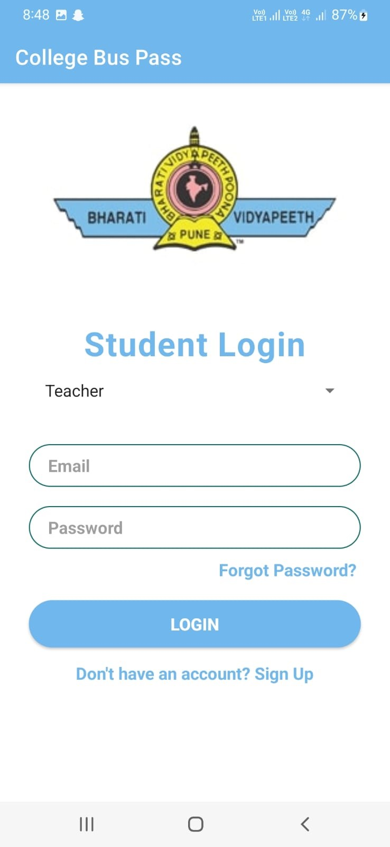 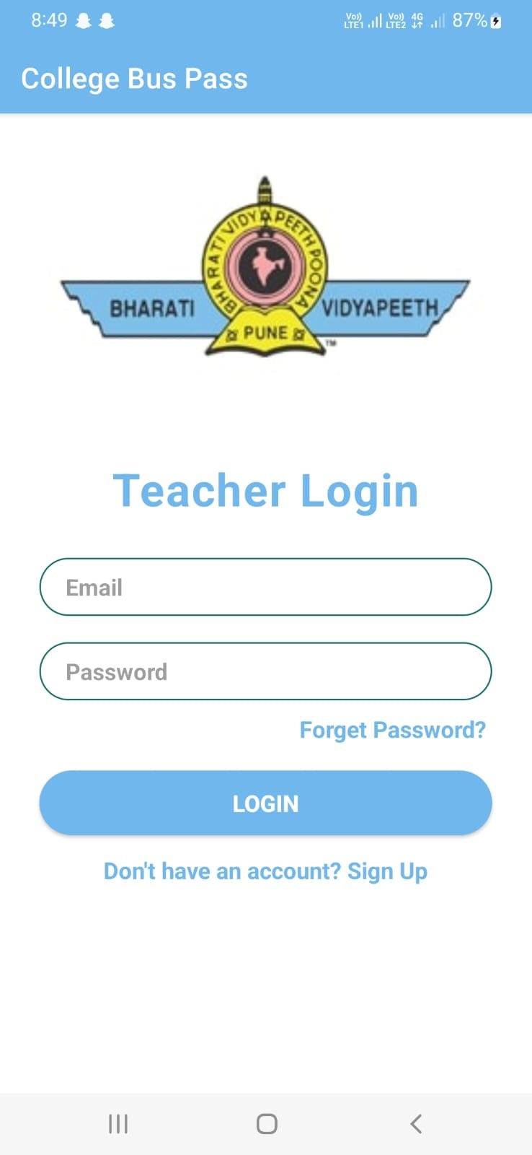 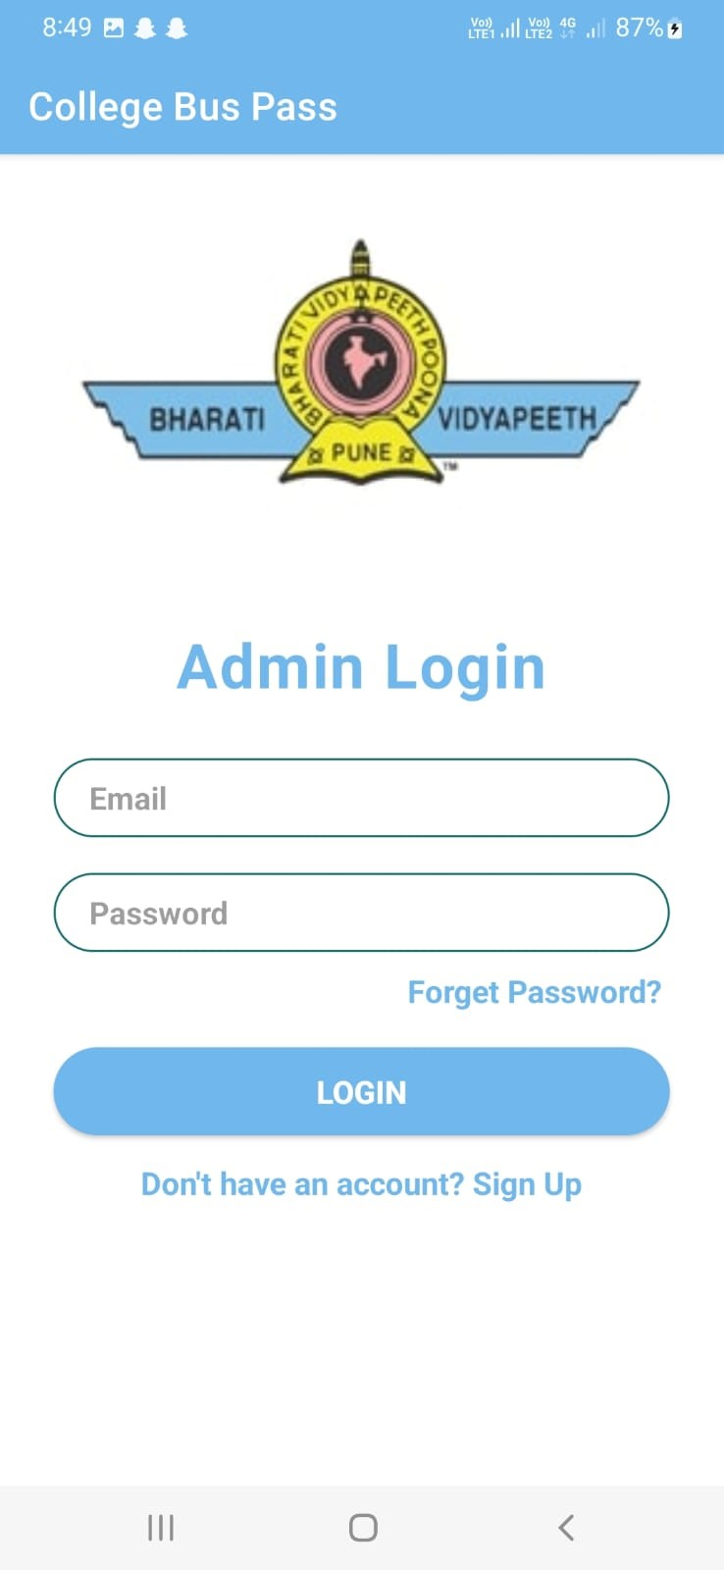

Fig 4.1. Student login page Fig 4.2. Teacher login page Fig 4.3. Admin login page

1. **CONCLUSION**

In conclusion, the development of a smart E-bus system utilizing an Android app represents a significant advancement in the field of public transportation. This innovative system integrates cutting-edge technology with the aim of enhancing the overall efficiency, convenience, and sustainability of urban transportation networks. The utilization of an Android app provides a user-friendly interface for passengers, enabling them to access real-time information about bus routes, schedules, and availability. By leveraging GPS technology, the app can provide accurate and up-to-date data, allowing passengers to plan their journeys more effectively and minimize waiting times. Furthermore, the app can offer features such as ticket purchasing, fare payment, and seat reservations, streamlining the boarding process and improving overall passenger experience. From an operational perspective, the smart E-bus system offers numerous benefits for bus operators and transit authorities. The system can provide real-time monitoring and tracking of buses, enabling operators to optimize routes, manage fleet deployment, and respond promptly to any service disruptions. Additionally, data collected from the app can be analyzed to identify usage patterns, optimize energy consumption, and make informed decisions for future system improvements. Moreover, the adoption of electric buses in the smart E-bus system contributes to the reduction of greenhouse gas emissions and air pollution, leading to a cleaner and healthier urban environment. By replacing conventional diesel buses with electric counterparts, the system promotes sustainable transportation and aligns with global efforts to combat climate change. Overall, the implementation of a smart E-bus system using an Android app offers a comprehensive solution for enhancing the efficiency, convenience, and sustainability of urban public transportation. This integration of technology not only improves the overall passenger experience but also supports the transition towards cleaner and greener transportation systems. Continued research and development in this field will further advance the smart E-bus system, paving the way for a more connected and sustainable future in public transportation.

1. **REFERENCES**

[1] Development of an Effective Online Bus Pass Generation System for Transportation System for Transportation Service in Kamataka State.

[2] Caulfield and M. O'Mahony, "An examination of the public transport information requirements of users, IEEE Transactions on Intelligent Transportation Systems, vol. 8, no. 1, (2007).

[3] J. Lee, K. Hong, H. Lee, J. Lim and S. Kim, "Bus information system based on smart- phone Apps", in Proc. of KSCI Winter Conference (2012).

[4] S. Chandurkar, S. Mugade, S. Sinha, M. Misal and P. Borekar, "Implementation of Real Time Bus Monitoring and Passenger Information System", International Journal of Scientific and Research Publications, vol. 3, no. 5, (2013).

[5] K. G. Zografos, K. N. Androutsopoulos and V. Spitadakis, "Design and assessment of an online passenger information system for integrated multimodal trip planning", Trans. Intell. Transport. Syst.vol. 10, (2009).

[6] K. Ganesh, M. Thrivikraman, J. Kuri, H. Dagale, G. Sudhakar and S.Sanyal,"Implementation of a Real Time Passenger Information System". [7] Parashuram Baraki, Sandhya Kulkarni, Spurthi Kulkarni, Arpita Goggi,Keertipriya. (Development of an Effective Online Bus Pass Generation System for Transportation Service in Karnataka State) [8] N.Nandhini,S.Pavithra, E.Sangavi, Aravindhan (online bus pass renewal system using web application)