BRAIN TUMOR DETECTION USING MACHINE LEARNING

Shahal Moideen P

Undergraduate student

B.Tech Computer Science Engineering

Sambhram Institute Of Technology, Bengaluru, Karnataka

Sayyid Marvan VT

Undergraduate student

B.Tech Computer Science Engineering

Sambhram Institute Of Technology, Bengaluru, Karnataka

Akash Raj K

Undergraduate student

B.Tech Computer Science Engineering

Sambhram Institute Of Technology, Bengaluru, Karnataka

Prof. Deepa S Bhat

Assistant Professor

B.Tech Computer Science Engineering

Sambhram Institute Of Technology, Bengaluru, Karnataka

Abstract -Medical imaging is gaining importance with an increase in the demand for automated, reliable, fast and efficient diagnosis, which can provide insight into the image better than human eyes. Brain tumors are two types: malignant and benign. Most of the disease will reach the critical stage if not detected earlier. Timely detection of the disease will help a lot in the treatment process. The major cause of brain tumors is because of the abnormal growth and uncontrolled cell division in the brain. Pituitary, meningioma and Glioma are some of the common types of tumors. We will use the MR images of the brain to predict the pattern of the tumor with the help of machine learning techniques, which makes the process less time consuming with the minimal amount of errors. The model to detect the tumor analyzes images.

Keywords- Classification, convolutional neural network, feature extraction, machine learning, magnetic resonance imaging, segmentation.

1. INTRODUCTION

Medical imaging is the technique and process of creating visual representations of the interior of a body for clinical analysis and medical intervention, as well as visual representation of the function of some organs or tissues. Medical imaging seeks to reveal internal structures hidden by the skin and bones, as well as to diagnose and treat disease. Medical imaging also establishes a database of normal anatomy and physiology to make it possible to identify abnormalities.

The medical imaging processing refers to handling images by using the computer. This processing includes many types of techniques and operations such as image gaining, storage, presentation, and communication. This process pursues the disorder identification and management. This process creates a data bank of the regular structure and function of the organs to make it easy to recognize the anomalies. This process includes both organic and radiological imaging which used electromagnetic energies (X-rays and gamma), sonography, magnetic, scopes, and thermal and isotope imaging. There are many other technologies used to record information about the location and function of the body. Those techniques have many limitations comparedto those modulates which produce images.

An image processing technique is the usage of a computer to manipulate thedigital image. This technique has many benefits such as elasticity, adaptability, datastoring, and communication. With the growth of different image resizing techniques,the images can be kept efficiently. This technique has many sets of rules to perform inthe images synchronously.During thispaper, an efficient automated classification technique for brain MRI is proposed using machine learning algorithms. The supervised machine- learning algorithm is used for classification of brain MR image.

1. RELATED WORK

The Brain tumor recognition from MRI is a very complex procedure; hence (AI) Artificial Intelligence plays an important role to detect the exact position of the tumor in an MRI. Hassan Khotanloua et.al [3] proposed a modern technology to divide brain tumor in 3-D MR Images. The initial phase in the proposed methodology is the Brain MRI Segmentation using a modern and powerful technique to detect tumor. Then tumor detection was performed depending upon selecting Asymmetric areas. This methodology considered to be the brain symmetry planes and used fuzzy classifications. Its outcome shapes the initializations of a segmentation procedure depending upon a combination of a spatial relations and de-formable model, directing to exact segmentation of the tumor. Rajeswari S.et al [4] proposed a methodology based upon the quality feature such as GLCM (Grey Level Co-

Occurrence Matrix) for MR Images. In this paper “Tumor Detection using Threshold operation in MRI Brain Images” by Natarajan P.et.al [5] states that Primary brain tumors comprise of tumors that begins from the brain. Primary brain tumor can begin from brain cells, the meninges, glands or gloves. Tumor can destroy brain cells and are very dangerous to human life. A Secondary brain tumor is cancerous, may be present anywhere in the body and spread to the brain.

But our strategy mutually tackles the issue of detecting

Brain tumor detection using MRI with the help of Machine Learning using proposed methods like Image Pre- processing, segmentation, feature extraction and classification.

III. PROPOSED WORK

We propose to solve this using Python, Tensorflow, Keras, OpenCV etc. Initially, the image input is taken from the user and is sent for pre-processing. Image is enhanced and image segmentation is performed. Then the brain tumor image classification is done using Convolutional Neural Networks. The model is then deployed using flask. Web Server Gateway Interface is used as an interface between the web server and the application. After deployment, the output is displayed on the web page.

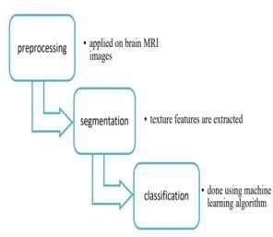

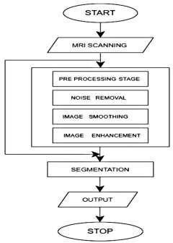

3.1. Image Acquisition

The image data that was used for this problem is brain MR images for brain tumor detection. It consists of MRI scans of two classes:

* No - no tumor, encoded as 0
* Yes - tumor encoded as 1

All images are in one folder with yes and no subfolders. I will split the data into train, Val and test folders which make it easier to work with the same dimension of images.

Table 1: Set of folders of images

|  |  |
| --- | --- |
| No. of Images | Folder Directory |
| 101 | Test |
| 501 | Train |
| 202 | Val |

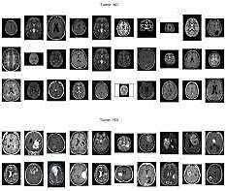

The images have different width and height and the different sizes of "black corners". Since the image size for the vgg-16 input layer is (224,224) some wide images may look weird after resizing. The first step of "normalization" would be to crop the brain out of the images.

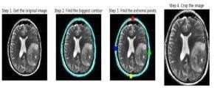

* 1. Preprocessing

Preprocessing is required because it provides an improvement in image data which reinforces a number of the image features which are important for further processing.

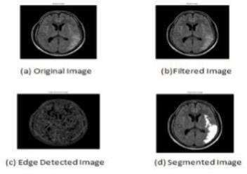

The pre-processing steps that are applied to the MR image are as follows: the RGB MR image is converted to gray scale image and then the median filter is applied for noise removal from brain MR images. The noise is to remove for further processing as high accuracy is needed. Then edges are detected from a filtered image using canny edge detection as shown. The edge detected image is needed for the segmentation of the image. The segmentation aims to change the representation of an image into something easier to analyze.

* 1. Image Segmentation

Image segmentation is a technique of segregating the image into many parts. The basic aim of this segregation is to make the images easy to analyze and interpret with preserving the quality. This technique is also used to trace the objects’ borders within the images. This technique labels the pixels according to their intensity and characteristics. Those parts represent the entire original image and acquire its characteristics such as intensity and similarity. The image segmentation technique is used to create contours of the body for clinical purposes. Segmentation is used in machine perception, malignant disease analysis, tissue volumes, anatomical and functional analyses, virtual reality visualization, and anomaly analysis, and object definition and detection.

Segmentation methods has ability to detect or identify the abnormal portion from the image which is useful for analyzing the size, volume, location, texture and shape of the extracted image. MR image segmentation with the aid of preserving the threshold information, which is convenient to identify the broken regions extra precisely. It was a trendy surmise that the objects that are placed in close propinquity might be sharing similar houses and characteristics.

* 1. Feature Extraction

a) Image-Based Features: The extraction of features based on the image data, potentially including intensity features, texture features, histogram-based features, and shape-based features; (b) Coordinate-Based Features: The extraction of features based on the registration to a standard coordinate system, potentially including coordinates features, spatial prior probabilities for structures or tissue types in the coordinate system, and local measures of anatomic variability within the coordinate system; (c) Registration- Based Features: The extraction of features based on known properties of the one or more aligned templates, potentially including features based on labeled regions in the template, image-based features at corresponding locations in the template, features derived from the warping field, and features derived from the use of the template's known line of symmetry.

3.5. Classification

Machine learning algorithms are used for the classification of MR brain images either as normal or abnormal. The major aim of ml algorithms is to automatically learn and make intelligent decisions the classification is done based on the below features:

1. Feature processing: before classification, the extracted feature set can be refined to make it more appropriate for achieving high classification accuracies:
2. Classifier training: pixels that are labeled as normal and abnormal are used with the extracted features to automatically learn a classification model that predicts labels based on the features;
3. Pixel classification: the learned classification model can then be used to predict the labels for pixels with unassigned labels, based on their extracted features;
4. Relaxation: since the learned classification model may be noisy, a relaxation of the classification results which takes into account dependencies in the labels (i.e. Classification) of neighboring pixels can be used to refine the classification predictions and yield a final segmentation. This CNN method requires only a small amount of training data to estimate the parameters which are needed for classification. The time taken for training and classification is less. This can extract useful attributes from trained weights by feeding data by levels and tune CNN for the specific task.

* 1. EXPECTED OUTPUT

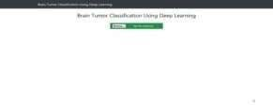

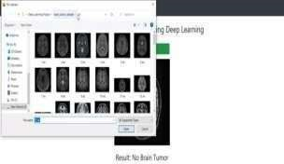

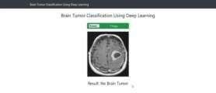

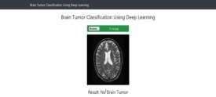

* 1. CONCLUSION

In this proposed work different medical images like MRI brain cancer images are taken for detecting tumor. The proposed approach for brain tumor detection supported convolution neural network categorizes into multi-layer perceptron neural network. The proposed approach utilizes a mixture of this neural network technique and consists of several steps including training the system, pre- processing, implementation of the tensor flow, classification. In the future, we'll take an outsized database and check out to offer more accuracy which can work on any sort of MRI brain tumor.

* 1. REFERENCES

[1]. Pankaj sapra, Rupinder pal Singh, Shivani Khurana, "brain tumor detection using neural network", international journal of science and modern engineering, ijisme, issn: 2319-6386, volume-1, issue9, August 2013.

[2]. Prachi gadpayleand, p.s. Mahajani, "detection and classification of brain tumor in MRI images ", international journal of emerging trends in electrical and electronics, ijetee – issn: 2320-9569, vol. 5, issue. 1, july-2013

[3]. Bakes.s., Reyes.m., menze, b.: identifying the best machine learning algorithms for brain tumor segmentation, progression assessment, and overall survival prediction in the Brats challenge. In: arxiv:1811.02629 (2018)

[4]. Bauer s., Nolte, Reyes.m, 2011. Fully automatic segmentation of brain tumor images using support

vector machine classification in combination with hierarchical conditional random field regularization. in miccai, pp. 354–361.

[5]. Prastawa m., Bullitt e., Greig, g., 2004. A brain tumor segmentation framework based on outlier detection.

Medical image analysis 8, 275–283.

[6]. Goodfellow, Warde-Farley, d., mirza, m., Courville,