**Machine Learning-Based Laptop Price Prediction**

Prof. J. S. Pawar, Rahul Jeswani, Satyam Sadhotra, Pranjal Dubey

*Department of Information Technology, Sinhgad College of Engineering, Pune*

**ABSTRACT**

This study aims to develop a forecast model for laptop costs using a number of factors, including CPU speed, memory, storage, screen size, brand, and other relevant components. The information for this study was gathered from several e-commerce websites and other relevant sources. By employing a range of statistical and machine learning approaches to discover the key factors that affect laptop costs, the study's goal is to build a prediction model for forecasting laptop pricing. The results of this study can assist customers and sellers in estimating a laptop's price based on features and other crucial factors.

**Keywords**- Machine Learning, Random Forest

**1. INTRODUCTION**

After 40 years of development since the introduction of laptops in 1984, laptops are now used for a wide range of activities such as business, education and leisure. Needless to say, modern people lead a mobile lifestyle, both at home and at work. Customers needed, and still need, the flexibility to access their computers from the kitchen table, office, or anywhere they needed a portable device.

device. While desktop PC sales are declining, laptop sales are increasing and are expected to continue to do so. Even before the outbreak, the laptop market segment was on a steady revenue growth trajectory from $132 billion in 2018 to $140 billion in 2020, according to Statista research. However, over the last three years, laptop sales have increased significantly due to increased demand for remote working, learning, and gaming. Comparing online and brick-and-mortar prices, the same laptop model can sometimes be found at surprisingly different prices, and the corresponding prices fluctuate wildly. If consumers are unaware of price changes, they will continue to overspend on inferior products. The team focused on this problem using the Kaggle dataset and successfully developed a random forest model for predicting laptop costs.

**2. RELATED WORK**

The task of predicting the price of a laptop in one of the Kaggle competitions has numerous approaches in current systems, combining common machine learning techniques with unique concepts such as: B. Neural network machine, logit transformation, residual regression. However, data analysis results suggest that the results of laptop price fluctuation prediction are not accurate enough. Due to the small sample size, the standard deviation of the results can be very high.

**3.RESEARCH METHODOLOGY**

Machine learning is the branch of artificial intelligence that deals with developing software that can predict the future based on past data. This article helps data science enthusiasts or practitioners start from scratch and build their own end-to-end machine learning projects. Building a machine learning project involves many processes, but not all of them need to be used in your project. It depends on the record.

**4. ARCHITECTURE**

Modeling

The modeling stage is a crucial step where we develop a predictive model to estimate laptop prices based on available features. Using insights from experimental data analysis and using appropriate modeling techniques, we aim to create an accurate and reliable price prediction model.

Choosing Model

The Random Forest algorithm proved to be a powerful and versatile tool for building a predictive model. It is an ensemble learning method that combines the strengths of multiple decision trees to make accurate predictions.

Website

Choosing Python to Create a Laptop Price Prediction Website

Python is an excellent choice for building a predictive web app because of its rich library ecosystem, simplicity, and versatility. Here are some key points to consider when choosing Python to build your predicting website laptop.

Flask Framework

Flask is a lightweight and flexible Python web framework that provides powerful tools for building web applications, including a laptop price prediction website. With Flask, you can create a user-friendly interface where users can enter laptop specifications and get predictions about the price of the laptop. Here are some key points to consider when building a laptop price prediction website using Flask.

Result

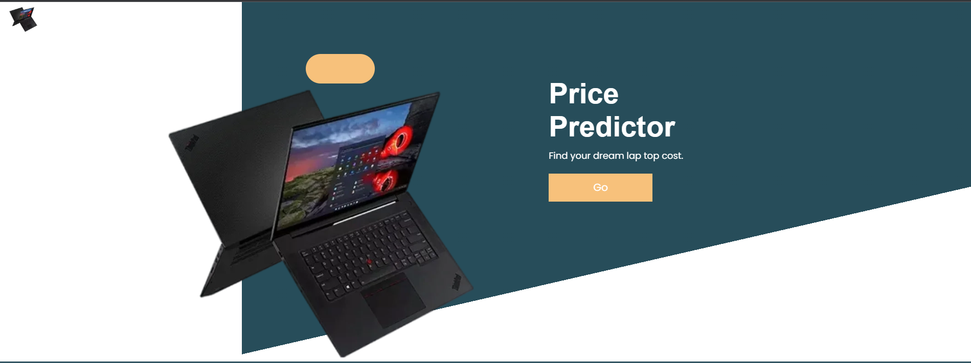

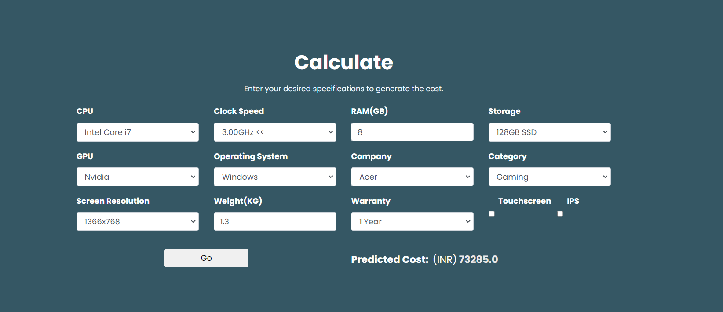

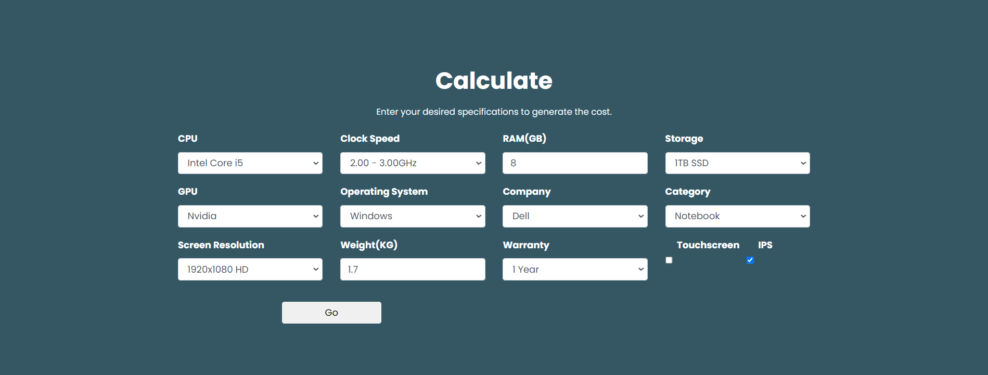

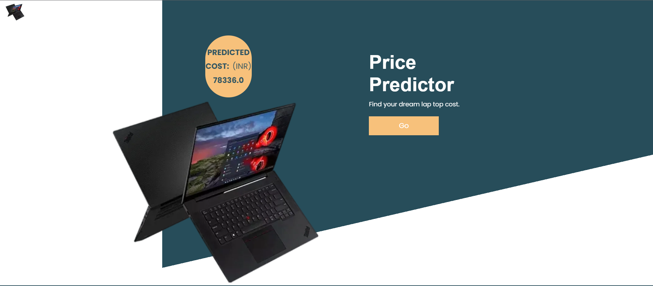

**5. RESULT ANALYSIS AND DISCUSSION**

To create a laptop price prediction website, the first step is to collect, clean up, and process data about laptop specifications and prices. Machine learning algorithms can be used to generate accurate predictive models for different laptop brands and types. The end result will be a website where users can enter laptop specifications and get an estimated price range based on available data. This type of platform is useful not only for consumers who want to make informed purchasing decisions, but also for manufacturers and retailers who need insight into pricing strategies and market trends. Ultimately, developing a laptop price prediction website will give you valuable information about the relationship between laptop specifications and market prices.

**6. FUTURE SCOPE AND CONCLUSION**

By adding more complex algorithms, expanding the database, and including user ratings, the laptop prediction site has a chance to grow. Laptop buyers may find this a useful tool.

**REFERENCES**

[1] International Journal of Computer Science and Mobile Computing. Laptop Price Prediction using Machine Learning.

[2] https://www.researchgate.net/publication/ 50946368_Exploratory_data_analysis_in_the_ context_of_data_mining_and_resampling.

[3] <https://www.academia.edu/69591584/Laptop_Price_Prediction_using_Machine_Learning>

[4] <https://medium.com/analytics-vidhya/laptop-price-prediction-by-machine-learning-7e1211bb96d1>

[5] <https://www.digitalocean.com/community/tutorials/how-to-make-a-web-application-using-flask-in-python-3>

[6] <https://www.kaggle.com/datasets/muhammetvarl/laptop-price>