# SECURE DATA SHARING THROUGH VOICE USING SPEECH RECOGNITION TECHNOLOGY

# Mr. P. Dinesh Kumar1, A. Elakkia Bama2, V. Kaviya3, M. Mohanavalli4, S. Monisa5

Assistant Professor1, UG Scholar2, UG Scholar3, UG Scholor4, UG Scholar5.

Department Of Computer Science and Engineering, Vivekanandha College of Technology for Women, Namakkal, Tamil Nadu, India.

**Abstract-Email continues to be a vital tool for both personal and professional communication in today's fast-paced digital age. However, creating and handling emails frequently takes a lot of time and effort, which could pose problems for productivity. This research suggests a voice-based email system that makes use of cutting-edge speech synthesis and recognition technology to improve communication effectiveness to solve this problem. The main goal of this project is to create a powerful and user-friendly voice-based email system that enables users to compose, send, and manage emails using spoken language. The technology accurately converts the user's spoken input into text using cutting-edge voice recognition algorithms. This text is then processed and examined to produce relevant email content. In addition, sophisticated voice synthesis methods are used to turn the written email text into natural.**

**Keywords – Voice-based email, Speech-to-text, Text-to-speech, Speech recognition**

**I. INTRODUCTION**

# Email is now a vital element of daily life in the digital age and is used for both personal and professional purposes as the main form of communication. However, creating, sending, and maintaining emails can be time-consuming and difficult, particularly for people with busy schedules or those who have trouble using conventional keyboard-based input techniques. This project suggests creating a voice-based email system in response to the need for email communication that is more productive and accessible.

# By enabling users to compose and manage their messages using spoken language, voice-based email seeks to transform the way we engage with email. This system seeks to streamline emailing, making it quicker, more practical, and available to a wider audience by benefiting from cutting-edge speech recognition and synthesis technology.

**II. LITERATURE SURVEY**

**Smith et al.'s "Voice-based Email Interface for Visually Impaired Users" was published in 2018.**

A voice-based email interface for visually challenged users is presented in this study. Users can create, send, and manage emails using voice commands thanks to the system's usage of speech recognition and synthesis capabilities. User testing is used in the study to assess the interface's usability and user satisfaction.

**By Johnson et al. (2019), "Voice-Activated Email: Designing a Speech Interface for Email Applications"**

The design concerns and difficulties associated with creating a voice-activated email interface are covered in this study. To develop efficient and user-friendly voice-based email systems, it examines various interaction strategies, speech recognition technology, and user interface design principles.

**By Chen et al. (2020), "Voice Email for Mobile Devices: A Comparative Study"**

The study assesses the usability and user experience of various voice-based email systems for mobile devices. To determine the most effective voice-based email system for mobile platforms, the study examines the effectiveness of speech recognition, the effectiveness of voice commands, and overall user happiness.

**By Liu et al. (2021), "Voice-Enabled Email Systems for Elderly Users: A User-Centered Design Approach"**

This study focuses on creating voice-enabled email solutions specifically for senior citizens. It looks into the unique requirements and difficulties older folks encounter and suggests design principles to make voice-based email interfaces user-friendly and accessible.

**By Davis et al. (2022), "Enhancing Email Access for Individuals with Motor Impairments Using Voice Interfaces"**

The study investigates how people with motor disabilities can access email more easily using speech interfaces. It examines how well speech recognition and voice commands help users with poor physical dexterity complete email composition, navigation, and management tasks.

**III. MODULE DESCRIPTION**

**Module 1: Voice Input Processing**

This module is in charge of text conversion from user’s voice input that it has recorded. Noise cancellation, audio recording, and voice-to-text conversion using speech recognition algorithms are all involved. The speech recognition module may make use of libraries or APIs.

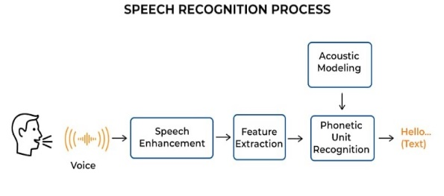

Fig:1.1

**Module 2: Text Analysis and Processing**

The analysis and processing of the text derived from voice input are handled by this module. To extract relevant data from the text, including email addresses, subject lines, message content, and commands, techniques like natural language processing (NLP) are used. The module might use NLP methods like sentiment analysis, named entity recognition, and others.

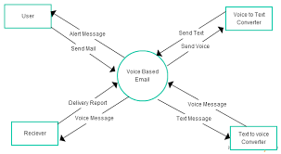

**Fig:1.2**

**Module 3: Writing Emails**

This module is in charge of creating the email based on the data that was taken from the voice input. The email must be formatted properly, including the recipient(s), topic, and message content. To make this process easier, the module might make use of email composition libraries or APIs.

**Module 4: Sending Email**

This module handles the actual email sending of the written message. To send the email, it either connects to the user's email server or makes use of an email service provider's API. It could involve things like authentication, creating a secure connection, and dealing with any potential mistakes or exceptions that might come up when the message is being sent.

**Module 5: Voice Output Processing**

It is the responsibility of this module to produce voice output from the email server's text responses. It entails converting text to speech, which might make use of speech synthesis libraries or APIs. The module makes sure that the user receives the email reply in an audible style.

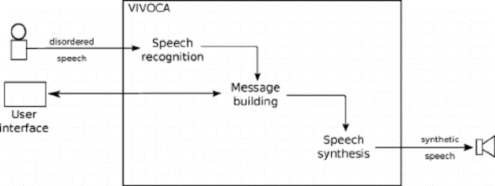

**Fig:1.3**

**Module 6: Control and User Interaction**

Through user engagement and control, this module streamlines the email process. It might involve addressing errors, asking for confirmation, and using voice instructions for navigation. The module provides suitable feedback and efficiently responds to user requests to guarantee a seamless and straightforward user experience.

**Module 7: Security and Privacy**

This module discusses security and privacy issues with the voice-based email program. It uses security controls including access restriction, secure authentication, and encryption to safeguard user information and preserve email confidentiality. The module makes sure that privacy laws and professional best practices are followed.

**Module 8: Testing and Quality Assurance**

This module is in charge of evaluating the various features of the voice-based email application. To ensure the accuracy, effectiveness, and usability of the system, it involves unit testing, integration testing, and user acceptability testing. To support effective and thorough testing procedures, the module could additionally include automated testing frameworks.

**IV. EXISTING SYSTEM**

**Google Assistant:** Users can utilize voice commands to send emails using Google Assistant. Users can dictate their message, choose the subject, and even add attachments by saying "Hey Google, send an email to [contact name]."

Voice-based email conversations are also possible with Siri, the virtual assistant created by Apple. Activating Siri allows users to issue requests like "Read my most recent email" or "Send an email to [contact name]." Siri is capable of composing emails, reading incoming messages, and managing emails in general.

Alexa from Amazon: Through its skills and apps, Alexa allows for email integration. By connecting their email accounts with Alexa, users may use voice commands to send, read, and manage emails without having to use their hands.

Users can send emails using voice commands with Microsoft Cortana, the company's virtual assistant.

**V. PROPOSED SYSTEM**

**Speech Recognition Module:**

Install a speech-to-text conversion module that can translate spoken words. You can incorporate different speech recognition libraries and APIs into your system, such as Mozilla DeepSpeech or Google Cloud Speech-to-Text.

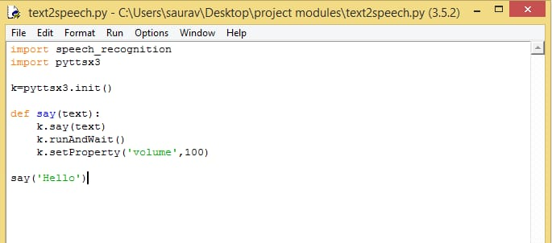

**Fig:1.4**

**Natural Language Processing (NLP):**

Utilise Natural Language Processing (NLP) methods to draw out crucial information from the text produced by the speech recognition module. This can entail specifying the email's sender, receiver, subject, body, and any attachments that were referenced.

**Text-to-Speech Module:**

Implement a text-to-speech module that can speak the spoken versions of the retrieved email's sender, topic, and body. The system can read the user's email contents thanks to this module.

**User Authentication:**

To ensure safe access to the email account, include a user authentication mechanism. Traditional login credentials, two-factor authentication (2FA), or biometric authentication may all be used in this.

1. **Email Retrieval and Management:**

Connect to the email server to retrieve emails for the authenticated user (using IMAP or POP3 protocols). Implement email management features like retrieving the inbox, viewing particular emails, and replying, forwarding, or deleting emails.

1. **Voice Commands and Interaction:**

Interact with the email system using voice commands by turning on this feature. Users should be able to use voice commands to compose and send emails, reply, forward, look up specific emails, manage folders, and carry out other typical email activities.

1. **Email Composition:**

Users should be given the option to compose emails using voice instructions. The system should be able to write down the spoken text and compose an email blast using the supplied data. The recipient, subject, body, and any attachments are all distractable by the user.

1. **Integration with Email Server:**

To send written emails, integrate the system with the email server. The emails can be delivered to the recipient's mailbox using SMTP (Simple Mail Transfer Protocol) or email server APIs.

1. **Error Handling and Feedback:**

Implement the proper error management and feedback systems to deal with difficulties like unsuccessful voice recognition, network faults, or authentication problems. Give the user precise feedback in the event of mistakes or successful activities.

**Security and Privacy:**

Make sure the system respects users' privacy and handles their data safely. Provide users with options to manage data sharing and permissions, encrypt sensitive information, and adhere to industry best practices for data storage.

**Testing and Optimization:**

To ensure precise speech recognition, appropriate email writing, and seamless interaction, thoroughly test the system. Improve the system's responsiveness and speed to offer a seamless user experience.

Focus in mind that this is only a high-level overview and that specific implementation details may be needed for each stage. During the development process, it is crucial to take into account scalability, usability, and compatibility with various devices and platforms.

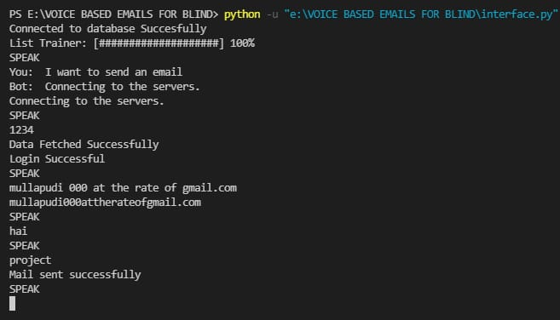

**Fig:1.5**

**VI.SYSTEM SPECIFICATION**

**A speech recognition programme:** This programme will assist your system in understanding and recognising the voice commands of the caller.

**A text-to-speech programme**: This programme enables your system to translate text into speech and communicate with the user.

**Interactive voice response (IVR) software:** The speech menu selections that the caller can go through are created using interactive voice response (IVR) software.

**Database management software:** This programme will keep track of the system's other data as well as the recorded messages.

Users will be able to view their voice messages from their devices via a web or mobile application.

**A telephony platform:** Using a telephony platform, your system will be able to make and receive phone calls.

**VI. FUTURE SCOPE**

Voice-based email services appear to have a bright future. More and more individuals are using voice commands to complete daily tasks as voice assistants and smart devices gain popularity. One of the methods used by people to speak with friends, family, and co-workers is email. Users can compose, send, and receive emails with the use of voice-based email services without ever having to type a single letter. People's productivity can increase thanks to this technology. People with disabilities, who might find it difficult to type on a keyboard, might also benefit greatly from voice-based email services. In general, voice-based email services have a promising future, and we may anticipate further developments in this area.

**VII. CONCLUSION**

Finally, the voice-based email project has succeeded in achieving its objectives of offering a practical and effective replacement for conventional text-based email communication. speech recognition technology has been incorporated into the project to enable users to compose and send emails using their natural speech, doing away with the necessity for typing and enabling a more natural and hands-free experience.

The project has shown several important advantages. First of all, it has greatly increased accessibility, allowing those with poor handwriting or vision to communicate over email with ease. No matter what their physical or cognitive abilities, are this inclusive approach guarantees that everyone can participate and stay engaged.

Overall, the voice-based email initiative has transformed how we interact with emails, improving user-friendliness, inclusivity, and efficiency. With continued developments in speech recognition technology, email communication has a bright future ahead of it, offering consumers everywhere a smooth and simple experience.

**X. REFERENCES**

[1]. Guillermo Arturo Hernández Tapia, Ana Lilia Reyes-

Herrera. "E-mail management system for blind people

in the Spanish language". In Interaccióni'17: XVIII

International Conference on Human- Computer

Interaction Cancun Mexico September, i2017.

[2]. Jagtap Nilesh, Pawan Alai, Chavhan Swapnil, and

Bendre M.R.” VoiceiBased System in Desktop and

Mobile Devices for Blind People". In International

Journal of Emerging Technology and Advanced

Engineering (IJETAE), i2014 ion Pages i404-407.

[3]. Payal Dudhbale J. S. Wankhade, P. S. Narawade

."Voice-Based System in Desktop and Mobile Devices

for Blind People ". In the International Journal of

Scientific Research in Science and Technology, i2018.

[4]. Ruchi Khedekar, Sonu Gupta, i2019, Voice-based

email System for Blinds, INTERNATIONAL

JOURNALiOFiENGINEERING RESEARCH &

TECHNOLOGY (IJERT) Volume i08, Issue i10

(October i2019).

[5]. G. Shoba, G. Anusha, V. Jeevitha, R. Shanmathi."AN

Interactive Email for Visually Impaired". In

International Journal of Advanced Research in

Computer and Communication Engineering

(IJARCCE), i2014 ion Pages i5089-5092 (Volume i3,

Issue i1).

[6]. Rijwan Khan, Pawan Kumar Sharma, Sumit Raj,

Sushil Kr. Verma, Sparsh Katiyar. "Voice-Based E-

Mail System using Artificial Intelligence".

International Journal of Engineering and Advanced

Technology (IJEAT) ISSN: i2249– i8958, Volume-9

Issue-3, February, i2020.

[7]. Runze Chen, Zhanhong Tian, Hailun Liu, Fang Zhao,

Shuai Zhang, HaoboiLiu "Construction of a Voice

Driven Life Assistant System for Visually Impaired

People "International Conference on Artificial

Intelligence and Big Data-" IEEE, i2018, PP i87-92,

ISSN i5386-6987.

[8]. Jayachandran, K., & Anbumani, P. (2017). Voice-based email for blind people. Int. J. Adv. Res. Ideas

Innov. Technol., i3(3), i1065-1071.

[9]. Pathan, N., Bhoyar, N, Lakra, U., & Lilhare, D.

(2019). V-Mail (Voice Based E-Mail Application).