SKIN DISEASE DETECTION USING DEEP LEARNING

SRINIDHI1 | THARUN KUMAR G2 | SRINIVAS N3 | RAHUL S4

Assistant Professor, Department of Computer Science and Engineering Students, Department of Computer Science and Engineering2,3,4

: Agni College of Engineering, Chennai, Tamil Nadu India.

ABSTRACT:The Skin Disease Detector website may discover external skin problems and offer treatments without ever contacting a doctor. Machine learning is used by this technology to find issues with the external body. This project was created with Keras and implemented in an app.py flask web application. The system is designed to be user-friendly and accessible, and the website is easily accessible.

KEYWORD: Flask, Keras, Machine Learning and NLP, Web application.

# 1.INTRODUCTION

Skin illness is a prevalent and difficult-todiagnose disorder as a result of ignorance and lack of understanding. In many poor countries, dermatologists are consulted for skin conditions and preventative measures. The current system is flawed, and the public is uncertain about the dermatologists' suggested treatments. Given that the skin serves as an essential line of defence for the body against harmful bacterial and fungal illnesses, the significance of treating skin issues at an early stage cannot be stressed. As a result of their genes, professions, poor food, regular settings, exposure to chemicals, etc., many people develop skin disorders. Climate, the summer season, and the winter season are a few instances of environmental elements that affect the presence of skin diseases. as a result, recognising and diagnosing skin diseases.

Therefore, due to its potential to deliver optimistic results quickly and the rise of smart phones, image processing-based sickness analysis is more in demand. Through the use of camera technology, individuals can contribute to the identification of the appropriate skin condition and the recommendation of a diagnosis. To solve this issue, the input analysis is carried out in two parts. While the second strategy trains the model using machine learning, the first technique trains the model using image processing. To anticipate various skin problems, this model is always being improved. The machine algorithm needs to be changed because each skin condition has a

different set of traits and sign. Early on, skin diseases are frequently disregarded and given little attention.

Ignorance on the part of certain people may aid in the growth of skin cancer. The elevated skin conditions are currently only identified afterwards, through biopsy. Numerous histopathological features are takeninto account throughout the manual inspection process. It takes 1-2 days to receive the biopsy results because the process is manual, which increases the chance of human mistake.

Additionally, defining the type of skin condition and the illness stage during the analysis stage can be difficult for the doctor. making it challenging to suggest a medication. By analysing the microscope image, machine learning and deep learning methods can be applied to solve this issue.

This proposed machine learning-based method might prove to be a useful instrument for quickly identifying clinical data and providing results. This approach, which integrates methods from computer vision and machine learning, could be fruitful. The model for image processing learns information about skin conditions from the microscope images. The image processing stage also involves preprocessing and feature extraction. Colour, texture, and feature share are a few of the features that are extracted and examined in the image processing model. The classifier model was then processed afterward. This classifier model predicts the benign, malignant, and normal categories of skin disorders.

# 2.LITERATURE SURVEY

A Method Of Skin Disease Detection Using Image Processing And Machine Learning by Nawal Solimon, In their approach, the authors suggested using input skin photos to identify skin lesions using medical imaging. They developed a prototype system to find skin diseases using approach. The goal of this research is to identify skin lesions using thresholding and computer vision to analyse the texture of input skin photos and detect and diagnose skin disease.

# Skin Disease Detection Using Computer Vision

And Machine Learning Technique by Leelavathy S, Jaichandran R, Shobana R, Vasudevan, Sreejith S Prasad and Nihad, In order to forecast the presence or absence of skin disease from a new input image, the userprovided input images are processed. An android application would be used to get the user's input image. In this system, based on the user's responses to a number of questions, the programme will forecast the disease kind. Finally, the suggested system, based on the skin disease trained model, suggests medical descriptions, operations, and pharmaceuticals. This study analyses skin conditions such eczema, fungus infection, and urticaria. Using CNN occasionally doesn't yield promising results for this question-and-answer application.

Skin disease diagnosis Matlab usage by smail Many different types of skin disorders are anticipated by Saif Sulaiman Al Shabibi, who offers users the option to upload skin photo images for analysis in order to identify the presence or absence of specific skin conditions.

This recommended approach employed a

Matlab code to identify several sorts of skin disorders, such as normal, melanoma, psoriasis, or dermo instances, based on the attributes recovered from the extracted photos. This technology would send a notification to the closest medical staff in the event of any anomaly. The segmentation issues in this methodology lower the classification model's accuracy.

Intelligent System for Skin Disease Prediction using Machine Learning Ahmed A. Elngar, Rishabh Kumar, Amber Hayat, Prathamesh Churi briefly discusses the relevance of skin illness given that skin conditions are currently the most prevalent due to the rise in skin allergies brought on by environmental factors. Both image processing and data mining strategies have been proposed in this study. Matlab is used to perform the experimental results. The dataset is used to get the input photos.

# 3.OPPORTUNITIES

The purpose of this project is to use virtual consultation to obtain the appropriate drug at the appropriate dosage for external diseases, particularly skin conditions.

This website, which uses the most accurate auto-skin illness detection technology, encourages individuals to stay at home during pandemics caused by such benign ailments. In fact, it is very difficult to schedule a doctor's appointment during the COVID-19 Pandemic, which increases the severity of the skin illness. This aids those who are hesitant to seek medical attention before their illness worsens. Because the illness is recognised and treated without involving humans.

# 4.METHODOLOGIES

The main goal of this project is to predict the disease with accuracy. This uses Flask, edge_app, pred_at_edge, time, cv2, numpy, inference to identify the right condition.

The project is divided into 3 modules :-

# Get the image as input

The first step is getting the image that the patient wants to diagnose. The visual must be distinct. The image is inspected and configured to discover matches using CV2. The following should be considered by users before using this online application.

# Getting diagnosed

The image that matches the source photos the closest is used as a reference, and using pred_at_edge and time the severity of the infection or sickness is projected in the following step.

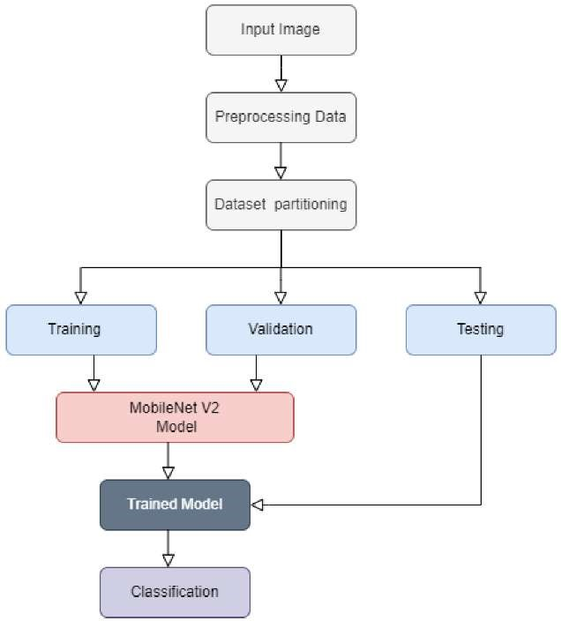

3. Finding the accuracy.

All depends on the project now that it is in its key stage. Now accuracy testing is being applied to the image that was matched with the reference image. In order to calculate the severity in an exact proportion, Numpy, an open source Python module, is employed. Then, inference is utilised to compare many logistic data points of the same sickness or infection and analyse them cumulatively to make a diagnosis with 100 percent accuracy.

# 6.ACKNOWLEDGEMENT

We are thankful to Mrs. Srinidhi, CSE Department, Dr. L Sharmila, HOD-CSE, Agni College of Technology,OMR,Chennai for providing the support for this work.

# 7.REFERENCE

1. Arifin, S., Kibria, G., Firoze, A., Amini, A., & Yan, H. (2012) “Dermatological Disease Diagnosis Using Color-Skin Images.”

Xian: International Conference on

Machine Learning and Cybernetics

1. Yasir, R., Rahman, A., & Ahmed, N. (2014) “Dermatological Disease Detection using Image Processing and Artificial Neural Network. “Dhaka: International Conference on Electrical and Computer

Engineering

1. Santy, A., & Joseph, R. (2015) “Segmentation Methods for Computer Aided Melanoma

Detection.” Global Conference on CommunicationTechnologies.

1. Zeljkovic, V., Druzgalski, C., BojicMinic, S., Tameze, C., & Mayorga, P. (2015) “ Supplemental Melanoma Diagnosis for Darker Skin Complexion Gradients.” Pan American Health Care Exchanges

1. Suganya R. (2016) “An Automated

Computer Aided Diagnosis of Skin

Lesions Detection and Classification

Dermoscopy Images.” International

Conference on Recent Trends in

Information Technology

1. Alam, N., Munia, T., Tavakolian, K.,

Vasefi, V., MacKinnon, N., & Fazel-

Rezai, R. (2016) “Automatic Detection and Severity Measurement of Eczema Using

Image Processing.” IEEE

1. Kumar, V., Kumar, S., & Saboo, V. (2016) “Dermatological Disease Detection Using Image Processing and Machine Learning.” IEEE