Biomass – A Futuristic Biofuel

Jai Shiv1

*1Student, Department of* *Mechanical Engineering, JSS Academy of Technical Education, Noida, India*

***Abstract*: The present study endeavours to conduct a functional analysis of biomass as a renewable energy source. The research seeks to create a broader understanding of the sources and energy conversion processes of biomass. The study specifically delves into the use of briquettes and pellets as a form of biomass fuel. Several key parameters related to the characteristics and performance of biomass were examined, based on a case study of the LEAF BIOFUELS company. The investigation provides detailed insights into the raw materials and products employed by the firm. The study's overarching objective is to demonstrate the advantages of utilizing biomass as a sustainable alternative to traditional fossil fuels. The research further explores the potential pathways and production techniques for converting biomass into obsolete fossil fuels.**

***Keywords*: Biomass & Biofuels, Briquettes & Pallets**

# **Introduction**

Whenever we talk about the fuels whether solid or liquid, the detrimental properties to the environment are always worrisome and kept into considerations. Most of the global energy supply has been catered by outdated fossil fuels like coal, gas, and crude oil. Rightful requirement of fossil fuels has been soaring abundantly because of escalated energy generation, industrialization, and transportation where coal being the vital fuel for energy generation and crude oil (gasoline, petroleum, and diesel) for industrial and transportation fuel. Also blistering utilization of these fuels have limits the source and high greenhouse gas emission due to which people have great need of renewable and green sources for energy generation. But today’s technology driven contemporary era provides the solution by the name biofuel and biomass. Biofuels and biomass have gained appreciable awareness due to renewable and eco-friendly nature. Biomass is nothing but the naturally obtained solid fuel such as wood, manure, organic waste, grass cuttings, rice, and mustard husk etc which can also be amended for betterment via heavy machinery by mixture of more organically obtained substances while alcohols biofuels, bio diesel are alternates for the bio fuels in liquid state which will replace spark and compression ignition engines whereas bio gas going to replace LPG’s successfully in the future.

# **Fossil Fuels**

Fossil fuels are non-renewable flammable hydrocarbon compounds derived from the remains of dead plants and animals that naturally formed within the earth's crust over extended periods of time. Coal, natural gas, and crude oil are the primary fossil fuels utilized as energy sources. The extraction of fossil fuels involves several steps, including exploration, extraction, processing, and refining. After combustion, energy is generated in the form of heat and electricity for commercial power plants. During combustion, carbon and hydrogen atoms in fossil fuels react with oxygen in the air to form carbon dioxide, water, and heat, which can then be converted into electrical energy using turbines or generators.

Fossil fuels accounted for 84% of primary energy consumption and 64% of global electricity production in 2019. However, large-scale burning of fossil fuels has caused significant environmental damage, with over 80% of human-generated carbon dioxide emissions resulting from the burning of these fuels. Annually, around 35 billion tonnes of CO2 are produced from the combustion of fossil fuels, posing a significant threat to the environment.

1. ***Biofuels & Biomass***

***Biofuels***  
Biofuels refer to renewable fuels generated from biomass, and the term biofuel is typically restricted to liquid or gaseous fuels that are employed for transportation purposes. (Biofuel, 2022)  
Biofuels are categorized into various generations based on their sources and production methods. First-generation biofuels, which include bio-diesel and bio-ethanol, are produced from crops such as grains, seeds, and sugar crops. Second-generation biofuels, including bio methanol, biogas, and bio-hydrogen, are produced from lignocellulosis materials. Third-generation biofuels, such as vegetable oils produced from algae, are derived from non-food biomass sources. (RóbertMagda,2020)  
The current global energy demand is approximately 4000 M.toe (Million Tonne) in oil equivalent, while the global production of biofuels, representing less than 1% of this demand, is only 36 M.toe. The major producers of liquid biofuels are Brazil and the USA, producing bio-ethanol, while Europe is the main producer of bio-diesel, accounting for 85% of the world's total biofuel production. (Liquid Biofuels for Transport Prospects, risks, and opportunities, 2022)

***Biomass***

Biomass is an organic solid fuel that is renewable and sustainable, typically derived from plant waste for the purpose of generating various forms of energy. It is a form of bio-energy that utilizes bio-based feed-stocks, and has the potential to increase the resilience of rural industries by generating revenue from waste streams while also mitigating carbon emissions by replacing fossil fuels. Biomass is primarily used as a raw organic material to produce energy in the form of electricity, heat, or other forms. The raw materials used for biomass include wood waste such as sawdust, wood chips, and lumber, crop waste such as rice husks, mustard, corn, sugar cane, and soybeans, animal manure, biogenic materials, and food waste. (Bioenergy HOLDINGS LLC, 2022)  
Biomass comprises organic matter that is non-fossilized and biodegradable in nature, originating from a variety of sources such as plants, animals, and byproduct residues from agricultural, municipal, and industrial waste. The utilization of biomass is becoming increasingly significant as a source of heat, electricity, and other forms of power. As of 2021, the United States' primary energy consumption from biomass was 4.8 quadrillion British thermal units, representing 5% of the total energy consumption. Of this total, 48% was derived from biofuels, primarily ethanol, while 43% was obtained from wood and its derivatives. The remaining 9% was sourced from animal manure, municipal waste, and agricultural by-products.

(Biomass explained, 2022)

The utilization of densified biomass as a fuel has gained significant popularity in many developing and developed countries. In Europe, countries such as Sweden, France, Austria, Switzerland, and Germany utilize small-scale biomass heating systems that combust pallets as fuel. In Brazil, briquettes are employed as substitutes for firewood in bakeries, pizzerias, food establishments, and factories with wood ovens, such as red brick factories. Nonetheless, the use of biomass briquetting has not yet fully spread in most countries, as this sector relies on the availability of a briquette market, suitable technologies, and waste availability.

1. ***Sources of Biomass***

FOREST RESIDUE

Forest biomass feed-stocks typically include sawdust from furniture mills, wood chips, lumber, and firewood. Woody debris from dead, diseased, and poorly formed trees left in forests can also be utilized for biomass generation. The excessive leftover wood biomass can be harvested, which not only reduces the risk of fire and pests but also promotes forest restoration and vitality. By doing so, bio-energy can be produced without negatively impacting the ecological functionality, health, and stability of the forest.

AGRICULTURAL FEED STOCKS

Agricultural feed stocks can be of two types namely food crops and non-food crops. The food crops are those crops grown with the intention of direct consumption by humans such as rice, wheat, Sugarcane, maize, barley, mustard. These crops grown in cultivating land can be in the form of stalks, leaves, husks, and cobs also known as stover while non-food crops are those crops grown for industrial or commercial purpose and are not used directly such as tobacco, cotton, tea, coffee. Non-food crops are further classified to herbaceous and woody based on the nature of the crop.

The utilization of feed-stocks for bio-energy can be classified into two categories: food crops and non-food crops. Food crops are those that are intentionally grown for direct human consumption, such as rice, wheat, sugarcane, maize, barley, and mustard. These crops are typically grown on arable land and their byproducts, such as stalks, leaves, husks, and cobs, are commonly referred to as stover. Non-food crops, on the other hand, are grown for industrial or commercial purposes and are not used directly for human consumption. Examples of non-food crops include tobacco, cotton, tea, and coffee. Non-food crops can be further classified as either herbaceous or woody based on the nature of the crop.

ALGAE

Algae are considered as promising feed-stocks for bio-energy and are a heterogeneous group of photosynthetic organisms that comprise macro-algae, micro-algae, and cyanobacteria. These organisms utilize solar energy along with essential nutrients like carbohydrates, proteins, and lipids to produce biomass. Algae cultivation can be carried out in diverse conditions, including fresh or saline water, and can be cultivated on various waste substrates, including industrial, agricultural, or municipal wastewater. (Biomass Resources, n.d.)

 BIOGENICAL MATERIAL/ MUNICIPAL WASTE

  Municipal waste, also known as urban solid waste, comprises a heterogeneous mixture of organic and inorganic materials, including paper, plastics, yard waste, rubber, leather, and food waste. These waste materials can be utilized as a potential feed-stock for bio-energy production, thereby reducing the amount of waste directed to landfills and promoting a circular economy.

WET WASTE   
   Wet waste feed-stocks refer to organic waste streams, which include a variety of commercial, institutional, and residential food wastes, bio solids derived from municipal wastewater treatment, manure slurry from concentrated animal feeding operations, and organic waste from industrial operations. These feed-stocks can be converted into energy, which can provide additional income for rural communities while also addressing waste management challenges. Furthermore, biogas generated from these waste streams can be utilized for energy production, adding value to the waste-to-energy conversion process. (Biomass Resources, n.d.)

1. ***Converting process from Biomass to Energy***

There are generally four ways to convert Biomass to energy. These are direct combustion, thermo-chemical conversion, chemical conversion, and biological conversion.

a) Direct Conversion is the basic usual method for converting biomass to heat energy. Raw Material in this conversion compress to small pallet and briquettes then are burned directly for commercial or industrial purposes for producing heat or electricity for steam turbines.

b) Chemical conversion process which is also known as transesterification of fatty acid methyl esters (FAME) obtained from vegetable oils, animal fats and greases to bio diesel for producing energy.

c) Biological conversion includes conversion of biomass into *[ethanol](https://www.eia.gov/energyexplained/biofuels/ethanol.php)* to produce natural gas by fermentation process. Ethanol is used as an automobile fuel while natural gas such as bio gas used in residential as well as commercial purpose. This biological waste can be easily obtained from solid waste landfills. (Biomass explained, 2022)

d) Thermochemical conversion includes pyrolysis and gasification and both are thermally decomposed in which raw material is heated in closed highly pressurized containers known as gasifiers at a very high temperature. The only difference occurs in the presence of their temperature process and amount of oxygen during conversion.

1. **Literature Review**

In a new contemporary and thoughtful era where pollution, depletion of coal and its cost being a neuralgia to the mankind, biomass is an alternate solution which is 3 times less costly and 2 times less polluting from making use of the product when compared to fossil fuel like coal. This biomass briquettes are acting as revolution in making developing countries and boosting economy slowly as no humongous cost spend over heaving machinery and labour for mining and these biomasses are made from waste and left out products as well.

It has been noticed that the general calorific value of fossil fuels is twice as compared to biomass, but that is certainly achievable for biomass after amendments to various parameters like moisture content, creating mixtures of different feed stock (saw dust), adding binders, carbon fixation, granulometry etc. as required.

A case study at industry provides rough idea of machinery, raw material, and product used along with a lab report of their product quality.

To reiterate, this investigation research paper summarizes about the biomass (briquettes and pallets), betterment of biomass over fossil fuel (coal), procedure of making biomass, a case study of an industry and effects of different parameters on a biomass.

**Briquettes and Pallets as Biomass**

***BRIQUETTES***

A Briquette (derives from french word brique means brick) is a wad into blocks of combustible material made of husks, charcoal, sawdust, peat, agricultural and animal waste etc. for fueling either small fire or large industries. (Briquette, 2022)

Briquetting as a compaction technology is well known for us. In the old era, fine pieces were passed from two counter-rotating wheels with the help of screw or gravity feeders. With high hydraulic pressure the rotating wheels compress the feed stock to form briquettes. (Briquetting, 10 December 2013.)

Briquetting does not always require binders but to hold them for transportation, briquetting them and for storage and the most common once are molasses, starch and tar pitch.

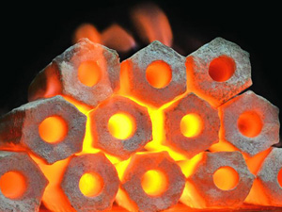

Fig.1 Briquettes

Coal briquetting is mostly produced as briquettes for a long time as they are easily available from finely broken pieces from the mining process otherwise these are very difficult to burn as they require adequate airflow. Culm bombs were the first briquettes which were hand molded and used wet clay as a binder but was very inefficient as the unburned clay used as binder provides larger ash content, thus blocking the airflow. The agglomeration of coal is the traditional application for briquetting as most of the crops are seasonal and require storage throughout the year. (Briquette, 2022)

***PALLETS***

Pallets are intense compression of organic matter as biomass at a smaller level through agricultural, animal, and industrial waste. This densified palletization of feed-stock used a wide range of materials for power generation. Also, pallets of high density promote compact storage for transportation over longer distances. As pallets are extremely dense, they facilitate low moisture content which provides high combustion efficiency while burning. Pallets and Briquettes both are very similar in composition, they only differ by granulometry as pallets are smaller in size and briquettes are larger in size

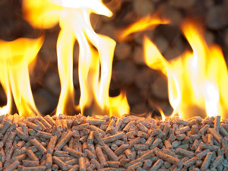

Fig.2 Pallets

**3. A Case study at LEAF BIOFUELS**

A **Leaf Biofuels** is a firm that offers coal alternatives made from processing Bio agricultural waste. Leaf biofuels help farmers as well as industries to grow together and make the nation a better place by discarding conservative carbon fuels made from fossils, making the environment cleaner and greener at an effective cost.

They are manufacturers of briquettes and pallets made from agricultural waste especially mustard, husk and saw dust, also providing financial aid to farmers.

The out product they receive as briquettes and pallets are highly combustible and provide a calorific value close to coal at a 3.5 times cheaper rate than coal.

The company is currently located in bayana district of Rajasthan and soon will expand its branch in the district of Madhya Pradesh. The Plant Capacity of Bayana is 45 Metric Ton/Day and runs 24/7 mostly.

As per the location, they depend on mustard farming so at the end of season they have tonnes of buffer storage of mustard husk that they can hold for a year. At Leaf Biofuels they have **Pneumatic Separator** that separates the raw material from unwanted stone, pebbles, poly waste, mud etc., **Hammer Mill Grinder** that grinds the filtered material and makes a well bonded product which increases density. **Biomass Briquetting Machine** which densifies the grinded filtered material by pressing and compaction to briquettes logs. All the main machinery of leaf biofuel is from **Lehra Machines** they made different kinds of Briquetting machines as well as separators, grinders, and other related machines.

1. **Process of Making Briquettes at Leaf Biofuels**

Step1. Raw Material

Different types of raw material such as charcoal, sawdust, peat, agricultural and animal waste etc. is collected to the storage house to produce these Biomasses.

Step 2. Filter

The raw material is pass-on for the filtration process in which raw material is separated from impurities (sand, stones).

For this process, material is placed on the conveyor belt by man which passes toward the cyclone chamber which sucks all the raw material including sand particles and the large impurities left like stones and pebbles are separated out from it. After that, a fan attached to cyclone chamber removes all the fine dust/sand particles and the raw material is then left filtered.

Step 3. Drying

The material after filtration is almost dried and passed on for crushing but if the material is wet then it is left for drying. After Drying sometimes raw material is also placed for buffer storage.

Step 4. Crushing

As per the desired product the raw material passed on for various small process like chopping, grinding, shredding & sieving. For Instance, if we need pallets of 20mm dia. then the material is finely crushed and for briquettes of 90- 100 mm dia. then material pieces left big.

The size of the material for larger diameter briquettes is large and keeps on decreasing as the size of the briquettes/ pallets decreases. As per the need, raw material is mixed with additional binding chemicals for better solid shape of the out product.

Step 5. Densification

After drying and crushing, the material passed to the biomass Briquetting machine for required briquettes and pallets through pressing and compaction.

For this process, after crushing material passed through conveyor belt which leads it to keep warram which leads the material in twisted motion towards die set, the material is then shaped in cylindrical logs using high force exerted by a piston which is driven by motor and crank mechanism.

Step 6. Briquettes/pallets

The briquettes and pallets received as out product left for cooling. Then, briquettes and pallets are passed for the carbonization process as per the need and requirement.

Step 7. Packaging

Then the briquettes/ pallets are cut to desired size and packed for delivering to required consumers/industries also stored in bulk for shipment and use.

1. **Machines used at Leaf Biofuels**

Machinery used at Leaf Biofuel was of high end from Lehra’s. They used a pneumatic separator and a Briquetting machine.

PNEUMATIC SEPARATOR

Pneumatic separator separates out the fine sand granules and dust particles from the feed stock. By the help of cyclone and fan fine dust particles are sucked up in the atmosphere and filtered input is passed on by conveyor towards Briquetting Machine.

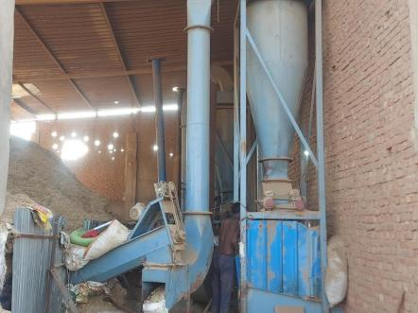

Fig. 3 Pneumatic Separator at Leaf Biofuels

Motor used in Pneumatic Separator

1. Conveyor - 3 HP
2. Cyclone - 3 HP
3. Fan - 7.5 HP

BRIQUETTING MACHINE

A Briquetting machine at Lehra’s comes in various size categories like 100mm, 90mm,80mm etc. as per by-product radius. The machine used at Leaf Biofuels is the **Lehra Briquette Press LBP 90 (1500/2000 kg/hr)** also known as Jumbo 90. This machine is used in large setup factories where the raw material capacity is high. Moreover, the production Capacity of LBP 90 Briquette Machines is 2000kg/hr with 69/86 HP is the best in Industry.

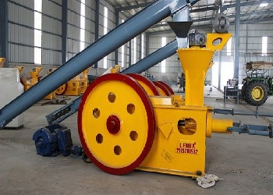

Fig. 4 Briquetting Machine at Leaf Biofuels (Source: Lehra Machinery)

Main features of LBP 90

* Robust structure with a commonly used design.
* Does not require Hammer Mill Grinder, accept up to 20 mm feed stock.
* Maximum production when compared with other industrial machinery.
* Easy and effective system for operating activities for up to 90mm Briquettes.
* Fine finishing with high density.
* Least expenditure on production & Maintenance.

Motor used in Briquetting Machine

1. Oil Pump - 1 HP
2. Main Motor - 75 HP
3. Keep Warram /Feed Input - 7.5 HP
4. Machine Conveyor - 3 HP

Oil Filter stored in a tank has the capacity of 60 Ltr and lasts up to 8-10 Days. It helps in cooling down the machine consisting of 2 pipes, one is reverse pipe which carries warm oil of the machine and other is forward pipe for passing fresh cool oil. Close to this filter is an Oil meter which enlightens us about the temperature and pressure passed towards the machine.

1. **Raw Material**

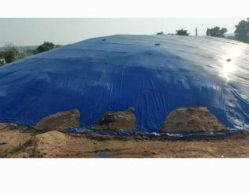 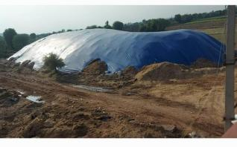

Fig.5 Feed Stock storage

**[Overall, briquettes](http://lehragroup.com/briquette-press.html) are the solution over coal and all the coal fueled power plants available in the world are the best platform for briquettes. Moreover, beside power plants briquettes can be used in small scale utilization such as:**

* For steam generation and heating of Boilers in the chemical plants and Sugar and paper mills. Also in cement, food processing and oil extraction units etc.
* For forging and furnacing metal scrap.
* Brick Kilns underneath for making bricks.
* Residential purpose mainly in winter for heating.

The mustard husk and the saw dust are the agricultural and forest waste used as feed stock for Biomass Briquetting at Leaf Biofuels.

**4. Results & Outcomes**

**COMPARISION OF BIOMASS WITH FOSSIL FUELS (COAL)**

|  |  |
| --- | --- |
| **BIOMASS** | **FOSSIL FUEL (COAL)** |
| Biomass is a solid fuel produced from organic matter. | Fossil fuel is a naturally occurring fuel formed from geographical processes. |
| Biomasses are obtained from renewable sources. | Fossil fuels are obtained mainly from non- renewable sources. |
| Emits a low number of unfavorable gases and causes less pollution than fossil fuel when burnt. | Emits a high number of unfavorable gases and plays a major role in environmental pollution when burnt. |
| Growing state of industry as it is cheaper than fossil fuel | Declining state of industry as fossils are on verge of extinction. |
| Energy generation is low. | Energy generation is comparatively high. |
| Can be produced from safer methods. | Obtained from unsafe methods such as drilling and milling. |

Comparison of Biomass with Fossil Fuels (Coal)

|  |  |
| --- | --- |
| **BIOMASS BRIQUETTE** | **CALORIFIC VALUE (cal/g)** |
| COCONUT HUSKS | 5267 |
| RICE HUSKS | 3350 |
| COFFEE HUSKS | 4045 |
| WOODY CHARCOAL | *3158* |
| COAL(CARBONIZED) | 6158 |
| SAW DUST | 4247 |

CalCorific Value of Different Feed Stocks (Source: (Sri Suryaningsih, May 2017)

|  |  |  |
| --- | --- | --- |
| **COMBUSTION PROPERTIES** | **BIOMASS BRIQUETTE** | **FOSSIL FUEL (COAL)** |
| GROSS CALORIFIC VALUE | 18.9 | 25.9 |
| SPECIFIC GRAVITY | 0.71 | 0.86 |
| CARBON W/W% | 22.5 | 61.2 |
| HYDROGEN W/W% | 0.71 | 4.3 |
| OXYGEN W/W% | 43.8 | 7.4 |
| SULPHUR W/W% | 0.0020 | 3.9 |
| NITROGEN W/W% | 0.0010 | 1.2 |
| ASH W/W% | 28.4 | 12.0 |
| WATER W/W% | 10.9 | 10.0 |
| CARBON DIOXIDE: VOLUME% | 19.7 | 15.0 |
| OXYGEN: VOLUME% | 13.4 | 3.7 |
| %EXCESS AIR | 12.8 | 20.0 |

Comparison of Combustion Properties of Biomass and Fossil Fuels (Coal) (source: (Tsietsi Jefrey Pilusa, November 2013))

**Latest Lab Report of Sample Testing of Leaf Biofuels By AETRL**

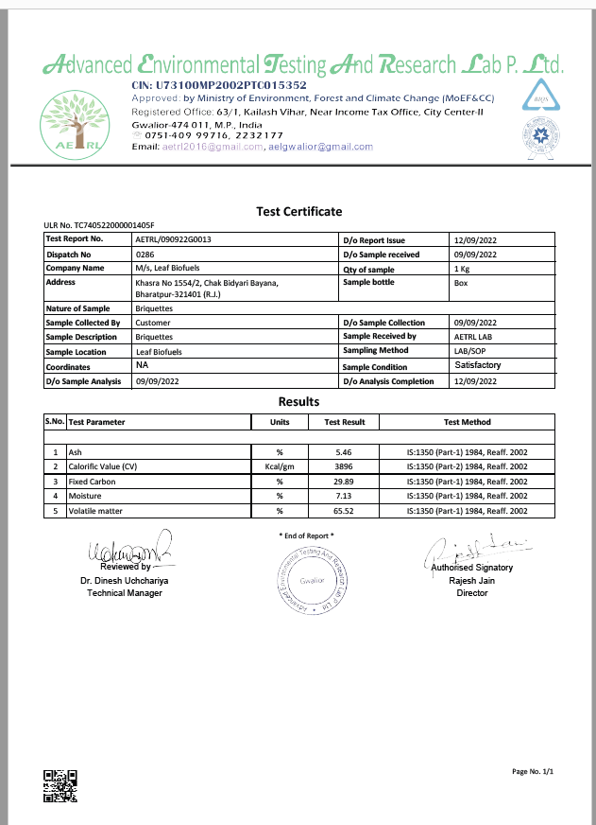

**Main Parameters of Briquette Production in Academic Works**

To obtain the desired characteristics for briquettes and pallets, various briquetting parameters are used, which also variates according to the process of production applied. Table below illustrates some work found in literature and researche, whose content is the briquetting parameters used and their respective authors.

It is easily observed that granulometry (refers to size of biomass particles to compose briquettes), moisture content and pressure are the most associated process/input variable among the research analyzed, which is 9 out of 11 studies, equivalent to around 80% of the studies, giving it uniformity.

The temperature, compaction time and binders registered in the production of the briquettes was also widely explored, being one of the vital parameters associated with the briquetting. This variable was studied in 5-6 studies, corresponding approx. to 50% of these. The fraction of binder incorporated in the briquettes was present in 5 of the studies analysed and worth mentioning that moisture in the production of briquettes is important to activate some binders, such as starch, helping in the densification process [14].

Subsequently, the types of biomasses of the raw material at the initial stage was the next input variable with the highest occurrence among the surveys, being present in 4 of them.

Finally, the compaction speed, % biomass and the cooling time of the briquettes after their production were the parameters with the lowest number of occurrences among the studies explored. Its frequency was in 2 and 3 works, respectively. This does not mean that these variables are less important for the briquetting process, or for the final properties of solid fuel. For Chungcharoen and Srisang [18], speed was the variable with the greatest effect on the rate of production of their briquettes. While the cooling time was necessary for processes involving heating in the production of briquettes [13,15].

Based on the occurrence between the works, it is observed that the most used input parameters to produce briquettes are the material granulometry, compaction pressure, moisture content of raw material before briquetting, pressing time of the briquettes during its production, presence of binder, the proportion of biomass mixture and briquetting temperature.

Since the production of briquettes consists of the densification of loose particles of solid material in high-density fuel [12], it is necessary that operational factors must be defined for production of briquettes like pressure, temperature, and compaction time. Loose particles being vital parameters, biomass must be in the form of loose particle, preferably classified as per size and distribution for densification process [13,17].

Another crucial parameter of the material needs to be controlled before briquetting is the moisture content. This parameter provides the advantage of smooth densification, without compromising the physical properties of briquettes [18].

The presence of another vital factor, binder, adhere to the biomass particles and it can be added to the material [14]. The binder can be triggered through other variables, like addition of heat and pressure along time of briquettes production [19]. Also, pressure densifies the biomass, influencing the soar in density as well as strength to solid fuel [16].

|  |  |  |  |  |  |  |  |  |  |  |
| --- | --- | --- | --- | --- | --- | --- | --- | --- | --- | --- |
| **Researchers** | **Temperature** | **Compaction Time** | **Cooling Time** | **Pressure** | **Granulometry** | **% Biomass** | **Types of Biomasses** | **Binder** | **Compaction Speed** | **Moisture Content** |
| 12 |  | X |  | X | X |  |  | X |  |  |
| 13 | X | X | X | X | X | X | X |  |  | X |
| 14 |  |  |  | X |  |  |  | X |  | X |
| 15 | X | X | X | X | X |  | X |  |  | X |
| 16 |  | X |  | X | X |  |  |  |  | X |
| 17 | X |  |  | X | X |  |  |  |  | X |
| 18 |  |  |  |  | X | X |  | X | X | X |
| 19 | X | X |  | X |  |  | X | X | X | X |
| 20 | X |  |  | X |  |  |  | X |  |  |
| Occurrence | 5 | 5 | 2 | 8 | 6 | 2 | 3 | 5 | 2 | 7 |
| Percentage | 55% | 55% | 22% | 89% | 67% | 22% | 33% | 55% | 22% | 78% |

Study Performed on various Parameters by Researchers

**CONCLUSION**

In this fast-moving new era, one side we are using highly expensive and harmful fuel while on the other hand we have an alternate better fuel in the name of biomass which is totally cheap, eco-friendly yet effective. These highly potential solid fuels by densification promote a noble destination by using agricultural and forest waste. After the review of literatures of knowledgeable authors and the analysis of input and output variables briquetting process, it is noticed that,

* The input variables that were studied most often were: particle size of biomass (95%), compaction pressure (73%), moisture content of the raw material (68%), compaction time (59%), proportion of binder (50%), proportion of biomass to compose the briquettes (45%) and temperature (32%);
* The response variables most used to classify the briquettes were: higher calorific value, moisture content, ash content, density, and resistance to compression. The input variables most studied were: particle size of biomass (95%), compaction pressure.

From a case study it has been noted that different machinery provides various variations on out product as well as distinct categories of feed stock providing different quality (calorific value) and efficiency of biomass briquettes.

**References**

1. *Biofuel*. (2022, september 24). Retrieved from wikipedia: <https://en.wikipedia.org/wiki/Biofuel>
2. RóbertMagda, S. J. (2020, Novemveer 13). *Bio-Economy and Agri-production* (Vols. Chapter-7). (C. A. Dionysis Bochtis, Ed.) doi:10.1016/B978-0-12-819774-5.00007-2
3. *Liquid Biofuels for Transpert Prospects, risks and opportunities*. (2022, April 5). Retrieved from GreenFacts: Facts on health and the Environment: <https://www.greenfacts.org/en/biofuels/l-2/1-definition.htm>
4. *Bioenergy HOLDINGS LLC*. (2022). Retrieved from ReEnergy: <https://reenergyholdings.com/renewable-energy/what-is-biomass/>
5. *Biomass explained*. (2022, june 2). Retrieved from eia U.S Energy Information Administration: <https://www.eia.gov/energyexplained/biomass/>
6. *Biomass Resources*. (n.d.). Retrieved from ENERGY EFFICIENCY & RENEWABLE ENERGY: <https://www.energy.gov/eere/bioenergy/biomass-resources>
7. *Briquette*. (2022, September 24). Retrieved from Wikipedia: https://en.wikipedia.org/wiki/Briquette
8. Briquetting. (10 December 2013.). In S. Seetharaman (Ed.), *Treatise on Process Metallurgy* (Vol. 3: Industrial Process, pp. 1727-1745). doi:10.1016/B978-0-08-096988-6.00016-X
9. 2017. Retrieved from Lehra : <https://lehrafuel.com/>
10. Tsietsi Jefrey Pilusa, E. M. (November 2013). Emissions analysis from combustion of ecofuel briquettes for domestic application. *Journal of Energy in Southern Africa* (p. 7). Research Gate. doi:10.17159/2413-3051/2013/v24i4a3143
11. Sri Suryaningsih, O. N. (May 2017). Combustion quality analysis of briquettes from variety of agricultural waste as source of alternative fuels. *IOP Conference Series Earth and Environmental Science* (p. 6). Research Gate. doi:10.1088/1755-1315/65/1/012012
12. Panwar, V.; Prasad, B.; Wasewar, K.L. Biomass Residue Briquetting and Characterization. J. Energy Eng. **2011**, 137, 108–114. [[https://ascelibrary.org/doi/10.1061/%28ASCE%29EY.1943-7897.0000040](https://ascelibrary.org/doi/10.1061/(ASCE)EY.1943-7897.0000040)]
13. . Martinez, C.L.M.; Sermyagina, E.; Carneiro, A.D.C.O.; Vakkilainen, E.; Cardoso,M. Production and characterization of coffee-pine wood residue briquettes as an alternative fuel for local firing systems in Brazil. Biomass-Bioenergy **2019**, 123, 70–77. [[https://www.sciencedirect.com/science/article/abs/pii/S096195341930073X?via%3Dihub](https://www.sciencedirect.com/science/article/abs/pii/S096195341930073X?via=ihub)]
14. . Navalta, C.J.L.G.; Banaag, K.G.C.; Raboy, V.A.O.; Go, A.W.; Cabatingan, L.K.; Ju, Y.-H. Solid fuel from Co-briquetting of sugarcane bagasse and rice bran. Renew. Energy **2019**, 147, 1941–1958. [[https://www.sciencedirect.com/science/article/abs/pii/S0960148119314739?via%3Dihub](https://www.sciencedirect.com/science/article/abs/pii/S0960148119314739?via=ihub)]
15. Araújo, S.; Boas, M.A.V.; Neiva, D.M.; Carneiro, A.D.C.; Vital, B.; Breguez, M.; Pereira, H. Effect of a mild torrefaction for production of eucalypt wood briquettes under different compression pressures. Biomass-Bioenergy **2016**, 90, 181–186. [[https://www.sciencedirect.com/science/article/abs/pii/S0961953416301209?via%3Dihub](https://www.sciencedirect.com/science/article/abs/pii/S0961953416301209?via=ihub)]
16. Granado, M.P.P.; Suhogusoff, Y.V.M.; Santos, L.R.O.; Yamaji, F.M.; De Conti, A.C. Effects of pressure densification on strength and properties of cassava waste briquettes. Renew. Energy **2020**, 167, 306–312. [[https://www.sciencedirect.com/science/article/abs/pii/S0960148120318371?via%3Dihub](https://www.sciencedirect.com/science/article/abs/pii/S0960148120318371?via=ihub)]
17. Francik, S.; Knapczyk, A.; Knapczyk, A.; Francik, R. Decision Support System for the Production of Miscanthus and Willow Briquettes. Energies **2020**, 13, 1364. [<https://www.mdpi.com/1996-1073/13/6/1364>]
18. Chungcharoen, T.; Srisang, N. Preparation and characterization of fuel briquettes made from dual agricultural waste: Cashew nut shells and areca nuts. J. Clean. Prod. **2020**, 256, 120434. [[https://www.sciencedirect.com/science/article/abs/pii/S0959652620304819?via%3Dihub](https://www.sciencedirect.com/science/article/abs/pii/S0959652620304819?via=ihub)]
19. Grover, P.D.; Mishra, S.K. Biomass Briquetting: Technology and Pratices. In Regional Wood Energy Development Program in Asia, Field Document No. 46; Food and Agriculture Organization of the United Nations: Bangkok, Thailand, 1996; p. 46.
20. Chung, F.H. Unified theory and guidelines on adhesion. J. Appl. Polym. Sci. **1991**, 42, 1319–1331. [<https://onlinelibrary.wiley.com/doi/10.1002/app.1991.070420515>]