**Automatic load sharing of distribution transformer for overload protection**

**Author Name**

1. Ankita Jiwane 2 Snehal Pachbhai 3 Prof Umesh Bonde

Student(EE) SSCET , Student(EE) SSCET , Asst Professor (EE) SSCET

### ***Abstract Load variation is a major problem in power system which affects the supply system adversely. Load fluctuation may damage the supply equipment's partially or permanently in a distributed generating system. The load variation at the receiving side of power system is not in our hand, but by using some techniques we can overcome this problem. Load Sharing is an excellent choice for the transformation of load from surplus zone to deficient zone. Load sharing is necessary for a distribution substation when a transformer is overloaded due to rapid increase in electrical load it might be damaged, also the overloading in 3-phase system makes the system unbalanced. With the help of fuzzy logic we can switch the power supply corresponding to the appropriate available load. This project report describes Automatic Load Sharing of Transformer to protect the transformers under overload condition and makes sure the supply is uninterrupted. When load on transformer one exceeds above its capacity then the Secondary transformer that is slave transformer will automatically turn ON. Our main purpose of this project is to give us uninterrupted power supply Our power distribution system works on Transformer, it is main component in the system it it gets overloaded then the supply will stop.***

### ***Keywords: Distribution substation feeders, fuzzy logic, load balancing, load sharing***

### **Objectives**

Load sharing provides sufficient protection to distribution transformer under overloaded conditions. Due to overload on transformer, the efficiency drops and windings get overheated and may burn. By sharing a load current on transformer for each phase the transformer was protected. Therefore, the objective of this study was to protect transformers from overloaded conditions by sharing the load.

**Introduction**

Power transformers are power system's most expensive and important elements. Malfunctions in power transformers may result in significant power cuts and, material damage. This important problem needs to be solved. Power transformers must be protected from various fault conditions and faults in the power system. High voltage transformers are unavoidably subject to various faults and relays like differential and directional relays with sensors are usually adopted to detect and transmit the decision to a circuit breaker that trips or opens the power system. These modern detection schemes do not tolerate uncertainties or impressions under changing operating conditions. Hence, the use of fuzzy logic in fault detection and protection in power transformers came into the limelight.

Fuzzy logic as an alternative method of fault detection and protection on power transformers has been adopted for this research. [2] Transformer is a static device which converts energy at one voltage level to another voltage level. It is an electrically isolated inductively coupled device which changes voltage level without change in frequency. Transformer transfers ac voltage from one electrical circuit to another by the principle of mutual induction. Distribution transformers are one of the most important equipment in power system and are also known as the heart of the power system. The reliable operation of a power system depends upon the effective functioning of the distribution transformer. Therefore monitoring and controlling of key parameters like voltage and current are necessary for evaluating the performance of the distribution transformer. Thus it helps in avoiding or reducing the disruption due to the sudden unexpected failure. Transformers being one of the most significant equipment in the electric power system, needs protection as a part of the general system protection approach. Moreover the increasing population and their unavoidable demands have led to an increasing demand on electrical power. With this increased needs, the existing systems have become overloaded. The overloading at the consumer end appears at the transformer terminals which can affect its efficiency and protection systems.[3]

**Fuzzy Logic** :To successfully design a fault detection system using fuzzy logic, an understanding of the basic components of a fuzzy decision system is important. These include fuzzy logic concepts such as fuzzy sets and their properties, fuzzy rule base, and fuzzy inference system[4] Due to technical advancement in power system and computer systems FUZZY LOGIC CONTROLLER or ARTIFICIAL NEURAL NETWORK methods are used for load sharing

**Load Sharing vs. Load Balancing**: In load balancing process all the load is equally divided for every transformer. So it ensures that every transformer has same amount of load. In load sharing process the focus is only on the area where the load is more and where the load is less[20].In load sharing process if load at one place is more than that of other area the excessive load is transport to the area where the load is less. By this technique no one transformer can get overloaded. Now day’s high speed processors are came into technology. Computer systems based on these processors are highly accurate and reliable. So it is become easy to share the entire load equally on the substation.[5]

**Block Diagram:**

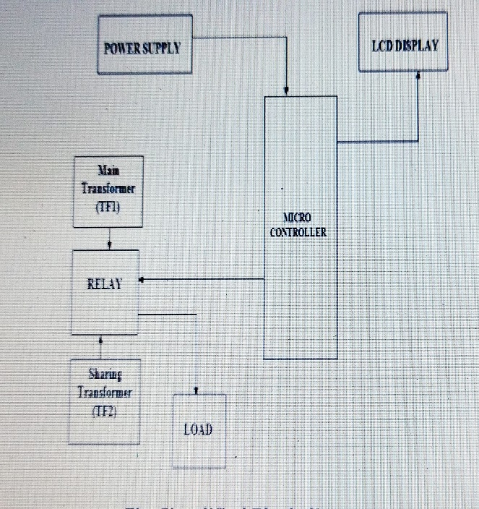

**Working** :In this paper three identical transformers are using which are connected in parallel through change over relay. Transformer-TF1 is a main transformer, which is called master transformer and transformer-TF2 is an auxiliary transformers which is called as slave transformers. Each transformer has its own load handling capacity. In case of a normal operation the master transformer shares the load but as the load is beyond the rated capacity of main transformer the slave transformer is connected in parallel automatically and shares the load. Load switching network is provided to ON/OFF the load on the transformers which is connected to load bank. Shunt is used to distribute the current to all the sections of the circuit. Comparator is having two inputs one is from shunt and the second is from the reference voltage. Reference voltage is set by the user. Comparator (microcontroller) compares the reference voltage and system voltage continuously and the output signal is given to the relay driver circuit. Relay driver circuit consists of NPN transistor to drive the relay. Relay driver gives the signal to the change over relay in case of overload conditions. Change over relay closes its contact when load on the master transformer is more than it’s rated capacity and the transformer-T2 i.e. slave transformer is automatically connected in parallel with the main transformer and if the load is increased to such a amount that can’t be handled with the two transformers then the third transformer T3 is automatically connected in parallel with T1 & T2 and shares the load. Due to which the transformer-T1 is not overloaded and the problem like overheating, burning of winding of transformer and un-interruption of supply is gets eliminated by this arrangement. The visual indicator contains the LED‟s which shows the ON/OFF status of the all transformers.[6]

**Conclusion:**

The work. all about how to supply power, manage an overload condition. The system automatically connects and disconnects switch to share the transformer load. Most of the villages were suffering with electric interruption .this was due to transformer failure. A recommendation to decrease power interruption in the town was: Loadsharing of transformer to protect from failures. Therefore this transformer load sharing system was the best solution to protect equipment failure and electric instructions. Rule base fuzzy logic manages the load and transformers were protected from overload condition.

**References:**

[1] Arun Alawa, Ashish Tiwari ,” Effective Load Sharing Scheme for Distribution Substation by Using Fuzzy Logic Controller” Journal of Innovation and Instrumentation Science Volume 4 Issue 2

[2] Babagana Ali Dapshima, Yasmin Chuupa Essa, Dr. Saumya Chaturvedi,” Fault Detection and Protection of Power Transformer Using Fuzzy Logic”2023-01-20 **ISSN :** 2321-9653

[3] T.Venkata Sai Kalyani, V.Sunil Kumar , Ch.Srinivas,” Automatic Load Sharing of Transformers using Microcontroller” International Journal of Advanced Research in Electrical, Electronics and Instrumentation Engineering

[4]. Nitish Kumar , Manish Sharma , Ayush Sinha ,Indu Bhushan,” FAULT DETECTION ON RADIAL POWER DISTRIBUTION SYSTEMS USING FUZZY LOGIC”

[5] Chonde Shrinath , Dange Jagdish , Mete Pratik , Mansuke Sowraj , J.V. Satre ,” Automatic load Sharing of Transformer” Vol-8 Issue-3 2022 IJARIIE-ISSN(O)-2395-4396 17063

[6] Laknapuram Sai Vani,” Distribution and Load Sharing of Transformer Automatically by Using Microcontroller” International Research Journal of Engineering and Technology (IRJET) e-ISSN: 2395 -0056 Volume: 04 Issue: 05 | May -2017

[7] Kiran Sara Thomas, Melbin Benny, Roy J Mathew, Sebin Jose,” Intelligent Transformer (I-Transformer) “ International Journal of New Technology and Research (IJNTR) ISSN: 2454-4116, Volume-7, Issue-4, April 2021

[8], Nilay.N.Shah , Aditya.D.Chafekar , Dwij.N.Mehta , Anant.R.Suthar,” Automatic Load Frequency Control Of Two Area Power System With Conventional And Fuzzy Logic Control” IJRET: International Journal of Research in Engineering and Technology ISSN: 2319-1163 Volume: 01 Issue: 03 | Nov-2012

[9] Ogbuatu M. O. , Ekiokekeme K. , Egonwa B. O. , Ibiam N. I. , Abioye A. E.,” 136 Minimization of Power System Outage Using Fuzzy Logic Control Mechanism” International Journal of Latest Technology in Engineering, Management & Applied Science (IJLTEMAS) Volume VII, Issue VIII, August 2018

[10] Okolo , T.C. Madueme,” A Fault Detection and Protection Scheme for A 200 MVA Transformer Using Fuzzy Logic” IOSR Journal of Electrical and Electronics Engineering (IOSR-JEEE) e-ISSN: 2278-1676,p-ISSN: 2320-3331, Volume 13, Issue 2 Ver. I (Mar. – Apr. 2018)

[11] Mr. K. Dilavar Basha Mr. P. Prasad,” A Novel Technique to Improve Power Quality using Fuzzy Logic Controller with Transformer Less Dynamic Voltage Restorer” IJSTE - International Journal of Science Technology & Engineering | Volume 1 | Issue 10 | April 2015 ISSN (online): 2349-784X

[12] M. Kavitha , A. Sreekanth Reddy & D. Mohan Reddy,” Power Quality Improvement Using Fuzzy Logic Controller Based Cmli And Fact Devices For Modern Power Systems” International Journal of Electrical and Electronics Engineering Research (IJEEER) ISSN(P): 2250-155X; ISSN(E): 2278-943X Vol. 4, Issue 2, Apr 2014

[13] Shailesh G. Thakre*, Pratima S. Komtolu*, Abhishek V. Bisen*, Saurabh D. Thengadi*, Ajit M. Lilhare*5,” AUTOMATIC LOAD SHARING OF TRANSFORMER USING MICROCONTROLER”, e-ISSN: 2582-5208 International Research Journal of Modernization in Engineering Technology and Science ( Peer-Reviewed, Open Access,

Fully Refereed International Journal ) Volume:04/Issue:04/April-2022

[14] Nivesh Kumar K.,” Automatic Load Sharing of Distribution Transformer for Over Load Protection” International Journal of Science and Research (IJSR) ISSN: 2319-7064 SJIF (2022): 7.942 Volume 11 Issue 5, May 2022

[15]Ahmed Rufai Salihu, Chibuike Peter Ohanu, Chinweike Chukwudebelu Okoli,” Topology of Sustainable Overload Protection of Transformer” International Journal of Innovative Technology and Exploring Engineering (IJITEE) ISSN: 2278-3075 (Online), Volume-12 Issue-1, December

2022